Cottage and Lopez Drainage Improvements Project
Sewer and drain work beginning January 6th

Dear Neighbor,

As part of the Cottage and Lopez Drainage Improvements Project, the City’s contractor, P. Gioioso and Sons, will begin sewer and drain work at the intersection of Magazine Street and Cottage Street.

Traffic will be restricted during work hours. Normal traffic patterns will resume at the end of each day once the work zone is cleaned up. Please use caution and follow the detour shown below. Parking restrictions will be in place on Magazine St. to allow for busses to get through.
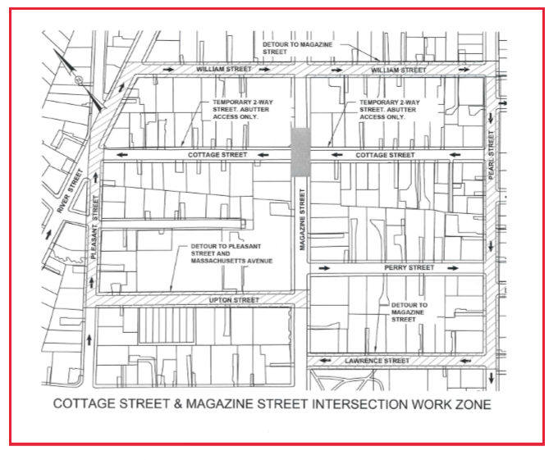
Closed to through traffic from 7 AM to 4 PM , Monday-Friday beginning January 6th.
What to Expect During Construction:
- Work hours will be 7 AM to 4 PM, Monday-Friday.
- “No Parking” signs will be posted; please be sure to check dates/times.
- Vehicle access in and out of properties will be maintained but may be restricted for short periods. If you need access and your driveway is blocked, please speak to a crew member on site and they will make accommodations for you.
- Emergency vehicles and City service vehicles will have access at all times.

Information & Assistance:
Questions regarding this project? Contact Kate Riley, Community Relations Manager, at 617.349.4870/ kriley@cambridgema.gov or Jen Letourneau / jletourneau@cambridgema.gov. If you have any special need or disability, please contact us to arrange for special accommodations that may be necessary. For more info about specific projects visit: www.cambridgema.gov/theworks/cityprojects.
Regards,
Kate Riley, Community Relations Manager, Department of Public Works

