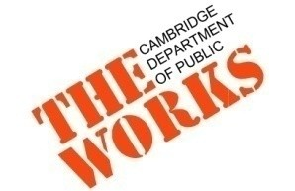
October 16, 2018

COMMUNITY MEETING NOTICE
Gore St & Rufo Rd reconstruction

Dear Neighbor,
Please join city staff and give us your thoughts on the design of Gore St & Rufo Rd:

Thursday, November 1st
6:30pm-8:00pm
Millers River Apartments
Community Room
15 Lambert St.

Eversource Gas and Divco West, the developer of Cambridge Crossing (formerly known as NorthPoint), are currently upgrading utilities on Gore St between Monsignor O’Brien Highway and Warren St.

Following this construction, the City will reconstruct the watermain, replace any lead services, and reconstruct the roadway and sidewalks on Gore St. This is an opportunity to improve Gore St for residents, as well as for people walking and biking along the street. We gathered ideas and feedback during the first meeting on Tuesday, June 19th and incorporated them into an initial plan for the street.

Please join City staff on Thursday, November 1st from 6:30PM-8PM in the Community Room of the Millers River Apartments to review this plan and provide feedback and discussion about the street and sidewalk reconstruction of Gore St. and Rufo Rd.

For Information or Assistance:
If you have any questions regarding the current construction, please contact Divco West at mitigation@csl-consulting.com or by phone at 617-866-8971. For more information, please visit the project website www.npconstruction.info .

If you have any questions regarding the redesign of Gore Street, please contact Kate Riley, Community Relations, at 617.349.4870 or kriley@cambridgema.gov. For information and plans from previous meetings or to join the email distribution list for this project visit http://bit.ly/GoreStRufoRd.

Thank you in advance for your cooperation and patience.

Sincerely,

Katherine F. Watkins
City Engineer

