City of Cambridge Public Information Office Contact: Ini Tomeu, Public Information Officer
For Immediate Release itomeu@cambridgema.gov

Members Sought for Port Infrastructure Project Working Group
Cambridge, MA, July 23, 2020 -- The City of Cambridge is seeking volunteers to serve on a new Working Group to help guide the Port Infrastructure Project. The group will advise City Manager Louis A. DePasquale and his staff on key issues related to the planning and design for this important project.
The Project consists of over $35 million in improvements to sewer, drainage, water, street, sidewalk, and open space infrastructure in The Port. The neighborhood is vulnerable to flooding and climate change is increasing the risk of flooding is increasing, due to the increasing frequency of short, very intense, rainstorms. This Project will reduce the frequency and severity of stormwater flooding and sewer backups in the neighborhood, and upgrade the neighborhood’s surface infrastructure, including streets, sidewalks, shade trees, landscaping, and open spaces.
The main components of the Project are:
- PL6 Stormwater Tank: Stormwater tank at City Parking Lot 6 (PL6) off of Bishop Allen Drive. This element of the project is currently under construction, with work expected to conclude near the end of 2020.

- Clement Morgan Park Tanks: Underground stormwater and sanitary sewage tanks will be constructed in the area of the basketball courts, which will be restored at the completion of the Project. Important issues for the Working Group to advise on include:
  - How/where can the basketball court be relocated during construction?
  - Should other permanent changes be made to the design and features of Clement Morgan Park during construction?

- Utilities: Significant construction in neighborhood streets will be needed to ensure that stormwater and sewer pipes are in good repair, properly sized, and conveying their flows to the new underground tanks described above. We will also take the opportunity to bring other public and private utilities such as water and gas into a state of good repair. A number of these utilities are more than 100 years old and need to be replaced.

The Working Group will help advise us on issues including:
  - How can we minimize disruption to residents, businesses, and community institutions during this phase of the work?

- Resiliency and Urban Forestry: In conjunction with ongoing Citywide planning efforts, the Project will implement features to reduce the impacts of Climate Change in The Port, including stormwater flooding and “urban heat island” effects. The Working Group can help us strategize on engaging property owners and all community members about this innovative and important aspect of the project

- Complete Street Design: The streets, sidewalks and other public spaces in the Project Area will be reconstructed as part of the Project. This presents an exciting opportunity to do more than simply repair and replace deteriorated asphalt, brick and concrete. Working with the community, we can also incorporate street trees, green infrastructure, traffic calming, improved crosswalks, shared street elements, improved lighting, artwork, and street furniture including seating and play elements.

The Working Group will play a critical role in helping us engage the overall community to determine what changes neighbors would like to see as streets and sidewalks are reconstructed.

The working group will consist of 10 to 15 members who will meet regularly for a period of 12 to 18 months, starting in fall 2020. Individuals with interest in The Port and a desire to work with city staff and neighbors on this critical project are encouraged to apply. Meetings of the Working Group will be open to the public.
For additional questions about the new Working Group, contact Jerry Friedman, Supervising Engineer, Department of Public Works at 617-349-9720 or jfriedman@cambridgema.gov.
Individuals interested in being considered should apply by using the city’s online application system at www.cambridgema.gov/apply. A cover letter and résumé or summary of applicable experience can be submitted during the online application process. Paper applications are available in the City Manager’s Office at Cambridge City Hall, 795 Massachusetts Avenue. The deadline for submitting applications is Friday, September 18, 2020.
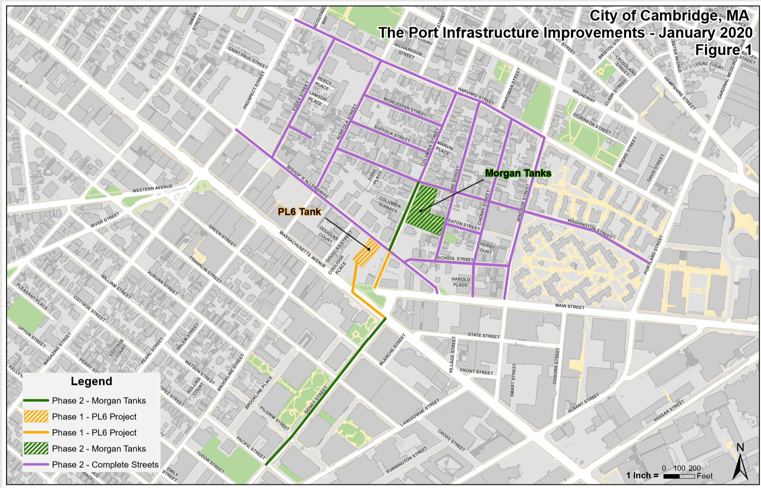
Project Limits
-###-

