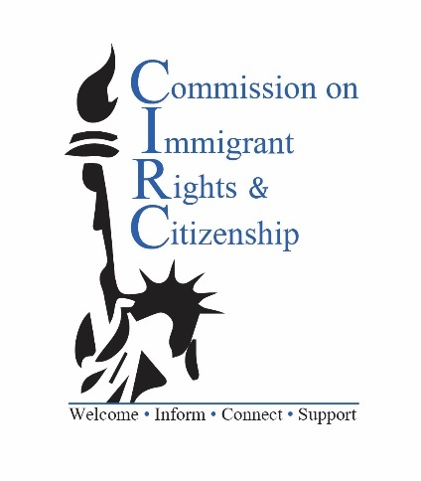
Regular Virtual Meeting via Zoom
Thursday, January 27, 2021

Present: Co-Chairs Karin Lin and Karim Razzaz, Commissioners Marcio Macedo, Tsamchoe Dolma, Ashebir Gezmu, Elizabeth Badger, Subandha Karmacharya, and Arantxa Ortiz

CIRC Staff: Executive Director Nancy Schlacter, Project Coordinator Crystal Rosa, and Immigrant Services Liaison Tagesech Wabeto

Absent:
Commissioners Ana Mejia, Jen Sparks, and Aleksandra Ibrahimi

- Call to order:
Co-Chair Lin called the meeting to order at 6:06 pm.

- Public comment
No public present at the start of the virtual meeting. There was no public comment.

- Introduction to New Commissioner
The members of the commission introduced themselves to Arantxa Ortiz, the newest member to join. Commissioner Ortiz is an anthropologist in training and has worked with organizations advocating the rights of immigrants. ED Schlacter provided a summary of the Commission’s work, specifically the Needs Assessment which led to the Legal Screening Clinic.

- Review and approval of December 2020 minutes
Commissioners reviewed the minutes of the December 10, 2020 meeting. Commissioner Badger moved to approve the meeting minutes, and Commissioner Macedo seconded. The minutes were approved unanimously.

- New Business
- Reliable resources for legal updates
ED Schlacter provided the following resources as useful places to receive updates to any changes in immigration law due to the new federal administration: Protecting Immigrant Families (PIF) Campaign, Massachusetts Immigrant Refugee Advocacy (MIRA) Coalition, the Office of the Attorney General, Massachusetts Law Reform Institute (MLRI).
- Vote for new Co-Chairs – postponed for 6 months
Co-Chair Lin reminded the Commission that according to the Ordinance there should be a vote for new Co-Chairs in January. Co-Chair Lin offered to continue for an additional 6 months to make up for the missed meetings that occurred at the beginning of the pandemic. Co-Chair Razzaz agreed to serve those 6 months with Co-Chair Lin. Commissioner Badger moved to postpone the vote for new Co-Chairs for 6 months, Commissioner Gezmu seconded. The vote was postponed unanimously. ED Schlacter suggested that the Commission revisit the topic in July or September.
- Know Your Rights
Commissioner Badger stated that the PAIR Project continues its work with KYRs in the community as a virtual event during the pandemic. All that is needed is an email list and a community group willing to schedule.
- Family Policy Council Working Committee on Language Justice
Project Coordinator (PC) Rosa shared with the Commission her work with the Language Justice working committee in partnership with the Family Policy Council. Executive Director Nancy Tauber has asked PC Rosa for her feedback on the survey being drafted by the working committee. The survey will help determine and develop recommendations to improve language justice policies, practices, supports, and resources needed to ensure equitable access within Cambridge.
- Collaboration with the Cambridge Public Library
PC Rosa will be meeting with Ana Barros from the Cambridge Public Library to discuss ideas of possible collaborations for virtual events to use remaining food and event funds that were budgeted before the pandemic.

- Executive Director’s (ED) report
Since the last meeting, CIRC and De Novo have served a total of 36 clients. There were 15 callers to the December virtual clinic and 15 callers to the January clinic. A finalized agreement seems to be in place be for the continuation of the legal screening clinic for the rest of 2021. ED Schlacter is awaiting word from the Law Department regarding the announcement of an Acting Interim Executive Director.

Immigrant Services Liaison (ISL) Wabeto Report
Immigrant Services Liaison (ISL) Wabeto provided a summary of her efforts during the COVID-19 shutdown. ISL Wabeto helped CPS families with the transition from virtual to in-person learning for SEI and IEP students in all grades and JK- 3rd grade students. ISL Wabeto helped Cambridge families with a survey that allows them to choose between in-person or virtual learning. CPSD has expanded its in-person learning plan for all grades beginning March. ISL Wabeto provided information about JK/K registration to families who are eligible to register their students for the 2021-2022 JK/K class, which ends on Jan. 31st.

ISL Wabeto has continued to attend the CET outreach workers’ weekly meetings where they share challenges, ideas, and resources. ISL Wabeto helped several people with scheduling appointments with the Cambridge De Novo Immigration Clinic and provided information for Rian Center and City of Boston’s Immigrant Advancement office. ISL Wabeto also shared information on immigration, college, housing, afterschool programs, and other resources with the outreach workers, families, and school liaisons.

ISL Wabeto participated in two CET team leader candidates task reviewing sessions, where outreach workers evaluated the candidates based on the job description for being a Community Engagement Team co-leader for Cambridge’s diverse community.

ISL Wabeto is also helping with outreach to recruit new families to the Baby U workshop. It is a virtual 6-week program, which strengthens parent/child relationships and supports parents to become better advocates for their children.

- Ongoing Business
Strategic planning
The Commission reviewed the list from the previous brainstorm to reassess priorities for new initiatives and developed action items:
- Family Preparedness – does not feel as urgent as it did in the previous administration
- Online Newsletter/Social media presence – ask Director of Communications, update Immigrant Resource page with new information
- Commissioner Bios – may be important to show the diversity of the Commission
- Engagement with Cambridge Public Schools/Supporting Parents address their children’s experience in schools -ISL Wabeto already doing this
- Expanding partnerships beyond Central Cambridge – unsure what this meant
- Entering CIRC events in Find It Cambridge events – PC Rosa already doing this
- Outreach to health centers in Cambridge – check in with Commissioner Sparks when is at the next meeting
- Worker’s rights information to undocumented workers
- Driver’s licenses – legislation is still pending at the State

Commissioner Macedo moved to adjourn the meeting at 7:28 p.m., seconded by Commissioner Razzaz.

The next commission meeting will be on Thursday, February 25, 2020, at 6 pm via a Virtual Zoom meeting.

