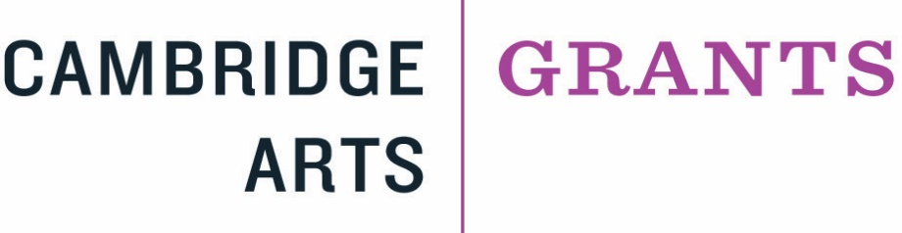

Public Art Grant Application Guidelines
If you are thinking of developing a public art project and are considering applying to any of the grant opportunities under the Cambridge Arts Grants Program to support a public art project, please follow these guidelines to prepare your project, application, and supplemental materials.
Connect with Public Art Staff
All applicants interested in public art projects must communicate with the Public Art staff during concept and design development of the project so that questions and issues can be addressed to the best advantage of the applicant. This includes public art in any medium including sculpture, murals, interactive, electronic, or time-based.
All public art applicants must meet virtually with the Cambridge Arts Public Art Division and secure a Statement of Eligibility. Public Art Staff are also available to help with any questions throughout the process of your application. Please email Lillian Hsu, lhsu@cambridgema.gov and Hilary Zelson, hzelson@cambridgema.gov to schedule a virtual meeting.
All public art applicants MUST meet virtually with the Public Art staff at least two weeks before the grant deadline and secure a Statement of Eligibility from the Public Art Staff before applications will be considered complete and eligible for review.
Secure a Statement of Eligibility
For the Public Art Statement of Eligibility, applicants must provide a detailed description of the project that includes a concept description, site location, property owner(s) name, materials used, fabrication methods, plans for installation and de-installation, plans for maintenance, names of collaborators, budget, schedule/timeline, and anticipated impact on community and neighborhood.
Secure Space Approvals
For projects that involve temporary or permanent installation of artwork in public space, applicants must submit a one-page letter outlining the ownership of the work and the maintenance plans for the project.
If the artwork is to be located on private property, the applicant must provide a letter naming the owner of the site with his/her signature of approval for the project.
Projects proposed to be on City property must meet the approval of the Cambridge Arts Public Art program staff and, where necessary, staff from other city departments who have jurisdiction over proposed locations or services.
Please Note: Applicants are advised that the funding of public artwork through the Cambridge Arts Grant Program is a separate process from the commissioning of artwork through the Cambridge Arts Percent-for-Art Program. The commissioning of artwork to be accessioned into the City's permanent Public Art Collection is accomplished through a highly specific public process in keeping with the Cambridge Public Art Ordinance, which is administered by the Cambridge Arts Percent-for-Art Program with oversight from the Public Art Commission.

