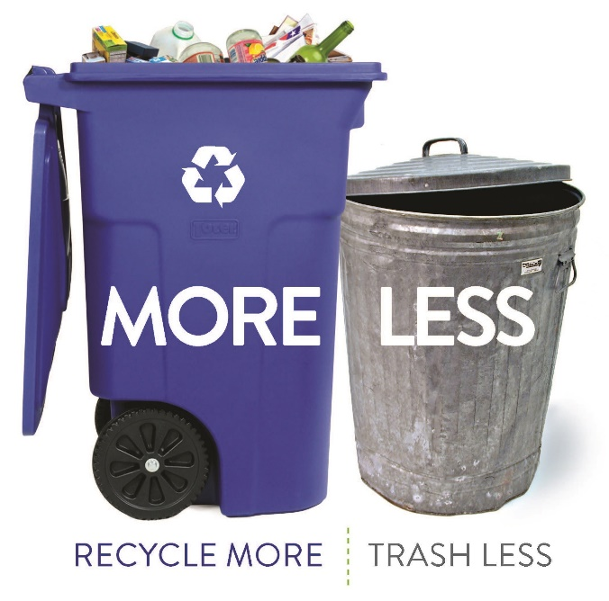
 | City o | Appendix D  Phase 2: Comparative Summary of ZWMP Options  Zero Waste Master Plan  City of Cambridge, MA  January 25, 2019

Appendix D: Phase 2 Comparative Summary of ZWMP Options
Statement of Purpose
This Phase 2 comparative summary of ZWMP options was originally issued to the City of Cambridge in November 2017. The purpose of this summary was to provide a general comparison of the ZWMP options that had been identified in Appendix C, looking at performance parameters like ability to reduce GHG emissions, trash reduction potential, potential to reduce vermin, potential for improvements to worker safety, and impacts on capital and operating expenses. The summary also notes the timeframes associated with implementation of the options and whether ordinance changes would be involved. Those options with more overall positive outcomes as noted in the comparison, were more strongly recommended for inclusion in the ZWMP recommendations.
This document is a supporting background document for the ZWMP, documenting the outcome of one component of Phase 2 of the ZWMP process. No further amendments will be made to this document based on review of the ZWMP.

Appendix D: Comparative Summary of ZWMP Options
 | GHG Reduction Potential (MTCO₂e) | Trash Reduction Potential (lbs/HH/wk) | Potential to Reduce Vermin | Potential to Improve Worker Safety | Impact on Capital Expenses | Overall Impact to Operating Costs | Ordinance Change Required | Timeframe | Note
 | Low (0 to -1000), Medium (-1001 to -5000), High (-5000+) | Low (<2), Medium (2.1-3), High (>3) | Low (No potential), Medium (Some Potential), High (High Potential) | Low (Little to No potential), Medium (Some Potential), High (High Potential) | High (ongoing capital costs), Medium (capital costs to implement), Low (no capital costs). | Low (some savings or no impact), Medium (some impact), High (greater increase in costs) | Yes/No | Short (1-5), Medium (6-10), Long 10+) years
Collection System Changes
Organics Rollout to All households with City trash collection | Medium  (1742) to (1868) | High  4.1 to 4.8 | High – More secure containers. | High - High potential to improve worker safety with better ergonomics and less lifting. | Medium | Medium/Low – No net change in fleet, lower trash disposal costs, ongoing cart replacement, storage, delivery. | No | Short  (1-2 years) | Program would collect currently acceptable materials (e.g. food scraps).
Provision of Standard Trash Container | High  (6795) to (9057) | Medium/High  3.4 to 4.2 | High – More secure containers. | High - High potential to improve worker safety with better ergonomics and less lifting. | Medium | Medium - No change to fleet, decrease trash disposal costs, ongoing cart replacement, storage, and delivery. | Yes | Short  (1-3 years) | Assume one cart per household. No option for overflow.
Enhancements to Current System
Hybrid PAYT (bag-based for all trash) | Medium/High  (2266) to (6795) | Low/Medium  1.7 to 3.3 | Low - No potential to reduce vermin with use of plastic bags. | Medium - potential to improve worker safety by use of bags which are easier to manage. | Low | Low/Medium - Program may lower trash disposal costs. Some costs for P&E and administration. | Yes | Medium | Assume all trash must be placed in bags which residents purchase.
Bi-weekly Trash Collection | High  (6795) to (9057) | Medium/High  3.4 to 4.2 | Medium – greater quantities of food waste collected more frequently | High - High potential to improve worker safety with better ergonomics and less lifting. | Low | Low - Program should decrease fleet, lower trash disposal costs. Some costs for P&E. | Yes | Medium/Long | Assume current trash containers used.
Mobile Recycling Depot (depends on what materials are managed) | Low  (243) - (843) | Low  1.0 to 1.2 | N/A | Medium – some potential to improve safety. | Low | Medium - May require a vehicle, staff time to organize and some P&E. | No | Medium/Long | Assume replaces Recycling Center.
Modified Recycling Center |  |  | N/A | Medium - Some potential to improve worker safety with better layout. | Low | Low - Minimal to no change to operating costs. | No | Short | Difficult to calculate as unknown what modifications would be made.
Enhanced HHW Program |  | Minimal (extremely small fraction of waste stream) | N/A | Medium - potential to improve worker safety if hazardous materials are kept out of trash. | Low | Medium - Cost related to holding extra events. | No | Short/Medium | WARM model has no capacity to model this waste stream.
Collection of Small Electronics | Low  (243) to (403) | Low  0.96 to 1.04 | N/A | Low - No potential to improve worker safety. | Low | Low - If managed through other programs. | No | Medium
Reduction and Reuse & Additional Programs
Sharing Libraries | High  (1015) - (7573) | Low  1.02 to 1.1 | N/A | Low - No potential to improve worker safety | Low | Low - Some staff time for P&E. | No | Short
Food Waste Reduction | High  (1093) to (1367) | Low  0.3 to 0.4 | Medium - some potential to reduce vermin if less food is available. | Low - No potential to improve worker safety | Low | Low - Some staff time for P&E. | No | Short
Support Reuse Events | High  (1015) - (7573) | Low  0.6 to 0.7 | N/A | Low - No potential to improve worker safety | Low | Low - Some staff time for P&E. | No | Short
Waste Exchange | High  (1015) - (7573) | Low  0.6 to 0.7 | N/A | Low - No potential to improve worker safety | Low | Low - Some staff time for P&E. | No | Short
Mattress Recycling | Low  (141) to (188) | Low  0.90 to 0.91 | N/A | Low - No potential to improve worker safety | Low | Medium - May require a vehicle for collection, staff time to collect and administer program. | No | Short/Medium
Carpet Recycling | High  (1634) to (1962) | Low  1.4 to 1.6 | N/A | Low - No potential to improve worker safety | Low | Medium - May require a vehicle for collection, staff time to collect and administer program. | No | Long
Textile Recycling | Medium  (753) to (943) | Low  1.1 to 1.2 | N/A | Low - No potential to improve worker safety | Low | Low - If outsourced, just staff time for P&E, could reduce trash disposal costs. | No | Short/Medium
Porcelain Recycling | Low  (<1) | Low  0.886 to 0.891 | N/A | Low - No potential to improve worker safety | Low | Medium - Requires staff/vehicle to collect store and dispose of material. Staff time for P&E. | No | Long
- All GHG and waste reduction potential calculated with estimated tonnages for 2025 in order to compare the programs on a more level basis rather than comparing when programs are first implemented.
- Note – details for operating costs - Low - fewer vehicles required, reduced trash disposal costs, minimal to no staff time required, Medium - no change in vehicles, no change to trash disposal costs, some staff time required, High - additional vehicles required, increase in trash disposal costs, significant staff time required.
 | Positive (e.g. high GHG emission reduction, High waste reduction potential, High potential to improve worker safety, low impact on capital or operating costs)
 | Neutral (e.g. medium GHG emission reduction, medium waste reduction potential, some impact to operating costs)
 | Negative (e.g. low GHG emission reduction potential, low potential to improve worker safety, no potential to reduce vermin, higher impact on capital or operating costs)

