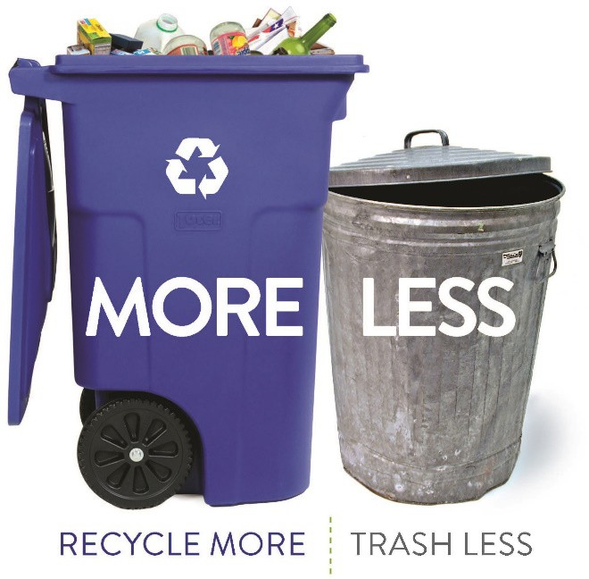
Appendix F:
Phase 3: Results of Community Engagement
Zero Waste Master Plan
City of Cambridge, MA
March 29, 2019

Appendix F: Results of Community Engagement from December 2018 to March 2019

Statement of Purpose

In Phase 1 of the ZWMP (as documented in Appendix B) engagement was undertaken with various City representatives and the City’s Recycling Advisory Committee (RAC) regarding concepts and ideas that could be considered as part of the ZWMP. Further engagement was recommended following the completion of Phase 2 of the ZWMP process.
This report on the outcome of the public engagement activities undertaken from December 2018 to March 2019 was used to support the recommendations in the ZWMP.
This document is a supporting background document for the ZWMP, documenting the outcome of one component of Phase 3 of the ZWMP process. No further amendments will be made to this document based on review of the ZWMP.

A community engagement plan was developed in October 2018, focused on engaging the City’s Recycling Advisory Committee (RAC) and interested members of the general community in discussions regarding the draft ZWMP recommendations. A Public Open House was held in the evening of December 18, 2018 from 6 to 8 p.m. at the Main Library at 449 Broadway Avenue. A meeting was held with the Cambridge RAC the following morning on December 19, 2018. The City made the draft ZWMP documents available on the project website and invited comments on the plan until March 15, 2019.
The draft ZWMP was also discussed at a RAC meeting on March 13, 2019. The approach used in the engagement process, and the outcome of these sessions is discussed below, and was considered in the development of the ZWMP recommendations.

Public Open House

The Public Open House began with a presentation (see Attachment 1) which provided an overview of the ZWMP process and draft recommendations, forming a background for discussions during the rest of the session. Display panels (see Attachment 2) were set up throughout the area used for the session, to provide attendees with information and to elicit feedback and encourage discussion. City staff and the consultant team, and several members of the RAC circulated among the attendees to encourage discussion and to seek feedback on the key issues and questions identified on the panels. 19 members of the community attended the session to provide their input to the ZWMP, many of whom participated in enthusiastic discussion during the entire 2-hour period timeframe.

Attendees were able to provide feedback through direct comment to the team supporting the session, and by providing written suggestions through notes and comments provided directly on the boards set up to support key discussion points.
A substantive part of the feedback provided by the public at the Open House, focused on promotion and education as a critical element of the City’s waste diversion programs. The range of suggestions overall as noted by participants in the public open house included:
  - More engagement in developing zero waste curriculum in schools
  - More opportunities for face-to-face engagement including use of volunteers, community discussions/debates, involvement with neighbors, community events
  - Educational programs/initiatives targeting small businesses
  - Promotion of community swaps, fixit events
  - More tips on how to avoid problem materials (e.g. how do I use less plastic)
Considerable support was also expressed for reduction and reuse options, with over 1/3 of all comments provided focused on options and concepts for reduction and reuse. The range of input provided included:
  - Emphasis on promotion and education, particularly communication on current re-use opportunities, promotion of reusables to replace single-use materials, food waste reduction and events/forums to allow for sharing of ideas.
  - Support for more Fix-It clinics.
  - Support for additional ordinances to ban materials (e.g. plastic straws), policies and/or permit requirements to increase waste reduction at events, waste reduction during construction/demolition.
The following table provides a summary of the key areas of discussion and the nature of the feedback provided by participants in the Open House.
Category of Discussion | Number of Comments | Key points / Issues
Education | 3 | - Need for more involvement in ZWMP curriculum development
General Thoughts | 14 | - More promotion and outreach, with a range of approaches. More involvement at a neighborhood level  - Support for food waste reduction
Increase Organics Participation | 12 | - Continue to provide compost bags  - Assistance/support to address problems (i.e. fruit flies)  - Emphasis on need for more promotion and outreach  - Mandatory composting
Reducing Recycling Contamination | 25 | - Emphasis on promotion and education  - Enforcement on contaminated carts
Reduce and Reuse | 51 | - Emphasis on promotion and education programs and community engagement  - Support for more Fix-it clinics and other community events to provide more hands-on reuse opportunities  - Support for swaps and waste exchanges  - Additional Ordinances / Policies targeting problem materials (plastic straws, mandatory requirements for businesses and building design, requirements for community events to be zero waste)
Trash Reduction | 15 | - Emphasis on promotion and outreach  - Support for standard trash bin (one comment did not support this concept)
Reducing Commercial Waste | 20 | - Policy development  - Emphasis on promotion and outreach including recognition programs  - Enforce mandatory diversion, ordinances on single use items (e.g. plastic straws, coffee stirrers)
Other ZWMP Recommendations | 5 | - Emphasis on promotion and outreach
City staff have all of the comments provided by the participants in the Open House for consideration in the ZWMP implementation process.

Recycling Advisory Committee

The following morning, the same presentation from the Public Open House was made to the RAC. Ten members of the RAC and three members of the public were present at the meeting, along with five City staff and the consultant team. Opportunity was provided for more in-depth discussion with the RAC members regarding the draft ZWMP recommendations. The results of the discussions are documented in the minutes of the December 19th meeting posted on the City’s website.

General support was expressed by the RAC members for the overall ZWMP recommendations as presented. Feedback provided by the members included:
  - Discussion regarding the role of in-sink garbage disposal units.
  - The need for more face-to-face messaging and promotion and use of motivational tactics.
  - Support for the concept of mobile recycling depot service.
  - Support for ongoing educational programs.
The RAC also provided additional input on the draft Zero Waste Master Plan posted on the City’s website, at a meeting held on March 13, 2019 and through written comments.
Feedback provided by the members included:
  - City needs to add contamination rate as a metric for measuring success.
  - What’s the Plan for meeting the 2050 goal?
  - Regular trash audits must be scheduled and made a priority to measure success of City programs. RAC should continue to monitor trash composition to stay current with packaging changes, resident sorting behavior, and recycling markets. Similarly, participation in curbside organics programs must be monitored.
  - Continued emphasis on education is critical. What should be done and how can the RAC help? How are different demographics targeted?
  - No mention of Extended Producer Responsibility programs. Implement material bans.
  - Like the idea of more capacity for recycling (bins), rethinking recycling center and implementing mobile collection for electronics, HHW, etc.
  - Add the idea of bin monitors at large events to encourage proper sorting and education/outreach.
  - There should be more significance on listing when and how the ZWMP will be revisited.
  - How is ICI/Business waste accounted for in this plan? What has been done to survey business recycling, and/or track trash disposal and GHG emissions.
  - What is current thinking on trash disincentives beyond Standard Bin?
  - Recommendations on hiring staff to monitor and enforce programs, and for promotion and education.
- Comments Received from the Public
The City uploaded a draft version of the Zero Waste Master Plan, along with Appendices A-F and the Zero Waste Master Plan presentation to a dedicated webpage about the Zero Waste Master Plan (https://www.cambridgema.gov/Departments/publicworks/zerowastemasterplan). The public was invited to provide comments from January 31, 2019 to March 15, 2019. Comments were received from members of the public (7), a councilor (1), a City sustainability planner (1) and from the RAC. The following are excerpts from the comments received, except for the RAC comments which are presented in the section above.
Category | Number of Comments |  | Key points/ Issues
Mobile Recycling Center | 2 | - Support for establishing a mobile unit for collection of single-use batteries, electronics, lightbulbs, small appliances and other household items that are no longer usable.  - Do a pilot right away!
Composting other materials | 2 | - Install composting toilets .  - Develop compost drop-off in empty lots.  - Find a way to compost diapers.
Recycling Other Materials | 4 | - Find a way to recycle other plastic bags (e.g. chip bags).  - Implement mattress recycling.  - Hold more HHW collection events.  - Establish recycling bins in stores for light bulbs, small appliances etc.
PAYT | 1 | - Comment on accessing data from communities using PAYT. Comment that a standard trash container will not encourage waste reduction.
Recycling System | 1 | - Suggest moving to a two-bin system – one bin for easy to recycle items, and another for “everything else”
Textile Recycling | 2 | - Develop recycling program, especially for textiles not in good condition.  - Implement textiles recycling
Waste Reduction & Reuse | 6 | - Schedule more fix-it clinics – waits are very long  - Encourage neighborhood block garage sale through promotion on City website.  - Allow residents to use a vacant city parking lot to sell/recycle their stuff.  - Promote Facebook groups for give-away/sell used materials.
Regulatory | 7 | - Change plastic bags in supermarkets to compostable bags and/or ban plastic bags for produce.  - Remove ordinance regarding visible bins as residents have issues storing bins.  - Implement mandatory food waste diversion.  - Implement every other week trash collection once people have reduced trash below a certain level.  - Ban Styrofoam from being shipped into City.  - Ban all single use plastics except for straws on request to accommodate people with medical needs.
Containers | 3 | - Consider providing more attractive kitchen compost bin  - Provide smaller bins on request (e.g. 12-gallon trash container, and/or smaller recycling container).  - Support standard size container.
Incentives | 1 | - Financial incentive to reduce waste – at neighborhood level. Could be weight based. Savings could be used in participatory budgeting process to allow those neighborhoods voting on how savings could be spent.

6

City of Cambridge | Results of Community Engagement

Attachments:
Attachment 1 – Information Panels on the Draft ZWMP Attachment 2 – Presentation on the Draft ZWMP

7

1

Information Panels on the Draft ZWMP

Zero Waste Master Plan –
an Overview
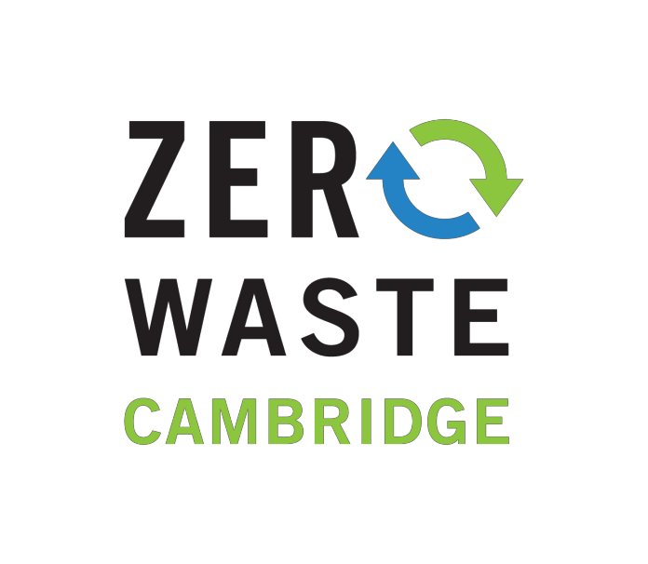
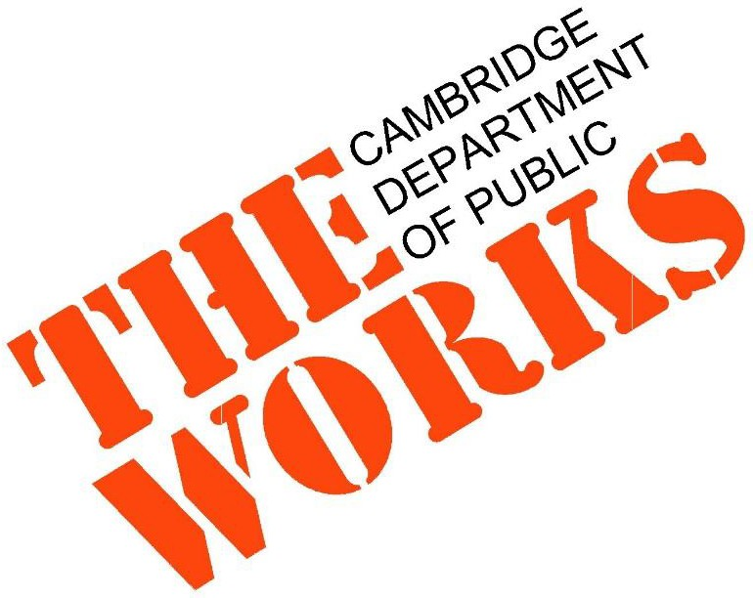
December 18, 2018

What is Zero Waste?
- “Zero Waste is a goal that envisions…all
discarded materials are designed to become resources for others to use.”
- But we must reduce & reuse first

Zero Waste International Alliance http://zwia.org/standards/zw-definition/

Purpose of the Plan

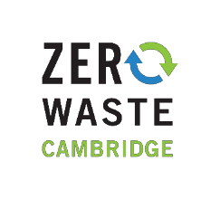
  - Meet City’s waste reduction goals
  - Continue to maintain high quality public services
  - Maximize operational efficiency
  - Protect employee health & safety
  - Reduce GHG emissions
  - Reduce costs

Current Waste Management System

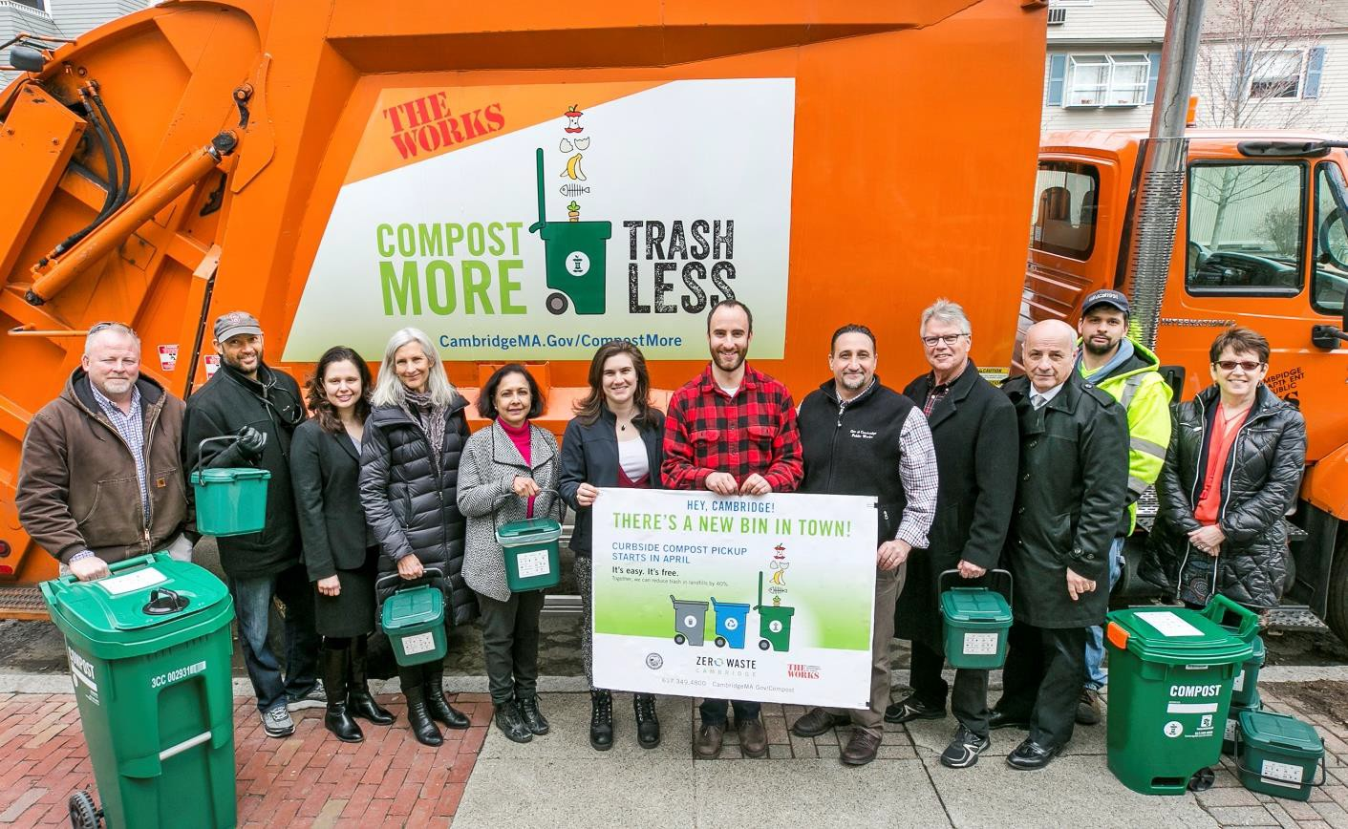
- Trash
- Recycling
- Yard Waste
- Curbside Organics
- Household Hazardous Waste
- Electronics
- Bulky Waste
- Recycling Center

How are we doing compared to others?
Recycling Rates among select big cities (2016 data)
San Francisco, CA 80%

Seattle, WA 58.8%

Alexandria, VA 49.3%

Cambridge, MA 42%

Boulder, CO 39%

Portland, ME 38%

Worcester, MA 38%

Trash Generation Rate
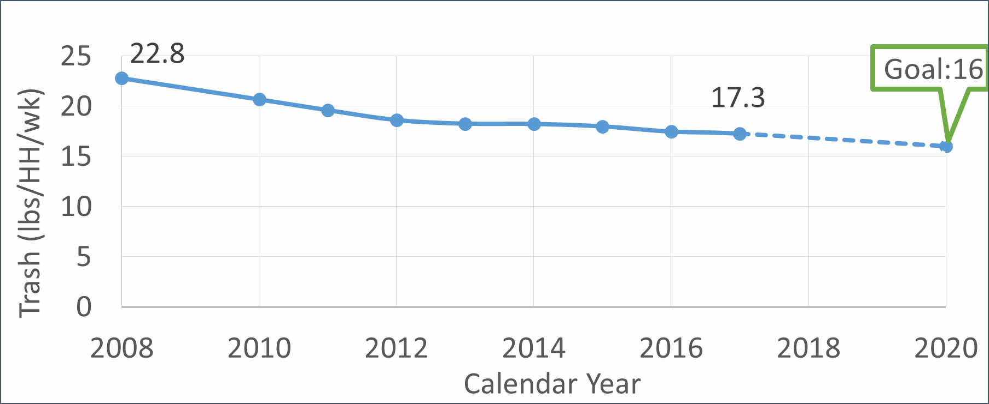

2050 Goal: 80% reduction in municipal waste, 4 lbs/HH/wk

What’s still in our trash barrels?

“Trash”, 30%

Other **, 13%
Compostables, 41%

Recycling, 16%

**Other: Textiles, Electronics, Scrap metal DATA: 2016 waste audit

Goal – Maintain High Quality Service

City has consistently high Customer satisfaction
86%
79%
86%
86%
80%
85%
93%
86%
88%
Satisfaction with Trash Collection Service
  - 90%+ of residents rate recycling and trash collection as “excellent or good”

2000 2002 2004 2006 2008 2010 2012 2014 2016

City collects trash from +/- 32,000 HH/week

Source: Biannual Citizen Satisfaction Telephone Survey

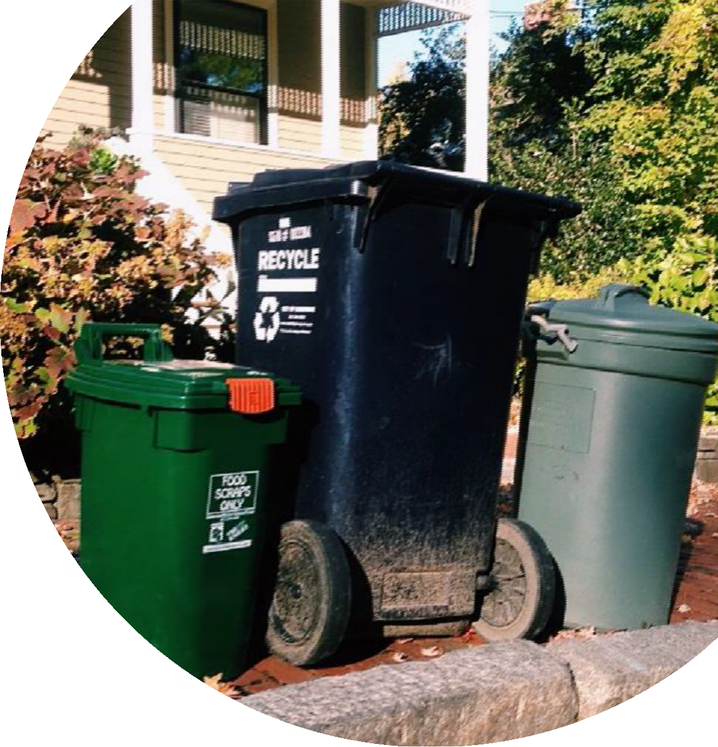
Goal – Maximize Operational Efficiency
- Example: Expansion of curbside organics program increased DPW fleet by 1 truck, not 2 trucks.
- Route Optimization

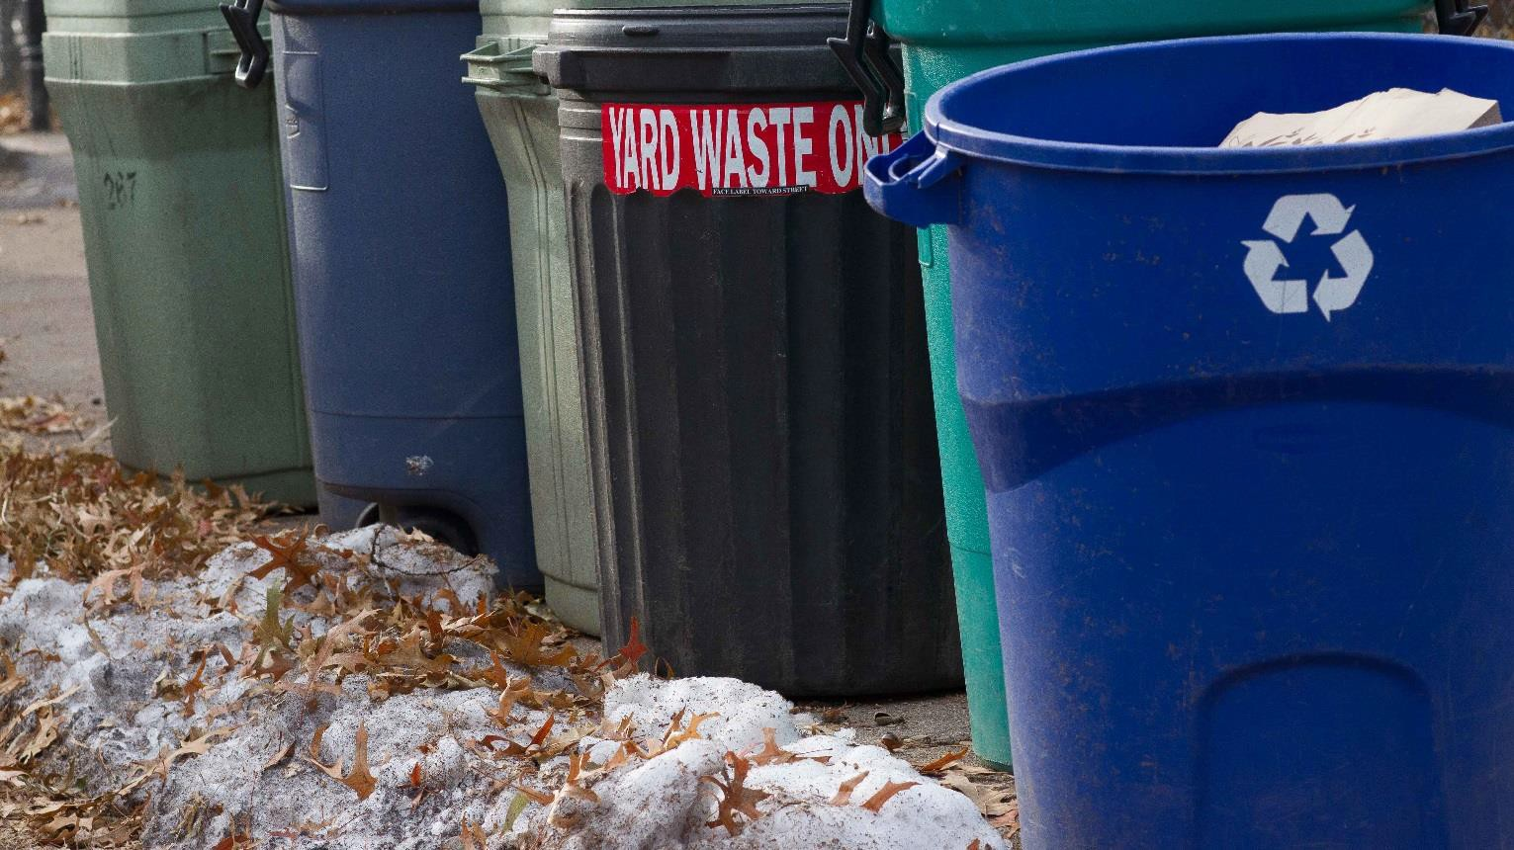

Goal – Protect Employee Health & Safety
- Example: reduce lifting impacts with semi- automated curbside trash collection

Goal – Evaluate Costs

  - Reduce costs by diverting materials from trash
  - Reduce contamination in recycling
FY19 Disposal Costs (Tip fee only)
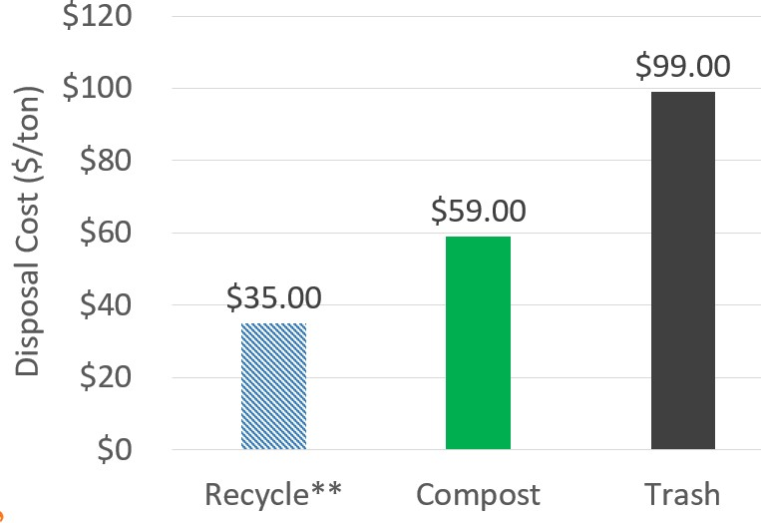
**Currently pay $70/ton to recycle due to excessive contamination.

Goal – Evaluate Impact of GHG Emissions

- Most of the emissions come from disposal, not transportation
- Waste reduction and diversion have potential to significantly decrease CO2 emissions from waste operations

14,000

12,000
GHG Emissions (MTCO2e)

10,000

8,000

6,000
Estimated Changes in GHG Emissions

4,000

2,000

0
2012
2013
2014
2015
2016
2017
2018
2019
2020
2021
2022
2023
2024
2025
2026
2027
2028
2029
2030

Master Plan Recommendations

Expand
Evaluate
Expand
Existing City policies
Evaluate
Waste reduction and diversion
programs
Trash disposal and collection
processes
Curbside Organics

Expand Curbside Organics

Early Implementation Moving Forward - Recommendations
- 600 HH

April 2014:

Oct 2015:

April 2018:
- 6 tons/month

- 5,200 HH
- 30 tons/month

- 25,000 HH
- 140 tons/month
  - Expand to 13+ units: fall 2019 to fall 2020
  - Continue evaluating options for disposal sites of food waste
  - Evaluate ordinances to increase diversion
  - Potential to reduce trash disposal by 4 to 5 lbs/HH/week

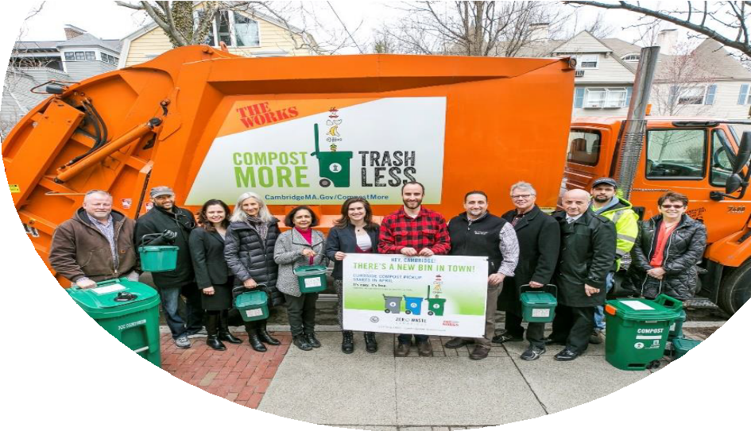
Expand Curbside Organics

An audit this Fall found that the set out
rate for organics was less than 60%. What do you think would increase participation in the program?

- Providing more compost bags periodically?
Curbside Organics August 2018 Survey:
1300 respondents, over
90% approval rating
- More guidance on how to use the program?
- More peer-to-peer education about reducing trash?
- Mandatory composting ordinance?
- All of the above?
- Other actions?

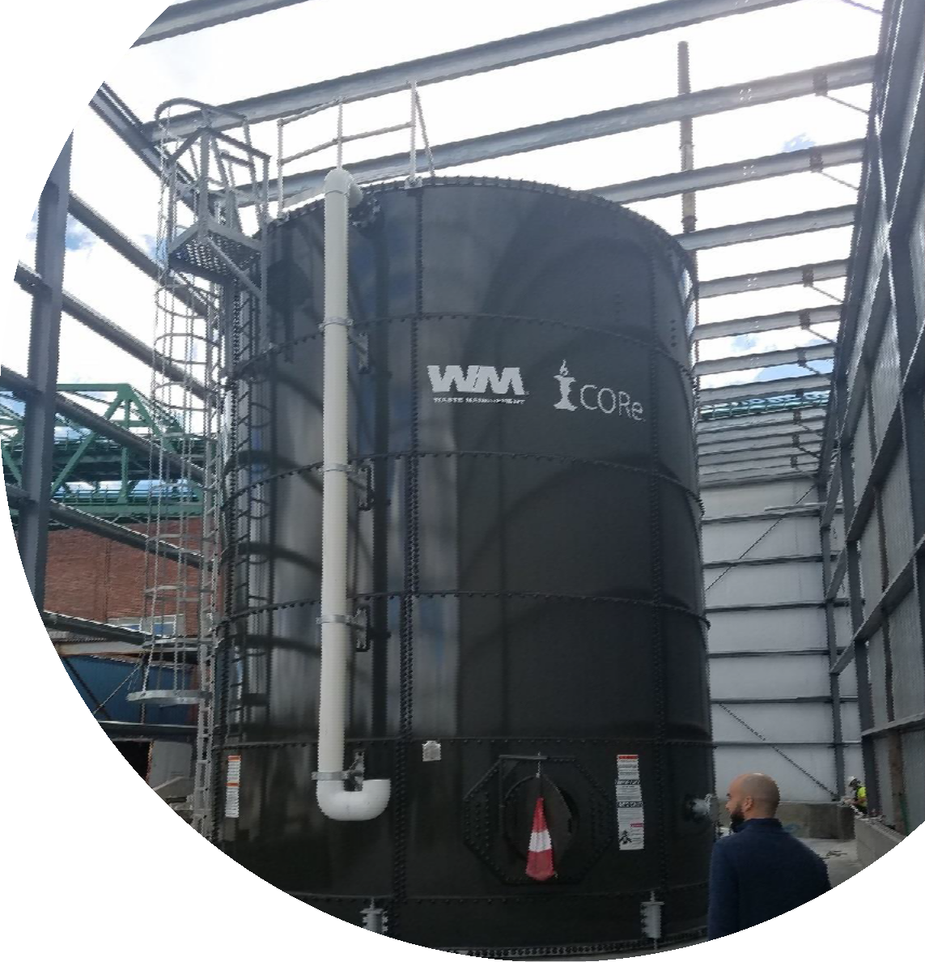
Expand Curbside Organics
Processing Organics
- Contract to implement program (expires April 1, 2021)
- Current program focus is to increase quantity of organics diverted
- Increase in state-wide permitted processing capacity offers new options

CORe in Charlestown pre-processes food scraps into a slurry sent to Greater Lawrence Sanitary District in North Andover

Evaluate Trash Disposal and Collection

Early Implementation
- Decreased trash truck fleet from 7 to 6 in April 2018
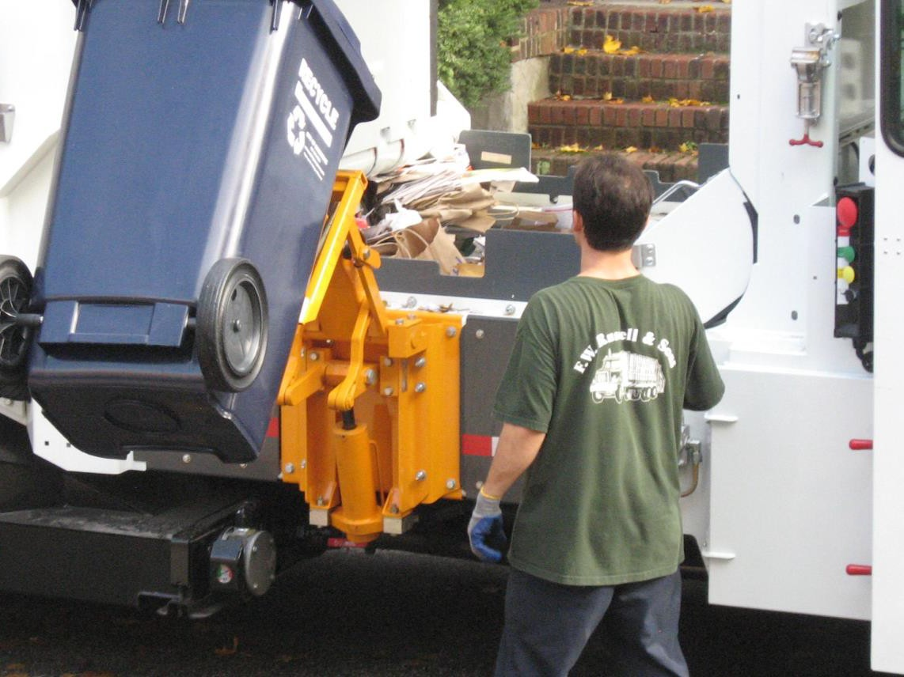
- Route optimization
Moving Forward -
Recommendations
Standard Trash Container
- Semi-automated collection, reduces lifting impacts
- Reinforced plastic helps rodent control
- Improved sidewalk accessibility
- Less trash spills
- Increased diversion

Curbside Audit Results
  - Over 75% of ²⁰

households set out ¹⁸
Pounds per household

less than 32 gallons of 16
14

trash that week 12

Monday route 10

example of mature 8

organics program 6
4
2
0
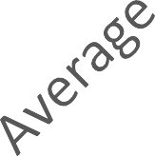

Waste Reduction & Diversion
Early Implementation Moving Forward- Recommendations

    - Recycle Right Campaign
    - Small Business Recycling Pilot (Nov 2018 launch)
    - Mattress Recycling
    - Examine existing recycling center, 2020
    - Textile recycling strategy, 2020/2021
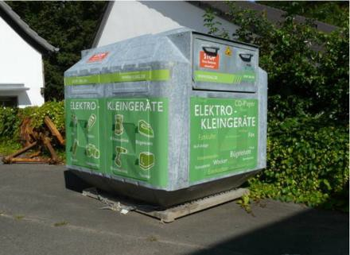
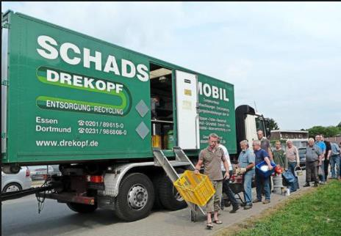
    - Continue support for food waste reduction, sharing libraries, reuse events
    - Potential to reduce trash by 2 to 3 lbs/HH/week

Improving Recycling
40% of recycle carts had moderate to major contamination. What do you think would help people reduce contamination?
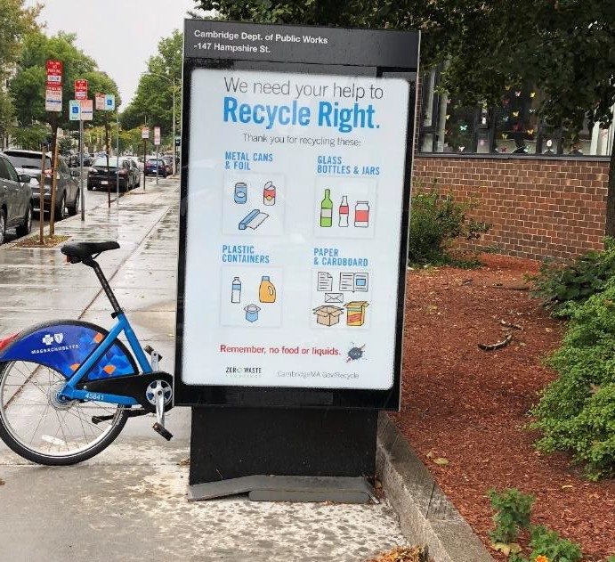
    - More guidance on how to use the program?
    - Notices on the carts when contamination is present?
    - Not emptying cart with contaminated material?
    - All of the above?
    - Other actions?

Evaluate Existing City Policies

Early Implementation Moving Forward- Recommendations

      - BYOB and Polystyrene Ordinances, 2016 (50 to 80% reduction in single- use bag consumption)
      - Mandatory Recycling Ordinance
      - Reduction in Trash Setout (from 150 gallons/HH to one standard trash container)

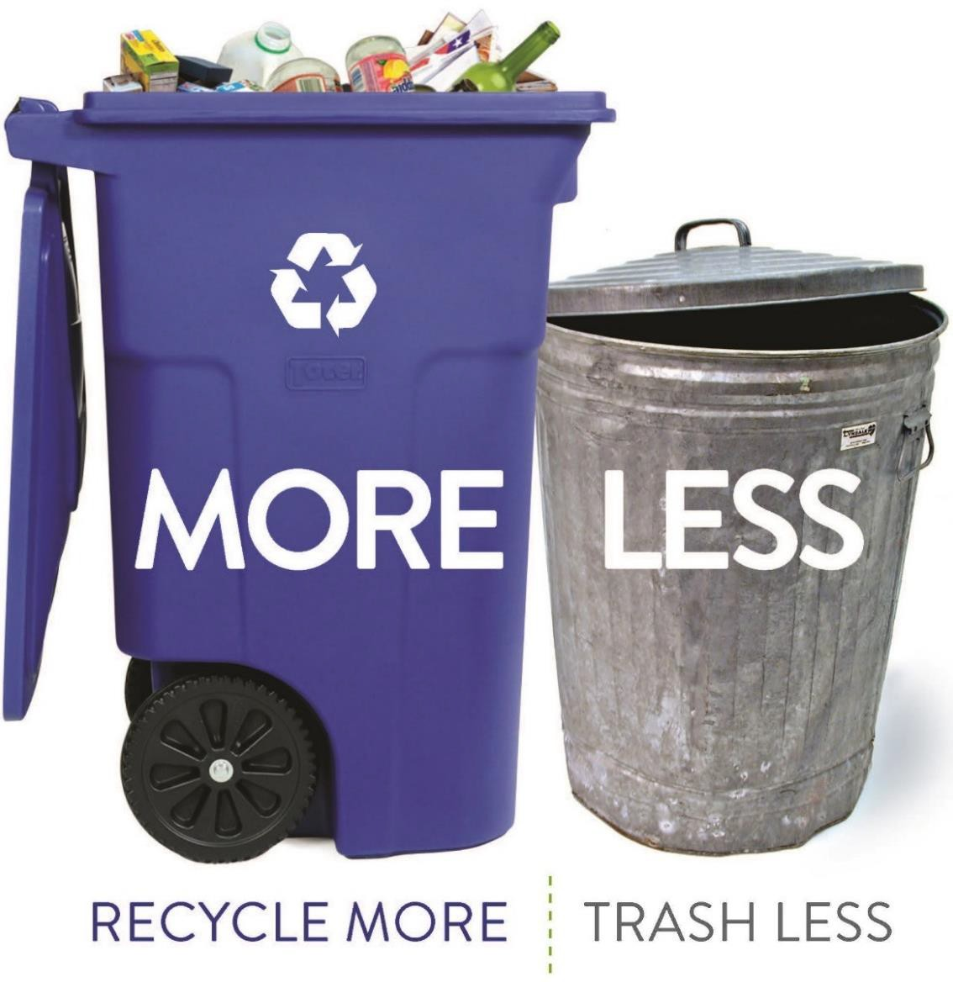
What are your thoughts
on goals and objectives for the Zero Waste Master Plan Recommendations?

Visit CambridgeMA.Gov/ZWMP
Email Recycle@cambridgema.gov to comment

2

Presentation on the Draft ZWMP

PURPOSE OF THE PLAN

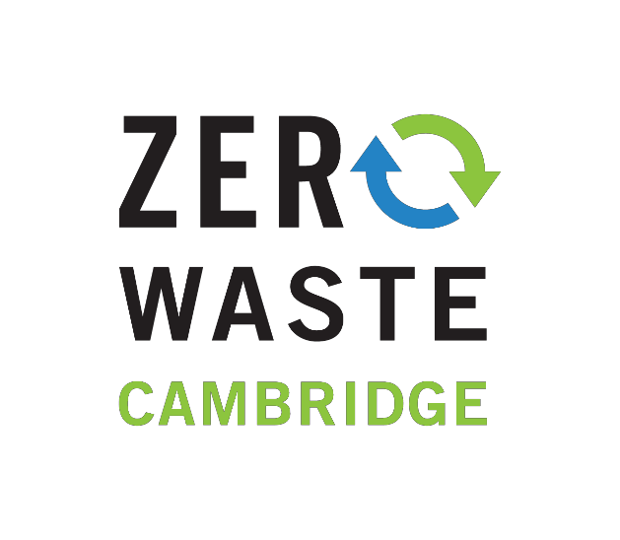
        - Meet City’s waste reduction goals
        - Continue to maintain high quality public services
        - Maximize operational efficiency
        - Protect employee health & safety
        - Reduce GHG emissions
        - Reduce costs

MASTER PLAN RECOMMENDATIONS

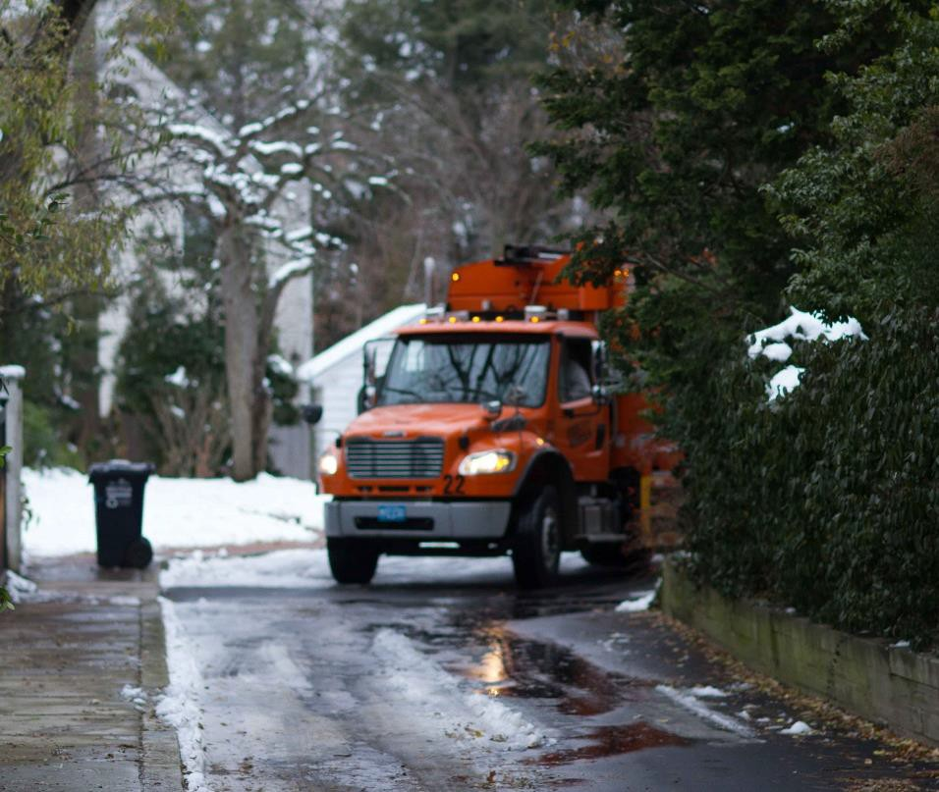
Expand
Evaluate
Expand

Existing City policies
Evaluate

Waste reduction and diversion programs

Trash disposal and collection processes

Curbside Organics

EXPAND CURBSIDE ORGANICS

Early Implementation Moving Forward - Recommendations

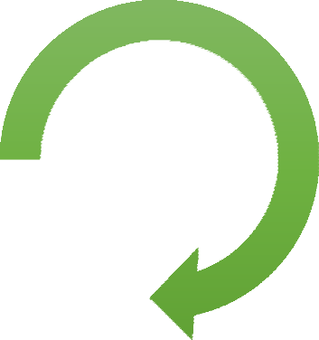
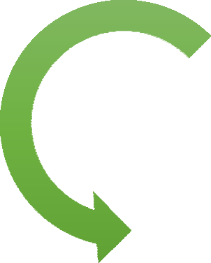
April 2014:

- 600 HH
- 6 tons/month
  - Expand to 13+ units: fall 2019 to fall 2020
  - Continue evaluating options for disposal sites of food waste

Oct
2015:

April
- 5,200 HH
- 30 tons/month

  - 25,000 HH
    - Evaluate ordinances to increase diversion
    - Potential to reduce trash disposal by 4 to

2018:
- 140 tons/month
5 lbs/HH/week

What do you think would
increase participation in the City’s organics program?
Please place a sticker beside those options you support below

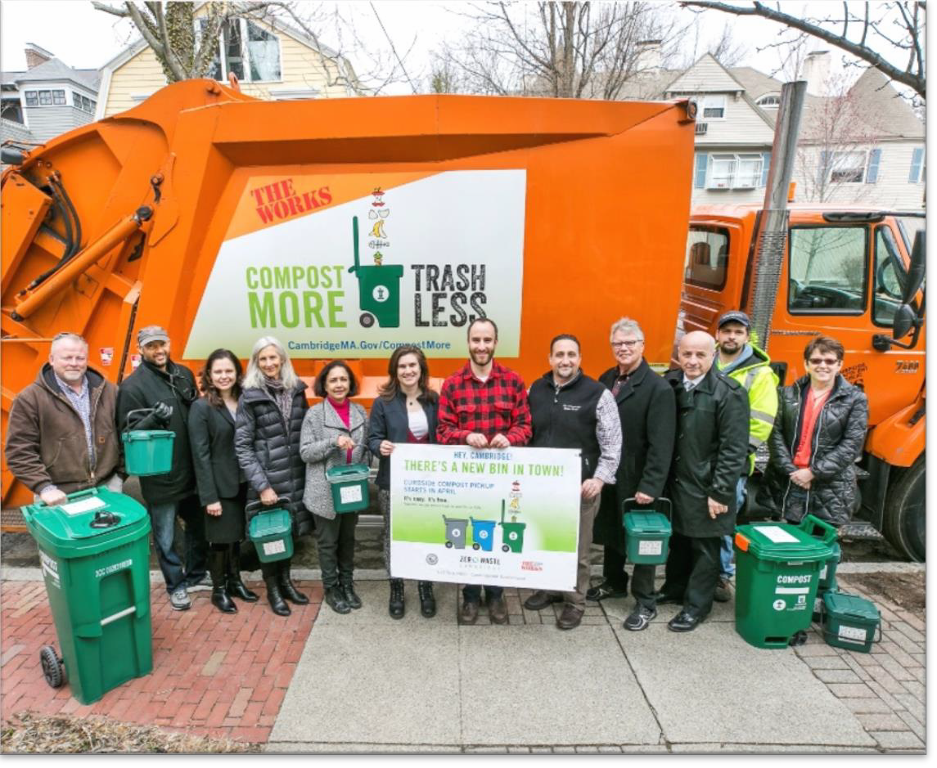

An audit in fall 2018 found that participation in curbside organics was less than 60%.
- Provide more compost bags periodically
- More guidance on how to use the program
- More peer-to-peer education on reducing trash
- Make composting mandatory
- Other actions

EVALUATE TRASH DISPOSAL AND COLLECTION

Early Implementation
  - Decreased trash truck fleet from 7 to 6 in April 2018
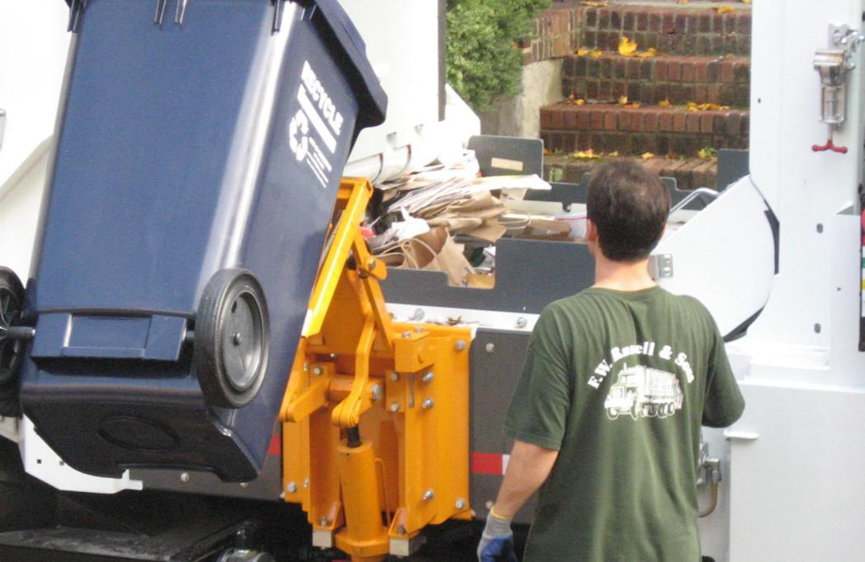
  - Route optimization
Moving Forward - Recommendations

    - Standard Trash Container
    - Semi-automated collection, reduces lifting impacts
    - Reinforced plastic helps rodent control
    - Improved sidewalk accessibility
    - Less trash spills
    - Increased diversion

What’s still in our trash barrels?
How can we reduce the amount
of trash disposed?
Please place a sticker beside those options you support below

      - Compost more

“Trash”
30%

Other **
13%

Recycling 16%

Compost ables 41%
- Recycle more

- More education on how to recycle and/or compost

- Divert more, such as mattresses and textiles

- Reduce the amount of trash allowed

**Other: Textiles, Electronics, Scrap metal
- Enforcement

EXPAND WASTE REDUCTION & DIVERSION

Early Implementation

- Recycle Right Campaign
- Small Business Recycling Pilot (Nov 2018 launch)
Moving Forward - Recommendations

- Mattress Recycling
- Examine existing recycling center, 2020
- Textile recycling strategy, 2020/2021
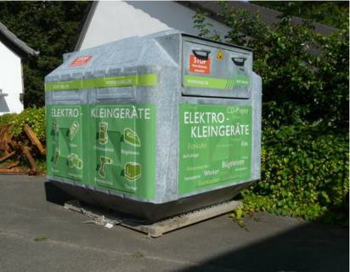
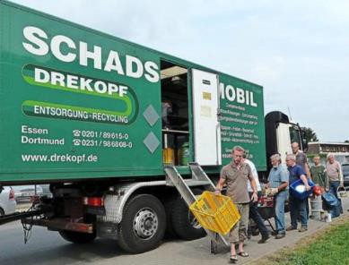
- Continue support for food waste reduction, sharing libraries, reuse events
Mobile Recycling Centers
- Potential to reduce trash by 2 to 3 lbs/HH/week

WASTE REDUCTION AND REUSE

What type of reduce or reuse programs/ initiatives should
the City prioritize?
Please place a sticker beside those options you support below

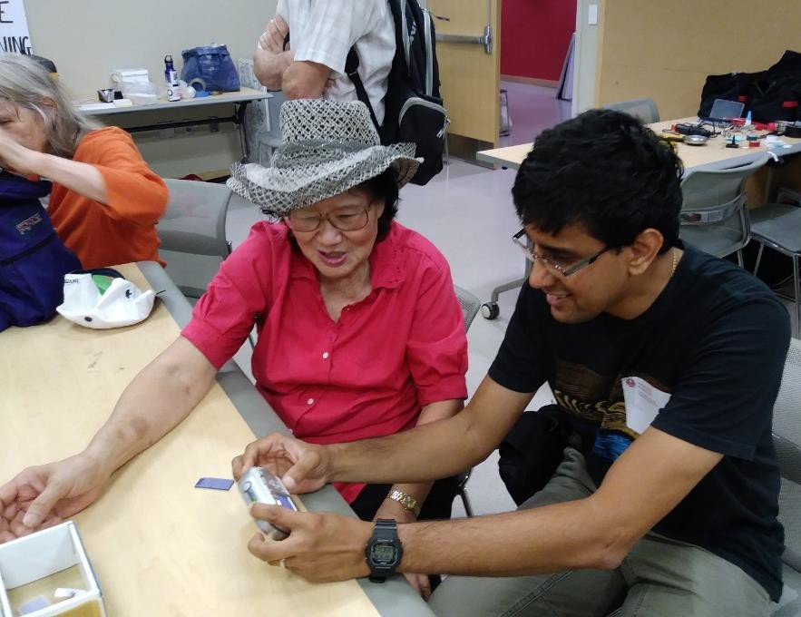

2018 Fix-It Clinic at Main Library (449 Broadway)
Reduction
- Host more Fix-it/ Repair clinics
- Ways to reduce food waste
Reuse – How can the City encourage reuse?
- Promotion of online sites such as Craigslist, NextDoor.com, or Buy Nothing Cambridge Facebook group
- Supporting reuse events such as clothing swaps
Others?

EVALUATE EXISTING CITY POLICIES

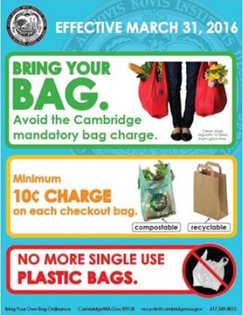
Early Implementation Moving Forward - Recommendations

  - BYOB and Polystyrene Ordinances, 2016 (50 to 80% reduction in single-use bag consumption)
  - Mandatory Recycling Ordinance
  - Reduction in Trash Setout (from 150 gallons/HH to one standard trash container)

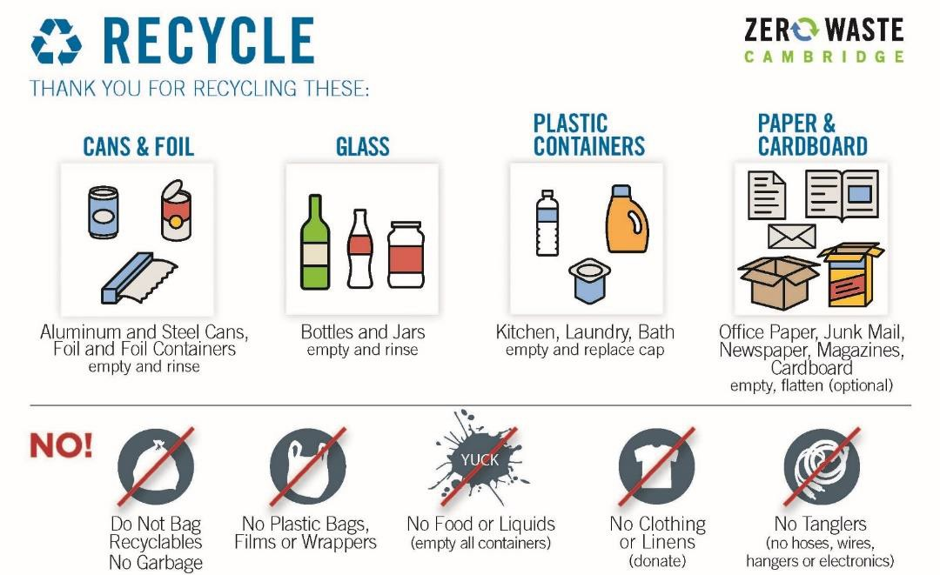

What would help reduce contamination in recycling?
Please place a sticker beside those options you support below

    - More guidance on how to use the program

    - Notices on the carts when contamination is present

    - Not emptying cart with contaminated material

Contaminant | Plastic Bags, Film, Wrappers | Plastic Bagged Recycling | Paper Towels, Tissues, Napkins | Excessive Food & Liquid | Paper Plates, Take-out containers | Clothing  & Textiles | Trash | Tanglers, Cords, Hoses | Straws,  Utensils | Wood, Metal,  Electronics
% of carts | 52% | 21% | 20% | 14% | 14% | 10% | 5% | 4% | 4% | 3%

SMALL BUSINESS RECYCLING How can Cambridge help

In November 2018, the City launched the Small Business Recycle Pilot
reduce waste at businesses?
Please place a sticker beside those options you support below

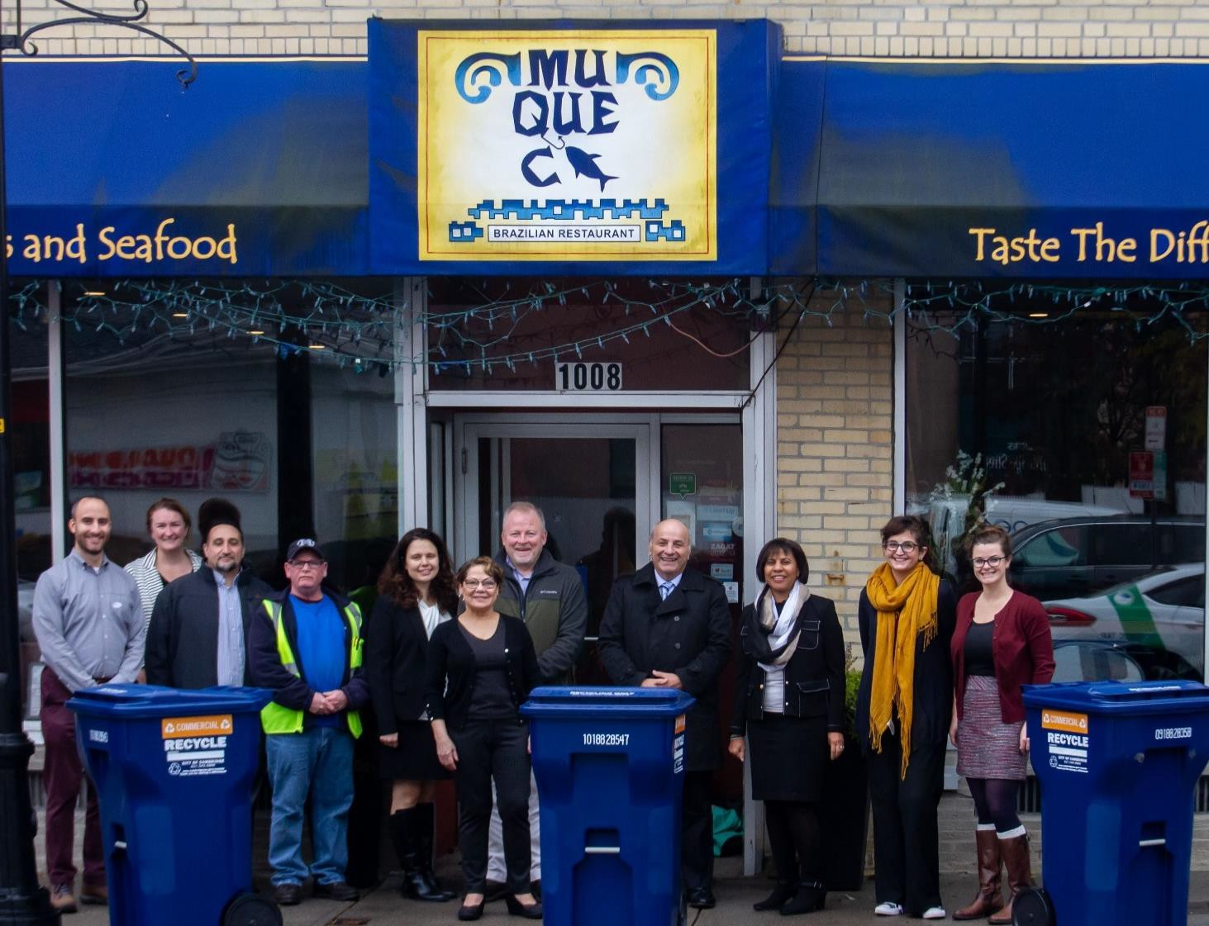

      - Provide information on reducing
single-use products
      - Promote reusable containers
      - More recycling and compost bins
at businesses
      - Other

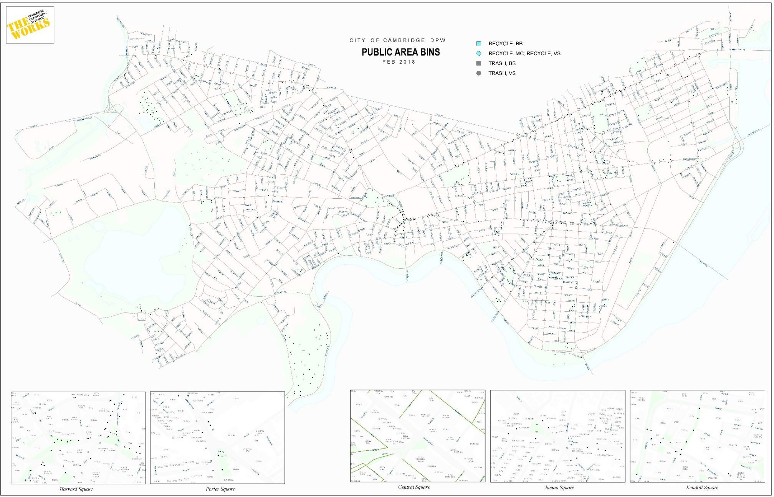
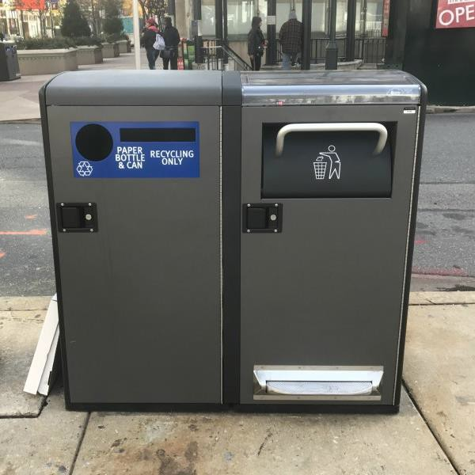
THE CITY IS GETTING NEW PUBLIC AREA RECYCLING BINS WHERE SHOULD THEY BE PLACED?
Please place a pin where you would like to see a recycling bin.

GOALS AND OBJECTIVES OF ZERO WASTE MASTER PLAN

What are your thoughts on the Zero Waste Master Plan
Recommendations?
Please place a sticker beside those options you support below

- Reduce waste to disposal
- Reduce Greenhouse Gas emissions related to waste
- Increase diversion of food scraps
- Expand curbside food scraps program to large apartments/condos
- Reduce trash allowance to encourage diversion
- Recycle more materials such as mattresses, textiles
- Continue support for waste reduction and reuse

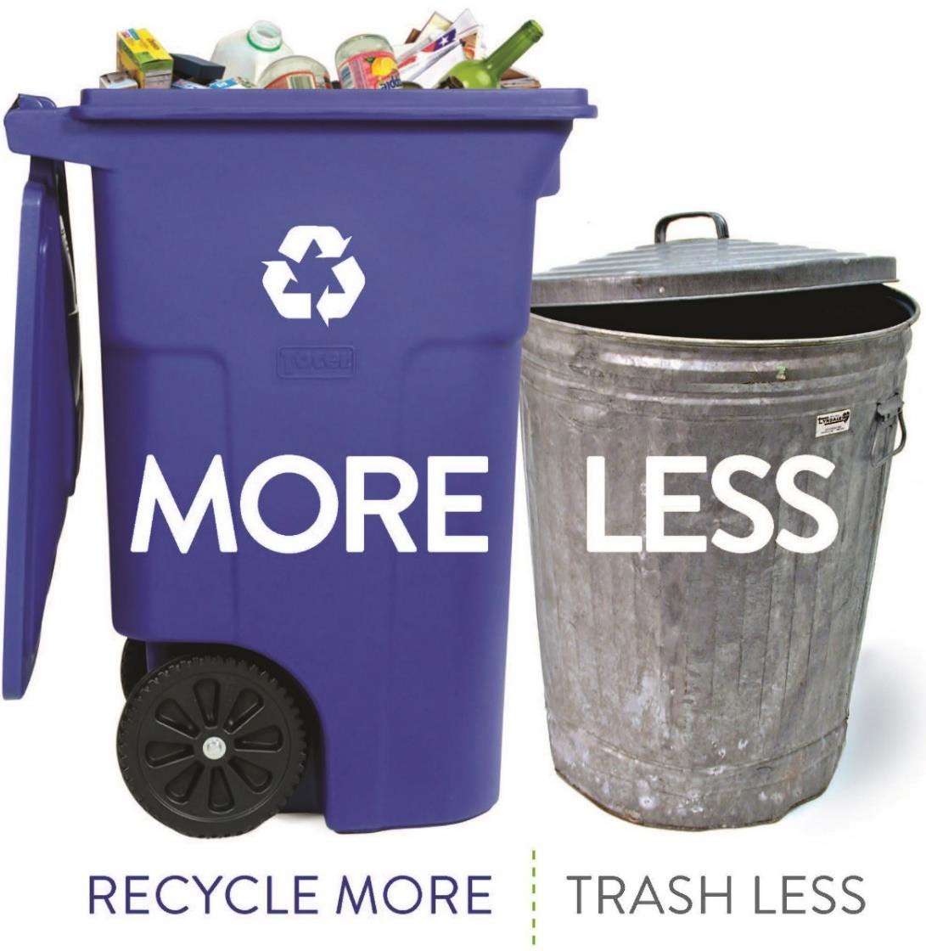

Any other thoughts you would like to share?
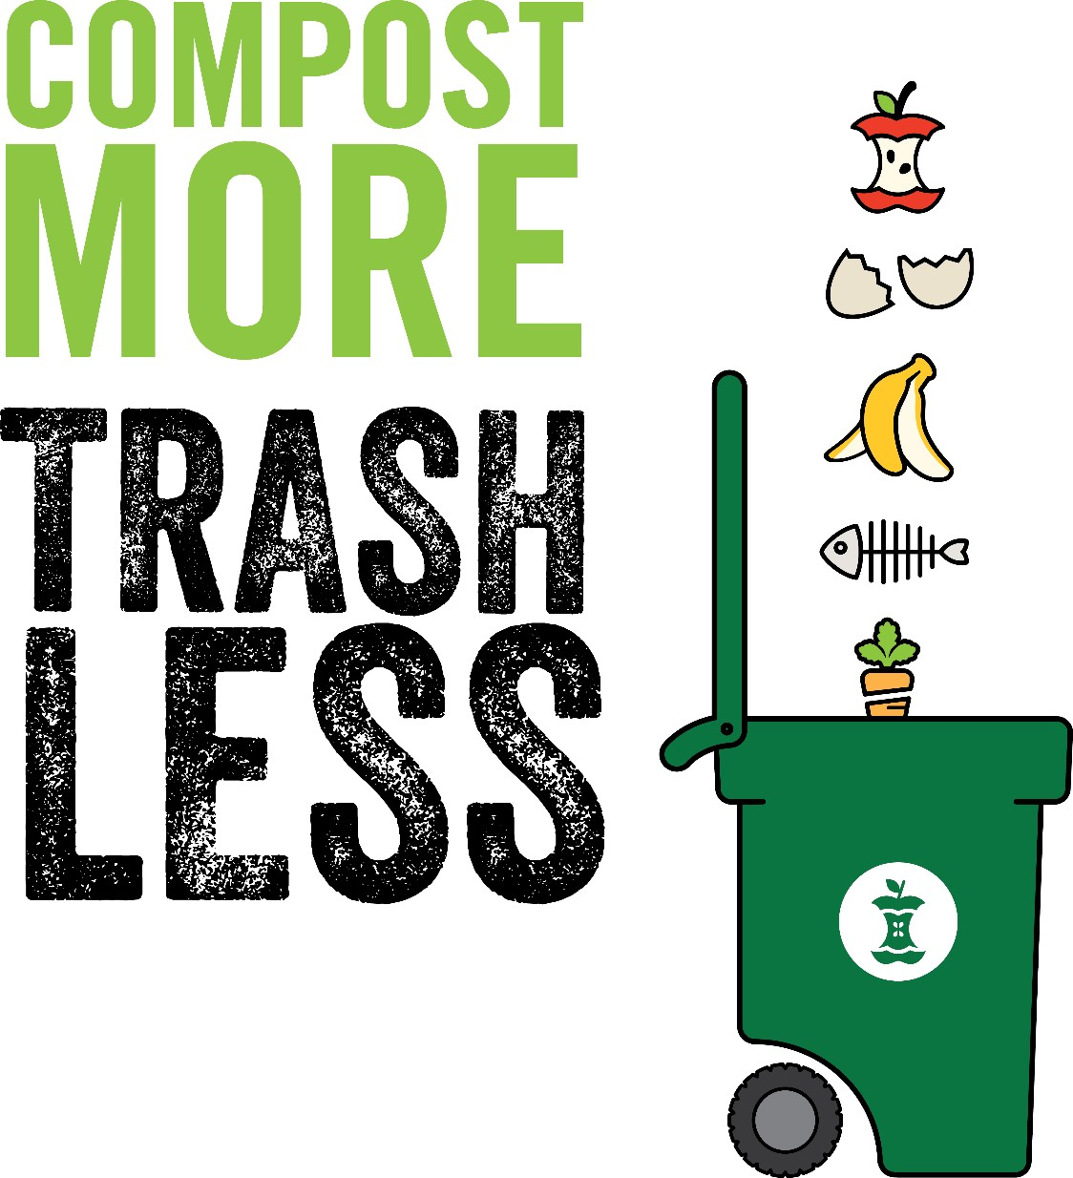

(https://www.cambridgema.gov/~/media/Files/publicworksdepartment/recyclingandrubbish/racminutes/2018/december2018 fullminutes.pdf?la=en).

