Living with Coyotes
A Special Presentation Will Be Held on
Thursday February 13, 2020 at 6:30pm
Walter J. Sullivan Water Purification Facility,
250 Fresh Pond Parkway Cambridge, MA.
Speaker: John Maguranis, (RET.) Belmont ACO and Massachusetts Representative for Project Coyote
LEARN ALL ABOUT THE MOST MISUNDERSTOOD AND REMARKABLE ANIMAL IN NORTH AMERICA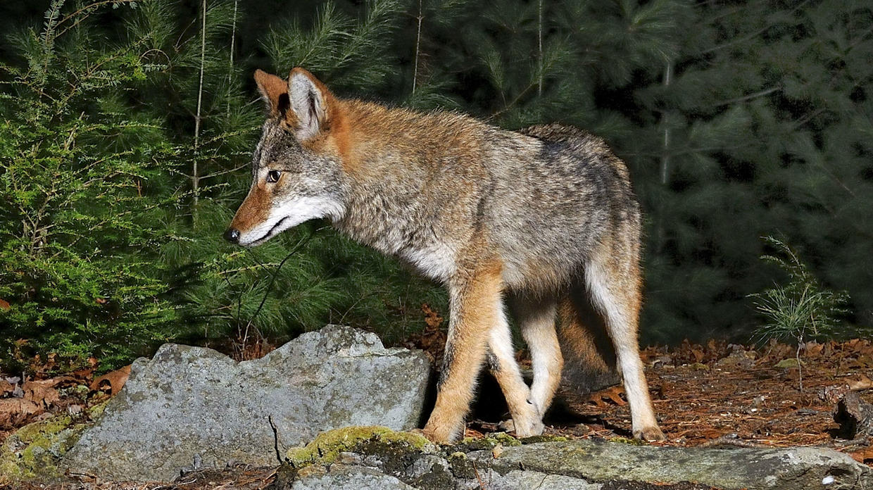
Presentation includes:
- Natural Behavior
- Diet and Habits
- Pet and Human Safety
- Myths and Facts
- Hazing
- Origin and History
For Questions Please Call Cambridge Animal Control at 617-349-4376

