

City of Cambridge Water Department

2016 Source Water Quality Report

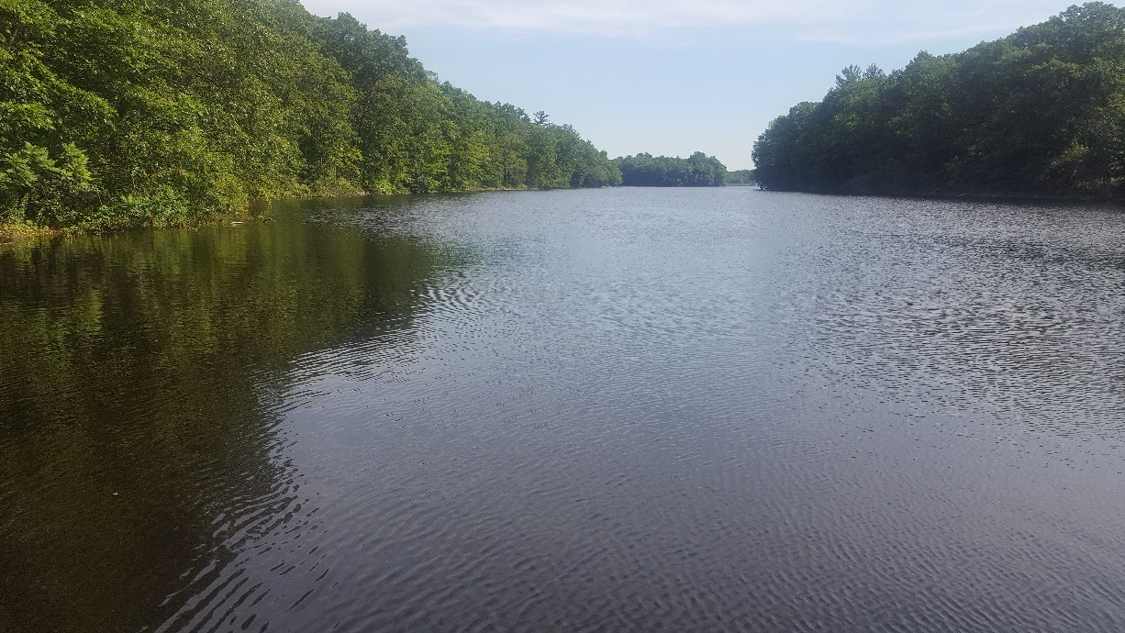

*Hobbs Brook Reservoir Middle Basin*

November, 2017

**Contents**

Table of Contents i

1 Executive Summary 1

2 Introduction 4

3 Purpose 4

4 Water Supply Network 6

5 Cambridge Source Water Quality Monitoring Program 7

5.1 Monitoring Objectives and Program Overview 7

5.2 Comparative Water Quality Standards and Parameters 7

5.2.1 Massachusetts Surface Water Quality Standards (Class A) 7

5.2.2 Massachusetts Drinking Water Standards and Guidelines 8

5.2.3 EPANutrientCriteria 9

5.2.4 Other Parameters 10

5.3 Monitoring Equipment 12

5.4 Routine Base-flow Reservoir and Tributary Water Quality Monitoring 12

5.5 Weekly Reservoir Water Quality Monitoring and Watershed Continuous Monitoring Stations 20

5.5.1 Weekly Reservoir Water Quality Monitoring 20

5.5.2 Continuous Watershed Monitoring Stations 20

5.6 Event-Based Water Quality Monitoring 20

5.6.1 Stormwater Sampling 20

5.6.2 Incident-Based Sampling 21

5.7 Data Management, Quality Control, Analysis and Reporting 21

5.8 Load and Yield Calculations 22

6 Reservoir Water Quality 23

6.1 Reservoir Water Quality Profiles 23

6.1.1 Temperature Profiles 23

6.1.2 Dissolved Oxygen (DO) Profiles 26

6.1.3 Specific Conductance Profiles 27

6.2 Comparison of Reservoir Surface and Bottom Water Quality 29

6.3 Reservoir Tropic State Index 32

6.4 Class A Water Quality Results 33

6.5 Maximum and Secondary Maximum Contaminant Levels (MCLs and SMCLs) and ORS Guidelines 38

6.6 EPA Nutrient Criteria for Upper Watershed 49

7 Tributary Base-flow Water Quality 53

7.1 Tributary Class A Water Quality Results 53

7.2 Maximum and Secondary Maximum Contaminant Levels (MCLs and SMCLs) and ORS Guidelines 57

7.3 EPA Nutrient Criteria for Upper Watershed 62

8 Tributary Wet Weather Monitoring 67

9 Load and Yields 71

10 Reservoir Retention Time 75

10.1 Retention Time Overview 75

10.2 Reservoir Retention Times 75

11 References 78

12 Glossary 80

13 Appendix A – Quality Control Measures 83

13.1 USGS Side-by-Sides 83

13.2 Field Duplicates and Trip Blanks 84

14 Appendix B – Base-flow and Stormflow Separation Method 88

15 Appendix C – Tributary Catchment Area and Land Cover 90

**Figures**

Figure 1. Cambridge Water Supply Source Area 5

Figure 2. Reservoir Sampling Locations. 14

Figure 3. Tributary Monitoring Station Locations within the Cambridge Watershed 15

Figure 4: Reservoir Temperature, Dissolved Oxygen (DO), and Specific Conductance Profiles, 2016 24

Figure 5: Reservoir Dissolved Oxygen (DO), Temperature, and Specific Conductance Profiles, 2016 25

Figure 6: Reservoir Temperature by Month, degrees C, 2000-2016 26

Figure 7: Comparison of 2016 Hobbs Brook Reservoir Lower Basin Epilimnion and Hypolimnion Metals, Nutrients, Chl-a, Turbidity, and TOC 31

Figure 8: Reservoir Trophic State Index (TSI), 2016. 32

Figure 9: Hobbs Brook Reservoir Weekly Intake Chloride, 2003-2016. 42

Figure 10: Hobbs Brook Reservoir Weekly Intake Sodium, 2003-2016. 44

Figure 11: Stony Brook Reservoir Weekly Intake Chloride, 2003-2016. 45

Figure 12: Stony Brook Reservoir Weekly Intake Sodium, 2003-2016. 46

Figure 13: Fresh Pond Reservoir Deep Hole (FP @ DH) Surface Chloride, 2000-2016. 47

Figure 14: Fresh Pond Reservoir Deep Hole (FP @ DH) Surface Sodium, 2000-2016. 48

Figure 15: WA-17 Nitrate (NO3-) Concentrations (mg/L), 2000-2016. 63

Figure 16: WA-17 Total Phosphorus (TP) Concentrations (mg/L), 2000-2016. 64

Figure 17: Comparison of Sodium Concentrations in CWD Base-flow and Preliminary USGS Base-flow and Stormflow Data, 2016 68

Figure 18: Comparison of Calcium Concentrations in CWD Base-flow and Preliminary USGS Base-flow and Stormflow Data, 2016 68

Figure 19: Comparison of Chloride Concentrations in CWD Base-flow and Preliminary USGS Base-flow and Stormflow Data, 2016 69

Figure 20: Comparison of Total Phosphorus (TP) Concentrations in CWD Base-flow and Preliminary USGS Base-flow and Stormflow Data, 2016. 70

Figure 21. Base-flow and Stormflow Na+, Cl-, NO3- and TP Load Comparison at Hobbs and Stony Brook Reservoirs, 2016 72

Figure 22. Comparison of Stormflow and Base-flow Na+, Cl-, NO3-, and TP Loads in Gauged Hobbs and Stony Brook Reservoir Tributaries, 2016 73

Figure 23. Comparison of Base-flow and Stormflow Na+, Cl-, NO3-, and TP Yields in Gauged Hobbs and Stony Brook Reservoir Tributaries, 2016 74

**Tables**

Table 1. Trophic State Index Explanation and Water Quality Implications 11

Table 2: Number of Reservoir Base-flow Sampling Events by Parameter and Site, 2016. 16

Table 3: Reservoir Base-flow Sampling Events by Date and Site, 2016. 17

Table 4: Number of Tributary Surface Sampling Events by Parameter and Site, 2016 18

Table 5: Tributary Surface Sampling Events by Date and Site, 2016. 19

Table 6. USGS Wet Weather Sampling Dates, 2016 21

Table 7: Reservoir Surface Dissolved Oxygen (DO) Results (mg/L) and Class A Exceedances 33

Table 8: Reservoir Bottom Dissolved Oxygen (DO) Results (mg/L) and Class A Exceedances 33

Table 9: Reservoir Surface 2016 E. coli Results (MPN/100 mL) and Class A Exceedances (> 235 MPN/100 mL) 34

Table 10: Reservoir Surface 2016 in situ pH Results and Class A Exceedances (<6.5 or >8.3) 34

Table 11: Reservoir Bottom 2016 in situ pH Results and Class A Exceedances (<6.5 or >8.3) 34

Table 12: Reservoir Surface 2016 Lab pH Results and Class A Exceedances (<6.5 or >8.3) 35

Table 13: Reservoir Bottom 2016 Lab pH Results and Class A Exceedances (<6.5 or >8.3) 35

Table 14: Reservoir Surface Temperature Results (degrees C) and Class A Exceedances (> 28.3 degrees C, warm water fisheries; < 20 degrees C, seven day average daily maximum, cold water fisheries) 35

Table 15: Reservoir Bottom Temperature Results (degrees C) and Class A Exceedances (> 28.3 degrees C, warm water fisheries; < 20 degrees C, seven day average daily maximum, cold water fisheries) 36

Table 16: Reservoir Surface 2016 Mn Results (mg/L) and SMCL Exceedances (>0.05 mg/L) 38

Table 17: Reservoir Bottom 2016 Mn Results (mg/L) and SMCL Exceedances (>0.05 mg/L) 39

Table 18: Reservoir Surface 2016 Fe Results (mg/L) and SMCL Exceedances (>0.3 mg/L) 39

Table 19: Reservoir Bottom 2016 Fe Results (mg/L) and SMCL Exceedances (>0.3 mg/L). 40

Table 20: Reservoir Surface 2016 TDS Results (mg/L) and Class A Exceedances (>500 mg/L) 40

Table 21: Reservoir Bottom 2016 TDS Results (mg/L) and Class A Exceedances, (>500 mg/L) 41

Table 22: Reservoir Surface 2016 Cl Results and SMCL Exceedances (>250 mg/L) 41

Table 23: Reservoir Bottom 2016 Cl Results and SMCL Exceedances (>250 mg/L) 42

Table 24: Reservoir Surface 2016 Na Results and ORS Guideline Exceedances (>20 mg/L) 43

Table 25: Reservoir Bottom 2016 Na Results and ORS Guideline Exceedances (>20 mg/L) 43

Table 26: Reservoir Surface 2016 TP Results (mg/L) and EPA Nutrient Criteria Exceedances (>0.008 mg/L*). 49

Table 27: Reservoir Bottom 2016 TP Results (mg/L) and EPA Nutrient Criteria Exceedances (>0.008 mg/L*). 50

Table 28: Reservoir Surface 2016 TKN Results (mg/L) and EPA Nutrient Criteria Exceedances (>0.43 mg/L). 50

Table 29: Reservoir Bottom 2016 TKN Results (mg/L) and EPA Nutrient Criteria Exceedances (>0.43 mg/L) 51

Table 30: Reservoir Surface 2016 Nitrate* Results (mg/L) and EPA Nutrient Criteria Exceedances (>0.05 mg/L). 51

Table 31: Reservoir Bottom 2016 Nitrate* Results (mg/L) and EPA Nutrient Criteria Exceedances (>0.05 mg/L). 52

Table 32: Tributary Surface 2016 in situ pH Results and Class A Exceedances (<6.5 or >8.3) 54

Table 33: Tributary Surface 2016 laboratory pH Results and Class A Exceedances (<6.5 or >8.3) 54

Table 34: Tributary 2016 Dissolved Oxygen (DO) Results (mg/L) and Class A Exceedances (< 5 mg/L warm water fisheries; < 6 mg/L cold water fisheries). 55

Table 35: Tributary 2016 Temperature Results (degrees C) and Class A Exceedances (> 28.3 degrees C, warm water fisheries; > 20 degrees C, seven day average daily maximum, cold water fisheries). 55

Table 36: Tributary E. coli Results (MPN/100 ml) and Class A Exceedances (> 235 MPN/100 mL), 2016. 56

Table 37: Tributary Mn Results (mg/L) and SMCL Exceedances (>0.05 mg/L), 2016 59

Table 38: Tributary Fe Results (mg/L) and SMCL Exceedances (>0.3 mg/L), 2016. 59

Table 39: Tributary TDS Results (mg/L) and Class A Exceedances (>500 mg/L), 2016. 60

Table 40: Tributary Cl- Results (mg/L) and SMCL Exceedances (>250 mg/L), 2016 60

Table 41: Tributary Na+ Results (mg/L) and ORS Guideline Exceedances (>20 mg/L), 2016. 61

Table 42: Tributary NO3- Results (mg/L) and EPA Nutrient Criteria Exceedances (>0.31 mg/L), 2016. 65

Table 43: Tributary TKN Results (mg/L) and EPA Nutrient Criteria Exceedances (>0.3 mg/L), 2016. 65

Table 44: Tributary TP Results (mg/L) and EPA Nutrient Criteria Exceedances (>0.02375 mg/L), 2016. 66

Table 45: Tributary Turbidity Results (NTU) and EPA Nutrient Criteria Exceedances (>1.68 NTU), 2016. 66

Table 46. Hobbs Brook Reservoir Retention Time 2008-2016 76

Table 47. Stony Brook Reservoir Retention Time, 2011-2016 76

Table 48. Hobbs Brook Below Dam Precipitation Gage (01104430) Total Annual Precipitation (Inches) 77

Table 49. Fresh Pond Reservoir Retention Time, 2008-2016 77

Table 50. USGS Side-by-Side Sample Results and Percent Differences by Parameter, 2016. 83

Table 51: Average Relative Percent Differences, 2016 84

Table 52: Reservoir Relative Percent Differences (RPDs) by sample and parameter (mg/L unless otherwise specified), 2016. 85

Table 53: Tributary Relative Percent Differences (RPDs) by sample and parameter (mg/L unless otherwise specified), 2016. 86

Table 54. Field Blank Results, 2016 87

Table 55. USGS Stations and Corresponding CWD Site Names 90

Table 56. 2005 MassGIS Land Use Classification, Percent by Area per USGS Subbasin 90

**List of Abbreviations**

CWD Cambridge Water Department

DO Dissolved oxygen

EPA Environmental Protection Agency

HDPE High density polyethylene

INDUST BROOK Industrial Brook

JFA Joint-Funding Agreement

Lex Brook Lexington Brook

MA DEP Massachusetts Department of Environmental Protection

MassGIS Massachusetts Office of Geographic Information

MCL Maximum contaminant level

MPN Most probable number

MWRA Massachusetts Water Resource Authority

MassDOT Massachusetts Department of Transportation

MassWildlife Massachusetts Division of Fisheries and Wildlife

ORS Massachusetts Office of Research and Standards

QC Quality Control

SMCL Secondary maximum contaminant level

SpC Specific conductance

TKN Total Kjeldahl nitrogen

TSI Trophic state index

TDS Total dissolved solids

TOC Total organic carbon

TP Total phosphorus

USGS United States Geological Survey

# Executive Summary

This report presents the 2016 results of the City of Cambridge Water Department (CWD)’s Source Water Quality Monitoring Program, an ongoing study to assess source water quality in Cambridge reservoirs and associated tributaries. In 2016, water quality sampling was conducted year round in the City’s three reservoirs: the Hobbs Brook, Stony Brook, and Fresh Pond Reservoirs. Additionally, water quality data were collected from 12 streams feeding the reservoirs. Calendar year 2016 water quality monitoring results were compared against state and federal ambient and drinking water quality standards, as well as against EPA nutrient criteria guidelines. This report is intended to aid City managers and decision makers, and to educate those who are interested in the Cambridge water supply.

Reservoir waters in 2016 generally met Massachusetts Class A Surface Water Quality Standards. All surface samples from Fresh Pond Reservoir, the terminal reservoir in Cambridge’s three reservoir system, met Class A standards for dissolved oxygen (DO), *E. coli* bacteria, pH, and temperature. At the Hobbs Brook Reservoir, one weekly surface sample from the reservoir gatehouse, along with one surface sample from the upper and middle basins of Hobbs Brook, exceeded the 235 MPN/100 ml *E. coli* standard. In addition, one surface sample from the Hobbs Brook Reservoir upper basin (HB @ Upper) and one weekly sample from the Stony Brook Reservoir gatehouse (SB @ Intake Weekly), analyzed in the CWD lab, were outside the acceptable Class A pH range of 6.5-8.3. However, *in situ* pH measurements performed at the time of sample collection were within the acceptable Class A range at both sites. Further, the average of the lab pH and *in situ* measurements met the pH Class A standard.

Temperatures above the Class A standard for warm water fisheries (28.3 degrees C) were not observed by CWD at any depth in Hobbs Brook Reservoir or Fresh Pond in 2016. However, Stony Brook Reservoir is considered a cold water fishery[1], with a Class A temperature standard of 20 degrees C pertaining to the mean daily maximum temperature over a seven day period. While CWD does not continuously monitor temperatures in the Stony Brook Reservoir, discrete measurements indicate that the standard was regularly exceeded during the summer months in surface layers and may have been exceeded in lower levels of the reservoir as well. The bottom depths of all three reservoirs met MA Class A standards for pH and *E. coli*. However, all three reservoirs were below the warm water and cold water fishery Class A standards for dissolved oxygen (DO) during summer thermal stratification.

According to nearly every parameter monitored in 2016, Fresh Pond had the best water quality of the three reservoirs. One exception, however, was nitrate, for which Hobbs Brook Reservoir had the lowest median concentration. Maximum nitrate levels at all three reservoirs were below 1 mg/L, which is far lower than the 10 mg/L MA drinking water Maximum Contaminant Level (MCL) set to protect human health.

Low dissolved oxygen near the reservoir bottoms was coincident with increases in iron (Fe), manganese (Mn), and total phosphorous (TP) at Hobbs Brook and Stony Brook Reservoirs. Iron and manganese are aqueous when reduced in low oxygen environments and phosphorous sorbed to iron sediments can be released into the water column. Chlorophyll-*a* (chl-*a*) in bottom samples from Hobbs Brook and Stony Brook Reservoirs increased steadily throughout the summer, likely due to the warmer water temperatures and phosphorus releases stimulating algal growth. While Fresh Pond also experienced elevated manganese during summer stratification, reservoir bottom samples did not have elevated iron, TP, or chl-*a*. Fresh Pond has an aeration system that operated continuously throughout 2016. Although the aeration system did not prevent anoxic conditions from occurring during the summer months, it may have lessened the duration and extent of the anoxic zone. It may also have helped prevent internal TP loading and resulting algal growth by keeping aqueous iron concentrations low.

Salt impairment is a serious concern in the Cambridge watershed. The Hobbs Brook Reservoir is strongly influenced by runoff from salt-treated impervious surfaces, most notably Route 2 and Interstate 95. Hobbs Brook Reservoir dam releases flows to the Stony Brook Reservoir which feeds Fresh Pond Reservoir, so elevated salt concentrations at Hobbs Brook Reservoir can translate into saltier water in the downstream reservoirs. This was especially true in 2016, when a historic drought minimized dilution of salt-impacted base-flow and, for the first time in the history of the CWD water quality monitoring program, water quality samples at Fresh Pond exceeded the Massachusetts Secondary Maximum Contaminant Level (SMCL) for chloride. At Stony Brook Reservoir, where exceedances of the 250 mg/L chloride SMCL are typically rare, 29 percent of 2016 weekly samples exceeded the SMCL. The Hobbs Brook Reservoir weekly median chloride concentration was above 250 mg/L for the first time in the CWD water quality records, which date to the early 2000s. The exceedance rate for Hobbs Brook Reservoir weekly samples also jumped from 22 percent in 2015 to 92 percent in 2016. Sodium concentrations at all reservoirs were above the MA Secondary Drinking Water Guideline (ORS Guideline) of 20 mg/L. All three reservoirs regularly exceed this metric.

Tributary base-flow at the 12 CWD sampling locations met Class A water quality standards, with a few notable exceptions. First, DO at the MBS and Tracer Ln sampling sites fell below the 5 mg/L MA Class A standard in two of six sampling events. Industrial Brook (Indust Brook) and HB @ Mill St dropped below 5 mg/L in one sampling event each. Provisional USGS temperature data from continuous monitoring stations along the Stony Brook tributary, classified as a cold water fishery by MassWildlife, showed that the Class A seven day average maximum daily temperature threshold for cold water fisheries was exceeded 117 times (RT 20 station) and 61 times (SB @ Viles St station) . All sites except for HB Below Dam and Salt Depot exceeded the Class A *E. coli* standard in at least one sample in 2016. All 12 tributary sites met the pH Class A standard, although one *in situ* measurement at MBS was below the lower limit of 6.5. However, the average of the laboratory and *in situ* sample was within the acceptable Class A bounds.

Tributary water quality reflected elevated reservoir salt concentrations. Seven of the 12 tributary sites had median chloride concentrations above the MA SMCL of 250 mg/L. All tributary sites had median sodium levels in excess of the Secondary Drinking Water Guideline of 20 mg/L, ranging from 49 mg/L at Summer St to 447 mg/L at Indust Brook.

Nutrient pollution is also a concern in the Cambridge watershed. While all tributary sites were well under the 10 mg/L MA MCL for nitrate, seven of 12 sites had median concentrations above the EPA Nutrient Criteria of 0.31 mg/L. In addition, three tributary sties had median total phosphorus (TP) values above the EPA nutrient criteria of 0.02375 mg/L and eight sites had at least one sample that exceeded the TP nutrient criteria. Many of these sites are downstream of wetland systems, which could be a natural source of phosphorus from wetland sediments and organic matter. One of these sites, WA-17, is downstream of a constructed stormwater treatment pond, indicating that the pond was exporting phosphorus under base-flow conditions. Wet weather sampling conducted by the U. S. Geological Survey (USGS) at four tributary sites in the Cambridge Watershed found increased concentrations of TP during storm events in three of the four catchments, which demonstrates the importance of stormwater management in controlling phosphorus pollution.

An analysis of tributary pollutant loads and yields revealed that the Hobbs Brook Reservoir was more affected by stormwater pollution than the Stony Brook Reservoir. Approximately 75 percent of TP loading from gaged tributaries feeding the Hobbs Brook Reservoir occurred during stormflow. By contrast, only 26 percent of gaged TP load was attributable to stormflow at Stony Brook Reservoir. The majority of sodium, chloride, and nitrate loads at both reservoirs was attributable to base-flow. While total tributary pollutant loads were higher at Stony Brook Reservoir than at Hobbs Brook Reservoir due to the large drainage area of the Stony Brook Reservoir, its impact was less dominant on a per area basis. For example, the Lex Brook tributary of the Hobbs Brook Reservoir had the highest TP yield in 2016. Catchments with state road deicing impacts draining to Hobbs Brook Reservoir (Lex Brook, Salt Depot Brook, and Tracer Ln) had the highest sodium and chloride yields of the primary tributaries draining to the reservoirs. However, when evaluated separately from RT 20, the WA-17 (which drains to RT 20) had the second highest nitrate and TP yields and the highest sodium and chloride yields of the seven tributary sites evaluated. Nitrate yields were highest from the Summer St catchment in the Stony Brook Reservoir watershed, followed by WA-17. The Summer St nitrates are likely attributable to golf course and residential fertilizer applications as well as leaching septic systems. The nitrate sources from WA-17 could include aerial deposition, leaking sewer pipes, and fertilizer use at commercial properties.

In this study period, the Cambridge watershed received 36.68 inches of rain as measured by the United States Geological Survey (USGS) meteorological station 422518071162501. This is over 9 inches less than the 45.71 inch NOAA 1981-2010 Climate Normal for precipitation at the Bedford, MA Station. CWD finished (treated) water was supplemented by 848 MG million gallons (MG) of Massachusetts Water Resource Authority (MWRA) water during maintenance projects and the 2016 drought. The Hobbs Brook Reservoir 2016 retention time was the longest of the three reservoirs at 21 months. The Fresh Pond retention time was 4.7 months and Stony Brook Reservoir had the shortest retention time at 26 days.

# Introduction

This report describes the results of the City of Cambridge Water Department (CWD)’s source water quality monitoring efforts in calendar year 2016, part of a long-term study of the health and overall state of the City’s drinking water supply.

The City obtains water from the Stony Brook watershed (referred to in this report as the Cambridge watershed) located in the towns of Lincoln, Weston, and Lexington and the City of Waltham. The Cambridge watershed is comprised of two primary subbasins: the Hobbs Brook Reservoir subbasin and the Stony Brook Reservoir subbasin (Figure 1). Water travels by gravity to the Walter J. Sullivan Purification Facility in Cambridge through a network of reservoirs, tributaries, and an underground aqueduct (Figure 1). The Cambridge watershed is relatively urbanized. Growth and development have the potential to negatively impact water quality. However, redevelopment projects may improve water quality by upgrading stormwater treatment systems in older parcels. The City of Cambridge only owns and controls approximately 10 percent of watershed lands. This lack of land ownership, along with high land development potential, requires collaboration with watershed stakeholders and regular water quality monitoring to ensure the long-term protection of the water supply.

The CWD source water quality monitoring program was designed by the U.S. Geological Survey (USGS), in cooperation with CWD, and is based in part on the results of a 1997 - 1998 comprehensive assessment of reservoir and stream quality (Waldron and Bent, 2001). The assessment, conducted jointly by the USGS and the CWD, included a detailed analy­sis of the watershed and the identification of sub­basins exporting disproportionate amounts of pollutants to the reservoirs. This information was then used to design the monitoring network which now makes up CWD’s long-term source water quality monitoring program.

The USGS/CWD partnership continues to this day and funds “real-time” water quantity and quality monitoring stations, data collection, and interpretive analysis. All data collected by USGS is public record and can be retrieved online at this URL.

<http://waterdata.usgs.gov/ma/nwis/current?type=cambrid&group_key=NONE&search_site_no_station_nm=&format=html_table>

# Purpose

The purpose of this report is to characterize Cambridge watershed source water quality for calendar year 2016. Obtaining long-term water quality information is essential in guiding watershed management practices and informing water treatment operations. By understanding where certain water quality problems exist, City resources can be better focused and targeted. Watershed staff can use water quality data to evaluate the efficacy of management initiatives and re-prioritize their efforts if necessary.

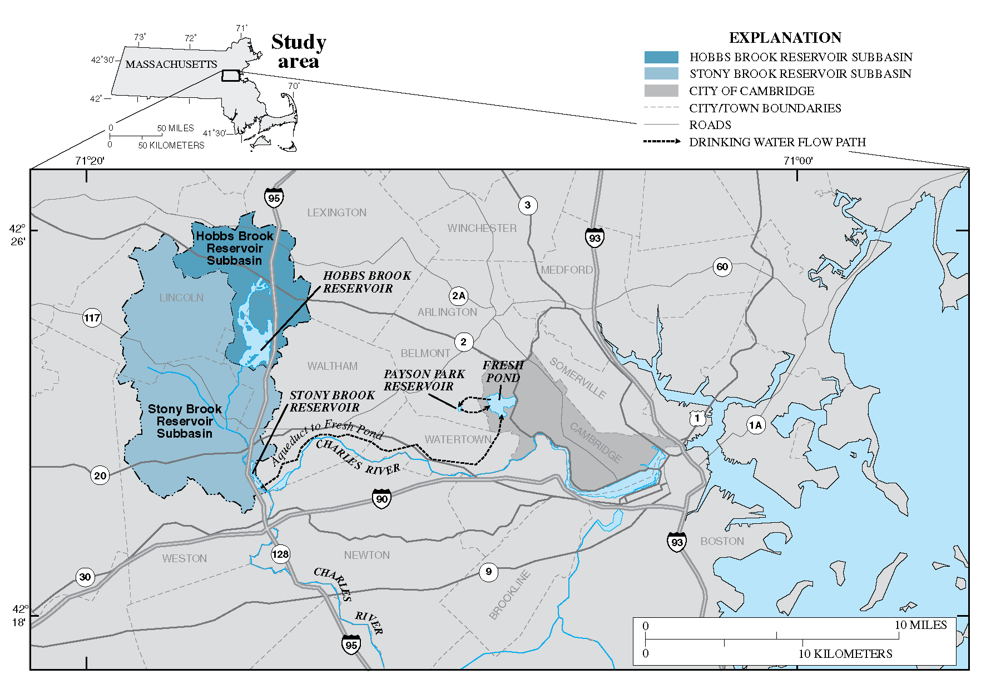

Figure . Cambridge Water Supply Source Area

**Figure source: Waldron and Bent, 2001**

# Water Supply Network

The City of Cambridge obtains its water from the 24-square mile Stony Brook (Cambridge) watershed located in the towns of Lincoln, Weston, Lexington and the City of Waltham. This “upcountry” watershed is nested within the Charles River Basin and contains two major impoundments constructed in the 1890’s, the Hobbs Brook and Stony Brook Reservoirs (Figure 1).The Hobbs Brook Reservoir (also known as the Cambridge Reservoir) receives water from a 7-square mile subbasin and discharges into Hobbs Brook through a gatehouse on Winter Street in Waltham. Hobbs Brook joins Stony Brook further downstream, which flows into the Stony Brook Reservoir on the Weston, Waltham town line. From the Stony Brook Reservoir, water is fed by gravity through a 7.5 mile underground pipeline to Fresh Pond, a kettle pond in western Cambridge, located in the Mystic River Basin.

During high flow periods (mainly winter and spring), the primary source area for the water supply is the Stony Brook Reservoir and its subbasin. During low flow periods (mainly summer and autumn), water is released at the Hobbs Brook dam to supply most of the City’s daily water demand.

The Walter J. Sullivan Water Purification Facility, located within the Fresh Pond Reservation, treats water from the Fresh Pond Reservoir. Treated water is pumped to the Payson Park underground storage facility in Belmont, where it is then fed by gravity to the City’s distribution system (Figure 1). Total capacity at full pool for the Hobbs Brook, Stony Brook, and Fresh Pond Reservoirs is roughly 2.5 billion, 418 million, and 1.5 billion gallons respectively.

In the event of an emergency, the City has a back-up connection to the MWRA (Massachusetts Water Resources Authority) supply. The MWRA supply was used exclusively during the construction of the current Water Treatment Plant from 1999-2001. In calendar year 2016, the City of Cambridge supplemented its supply during infrastructure repairs and maintenance during the summer months. Drought conditions in 2016 also necessitated the purchase of supplemental MWRA water from October through December. MWRA purchases totaled 848 million gallons (MG) and accounted for 18 percent of the total water supplied by the CWD in 2016.

# Cambridge Source Water Quality Monitoring Program

## Monitoring Objectives and Program Overview

Given the City’s lack of ownership and control of most watershed lands, water quality monitoring is a necessary and effective means of identifying sources of pollution and tracking water quality changes over time. The primary goal of the Cambridge Source Water Quality Monitoring Program is to ensure that water withdrawn from Fresh Pond Reservoir for treatment is as free as possible from contaminants, thereby minimizing the costs of treatment and protecting overall water quality. Specific objectives of the program are to:

• Monitor the condition of source waters in the Cambridge drinking water supply system;

• Determine where, when, and how water quality conditions are changing over time;

• Identify actual and potential problems related to source water quality;

• Evaluate the effectiveness of programs designed to prevent or remediate water quality problems;

• Ensure that all applicable water quality goals, standards, and guidelines are being met; and

• Provide for rapid response to real-time and emerging problems.

The Cambridge Source Water Quality Monitoring Program consists of four major elements: (1) routine monitoring of reservoirs and tributary streams during base-flow (dry weather) conditions, (2) continuous recording of stage and selected water quality characteristics at critical sites within the drainage basin, (3) event-based monitoring of streams, storm drains, and other outfalls during wet weather and special water quality investigations, and (4) data management, quality control, analysis and reporting. Results of the sampling program are compared against various state and federal regulations and standards.

## Comparative Water Quality Standards and Parameters

CWD evaluated water quality results against three different sets of standards and guidelines: Massachusetts Surface Water Quality Standards, Massachusetts Drinking Water Standards and Guidelines, and U.S. Environmental Protection Agency (EPA) nutrient criteria. A description of each set of standards or guidelines is provided in the following sections.

### Massachusetts Surface Water Quality Standards (Class A)

The Class A ambient surface water quality standards are set by the Massachusetts Department of Environmental Protection (MA DEP) (314 CMR 4.00) and were created to implement the Massachusetts Clean Water Act. The MA Clean Water Act requires MA DEP to define permissible uses for all water bodies in Massachusetts and to define minimum water quality criteria necessary to maintain those uses. All drinking water reservoirs and their associated tributaries are considered Class A; Class A water quality standards are intended to protect waterways for wildlife habitat and human contact.

CWD monitors the following parameters to compare against the MA Class A standards:

* *E. coli* – This *E. coli* bacteria serotype is found in the digestive systems of warm-blooded animals and is used as an indicator for sewage-related pathogens. MA Class A ambient water quality standards state that no single sample shall exceed 235 Colonies/100mL (measured as *most probable number* [MPN] by the CWD laboratory).
* Dissolved Oxygen (DO) – DO in water is critical to supporting a healthy fish and wildlife population. Low DO and anoxic conditions can mobilize nuisance metals such as iron and manganese and release nutrients from sediments. MA Class A ambient water quality standards state that dissolved oxygen should not be less than 6 mg/L in cold water fisheries and 5 mg/L in warm water fisheries, unless natural background conditions are lower.
* pH – pH is a measure of acidity in water and is defined as the –log[H+]. Water with a pH level of 7 is considered neutral; water with a pH below 7 is acidic and above 7 is basic. The acceptable range of pH levels for Massachusetts Class A freshwater systems is 6.5 to 8.3, although pH levels must be no more than 0.5 units outside of the background range for the system. Waters with pH levels outside of this range can be harmful to fish and wildlife, and high pH levels can be indicative of algae blooms.
* Temperature – Water temperature is an important metric for aquatic habitat suitability. Certain aquatic species are temperature sensitive and require cooler water to survive. Warmer water also holds less DO and can promote harmful biological growth such as algal blooms. The MA Class A maximum seven day average water temperature is 20 degrees C for cold water fisheries and 28.3 degrees C for warm water fisheries. The regulations also place limits on the temperature increases permissible from discharges. Exceptions to these standards are made for streams with naturally occurring higher temperatures.

### Massachusetts Drinking Water Standards and Guidelines

MA drinking water standards and guidelines apply to treated drinking water, and are set by MA DEP (310 CMR 22.00) and the Massachusetts Office of Research and Standards (ORS). Created to implement the requirements of the federal Safe Drinking Water Act, these standards consist of Massachusetts Maximum Contaminant Levels (MA MCLs), Massachusetts Secondary Maximum Contaminant Levels (MA SMCLs), and Massachusetts Drinking Water Guidelines (ORS Guidelines). The MA MCL and MA SMCL standards are developed by the EPA and adopted or made more stringent by the state of Massachusetts. Parameters in drinking water delivered to customers must not exceed the MA MCLs. Drinking water is not required to meet MA SMCLs unless deemed by MA DEP or EPA to be a threat to public health. While not mandatory for compliance, ORS Guidelines can help water suppliers monitor and address pollutants of concern that are not regulated by state or federal agencies. All MA MCLs, SMCLs, and ORS Guidelines apply to treated drinking water rather than untreated source water. However, these metrics are useful points of comparison to assess ambient water quality in the Cambridge watershed and identify potential contaminants for treatment.

The CWD source water monitoring program tests ambient water for the following subset of MA MCL, SMCL, and ORS Guideline parameters. CWD performs more extensive testing on treated drinking water to ensure that all required standards and guidelines are met post-treatment.

* Nitrate and Nitrite as Nitrogen – Nitrate (NO3-) and nitrite (NO2-) are common inorganic forms of nitrogen. Typical sources of nitrate and nitrite pollution include the application of fertilizer and effluent from septic systems and other sewage discharges. The drinking water maximum containment level (MCL), set to protect public health, is 10 mg/L; the EPA nutrient criteria is more restrictive at 0.05 mg/L for reservoirs and 0.31 mg/L for tributaries (see section 5.2.3 EPA Nutrient Criteria).
* Chloride, Sodium, and Calcium – Sodium chloride (NaCl) is the most commonly used winter deicing agent in the Cambridge watershed. Calcium chloride (CaCl2) is another deicing agent used in the watershed, although to a lesser extent than NaCl. Tracking chloride, sodium, and calcium levels in the water supply helps steer efforts to reduce their use and protect long term water quality. According to EPA, chloride is considered toxic to aquatic life at 230 mg/L (four day average, exceeded at least once every three years, considered chronic toxicity). Chloride concentrations in drinking water above 250 mg/L (MA SMCL) typically correspond with sodium levels high enough to impart a noticeably “salty” taste. The ORS Guideline for sodium is 20 mg/L. Calcium does not have a guideline under the drinking water standards but is important to monitor given its presence in the deicing compound CaCl2.
* Iron/Manganese – Iron (Fe) and manganese (Mn) in drinking water are not considered health hazards but an excess can lead to staining and other aesthetic issues. These metallic elements are naturally-occurring in the earth’s crust and soils. The MA SMCLs are 0.3 mg/L for iron and 0.05 mg/L for manganese.
* Total Dissolved Solids (TDS) – TDS is a measure of all organic and inorganic particles and ions dissolved in water. Elevated TDS levels can lead to taste, odor, or other aesthetic issues. The MA SMCL for TDS is 500 mg/L.

### EPANutrientCriteria

EPA Nutrient Criteria represent concentrations of nutrients in lakes, reservoirs, and tributaries which have not experienced accelerated eutrophication due to anthropogenic nutrient inputs (reference conditions).[2] Nutrients facilitate plant and algal growth and promote eutrophication (water body productivity). Excessive nutrient inputs can cause increased rates of eutrophication, leading to water quality impairments including, but not limited to, taste and odor problems and low dissolved oxygen availability for fish and wildlife.

The EPA developed these criteria to help states adopt nutrient water quality standards to maintain the uses defined by the Clean Water Act (U.S. Environmental Protection Agency 2000, 2001). Because Massachusetts does not include nutrients in its Class A Water Quality Standards, this report uses the nutrient criteria developed by EPA as a benchmark for assessing nutrient concentrations in the Cambridge watershed.

Nitrate/Nitrite – see section 5.2.2 Massachusetts Drinking Water Standards and Guidelines

Total Kjeldahl Nitrogen (TKN) – TKN is the total of organic nitrogen and ammonia. The EPA nutrient criteria for TKN is 0.43 mg/L for reservoirs and 0.30 mg/L for tributaries. CWD also monitors ammonia concentrations separate from TKN.

Total Phosphorus (TP) – The EPA TP nutrient criterion is 0.02375 mg/L for streams and 0.008 mg/L for lakes/reservoirs. Phosphorus is believed to be the limiting nutrient for plant and algal growth in the Cambridge watershed (Waldron and Bent, 2001). Phosphorous sorbed to sediment particles can be released into the water column under anoxic conditions, which can lead to excessive plant and algal growth, especially during the warm summer months.

Turbidity – Turbidity is a measure of water clarity. Turbid water often has increased levels of suspended dirt and organic matter, which can have adverse effects on water quality and aquatic habitat. The EPA nutrient criteria for streams in ecoregion 59 is 1.68 NTU. No turbidity nutrient criteria exists for reservoirs.

### Other Parameters

The CWD Source Water Monitoring Program also monitors additional water quality indicators, including:

* Chlorophyll-*a* (chl-*a*) – The measured amount of chl-*a* in the water column is indicative of suspended algae biomass and is used to characterize a reservoir’s productivity or trophic state.
* Reservoir Trophic State (TSI)- Carlson’s trophic state index (TSI) is a dimensionless numerical index ranging from 0 – 100, indicating the degree of nutrient enrichment or biomass productivity of a water body (North American Lake Management Society Secchi Dip-In Program, [n.d]; Carlson, 1977). TSI values less than 40 indicate a low productivity state (oligotrophic) and optimal water quality for drinking water supplies (Table 1). Values ranging between 40 and 50 indicate moderate productivity (a mesotrophic state) and may correspond with taste and odor problems. Values greater than 50 indicate a water body that is highly productive (eutrophic), potentially from external nutrient loading, and likely to produce algal blooms.

The TSI of a water body can be estimated using chl-*a* concentrations, TP concentrations, or measured secchi depths (SD). Since TSI is an estimator of algal biomass weight in the reservoir, chl-*a* is likely the optimal parameter for calculating TSI (North American Lake Management Society Secchi Dip-In Program, [n.d]; Carlson, 1977). The formula for calculating TSI using chl-*a* is as follows (North American Lake Management Society Secchi Dip-In Program, [n.d]):

TSI (CHL) = 9.81 ln(chl-*a mg/m3*) + 30.6

|  |  |  |  |  |  |
| --- | --- | --- | --- | --- | --- |
| **A list of possible changes that might be expected in a north temperate lake as the amount of algae changes along the trophic state gradient.** | | | | | |
| **TSI** | **Chl-*a* (µg/L)** | **SD (m)** | **TP (ug/L)** | **Attributes** | **Water Supply** |
| <30 | <0.95 | >8 | <6 | Oligotrophy: Clear water, oxygen throughout the year in the hypolimnion | Water may be suitable for an unfiltered water supply. |
| 30 - 40 | 0.95 - 2.6 | 8 - 4 | 6 - 12 | Hypolimnia of shallower lakes may become anoxic. |  |
| 40 - 50 | 2.6 - 7.3 | 4 - 2 | 12 - 24 | Mesotrophy: Water moderately clear; increasing probability of hypolimnetic anoxia during summer. | Iron, manganese, taste, and odor problems worse. Raw water turbidity requires filtration. |
| 50 - 60 | 7.3 - 20 | 2 - 1 | 24 - 48 | Eutrophy: Anoxic hylpolimnia, macrophyte problems possible. |  |
| 60 -70 | 20 - 56 | 0.5 - 1 | 48 - 96 | Blue-green algae dominate, algal scums and macrophyte problems. | Episodes of severe taste and odor possible. |
| 70 - 80 | 56 - 155 | 0.25 - 0.5 | 96 - 192 | Hypereutrophy: (light limited productivity). Dense algae and macrophytes. |  |
| >80 | >155 | <0.25 | 192 - 384 | Algal scums, few macrophytes. |  |
| Table source: North American Lake Management Society Secchi Dip-In Program, [n.d] | | | | | |

Table . Trophic State Index Explanation and Water Quality Implications

* Specific Conductance (SpC) – Specific conductance is the ability of water to conduct electrical current, normalized to 25°C. In the field, it is used as a surrogate for sodium and calcium chloride deicing agents. Abrupt changes in specific conductance can also be an indicator of pumping, dumping or other activities requiring investigation.
* Total Organic Carbon (TOC) – TOC is used to quantify naturally-occurring organic matter in the water supply. When mixed with chlorine, carbon can react to form disinfection byproducts (haloacetic acids and trihalomethanes) regulated by Massachusetts Drinking Water Standards and monitored by CWD.

## Monitoring Equipment

CWD measures temperature, DO, specific conductance, TDS, and pH *in situ* using a calibrated Eureka Water Probes Manta2™ Multiprobe. Grab samples are also collected from streams and reservoirs using 1 Liter Teflon bottles for nutrients and high density polyethylene (HDPE) bottles for all other parameters. A peristaltic pump and pre-cleaned Tygon tubing is used for collecting samples from bottom depths of the reservoirs. All samples are transported back to the Walter J. Sullivan Purification Facility on ice for processing. A contracted laboratory analyzes samples for TKN, ammonia, TP, and chlorophyll-*a.* The CWD laboratory performs the tests for all other parameters.

## Routine Base-flow Reservoir and Tributary Water Quality Monitoring

Base-flow (dry weather) sampling was conducted on days with no more than 0.10 in of rain within the prior 72 hours. In 2016, base-flow water quality samples were collected at 9 reservoir and 12 tributary sampling stations using *Clean Water* protocols (Wilde and others, 1999) for all aspects of sample collection, preservation, and transport (Figures 2 and 3).

The Hobbs Brook Reservoir is divided into three basins by State Route 2, Trapelo Road, and Winter Street (Figure 2). Hobbs Brook Reservoir has four monitoring sites, two of which are sampled from the shoreline (HB @ Upper and HB @ Middle), and the other two (HB @ DH and HB @ Intake), are sampled by boat at fixed mooring locations (Figure 2). Stony Brook Reservoir has two sites (SB @ DH, and SB @ Intake), and Fresh Pond Reservoir has three sites (FP @ Cove, FP @ DH, FP @ Intake), all sampled by boat. All tributary monitoring sites are sampled from the stream center using the centroid dip technique (Edwards and Glysson, 1999).

In 2016, water quality profiles of temperature, DO, specific conductance, pH, and TDS were collected between 5 and 9 times at each reservoir site when weather conditions and water levels permitted (Tables 2 and 3). Water quality profiles began at 0.3 meters below the reservoir surface and recorded measurements every 1 to 2 meters in depth down to 0.5 meters above the reservoir bottom.[3] The profiles were used to monitor thermal and chemical stratification within the reservoirs, and to inform the operation of the aeration system at Fresh Pond (see section 6.0 *Reservoir Water Quality* for more information). The Manta2™ Multiprobe was also used to evaluate surface water quality at the 12 tributary monitoring sites.

Surface grab samples in 2016 were collected 5 to 7 times in each reservoir basin and analyzed for select nutrients, metals, chlorophyll-*a*, bacteria, and Eureka Water Probes Manta2™ parameters (Tables 2 and 3). During the summer and early fall months, when the water column was thermally stratified, water quality grab samples were also collected from the reservoir bottoms. In 2016, an additional bottom sample was collected at the FP @ DH site in October after fall turnover. Surface grab samples were collected at all tributary sites between 4 and 7 times in 2016 and analyzed for the same parameters as the reservoirs, with the exception of chl-*a* (Tables 4 and 5).

Through a joint funding agreement (JFA) between the City of Cambridge and the United States Geological Survey (USGS), USGS also collected water quality grab samples during base-flow conditions in 2016. USGS samples were collected between four to five times in 2016 at the following tributary sties: Lexington Brook (Lex Brook), Tracer Lane (Tracer Ln), WA-17, and Summer St. USGS water quality results are publically accessible through the agency’s website: <https://nwis.waterdata.usgs.gov/ma/nwis/qwdata>.

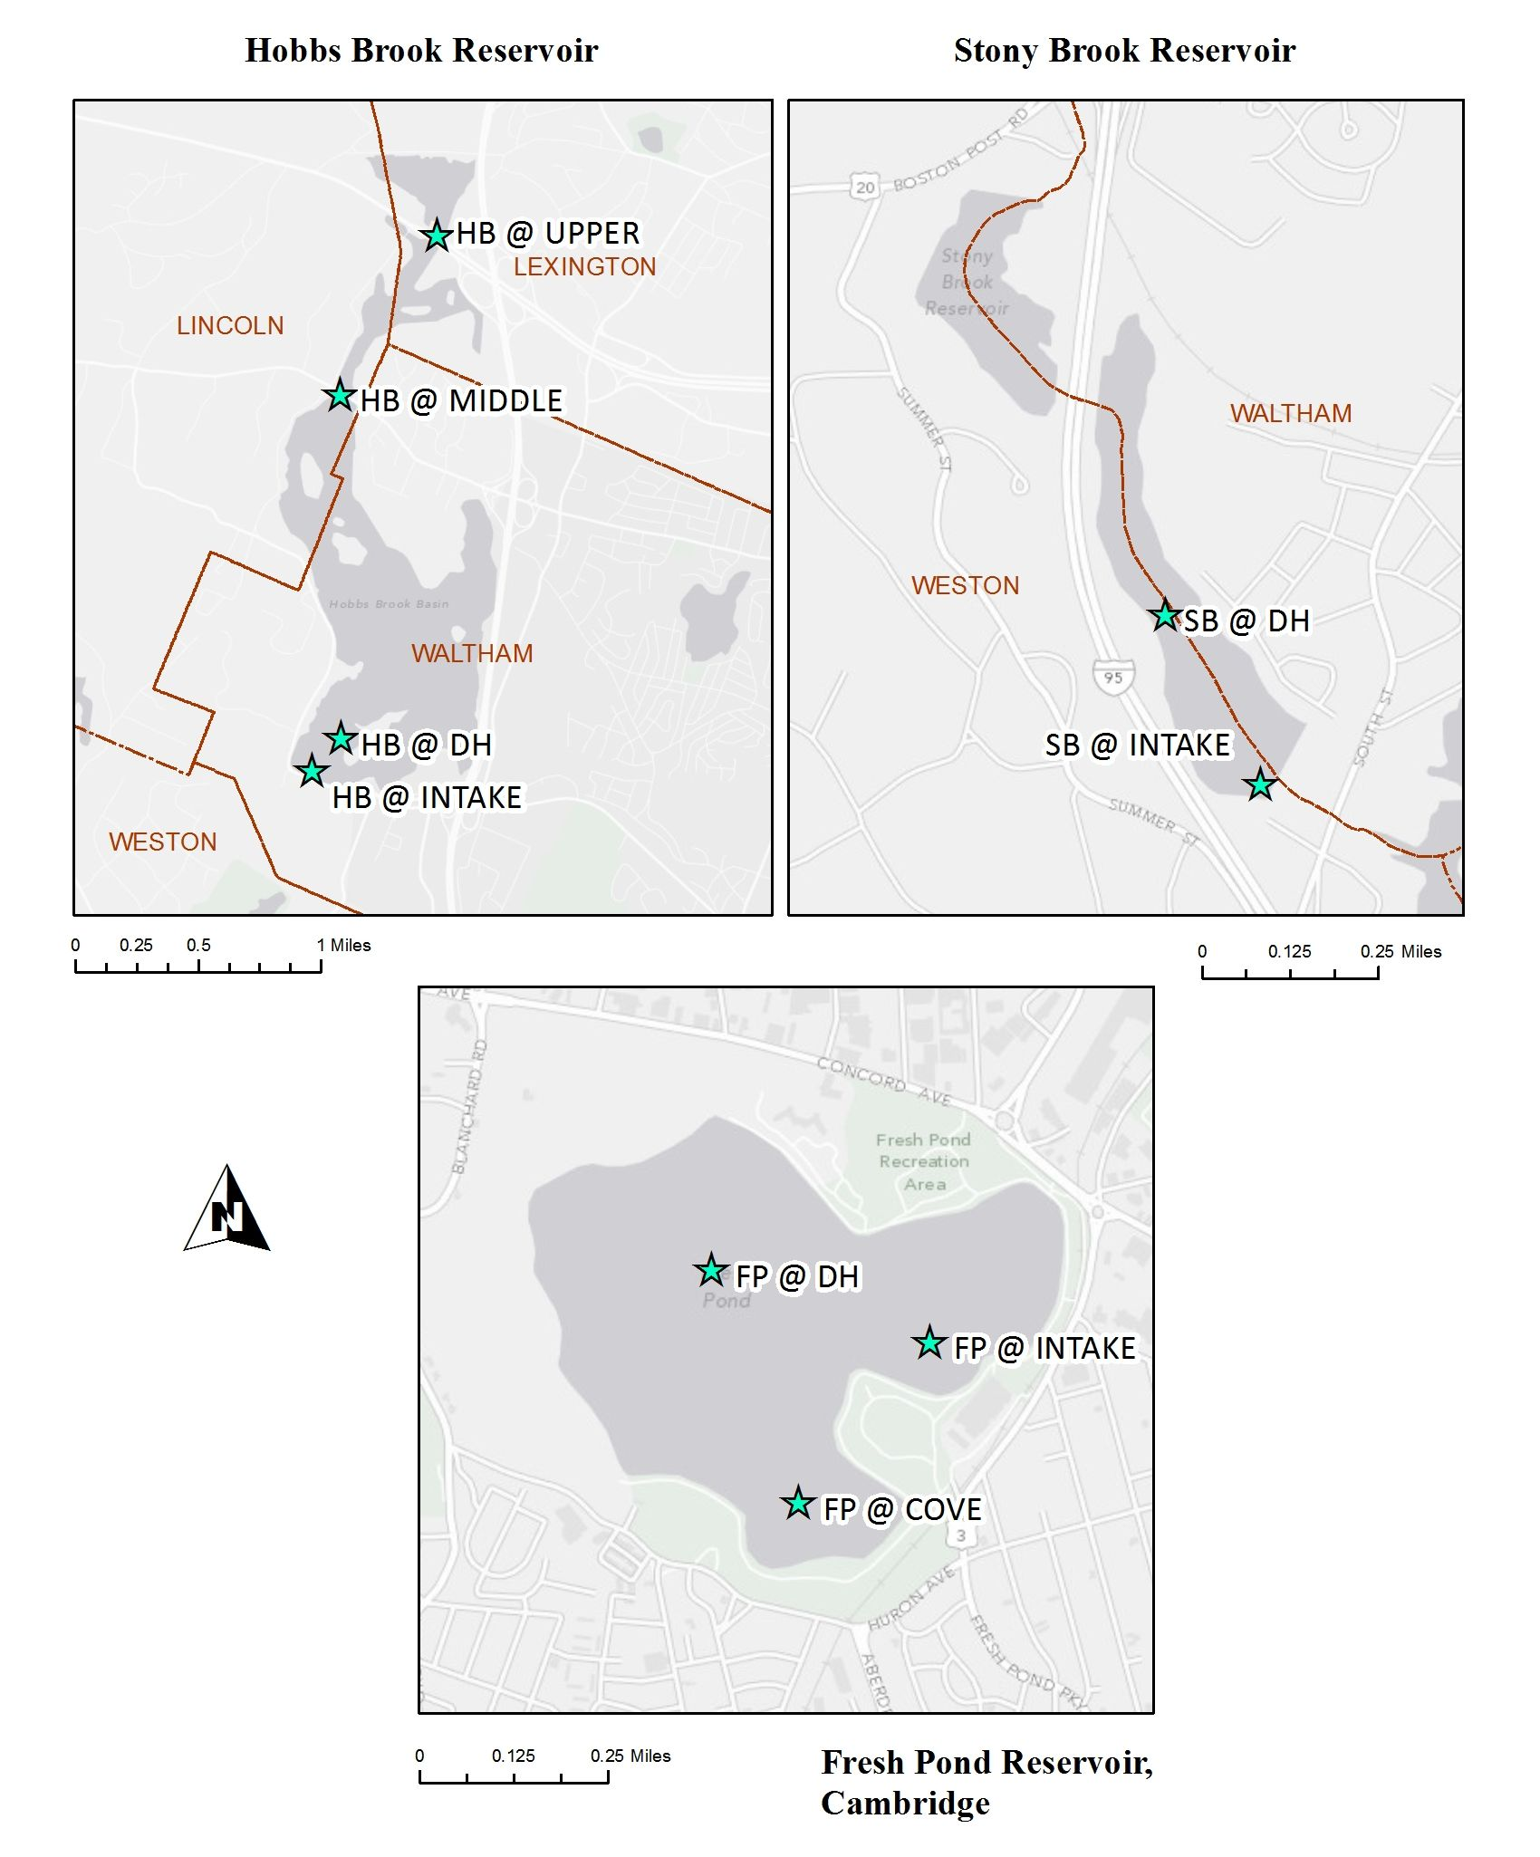Figure . Reservoir Sampling Locations.

**HB @ Intake and SB @ Intake represent the sampling locations for both the periodic reservoir sampling by boat at the approximate location of the intake pipe and the weekly sample collection from inside the gatehouses.**

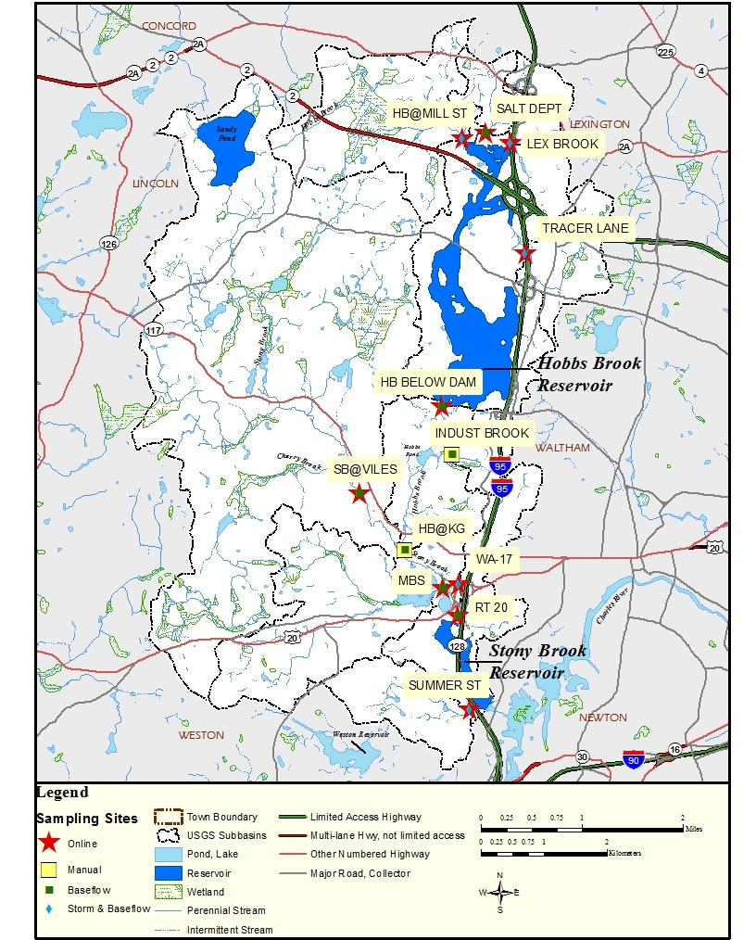

Figure . Tributary Monitoring Station Locations within the Cambridge Watershed

Table : Number of Reservoir Base-flow Sampling Events by Parameter and Site, 2016.

**S = surface (0-0.3 m depth); B=0.5 m from the reservoir bottom; P = water quality profile, measurements collected at 0.3 m depth and every 1 – 2 m in depth. SpC = specific conductance.**

**- - indicates that the site or location was not sampled for the given set of parameters.**

|  |  |  |  |  |  |  |  |  |  |  |  |  |  |  |  |  |  |  |  |  |  |  |  |  |  |  |
| --- | --- | --- | --- | --- | --- | --- | --- | --- | --- | --- | --- | --- | --- | --- | --- | --- | --- | --- | --- | --- | --- | --- | --- | --- | --- | --- |
| **Parameters** | | **HB @ Upper** | **HB @ Middle** | **HB @ DH** | | | **HB @ Intake** | | | | **SB @ DH** | | | | **SB @ Intake** | | | | **FP @ DH** | | | | **FP @ Cove** | **FP @ Intake** | | |
| **S** | **S** | **S** | **B** | **P** | **S** | **B** | **P** | | **S** | **B** | | **P** | **S** | **B** | **P** | | **S** | **B** | **P** | | **P** | **S** | **B** | **P** |
| **Manta2™ Multiprobe Reading,**  ***measured in situ*** | **DO** | 6 | 6 | 5 | 5 | 5 | 5 | 5 | | 5 | 6 | | 6 | 6 | 6 | 6 | | 6 | 9 | 9 | | 9 | 9 | 9 | 9 | 9 |
| **SpC** |
| **Temperature** |
| **pH** |
| **TDS** |
| **Secchi DiskDepth,**  ***measured in situ*** | **Secchi Disk Depth** | -- | -- | 5 | -- | -- | 5 | -- | | -- | 6 | | -- | -- | 6 | -- | | -- | 9 | -- | | -- | 9 | 9 | -- | -- |
| **Water Quality Grab Samples,**  ***Analyzed by CWD laboratory*** | **Al** | 6 | 6 | 5 | 3 | -- | -- | -- | | -- | 6 | | 3 | -- | -- | -- | | -- | 7 | 4 | | -- | -- | -- | -- | -- |
| **Alkalinity** |
| **Ca2+** |
| **Cl-** |
| **Color** |
| **Fe** |
| **Mn** |
| **Na+** |
| **NO3- / NO2\*** |
| **pH** |
| **SpC** |
| **TOC** |
| **Turbidity** |
| ***E. coli*** | 6 | 6 | -- | -- | -- | 4 | -- | | -- | -- | | -- | -- | 4 | -- | | -- | -- | -- | | -- | -- | 7 | -- | -- |
| **Water Quality Grab Samples,**  ***Analyzed by contract laboratory*** | **Chl-*a*** | 6 | 6 | 5 | 3 | -- | -- | -- | | -- | 6 | | 3 | -- | -- | -- | | -- | 7 | 4 | | -- | -- | -- | -- | -- |
| **NH3** |
| **TKN** |
| **TP** |
| *NO3-/NO2+ samples were analyzed by a contract lab if scheduling conflicts prevented CWD staff from performing the analysis in house. | | | | | | | | | | | | | | | | | | | | | | | | | | |

Table : Reservoir Base-flow Sampling Events by Date and Site, 2016.

**M=Manta2™ Multiprobe surface reading; MP = Manta2™ Multiprobe water column profile; E = E. coli sample; WL = water quality sample analyzed by CWD laboratory (except E. coli); WC = water quality grab sample analyzed by contract laboratory; B = bottom grab sample analyzed for WL and WC parameters. See Table 2 for list of parameters analyzed by the Manta2™ Multiprobe, CWD laboratory (WL), and contract laboratory (WC).**

|  |  |  |  |  |  |  |  |  |  |  |  |  |  |  |  |  |  |  |  |  |  |  |
| --- | --- | --- | --- | --- | --- | --- | --- | --- | --- | --- | --- | --- | --- | --- | --- | --- | --- | --- | --- | --- | --- | --- |
| **Date** | **Feb** | **April** | | | **May** | | | **June** | **Jul** | | | **August** | | | **Sept** | | | **Oct** | **Nov** | **Dec** | | |
| **23** | **13** | **21** | **28** | **11** | **18** | **19** | **14** | **6** | **7** | **20** | **3** | **9** | **29** | **8** | **13** | **21** | **5** | **9** | **8** | **14** | **15** |
| **HB @ Upper** | M, E, WL, WC |  |  |  | M, E, WL, WC |  |  | M, E, WL, WC |  |  | M, E, WL, WC |  |  |  |  |  | M, E, WL, WC |  |  |  |  | M, E, WL, WC |
| **HB @ Middle** | M, E, WL, WC |  |  |  | M, E, WL, WC |  |  | M, E, WL, WC |  |  | M, E, WL, WC |  |  |  |  |  | M, E, WL, WC |  |  |  |  | M, E, WL, WC |
| **HB @ DH** |  |  |  | MP, WL, WC |  |  | MP, WL, WC |  |  | MP, WL, WC,B |  |  | MP, WL, WC,B | MP, WL, WC,B |  |  |  |  |  |  |  |  |
| **HB @ Intake** |  |  |  | MP, E |  |  | MP, E |  |  | MP, E |  |  | MP | MP, E |  |  |  |  |  |  |  |  |
| **SB @ DH** |  |  |  | MP, WL, WC |  |  | MP, WL, WC |  |  | MP, WL, WC, B |  |  | MP, WL, WC, B |  |  | MP, WL, WC, B |  |  |  |  | MP, WL, WC |  |
| **SB @ Intake** |  |  |  | MP, E |  |  | MP, E |  |  | MP, E |  |  | MP |  |  | MP |  |  |  |  | MP, E |  |
| **FP @ DH** |  | MP | MP, WL, WC |  |  | MP, WL, WC |  |  | MP, WL, WC, B |  |  | MP, WL, WC, B |  |  | MP, WL, WC, B |  |  | MP, WL, WC, B | MP, WL, WC | MP |  |  |
| **FP @ Cove** |  | MP | MP |  |  | MP |  |  | MP |  |  | MP |  |  | MP |  |  | MP | MP | MP |  |  |
| **FP @ Intake** |  | MP | MP, E |  |  | MP, E |  |  | MP, E |  |  | MP, E |  |  | MP, E |  |  | MP, E | MP, E | MP |  |  |

|  |  |  |  |  |  |  |  |  |  |  |  |  |  |
| --- | --- | --- | --- | --- | --- | --- | --- | --- | --- | --- | --- | --- | --- |
| **Parameters** | | **HB @ Mill St** | **Salt Depot** | **Lex Brook** | **Tracer Ln** | **HB Below Dam** | **Indust Brook** | **HB @ KG** | **SB @ Viles St** | **MBS** | **WA-17** | **RT 20** | **Summer St** |
| **Manta2™ Multiprobe Reading,**  ***measured in situ*** | DO | 5 | 4 | 5 | 6 | 5 | 6 | 6 | 7 | 6 | 7 | 5 | 5 |
| SpC |
| Temperature |
| pH |
| TDS |
| **Water Quality Grab Samples,**  ***Analyzed by CWD laboratory*** | Al | 5 | 4 | 5 | 6 | 5 | 6 | 6 | 7 | 6 | 7 | 5 | 5 |
| Alkalinity |
| Ca |
| **Cl-** |
| Color |
| Fe |
| Mn |
| Na+ |
| NO3- / NO2* |
| pH |
| SpC |
| TOC |
| Turbidity |
| *E. coli* |
| **Water Quality Grab Samples,**  ***Analyzed by contract laboratory*** | NH3 | 5 | 4 | 5 | 6 | 5 | 6 | 6 | 7 | 6 | 7 | 5 | 5 |
| TKN |
| TP |
| *NO3-/NO2+ samples were analyzed by a contract lab if scheduling conflicts prevented CWD staff from performing the analysis in house. | | | | | | | | | | | | | |

Table : Number of Tributary Surface Sampling Events by Parameter and Site, 2016

Table : Tributary Surface Sampling Events by Date and Site, 2016.

**All sampling events included a Manta2™ Multiprobe reading, E. coli sample, and all water quality grab sample parameters analyzed by the CWD laboratory and contract laboratory. See Table 4 for list of parameters analyzed by the Manta2™ Multiprobe, CWD laboratory, and contract laboratory. X = sampling date; dry = streambed was dry and could not be sampled.**

|  |  |  |  |  |  |  |  |  |  |  |  |  |  |  |  |  |  |  |  |  |  |
| --- | --- | --- | --- | --- | --- | --- | --- | --- | --- | --- | --- | --- | --- | --- | --- | --- | --- | --- | --- | --- | --- |
| **Date** | **Feb** | | | **Mar** | **April** | **May** | | **June** | | | **Jul** | | | **August** | | | **Sept** | | **Oct** | **Nov** | **Dec** |
| **2** | **22** | **23** | **7** | **20** | **11** | **12** | **2** | **14** | **13** | | **14** | **20** | **15** | **23** | **31** | **21** | **22** | **13** | **22** | **15** |
| **HB @ Mill St** | X |  |  | X |  |  | X |  |  | X | |  |  |  | dry |  |  |  |  | X |  |
| **Salt Depot** | X |  |  | X |  |  | X |  |  | dry | |  |  |  | dry |  |  |  |  | X |  |
| **Lex Brook** |  | X |  |  | X |  |  | X |  |  | | X |  |  |  |  |  |  | X |  |  |
| **Tracer Ln** | X |  |  | X |  |  | X |  |  | X | |  |  |  | X |  |  |  |  | X |  |
| **HB Below Dam** |  | X |  |  | X |  |  | X |  |  | | X |  |  |  |  |  |  | X |  |  |
| **Indust Brook** |  |  | X |  |  | X |  |  | X |  | |  | X |  |  |  | X |  |  |  | X |
| **HB @ KG** |  |  | X |  |  | X |  |  | X |  | |  | X |  |  |  | X |  |  |  | X |
| **SB @ Viles** | X |  |  | X |  |  | X |  |  | X | |  |  | X | X |  |  |  |  | X |  |
| **MBS** | X |  |  | X |  |  | X |  |  | X | |  |  |  | X |  |  |  |  | X |  |
| **WA-17** |  | X |  |  | X |  |  | X |  |  | | X |  |  |  | X |  | X | X |  |  |
| **RT 20** |  | X |  |  | X |  |  | X |  |  | | X |  |  |  |  |  |  | X |  |  |
| **Summer St** |  | X |  |  | X |  |  | X |  |  | | X |  |  |  |  |  |  | X |  |  |

## Weekly Reservoir Water Quality Monitoring and Watershed Continuous Monitoring Stations

### Weekly Reservoir Water Quality Monitoring

In addition to the dry weather reservoir monitoring program, CWD collects weekly surface grab samples regardless of weather from inside the Hobbs Brook Dam and Stony Brook Dam gatehouses (HB @ Intake Weekly and SB @ Intake Weekly). During weeks when the Hobbs Brook Reservoir was frozen, the sample was collected downstream of the gatehouse at the dam outlet. When weekly sampling events coincided with a routine dry-weather reservoir sampling event, the weekly samples were collected form the HB @ Intake site instead of inside the gatehouse.

Weekly samples help identify immediate contamination, capture seasonal and climatic water quality variability, and track chemical concentration changes over time. Weekly samples are analyzed for *E. coli* bacteria, alkalinity, color, select metals and salts (Al, Ca2+, Cl-, Fe, Mn, Na+), pH, specific conductance, TOC, and turbidity.

### Continuous Watershed Monitoring Stations

In addition, nine of the 12 primary tributary sites, as well as all three reservoirs, were equipped with USGS stations that continuously monitored (10-15 minute data collection interval) stream and reservoir stage, reservoir storage, and reservoir discharge as part of the JFA between CWD and USGS (Figure 3). Temperature, specific conductance, stream discharge (based on stage), and other water quality parameters such as chl-*a* and turbidity were also collected continuously at a subset of stations. Precipitation was monitored at the three reservoir stations, and wind speed and direction were measured at the Stony Brook reservoir. Data from these sites are available in real time on the USGS website:

(<http://waterdata.usgs.gov/ma/nwis/current/?type=cambrid&group_key=basin_cd&site_no_name_select=siteno>).

## Event-Based Water Quality Monitoring

### Stormwater Sampling

Wet weather or stormwater sampling by staff in the field can be difficult to schedule due to the unpredictable timing of precipitation events. Thus, automatic sampling is a preferred method for obtaining wet weather samples. USGS continuous monitoring stations at Lex Brook, Tracer Ln, WA-17, and Summer St are equipped with automatic samplers which collect storm water when triggered by high stream flow. USGS storm sample collection dates for 2016 are presented below in Table 6. The range of dates indicates the duration of the storm from which the composite sample was derived. Results from USGS stormwater sampling in 2016 are presented in this report, but are also publicly accessible from the USGS website:

<https://nwis.waterdata.usgs.gov/ma/nwis/qwdata>

Table . USGS Wet Weather Sampling Dates, 2016

|  |  |  |
| --- | --- | --- |
| **Site** | **USGS Site ID** | **USGS Wet Weather Sampling Dates** |
| Lex Brook | 01104415 | 3/14-3/16 |
| 3/28-3/29 |
| 9/19-9/19 |
| 10/21-10/22 |
| 10/27-10/29 |
| 11/15-11/16 |
| Tracer Ln | 01104420 | 2/3-2/4 |
| 3/28-3/29 |
| 10/27-10/29 |
| 11/29-12/1 |
| WA-17 | 01104455 | 1/10-1/11 |
| 3/28-3/29 |
| 9/19-9/19 |
| 10/20-10/21 |
| 11/15-11/16 |
| Summer St | 01104475 | 1/10-1/12 |
| 3/28-3/29 |
| 11/15-11/16 |
| 11/29-11/30 |

### Incident-Based Sampling

CWD staff perform additional sampling on an as-needed basis to investigate problems associated emergency spills or illicit discharges within the watershed, and to monitor runoff from construction activities. These test results help guide spill response and enforcement activities within the watershed and are not included in this report.

## Data Management, Quality Control, Analysis and Reporting

All water quality monitoring and quality-assurance data are entered into a CWD-maintained database that enables the CWD analyze, track, and report changes in water quality efficiently. This report satisfies the reporting portion of the water quality monitoring program. Source water quality data is available upon request. To submit a data request, email [joconnell@cambridgema.gov](mailto:joconnell@cambridgema.gov).

See Appendix A for CWD quality control measures.

## Load and Yield Calculations

The water quality monitoring program described above measures the concentration of pollutants in tributaries at specific points in time. However, the impact of a pollutant on reservoir water quality depends not only on pollutant concentration, but also on the volume of water discharging into the reservoir. For example, a small (low flow) tributary with a high salt concentration may contribute less sodium than a large (high flow) tributary with a lower concentration of sodium. Therefore, to account for the effect of tributary water volume on reservoir water quality, the annual load and yield of sodium, chloride, nitrate, and TP were calculated for each tributary that discharges directly into the Hobbs Brook and Stony Brook reservoirs, as well as WA-17. The annual load (total pollutant mass) and yield (load standardized by catchment area) were calculated separately for base-flow and stormflow using the formulas below:

Loadbase-flow = µCWD x Q base-flow

Loadstormflow = µUSGS x Q stormflow

Where:

µCWD = 2016 geometric mean concentration of Na+, Cl-, NO3-, or TP measured by CWD during dry conditions, in mg/L

Q base-flow = 2016 base-flow, in L/yr

µUSGS[4]= 2016 geometric mean concentration of Na+, Cl-, NO3- or TP measured by USGS during storm events,[5] in mg/L

Q stormflow = 2016 stormflow, in L/yr

See Appendix B for the methodology used to separate base-flow and stormflow from total discharge at each site.

# Reservoir Water Quality

Since the 1970s, CWD has monitored seasonal thermal stratification, which occurs in all three reservoirs and has implications on water quality. In the spring, surface water begins to warm, forming a distinct upper layer (epilimnion) of less dense water that will not mix with colder, denser bottom waters (hypolimnion). Biochemical processes in the isolated bottom waters require oxygen and can create reduced (anoxic) conditions which stress fish and other aquatic fauna. Nuisance metals, such as iron and manganese, and phosphorus normally bound to sediments can be released into the hypolimnion in the absence of oxygen. These metals and nutrients are then mixed throughout the water column during fall “turn over,” the mixing of layers as surface water cools and water temperature becomes homogeneous throughout the reservoir depth profile.

The following sections describe water quality in the Hobbs Brook, Stony Brook, and Fresh Pond Reservoirs throughout all seasons in 2016. Water quality results are also compared to the Class A water quality standards, MA MCL and SMCLs, ORS Guidelines, and EPA nutrient criteria.

## Reservoir Water Quality Profiles

### Temperature Profiles

In 2016, all three reservoirs exhibited the expected behavior of thermal stratification during the spring and summer months, followed by fall mixing (Figures 4 and 5).[6] The reservoirs began exhibiting slight thermal stratification in late April and May and were fully stratified in July and August. By September, temperature profiles at Stony Brook and Fresh Pond showed signs of mixing, although thermal separation between the surface layers and bottom layers was still apparent, especially in Fresh Pond which had the deepest water of the three reservoirs. Stony Brook was more mixed than Fresh Pond likely due to its shallower water depth. However, Fresh Pond had fully mixed by October and both Stony Brook and Fresh Pond remained mixed through December. Fall profiles at Hobbs Brook likely behaved similarly, although low water levels from a historic drought in 2016 prevented boat access for sampling in September through the end of the calendar year.

Overall water column temperatures increased throughout the spring and summer, peaking in July and August (Figures 4 and 5). Water column temperatures began to cool in September and consistently dropped through December. Despite the drought, none of the three reservoirs appeared to be thermally stressed as monthly water surface temperatures generally approximated the median surface temperatures for the 2000-2016 time period (Figure 6). Fresh Pond surface water temperatures in August and September were near the 90th percentile, although they were still well below the warm water fisheries Class A threshold of 28.3 degrees C. While Stony Brook Reservoir may have exceeded the Class A standard for cold water fisheries[7], temperatures were not abnormally high (Figures 5 and 6). The Class A standard temperature standard for cold water fisheries is specific to the seven day average maximum daily temperature, so a single temperature measurement does not necessarily mean the Class A standard was exceeded.

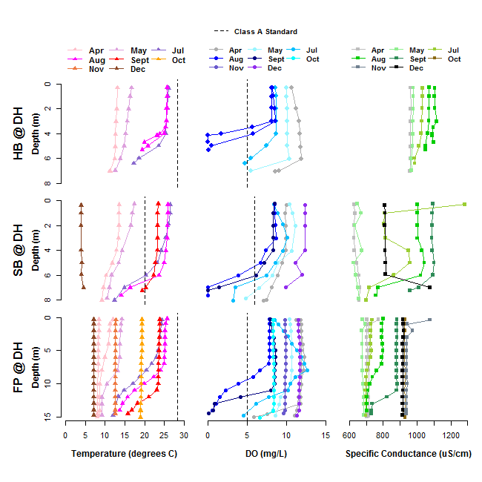

Figure : Reservoir Temperature, Dissolved Oxygen (DO), and Specific Conductance Profiles, 2016

*The Class A temperature standard at Stony Brook Reservoir is specific to cold water fisheries. The standard relates to the seven day average maximum daily temperature. However, temperature data presented in Figure 4 represent discrete measurements rather than the seven day average daily temperature.*

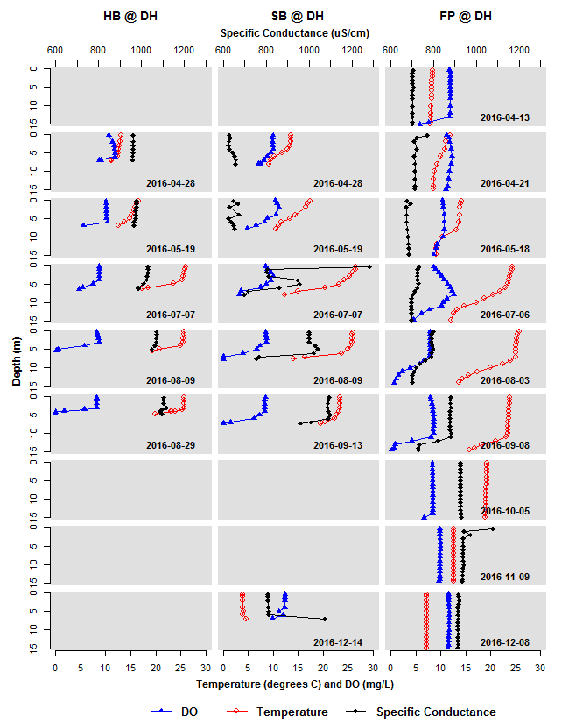

Figure : Reservoir Dissolved Oxygen (DO), Temperature, and Specific Conductance Profiles, 2016

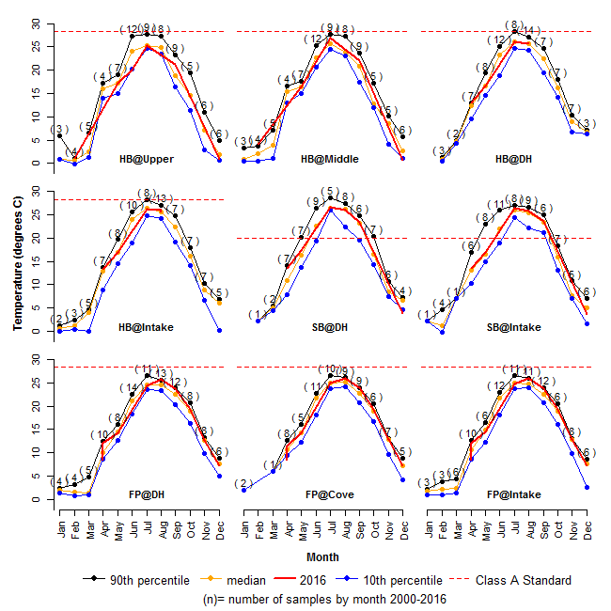*The Class A temperature standard at Stony Brook Reservoir is specific to cold water fisheries. The standard relates to the seven day average maximum daily temperature. However, temperature data presented in Figure 6 were discrete measurements rather than the seven day average daily temperature.*

Figure : Reservoir Temperature by Month, degrees C, 2000-2016

### Dissolved Oxygen (DO) Profiles

DO profiles generally followed the reverse pattern of temperature throughout the year (Figures 4 and 5). Because cold water can hold greater concentrations of DO, concentrations in all three reservoirs were generally highest during April and December, when water temperature was the coldest (Figures 4 and 5). As the surface waters warmed and the reservoirs thermally stratified, low DO conditions developed in the bottom depths of water column. All reservoirs were fully thermally stratified with low or anoxic DO conditions in July and August, and where profiles were recorded in September, anoxic conditions were present as well. DO concentrations after fall turnover in October and November (Fresh Pond) and December (Fresh Pond and Stony Brook) were uniform throughout the water column.

Hobbs Brook was the shallowest of the three reservoirs. It was approximately seven meters deep in April, and less than five meters deep by the end of August due to releases of water to supplement flows to the Stony Brook Reservoir (Figures 4 and 5). In July, DO in the bottom half meter of water (depth of 6.41 meters) dropped below the 5 mg/L Class A Standard for warm water fisheries. In both August profiles, stratification intensified and anoxic conditions developed in the bottom meter of the water column. DO concentrations below 5 mg/L also occurred shallower in the water column compared to July. DO was below 5 mg/L at 5 meters depth on the August 9th profile and at 4 meters depth on the August 29th profile.

At Stony Brook, the May through September profiles all had DO concentrations in the hypolimnion below the Class A standard of 6 mg/L for cold water fisheries (Figure 4). The proportion of the water column affected by low DO conditions increased from May through August, with low DO conditions beginning at approximately 7.9 meters depth in May versus 6 meters depth in August. Although the profile was more thermally mixed in September, DO still had not replenished the hypolimnion. By December, the reservoir had mixed and the water temperatures had dropped, resulting in the highest DO concentrations of the year (ranging from 9.9-12.39 mg/L). Stony Brook Reservoir has an aeration system designed to aid in mixing and to supplement hypolimnion DO. However, the system was shut down after compressors failed in July 2014 and has remained offline since.

At Fresh Pond, the deepest of the three reservoirs, an aeration system operated continuously throughout the year. While the aeration was not sufficient to prevent stratification and hypoxic conditions from forming, it likely minimized the duration and extent of the anoxic zone. Although Fresh Pond began to thermally stratify in May, DO concentrations did not drop below 5 mg/L until July at a depth of 14.8 meters (Figures 3 and 4). The July profile exhibited an unusual peak in DO in the middle of the water column. This could be due to algae photosynthesis, although a corresponding peak in pH, which is indicative of algal productivity, was not observed in the profile. Another possibility is that an aeration line floated from the reservoir bottom to the middle of the reservoir, supplying a boost of oxygen to the middle water column.

Even though anoxic conditions were present at Fresh Pond in August and September, DO did not drop below 5 mg/L until a depth of 10 meters (August) and 12 meters (September), depths greater than the entire water column depth at Hobbs Brook or Stony Brook Reservoirs (Figure 4). By October, with fall turnover and cooler water temperatures, the water column was well oxygenated with levels in the 8 mg/L range. DO concentrations continued to increase through the December profile.

### Specific Conductance Profiles

Specific conductance in the Hobbs Brook Reservoir is heavily influenced by road salt impacts from Interstate 95 and Route 2, as well as from a historic groundwater salt plume from the District 4 Massachusetts Department of Transportation (MassDOT) salt storage facility (Geotechnical Engineers Inc., 1985). Water stored in the Hobbs Brook Reservoir during the winter and spring is released during the summer and fall to meet demand, which supplements flows to the Stony Brook Reservoir. Therefore, the specific conductance at Hobbs Brook Reservoir influences the specific conductance downstream at Stony Brook and Fresh Pond Reservoirs.

At Hobbs Brook Reservoir, the specific conductance profiles were relatively homogenous, although the overall concentration increased throughout the spring and summer (Figures 4 and 5). The observed increase is likely due to salt impacted base-flow, the influence of which may have been exacerbated during the drought of 2016 (Massachusetts Executive Office of Energy and Environmental Affairs, 2017). The April specific conductance profile ranged from 957-963 uS/cm. By August 29th, the specific conductance had increased by approximately 100 uS/cm and ranged from 1,088 uS/cm to 1,117 uS/cm.

Specific conductance in the Stony Brook Reservoir ranged from 625-674 uS/cm in April and May, approximately 300 uS/cm or 30 percent less than in Hobbs Brook Reservoir for the same time period (Figures 4 and 5). The July profile showed an increase in specific conductance with values ranging from 717 uS/cm to 1,284 uS/cm (the latter of which may have been an anomalously high reading). The July profile was also less homogeneous, indicating mixing of the lower specific conductance water (under 700 uS/cm in April and May) with the higher specific conductance water released from the Hobbs Brook Reservoir (986-1032 uS/cm in July). Specific conductance levels continued to increase in August and September as inflows from the Stony Brook subbasin diminished and releases from Hobbs Brook Reservoir increased. The August 9th profile at Stony Brook Reservoir was almost identical to the Hobbs Brook profile on the same date, with only the bottom depth at 7 meters remaining in the 700 uS/cm range, likely unable to mix due to thermal stratification. Likewise, the September specific conductance profile was reflective of the August 29th profile at Hobbs Brook. Releases of water from Hobbs Brook ceased in mid-October. By December, specific conductance in all but the very bottom depths of the Stony Brook reservoir had dropped from over 1,000 uS/cm in September to between 808 and 813 uS/cm.

Because the Cambridge reservoirs are located in succession, releases of water from Hobbs Brook Reservoir to the Stony Brook Reservoir during the drought also affected specific conductance at Fresh Pond. Changes in specific conductance at Stony Brook Reservoir took about a month to materialize at Fresh Pond. In April and May, specific conductance at Fresh Pond mirrored that of Stony Brook. The increase in specific conductance at Stony Brook in July was not observed at Fresh Pond until August, when the top 7 meters of the water column were in the range of the July Stony Brook Reservoir profile. In September, the depth of elevated specific conductance had deepened to 11 meters. Although the Fresh Pond September specific conductance profile was not as high as either the August or September profiles at Stony Brook Reservoir, the average specific conductance (848 uS/cm) of the water column was similar the average for Stony Brook Reservoir in July (860 uS/cm).

To begin recharge at Hobbs Brook Reservoir, releases of water from the reservoir ceased for the year in October. However, to meet demand during persistent drought conditions, CWD purchased supplemental water from the Massachusetts Water Resources Authority (MWRA) through mid-December. Given the minimal inflows to Fresh Pond from the Stony Brook subwatershed and the limited intake by the treatment plant due to MWRA purchases, the October, November, and December specific conductance profiles at Fresh Pond remained elevated, above 900 uS/cm.

## Comparison of Reservoir Surface and Bottom Water Quality

At Hobbs Brook and Stony Brook Reservoirs, concentrations of nutrients and metals common in low oxygen, reducing aquatic environments (iron, manganese, ammonia, TKN, and TP) were higher in bottom samples collected during periods of thermal stratification than in surface samples (Figure 7). Elevated chl-*a* and turbidity were also observed in the bottom levels of these reservoirs during the summer and early fall, indicating a subsurface algal bloom or aquatic plant growth.

This biological growth could be due to the increased TP availability in the bottom strata of the reservoirs (Figure 7). Despite elevated levels of nutrients, metals, turbidity, and chl-*a* at the bottom of Hobbs Brook and Stony Brook Reservoirs in July through September, the consistent year-round concentrations of these parameters in surface samples indicate that overall reservoir water quality was not impacted by reservoir mixing in the late fall. However, given the hypolimnion water quality conditions during summer stratification, dam releases for water supply purposes drew from the surface and middle layers of the reservoir.

While Fresh Pond experienced elevated manganese, TKN, and ammonia at the reservoir bottom, it notably did not have elevated iron, TP, or chl-*a* during the summer months (Figure 7). Phosphorus is typically the limiting nutrient for lake productivity, so it is unsurprising that low TP levels were found in concert with low chl-*a* concentrations. In well oxygenated lakes, phosphorus is typically sorbed to solid iron compounds in the benthic sediments. Under low DO conditions, redox reactions convert iron into its reduced, aqueous form which releases the previously sorbed phosphorus into the water column. Perhaps due to the Fresh Pond aeration system, hypolimnion iron concentrations remained below the SMCL standard and likely prevented internal phosphorus loading.

Nitrate is an oxidized form of nitrogen and can be attributed to fertilizer runoff as well as septic system leachate. Nitrate levels at the Hobbs Brook Reservoir were the lowest of the three reservoirs, with both surface and bottom samples near or below the EPA nutrient criteria of 0.05 mg/L (Figure 7). Samples were also well below the MCL of 10 mg/L set to protect human health.

Stony Brook Reservoir had the highest surface concentrations of nitrate of the three reservoirs. All but one sample from SB @ DH was at or above the EPA nutrient criteria, although all samples were well below the MCL. The Stony Brook reservoir subcatchments have a golf course and more low density residential areas than the Hobbs Brook Reservoir watershed. The Stony Brook Reservoir subcatchments in Weston and Lincoln are served by septic systems, whereas most homes and businesses in the Hobbs Brook Reservoir subcatchments are served by sewer systems. Widespread use of septic systems, as well as probable fertilizer use on lawns and golf courses, likely explains the difference in nitrate concentrations between the Hobbs Brook and Stony Brook Reservoirs.

Concentrations of nitrate in bottom samples at Stony Brook Reservoir were at or below the EPA nutrient criterion, likely due to the reduction of nitrogen in low or anoxic DO conditions (Figures 4, 5, and 7). Given that ammonia and TKN showed the opposite trend of nitrate, with low concentrations in the well oxygenated surface water and high concentrations in the poorly oxygenated hypolimnion, total nitrogen is presumably similar throughout the reservoir.

Fresh Pond also had surface nitrate concentrations consistently above the EPA Nutrient criteria, although the median concentration was lower than at the Stony Brook Reservoir. The median bottom concentration of nitrate, while lower than the surface concentration, was above the EPA nutrient criteria. This could be attributable to oxygen supplied by the aeration system, which may have prevented the nitrate load from fully converting to ammonia or other reduced forms of nitrogen during stratification.

TOC, which can react with chlorine during the treatment disinfection process to form harmful byproducts, ranged between 2 mg/L and 5.1 mg/L in the three reservoirs. TOC concentrations were relatively homogenous between the surface and bottom the water column at all three reservoirs, although TOC was slightly higher in the Hobbs Brook Reservoir bottom samples compared to surface samples. This could indicate contamination of the sample with organic matter from the bottom substrate, or it could be indicative of the high chl-*a* concentrations observed during the summer months. Overall surface TOC concentrations were higher at Stony Brook Reservoir than at Hobbs Brook Reservoir, with median surface TOC concentrations approximately 1 mg/L higher in the Stony Brook Reservoir than in the Hobbs Brook lower basin. However, the increase in TOC concentrations observed at Stony Brook were not present at Fresh Pond where the median surface concentration at FP @ DH (2.4 mg/L) was the same as HB @ DH. It is possible that the longer retention time at Fresh Pond allowed suspended organic particles to settle, thereby reducing the concentration of TOC in the water to drop (see section 10.2 *Reservoir* *Retention Times*).

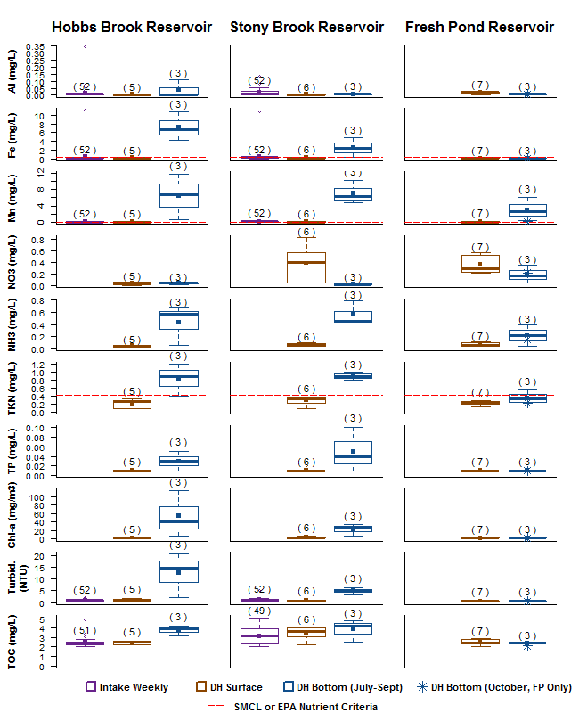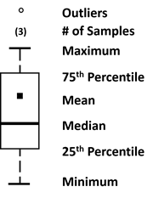

**Deep hole (DH) bottom samples were collected during summer stratification July-August at HB @ DH and July – September at SB @ DH and FP @ DH. An additional bottom sample was collected at FP @ DH in October after fall turnover. Weekly surface intake samples were collected at Hobbs Brook and Stony Brook in all months of 2016. Intake samples were not analyzed for nutrients or chl-a. Numbers in parenthesis () show the number of samples represented by each boxplot. Samples below the detection limit were set to the detection limit for the purposes of this analysis.**

Figure : Comparison of 2016 Hobbs Brook Reservoir Lower Basin Epilimnion and Hypolimnion Metals, Nutrients, Chl-a, Turbidity, and TOC

## Reservoir Tropic State Index

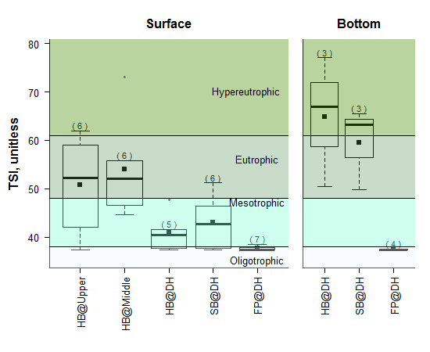According to Carlson’s trophic state index (TSI),*[8]* HB @ Upper and HB @ Middle were the most productive reservoir surface sampling locations. The 2016 median TSI categorizes these basins as eutrophic. However, median TSI dropped by over 10 points between the middle and upper basins and the HB @ DH site in the lower basin. The drop in TSI between the basins indicates an improvement in water quality, likely due to dilution and settling in the larger lower basin. Median surface TSI at SB @ DH was higher than at HB @ DH, although the reservoir was still categorized as mesotrophic. However, bottom samples from HB @ DH and SB @ DH were reflective of the high chl-*a* from a presumed summer benthic algal bloom, with TSI values in the eutrophic and hypereutrophic zone.

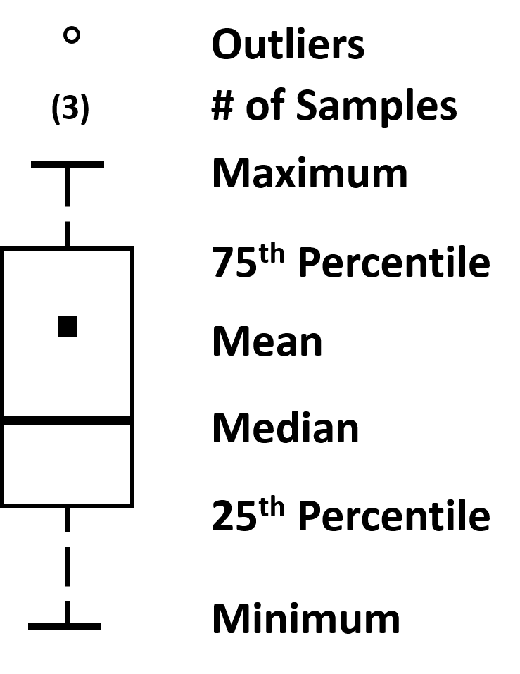

Figure : Reservoir Trophic State Index (TSI), 2016.

**Samples below the chl-a detection limit of 2 mg/m3 were assumed to have a chl-a concentration of 2 mg/m3 for the purposes of calculating TSI. Therefore, TSI values from these samples may be artificially high. HB @ Upper, HB @ DH surface, SB @ DH surface, and FP @ DH surface and bottom all had at least one sample below the chl-a detection limit.**

Fresh Pond had the lowest productivity of the three reservoirs, with median TSI for both surface and bottom samples in the oligotrophic range. The improvement in water quality between Stony Brook Reservoir and Fresh Pond Reservoir is likely attributable to the aeration system, low iron and TP, and increased capacity for dilution and settling given the larger reservoir size (1.5 billion gallons of storage at Fresh Pond versus only 418 million gallons at Stony Brook Reservoir).

## Class A Water Quality Results

Surface water quality at Fresh Pond, the terminal reservoir in Cambridge’s three reservoir system, met all Class A water quality standards (Tables 7, 9, 10, 12, and 14). Bottom samples at Fresh Pond also met the Class A standards, with the exception of DO (Tables 8, 11, 13, and 15). DO at the FP @ DH and FP @ Cove sites dropped below 5 mg/L at the bottom depths during thermal stratification in July, August, and September (Table 8; Figure 4). DO also dropped below 5 mg/L during the August profile at the FP @ Intake bottom (Table 8).

Table : Reservoir Surface Dissolved Oxygen (DO) Results (mg/L) and Class A Exceedances

**Exceedances threshold is < 5 mg/L for warm water fisheries; < 6 mg/L for cold water fisheries. Exceedances are bolded.**

|  |  |  |  |  |  |  |  |  |  |
| --- | --- | --- | --- | --- | --- | --- | --- | --- | --- |
| **Site Name** | **HB @ Upper** | **HB @ Middle** | **HB @ DH** | **HB @ Intake** | **SB @ DH** | **SB @ Intake** | **FP @ DH** | **FP @ Cove** | **FP @ Intake** |
| Median | 9.26 | 9.66 | 8.63 | 8.69 | 9.25 | 9.51 | 9.79 | 9.94 | 9.88 |
| Mean | 10.14 | 9.46 | 9.13 | 9.13 | 9.70 | 9.96 | 9.71 | 9.82 | 9.77 |
| Min | 6.4 | **3.52** | 8.14 | 7.92 | 8.41 | 8.61 | 7.86 | 7.88 | 7.81 |
| Max | 14.62 | 14.04 | 10.62 | 10.64 | 12.39 | 12.63 | 11.78 | 11.95 | 11.89 |
| Number of Samples (n) | 6 | 6 | 5 | 5 | 6 | 6 | 9 | 9 | 9 |
| Number of Exceedances | 0 | 1 | 0 | 0 | 0 | 0 | 0 | 0 | 0 |
| % Exceedance | 0% | 17% | 0% | 0% | 0% | 0% | 0% | 0% | 0% |

Table : Reservoir Bottom Dissolved Oxygen (DO) Results (mg/L) and Class A Exceedances

**Exceedances threshold is < 5 mg/L for warm water fisheries; < 6 mg/L for cold water fisheries. Exceedances are bolded.**

|  |  |  |  |  |  |  |  |
| --- | --- | --- | --- | --- | --- | --- | --- |
| **Site Name** | **HB @ DH** | **HB @ Intake** | **SB @ DH** | **SB @ Intake** | **FP @ DH** | **FP @ Cove** | **FP @ Intake** |
| Median | **4.71** | 8.65 | **3.75** | **5.57** | 8.28 | 7.8 | 9.5 |
| Mean | **3.79** | 8.46 | **4.52** | **5.31** | 6.87 | 6.26 | 8.94 |
| Min | **0.00** | 6.84 | **0.00** | **0.28** | 0.15 | 0.18 | **3.52** |
| Max | 8.61 | 10.44 | 12.39 | 12.38 | 11.35 | 11.59 | 12.15 |
| Number of Samples (n) | 5 | 5 | 6 | 6 | 9 | 9 | 9 |
| Number of Exceedances | 3 | 0 | 4 | 3 | 3 | 3 | 1 |
| % Exceedance | 60% | 0% | 67% | 50% | 33% | 33% | 11% |

Table : Reservoir Surface 2016 E. coli Results (MPN/100 mL) and Class A Exceedances (> 235 MPN/100 mL)

**Values above or below detection limit were set to the detection limit for the purposes of calculating means.** **Exceedances are bolded.**

|  |  |  |  |  |  |  |  |
| --- | --- | --- | --- | --- | --- | --- | --- |
| **Site Name** | **HB @ Upper** | **HB @ Middle** | **HB @ Intake** | **HB @ Intake Weekly** | **SB @ Intake** | **SB @ Intake Weekly** | **FP @ Intake** |
| Median | 15 | 15 | 3 | 3 | <1 | 4 | 3 |
| Mean | 161 | **418** | 5 | 52 | 2 | 14 | 4 |
| Min | <1 | 1 | <1 | <1 | <1 | <1 | 1 |
| Max | 866 | **>2,419.6** | 12 | **>2,419.6** | 4 | 178 | 10 |
| Number of  Samples (n) | 6 | 6 | 4 | 52 | 4 | 52 | 7 |
| Number of  Exceedances | 1 | 1 | 0 | 1 | 0 | 0 | 0 |
| % Exceedance | 17% | 17% | 0% | 2% | 0% | 0% | 0% |

Table : Reservoir Surface 2016 in situ pH Results and Class A Exceedances (<6.5 or >8.3)

|  |  |  |  |  |  |  |  |  |  |
| --- | --- | --- | --- | --- | --- | --- | --- | --- | --- |
| **Site Name** | **HB @ Upper** | **HB @ Middle** | **HB @ DH** | **HB @ Intake** | **SB @ DH** | **SB @ Intake** | **FP @ DH** | **FP @ Cove** | **FP @ Intake** |
| Median | 7.52 | 7.50 | 7.54 | 7.60 | 7.71 | 7.48 | 7.48 | 7.48 | 7.39 |
| Mean | 7.46 | 7.47 | 7.63 | 7.66 | 7.72 | 7.50 | 7.50 | 7.43 | 7.40 |
| Min | 6.77 | 6.70 | 7.42 | 7.38 | 7.52 | 7.22 | 7.28 | 7.14 | 7.13 |
| Max | 7.92 | 8.05 | 8.04 | 8.17 | 7.93 | 7.99 | 7.92 | 7.66 | 7.64 |
| Number of Samples (n) | 6 | 6 | 5 | 5 | 6 | 6 | 9 | 9 | 9 |
| Number of Exceedances | 0 | 0 | 0 | 0 | 0 | 0 | 0 | 0 | 0 |
| % Exceedance | 0% | 0% | 0% | 0% | 0% | 0% | 0% | 0% | 0% |

|  |  |  |  |  |  |  |  |
| --- | --- | --- | --- | --- | --- | --- | --- |
| **Site Name** | **HB @ DH** | **HB @ Intake** | **SB @ DH** | **SB @ Intake** | **FP @ DH** | **FP @ Cove** | **FP @ Intake** |
| Median | 7.15 | 7.41 | 7.07 | 6.93 | 7.31 | 7.33 | 7.45 |
| Mean | 7.15 | 7.50 | 7.08 | 6.96 | 7.22 | 7.17 | 7.34 |
| Min | 6.90 | 7.35 | 6.77 | 6.69 | 6.72 | 6.55 | 6.87 |
| Max | 7.40 | 7.92 | 7.37 | 7.43 | 7.63 | 7.60 | 7.63 |
| Number of Samples (n) | 5 | 5 | 6 | 6 | 9 | 9 | 9 |
| Number of Exceedances | 0 | 0 | 0 | 0 | 0 | 0 | 0 |
| % Exceedance | 0% | 0% | 0% | 0% | 0% | 0% | 0% |

Table : Reservoir Bottom 2016 in situ pH Results and Class A Exceedances (<6.5 or >8.3)

Table : Reservoir Surface 2016 Lab pH Results and Class A Exceedances (<6.5 or >8.3)

**Exceedances are bolded.**

|  |  |  |  |  |  |  |  |
| --- | --- | --- | --- | --- | --- | --- | --- |
| **Site Name** | **HB @ Upper** | **HB @ Middle** | **HB @ DH** | **HB @ Intake Weekly** | **SB @ DH** | **SB @ Intake Weekly** | **FP @ DH** |
| Median | 7.30 | 7.44 | 7.84 | 7.57 | 7.77 | 7.36 | 7.58 |
| Mean | 7.18 | 7.42 | 7.80 | 7.57 | 7.71 | 7.44 | 7.55 |
| Min | **6.31** | 6.72 | 7.43 | 6.95 | 7.30 | 6.94 | 7.31 |
| Max | 7.74 | 8.24 | 8.20 | 8.27 | 8.24 | **8.38** | 7.81 |
| Number of Samples (n) | 6 | 6 | 5 | 52 | 6 | 52 | 7 |
| Number of Exceedances | 1 | 0 | 0 | 0 | 0 | 1 | 0 |
| % Exceedance | 17% | 0% | 0% | 0% | 0% | 2% | 0% |

Table : Reservoir Bottom 2016 Lab pH Results and Class A Exceedances (<6.5 or >8.3)

|  |  |  |  |
| --- | --- | --- | --- |
| **Site Name** | **HB @ DH** | **SB @ DH** | **FP @ DH** |
| Median | 7.15 | 7.12 | 7.10 |
| Mean | 7.50 | 7.15 | 7.15 |
| Min | 7.11 | 7.08 | 6.88 |
| Max | 8.23 | 7.25 | 7.52 |
| Number of Samples (n) | 3 | 3 | 4 |
| Number of Exceedances | 0 | 0 | 0 |
| % Exceedance | 0% | 0% | 0% |

Table : Reservoir Surface Temperature Results (degrees C) and Class A Exceedances (> 28.3 degrees C, warm water fisheries; < 20 degrees C, seven day average daily maximum, cold water fisheries)

**Exceedances are bolded. Stony Brook temperature data represent discrete measurements, not seven day maximum temperature averages, but are compared against the Class A cold water fisheries standard for informational purposes.**

|  |  |  |  |  |  |  |  |  |  |
| --- | --- | --- | --- | --- | --- | --- | --- | --- | --- |
| **Site Name** | **HB @ Upper** | **HB @ Middle** | **HB @ DH** | **HB @ Intake** | **SB @ DH** | **SB @ Intake** | **FP @ DH** | **FP @ Cove** | **FP @ Intake** |
| Median | 18.59 | 19.12 | 25.70 | 25.58 | **20.40** | **20.25** | 14.18 | 14.19 | 14.43 |
| Mean | 14.26 | 15.32 | 21.44 | 21.62 | 18.45 | 18.36 | 16.39 | 16.48 | 16.53 |
| Min | 0.80 | 0.61 | 13.06 | 13.29 | 3.84 | 3.64 | 7.14 | 7.21 | 7.17 |
| Max | 25.24 | 26.93 | 26.04 | 26.21 | **26.54** | **26.53** | 25.7 | 26.02 | 25.92 |
| Number of Samples (n) | 6 | 6 | 5 | 5 | 6 | 6 | 9 | 9 | 9 |
| Number of Exceedances | 0 | 0 | 0 | 0 | 3 | 3 | 0 | 0 | 0 |
| % Exceedance | 0% | 0% | 0% | 0% | 50% | 50% | 0% | 0% | 0% |

Table : Reservoir Bottom Temperature Results (degrees C) and Class A Exceedances (> 28.3 degrees C, warm water fisheries; < 20 degrees C, seven day average daily maximum, cold water fisheries)

**Exceedances are bolded. Stony Brook temperatures data represent discrete measurements, not seven day maximum temperature averages, but are compared against the Class A cold water fisheries standard for informational purposes.**

|  |  |  |  |  |  |  |  |
| --- | --- | --- | --- | --- | --- | --- | --- |
| **Site Name** | **HB @ DH** | **HB @ Intake** | **SB @ DH** | **SB @ Intake** | **FP @ DH** | **FP @ Cove** | **FP @ Intake** |
| Median | 17.30 | 22.38 | 11.41 | 13.24 | 12.01 | 14.10 | 12.57 |
| Mean | 16.09 | 19.93 | 12.05 | 13.68 | 11.74 | 15.60 | 14.49 |
| Min | 11.22 | 12.61 | 4.53 | 3.69 | 7.10 | 7.04 | 7.09 |
| Max | 19.97 | 25.46 | 19.41 | **21.75** | 18.99 | 25.15 | 23.40 |
| Number of Samples (n) | 5 | 5 | 6 | 6 | 9 | 9 | 9 |
| Number of Exceedances | 0 | 0 | 0 | 2 | 0 | 0 | 0 |
| % Exceedance | 0% | 0% | 0% | 33% | 0% | 0% | 0% |

Hobbs Brook and Stony Brook water quality also generally met the Class A standards (Tables 7 through 15). However, exceedances of the *E. coli* and pH standards occurred at both reservoirs (Tables 9 and 12) and possible Class A temperature exceedances were measured at Stony Brook Reservoir (Tables 14 and 15; Figures 4 and 6).

At Hobbs Brook Reservoir, 2 percent (one sample) of weekly *E. coli* gatehouse samples (HB @ Intake Weekly) exceeded the Class A standard (Table 9). This sample was collected on October 20th during the height of the drought. Seventeen percent of *E. coli* samples (one of six samples) at both HB @ Upper and HB @ Middle exceeded the 235 MPN/100 mL standard. Both samples were collected on September 21st during extreme low water levels under drought conditions. DO at HB @ Middle also fell below the Class A standard of 5 mg/L on the same date as the *E. coli* exceedance, September 21st.

No *in situ* measurements of pH were outside the Class A water quality standard range (6.5-8.3) in Hobbs Brook Reservoir (Tables 10 and 11). However, one HB @ Upper water quality sample, collected on 2/23/2017 and analyzed in the CWD lab, had a pH of 6.31 which was outside the lower limit of the Class A standard (Table 12). Notably, the *in situ* pH reading from the same date was 7.92 and the average of the two readings was within the bounds of the Class A pH standard. The discrepancy between the two pH readings could be caused by ice cover at the site. The ice may have prevented atmospheric carbon dioxide (CO2)from mixing with the water (H2O), thereby reducing the concentration of bicarbonate (HCO3-) and hydrogen (H+) molecules and driving up the pH. The laboratory pH measurement could be lower (higher hydrogen ion concentration) due to atmospheric mixing of carbon dioxide with water to form hydrogen ions and bicarbonate.

All temperature measurements performed by CWD met the Class A temperature standard for warm water fisheries at Hobbs Brook Reservoir (Tables 14 and 15; Figure 4 and 5). Continuous temperature measurements from USGS station 01104430, located at the Hobbs Brook Reservoir gatehouse, also largely met the Class A standard. Two dates in 2016 recorded temperatures slightly over 28.3 degrees C:

* July 29th (28.4 degrees C between 5:00 pm and 6:00 pm)
* August 19th (28.5-28.8 degrees C between 3:45 pm and 7 pm)

However, the average water temperature on both days was below 28.3 degrees C.

At Stony Brook Reservoir, one weekly intake sample was above the Class A acceptable range for pH (Table 12). The sample measured 8.38 whereas the Class A pH ceiling was at 8.3. However, an *in situ* pH measurement performed on the same date was 7.99, which was within the acceptable Class A range. No exceedances of the DO or *E. coli* Class A standard were observed in Stony Brook Reservoir surface samples in 2016, although DO fell below the 6 mg/L Class A Standard for cold water fisheries at the reservoir bottom during periods of thermal stratification (Tables 7 through 9; Figure 4).

Discrete water temperature measurements at Stony Brook Reservoir were above the Class A threshold for cold water fisheries in the top 6 to 7 meters of the water column in the July, August, and September sampling events (Table 14; Figure 4). At SB @ Intake, this depth encompassed the entire water column in August and September, and all but the bottom half meter in July (Tables 14 and 15). However, the Class A temperature standard for cold water fisheries is specific to the seven day average maximum daily temperature, so a single temperature measurement does not necessarily mean the Class A standard was exceeded. CWD does not currently continuously monitor temperature in the Stony Brook Reservoir. However, CWD sampling events regularly record temperatures above 20 degrees C at Stony Brook Reservoir during the summer, so it is likely that exceedances occur (Figure 6).

It is unknown whether these elevated temperatures represent natural conditions or temperatures elevated by human activates. Human influences on water temperature include urbanization, which can produce runoff from pavement that is hot relative to runoff from natural ground cover. Another potential human influence includes the clearing of riparian vegetation, which provides shade to streams that flow to the reservoir. Water ponded in the reservoir may also be more susceptible to heating in the summer months compared to a faster moving, shaded stream.

## Maximum and Secondary Maximum Contaminant Levels (MCLs and SMCLs) and ORS Guidelines

The ORS Guideline for sodium and the MA SMCL standards for manganese, iron, TDS, and chloride were exceeded more frequently than the MA Class A ambient (environmental) water quality standards (Tables 16 through 25). MA SMCL standards are primarily for aesthetic, not health, purposes and apply to treated drinking water. However, the SMCL standards are still a useful metric for evaluating source water quality in the Cambridge watershed. Nitrate concentrations are discussed in section 6.6 with regard to the EPA nutrient criteria. However, all reservoir nitrate samples were under 1 mg/L, which is well below the 10 mg/L MA MCL set to protect human health.

When oxygen is abundant, iron and manganese are typically found in a solid state and precipitate out of the water column. Therefore, manganese and iron concentrations in water are typically lower in high oxygen conditions. In the absence of oxygen, redox reactions convert iron and manganese in solid compounds into reduced, aqueous ions which increases their concentration in water.

All three reservoirs exceeded the Mn SMCL in both surface and bottom samples in 2016 (Tables 16 and 17). However, exceedance rates and median concentrations were higher in bottom samples collected under low DO conditions (Tables 16 and 17; Figure 7). HB @ Upper and HB @ Middle had the highest surface median Mn concentrations (0.15 mg/L and 0.12 mg/L, respectively) and MA SMCL exceedance rates (83 percent or five out of six samples) of all reservoir surface sampling locations (Table 16). The relatively small volume of water in middle and upper basins of Hobbs Brook Reservoir, especially under drought conditions, may have resulted in higher concentrations of manganese. The manganese may have become diluted in the larger reservoir basins. Additionally, the shallowness of the middle and upper basins may have resulted in suspended sediments elevating manganese concentrations.

Table : Reservoir Surface 2016 Mn Results (mg/L) and SMCL Exceedances (>0.05 mg/L)

**Exceedances are bolded.**

|  |  |  |  |  |  |  |  |
| --- | --- | --- | --- | --- | --- | --- | --- |
| **Site Name** | **HB @ Upper** | **HB @ Middle** | **HB @ DH** | **HB @ Intake Weekly** | **SB @ DH** | **SB @ Intake Weekly** | **FP @ DH** |
| Median | **0.15** | **0.12** | 0.03 | 0.03 | 0.04 | **0.10** | 0.04 |
| Mean | **0.19** | **0.25** | 0.04 | 0.05 | 0.06 | **0.11** | 0.07 |
| Min | 0.05 | 0.05 | 0.01 | 0.00 | 0.01 | 0.00 | 0.02 |
| Max | **0.50** | **0.77** | **0.10** | **0.21** | **0.17** | **0.34** | **0.18** |
| Number of  Samples (n) | 6 | 6 | 5 | 52 | 6 | 52 | 7 |
| Number of  Exceedances | 5 | 5 | 2 | 14 | 2 | 37 | 3 |
| % Exceedance | 83% | 83% | 40% | 27% | 33% | 71% | 43% |

Table : Reservoir Bottom 2016 Mn Results (mg/L) and SMCL Exceedances (>0.05 mg/L)

**Exceedances are bolded.**

|  |  |  |  |
| --- | --- | --- | --- |
| **Site Name** | **HB @ DH** | **SB @ DH** | **FP @ DH** |
| Median | **6.7** | **6.2** | **1.4** |
| Mean | **6.4** | **7.1** | **2.3** |
| Min | **0.68** | **4.7** | **0.12** |
| Max | **11.9** | **10.3** | **6.1** |
| Number of Samples (n) | 3 | 3 | 4 |
| Number of Exceedances | 3 | 3 | 4 |
| % Exceedance | 100% | 100% | 100% |

The Stony Brook @ Intake Weekly manganese exceedance rate was high compared to the HB @ DH and HB @ Intake Weekly exceedance rates (Table 16). Seventy one percent of SB @ Intake Weekly surface samples exceeded the standard, although only two of six samples (33 percent) exceeded the SMCL from the SB @ DH site. It was unclear whether the difference in manganese exceedance rates between the two Stony Brook sites was due to differences in water quality between the locations or due to the much larger sample size collected at the weekly intake location (52) compared to the deep hole site (6). Higher manganese levels at Stony Brook Reservoir relative to Hobbs Brook Reservoir could be attributable to differences in the composition of bed sediments between the reservoirs (Waldron and Bent, 2001). At Fresh Pond, which is fed primarily from Stony Brook Reservoir, 43 percent of FP @ DH surface samples exceeded the SMCL.

While all samples collected from HB @ Upper and HB @ Middle exceeded the iron (Fe) SMCL, exceedance rates for iron were overall lower than for manganese (Tables 16 through 19). Surface samples from the reservoir deep hole sites did not exceed the iron SMCL and only 8 percent and 27 percent of the weekly samples at Hobbs Brook and Stony Brook Reservoirs, respectively, exceeded the SMCL (Table 18). Although all bottom samples at HB @ DH and SB @ DH exceeded the iron SMCL, no bottom samples from FP @ DH exceeded the standard (Table 19).

Table : Reservoir Surface 2016 Fe Results (mg/L) and SMCL Exceedances (>0.3 mg/L)

**Exceedances are bolded.**

|  |  |  |  |  |  |  |  |
| --- | --- | --- | --- | --- | --- | --- | --- |
| **Site Name** | **HB @ Upper** | **HB @ Middle** | **HB @ DH** | **HB @ Intake Weekly** | **SB @ DH** | **SB @ Intake Weekly** | **FP @ DH** |
| Median | **1.53** | **0.84** | 0.20 | 0.22 | 0.20 | 0.24 | 0.13 |
| Mean | **2.72** | **1.95** | 0.20 | **0.43** | 0.22 | **0.45** | 0.14 |
| Min | **0.33** | **0.33** | 0.17 | 0.05 | 0.14 | 0.02 | 0.07 |
| Max | **9.94** | **7.59** | 0.24 | **11.10** | 0.30 | **10.80** | 0.23 |
| Number of  Samples (n) | 6 | 6 | 5 | 52 | 6 | 52 | 7 |
| Number of  Exceedances | 6 | 6 | 0 | 4 | 0 | 14 | 0 |
| % Exceedance | 100% | 100% | 0% | 8% | 0% | 27% | 0% |

Table : Reservoir Bottom 2016 Fe Results (mg/L) and SMCL Exceedances (>0.3 mg/L).

**Values below detection limit were set to the detection limit for the purposes of calculating means. Exceedances are bolded.**

|  |  |  |  |
| --- | --- | --- | --- |
| **Site Name** | **HB @ DH** | **SB @ DH** | **FP @ DH** |
| Median | **6.75** | **2.28** | **0.11** |
| Mean | **7.27** | **2.50** | **0.12** |
| Min | **4.26** | **0.32** | <0.05 |
| Max | **10.80** | **4.90** | 0.21 |
| Number of Samples (n) | 3 | 3 | 4 |
| Number of Exceedances | 3 | 3 | 0 |
| % Exceedance | 100% | 100% | 0% |

The TDS SMCL (500 mg/L) was regularly exceeded in all basins of the Hobbs Brook Reservoir, and was exceeded in more than 50 percent of surface samples at Stony Brook and Fresh Pond in 2016 (Tables 20 and 21). Despite observed reservoir exceedances of iron, manganese, and TDS, finished (treated) water in Cambridge meets and/or exceeds these aesthetic SMCL standards.

Table : Reservoir Surface 2016 TDS Results (mg/L) and Class A Exceedances (>500 mg/L)

**Exceedances are bolded.**

|  |  |  |  |  |  |  |  |  |  |
| --- | --- | --- | --- | --- | --- | --- | --- | --- | --- |
| **Site Name** | **HB @ Upper** | **HB @ Middle** | **HB @ DH** | **HB @ Intake** | **SB @ DH** | **SB @ Intake** | **FP @ DH** | **FP @ Cove** | **FP @ Intake** |
| Median | **728** | **775** | **661** | **660** | **580** | **516** | **511** | **511** | **505** |
| Mean | **754** | **783** | **659** | **660** | **583** | **533** | **532** | **517** | **517** |
| Min | 407 | 376 | **616** | **617** | 402 | 400 | 433 | 429 | 433 |
| Max | **754** | **783** | **659** | **660** | **583** | **533** | **532** | **517** | **517** |
| Number of  Samples (n) | 6 | 6 | 5 | 5 | 6 | 6 | 9 | 9 | 9 |
| Number of  Exceedances | 4 | 5 | 5 | 5 | 4 | 4 | 5 | 5 | 5 |
| % Exceedance | 67% | 83% | 100% | 100% | 67% | 67% | 56% | 56% | 56% |

Table : Reservoir Bottom 2016 TDS Results (mg/L) and Class A Exceedances, (>500 mg/L)

**Exceedances are bolded.**

|  |  |  |  |  |  |  |  |
| --- | --- | --- | --- | --- | --- | --- | --- |
| **Site Name** | **HB @ DH** | **HB @ Intake** | **SB @ DH** | **SB @ Intake** | **FP @ DH** | **FP @ Cove** | **FP @ Intake** |
| Median | **631** | **640** | 470 | 481 | 456 | **524** | **516** |
| Mean | **647** | **653** | **514** | **514** | 498 | **523** | **517** |
| Min | **612** | **616** | 420 | 413 | 438 | 432 | 435 |
| Max | **647** | **653** | **514** | **514** | 498 | **523** | **517** |
| Number of  Samples (n) | 5 | 5 | 6 | 6 | 9 | 9 | 9 |
| Number of  Exceedances | 5 | 5 | 2 | 3 | 3 | 5 | 5 |
| % Exceedance | 100% | 100% | 33% | 50% | 33% | 56% | 56% |

The CWD treatment plant cannot currently remove salts such as chloride or sodium from drinking water. Chloride concentrations in the Hobbs Brook reservoir increased dramatically compared to 2015, with 100 percent of HB @ DH surface samples and 92 percent of weekly intake samples exceeding the SMCL of 250 mg/L (Tables 22 and 23; Figure 9). By contrast, only 22 percent of weekly intake samples exceeded the SMCL in 2015 and no samples exceeded the SMCL in 2014 (Figure 9). The dramatic change in the chloride exceedances is likely due to severe drought conditions resulting from below normal rainfall in 2015 and 2016 (see section 10.2 *Reservoir Retention Times*, Table 48). The lack of rainfall minimized the dilution of salt-impacted base-flow. Sodium concentrations were also in excess of the 20 mg/L ORS Guideline (Tables 24 and 25). However, this guideline is regularly exceeded at all sampling locations throughout the Cambridge watershed (Figures 10, 12, and 14).

Table : Reservoir Surface 2016 Cl Results and SMCL Exceedances (>250 mg/L)

**Exceedances are bolded.**

|  |  |  |  |  |  |  |  |
| --- | --- | --- | --- | --- | --- | --- | --- |
| **Site Name** | **HB @ Upper** | **HB @ Middle** | **HB @ DH** | **HB @ Intake Weekly** | **SB @ DH** | **SB @ Intake Weekly** | **FP @ DH** |
| Median | **319** | **337** | **285** | **279** | 209 | 188 | 206 |
| Mean | **322** | **343** | **284** | **279** | 218 | 210 | 215 |
| Min | 132 | 188 | 267 | 166 | 157 | 112 | 179 |
| Max | **552** | **522** | **306** | **329** | **299** | **312** | **259** |
| Number of  Samples (n) | 6 | 6 | 5 | 51 | 6 | 51 | 7 |
| Number of  Exceedances | 4 | 5 | 5 | 47 | 2 | 15 | 2 |
| % Exceedance | 67% | 83% | 100% | 92% | 33% | 29% | 29% |

Table : Reservoir Bottom 2016 Cl Results and SMCL Exceedances (>250 mg/L)

**Exceedances are bolded.**

|  |  |  |  |
| --- | --- | --- | --- |
| **Site Name** | **HB @ DH** | **SB @ DH** | **FP @ DH** |
| Median | **277** | 236 | 183 |
| Mean | **277** | 222 | 201 |
| Min | **270** | 183 | 180 |
| Max | **285** | 246 | **258** |
| Number of Samples (n) | 3 | 3 | 4 |
| Number of Exceedances | 3 | 0 | 1 |
| % Exceedance | 100% | 0% | 25% |

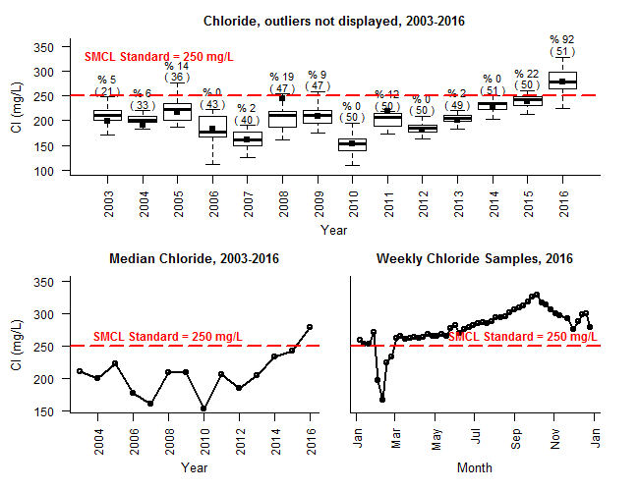

Figure : Hobbs Brook Reservoir Weekly Intake Chloride, 2003-2016.

**Percentages (%) represent the number of samples exceeding the chloride SMCL of 250 mg/L. Numbers in parenthesis () indicate the total number of samples collected in the year.**

Table : Reservoir Surface 2016 Na Results and ORS Guideline Exceedances (>20 mg/L)

**Exceedances are bolded.**

|  |  |  |  |  |  |  |  |
| --- | --- | --- | --- | --- | --- | --- | --- |
| **Site Name** | **HB @ Upper** | **HB @ Middle** | **HB @ DH** | **HB @ Intake Weekly** | **SB @ DH** | **SB @ Intake Weekly** | **FP @ DH** |
| Median | **199** | **209** | **160** | **154** | **106** | **104** | **120** |
| Mean | **199** | **206** | **157** | **152** | **116** | **114** | **114** |
| Min | **67** | **104** | **143** | **76** | **81** | 8 | **94** |
| Max | **332** | **313** | **171** | **198** | **178** | **180** | **139** |
| Number of  Samples (n) | 6 | 6 | 5 | 52 | 6 | 52 | 7 |
| Number of  Exceedances | 6 | 6 | 5 | 52 | 6 | 52 | 7 |
| % Exceedance | 100% | 100% | 100% | 100% | 100% | 100% | 100% |

Table : Reservoir Bottom 2016 Na Results and ORS Guideline Exceedances (>20 mg/L)

**Exceedances are bolded.**

|  |  |  |  |
| --- | --- | --- | --- |
| **Site Name** | **HB @ DH** | **SB @ DH** | **FP @ DH** |
| Median | **163** | **112** | **105** |
| Mean | **168** | **120** | **109** |
| Min | **163** | **94** | **90** |
| Max | **178** | **153** | **137** |
| Number of Samples (n) | 3 | 3 | 4 |
| Number of Exceedances | 3 | 3 | 4 |
| % Exceedance | 100% | 100% | 100% |

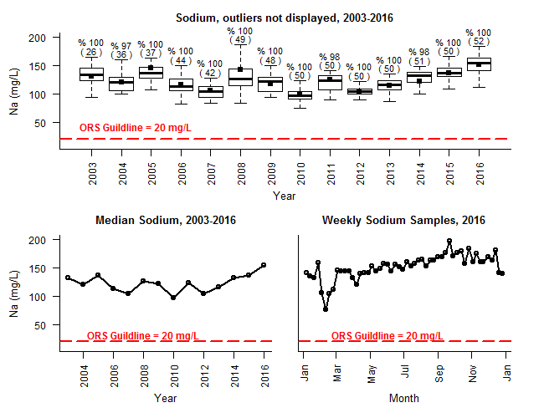

Figure : Hobbs Brook Reservoir Weekly Intake Sodium, 2003-2016.

**Percentages (%) represent the number of samples exceeding the sodium ORS Guideline of 250 mg/L. Numbers in parenthesis () indicate the total number of samples collected in the year.**

Given the influence of Hobbs Brook Reservoir inflows to Stony Brook Reservoir during the drought, Stony Brook Reservoir also experienced historically high salt concentrations in 2016 (Tables 22 through 25; Figures 11 and 12). In a typical year, base-flow and stormflow from the Stony Brook subwatershed dilutes the relatively salty water released from the Hobbs Brook Reservoir, and no samples exceed the 250 mg/L chloride SMCL threshold. However, in 2016, a third of SB @ DH surface samples and 29 percent of SB @ Intake Weekly samples exceeded the 250 mg/L criteria (Table 18). The exceedances occurred between the months of August and November when the influence of releases from the Hobbs Brook Reservoir was the highest. Unlike the Hobbs Brook Reservoir, however, the median chloride concentration for 2016 was below the 250 mg/L SMCL (Table 22; Figure 11). All sodium samples in Stony Brook Reservoir exceeded the ORS Guideline of 20 mg/L, although this is a common occurrence throughout the watershed and not unique to the drought (Tables 24 and 25; Figure 12).

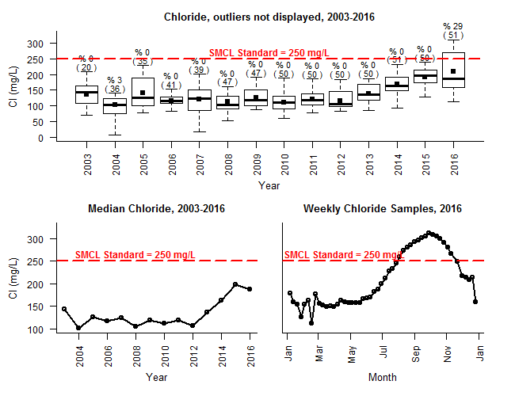

Figure : Stony Brook Reservoir Weekly Intake Chloride, 2003-2016.

**Percentages (%) represent the number of samples exceeding the chloride SMCL of 250 mg/L. Numbers in parenthesis () indicate the total number of samples collected in the year.**

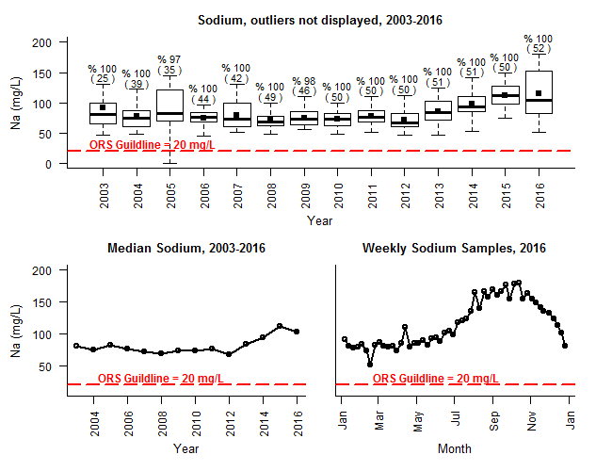

Figure : Stony Brook Reservoir Weekly Intake Sodium, 2003-2016.

**Percentages (%) represent the number of samples exceeding the sodium ORS Guideline of 20 mg/L. Numbers in parenthesis () indicate the total number of samples collected in the year.**

Similarly, Fresh Pond experienced exceedances of the 250 mg/L SMCL for the first time in the CWD sampling program since at least 2000 (Figure 13). However, Fresh Pond did not exceed the SMCL until October even though Stony Brook Reservoir began to exceed the SMCL in July (Figure 4). This is due to the relatively short retention time (high flushing rate) in Stony Brook Reservoir of 26 days compared to the longer retention time (slower flushing rate) of 4.7 months at Fresh Pond in 2016 (see section 10.2 *Reservoir Retention Times*). Fresh Pond also consistently exceeded the ORS Guideline for sodium and the median concentration was the highest of all years since 2000 (Tables 24 and 25; Figure 14).

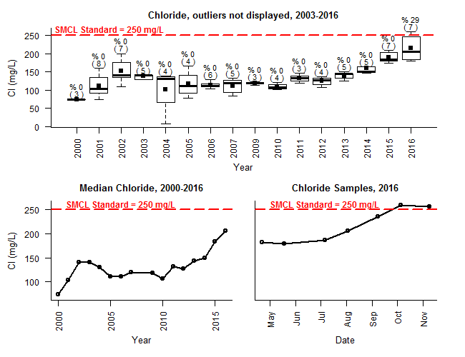

Figure : Fresh Pond Reservoir Deep Hole (FP @ DH) Surface Chloride, 2000-2016.

**Percentages (%) represent the number of samples exceeding the chloride SMCL of 250 mg/L. Numbers in parenthesis () indicate the total number of samples collected in the year.**

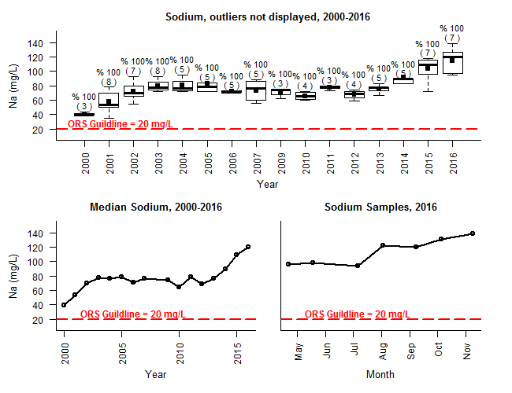

Figure : Fresh Pond Reservoir Deep Hole (FP @ DH) Surface Sodium, 2000-2016.

**Percentages (%) represent the number of samples exceeding the ORS Guideline of 20 mg/L. Numbers in parenthesis () indicate the total number of samples collected in the year.**

## EPA Nutrient Criteria for Upper Watershed

Because TP is typically the limiting nutrient for biologic productivity in lakes, it is a good indication of overall water quality. Fresh Pond had the best water quality of the three reservoirs with respect to TP. No TP surface or bottom samples exceeded the EPA nutrient criteria of 0.008 mg/L[9] at Fresh Pond in 2016 (Tables 26 and 27). FP @ DH median surface TP concentration was similar to HB @ DH and SB @ DH. However, HB @ DH and SB @ DH each had one surface sample which exceeded the EPA nutrient criteria (Table 26). Two of three bottom samples at both HB @ DH and SB @ DH also exceeded the TP standard during summer stratification (Table 27). The elevated TP at the reservoir bottom was likely due to internal loading caused by low DO levels in the summer months. The aeration system at FP likely helped avoid TP exceedances attributable to internal loading.

The biggest difference in TP concentrations was between the lower basin of the Hobbs Brook Reservoir and the middle and upper basins (Tables 26). All but one surface sample from the HB @ Upper and HB @ Middle sites exceeded the criteria for TP, while only one surface sample from HB @ DH exceeded the criteria. Median TP concentrations also decreased between each basin of Hobbs Brook Reservoir, dropping from 0.05 mg/L at HB @ Upper to 0.01 mg/L at HB @ DH (Table 26). This observed improvement in water quality illustrates how solids settle and pollutants become diluted as water cascades between the upper and middle basins and into the larger lower basin. The extreme low water levels during the summer and fall in may also have contributed to higher TP levels at HB @ Upper and HB @ Middle. Low water during the summer months, at times less than ankle deep, may also have increased the chance of disturbed or suspended sediments entering the samples.

Table : Reservoir Surface 2016 TP Results (mg/L) and EPA Nutrient Criteria Exceedances (>0.008 mg/L*).

**Values below the detection limit were set to the detection limit for the purposes of calculating means.** **Exceedances are bolded.**

|  |  |  |  |  |  |
| --- | --- | --- | --- | --- | --- |
| **Site Name** | **HB @ Upper** | **HB @ Middle** | **HB @ DH** | **SB @ DH** | **FP @ DH** |
| Median | **0.050** | **0.040** | **0.010** | <0.010 | <0.010 |
| Mean | **0.088** | **0.058** | **0.010** | **0.012** | **0.010** |
| Min | **0.020** | **0.010** | <0.010 | <0.010 | <0.010 |
| Max | **0.310** | **0.170** | **0.012** | **0.020** | **0.010** |
| Number of  Samples (n) | 6 | 6 | 5 | 6 | 7 |
| Number of  Exceedances | 6 | 5 | 1 | 1 | 0 |
| % Exceedance | 100% | 83% | 20% | 17% | 0% |
| * The detection limit for TP was 0.010 mg/L, which is above the EPA nutrient criteria. For the purposes of this analysis, it was assumed that sample results below the detection limit were below the EPA nutrient criteria. | | | | | |

Table : Reservoir Bottom 2016 TP Results (mg/L) and EPA Nutrient Criteria Exceedances (>0.008 mg/L*).

**Values below the detection limit were set to the detection limit for the purposes of calculating means. Exceedances are bolded.**

|  |  |  |  |
| --- | --- | --- | --- |
| **Site Name** | **HB @ DH** | **SB @ DH** | **FP @ DH** |
| Median | **0.030** | **0.040** | <0.010 |
| Mean | **0.030** | **0.050** | **0.010** |
| Min | <0.010 | **0.010** | <0.010 |
| Max | **0.050** | **0.100** | <0.010 |
| Number of Samples (n) | 3 | 3 | 4 |
| Number of Exceedances | 2 | 2 | 0 |
| % Exceedance | 67% | 67% | 0% |
| * The detection limit for TP was 0.010 mg/L, which is above the EPA nutrient criteria. For the purposes of this analysis, it was assumed that sample results below the detection limit were below the EPA nutrient criteria. | | | |

Nitrate and TKN also demonstrated a trend of decreasing exceedance frequency and/or decreasing median concentrations between HB @ Upper, HB @ Middle, and HB @ DH surface samples (Table 28). None of the deep hole surface samples collected from the three reservoirs exceeded the TKN nutrient criteria, although all deep hole sites exceeded the nitrate criteria of 0.05 mg/L at least once (Tables 28 and 30). HB @ DH had the lowest surface median nitrate concentration and exceedance rate (Table 30). FP @ DH had the highest surface nitrate exceedance rate, although SB @ DH had the highest median concentration. The difference in nitrate concentrations between the reservoirs is likely attributable to different watershed land use practices, particularly septic systems and fertilizer applications, as discussed in section 6.2. FP @ DH was the only site with nitrate concentrations above the EPA nutrient criteria in bottom samples, likely due to oxygen supplied by the aeration system (Table 31). TKN exceedances were more frequent in HB @ DH and SB @ DH bottom samples than in FP @ DH bottom samples, also likely due to the aeration system at Fresh Pond (Table 29).

Table : Reservoir Surface 2016 TKN Results (mg/L) and EPA Nutrient Criteria Exceedances (>0.43 mg/L).

**Values below the detection limit were set to the detection limit for the purposes of calculating means. Exceedances are bolded.**

|  |  |  |  |  |  |
| --- | --- | --- | --- | --- | --- |
| **Site Name** | **HB @ Upper** | **HB @ Middle** | **HB @ DH** | **SB @ DH** | **FP @ DH** |
| Median | **0.65** | **0.45** | 0.26 | 0.34 | 0.25 |
| Mean | **0.94** | **0.66** | 0.22 | 0.29 | 0.25 |
| Min | 0.38 | 0.26 | <0.10 | <0.10 | 0.13 |
| Max | **2.6** | **1.8** | 0.33 | 0.38 | 0.41 |
| Number of  Samples (n) | 6 | 6 | 5 | 6 | 7 |
| Number of  Exceedances | 5 | 3 | 0 | 0 | 0 |
| % Exceedance | 83% | 50% | 0% | 0% | 0% |

Table : Reservoir Bottom 2016 TKN Results (mg/L) and EPA Nutrient Criteria Exceedances (>0.43 mg/L)

**Exceedances are bolded.**

|  |  |  |  |
| --- | --- | --- | --- |
| **Site Name** | **HB @ DH** | **SB @ DH** | **FP @ DH** |
| Median | **0.90** | **0.90** | 0.28 |
| Mean | **0.83** | **0.90** | 0.32 |
| Min | 0.40 | **0.81** | 0.15 |
| Max | **1.2** | **1.0** | **0.56** |
| Number of Samples (n) | 3 | 3 | 4 |
| Number of Exceedances | 2 | 3 | 1 |
| % Exceedance | 67% | 100% | 25% |

Table : Reservoir Surface 2016 Nitrate* Results (mg/L) and EPA Nutrient Criteria Exceedances (>0.05 mg/L).

**Values below the detection limit were set to the detection limit for the purposes of calculating means. Exceedances are bolded.**

|  |  |  |  |  |  |
| --- | --- | --- | --- | --- | --- |
| **Site Name** | **HB @ Upper\*\*** | **HB @ Middle\*\*\*** | **HB @ DH\*\*\*\*** | **SB @ DH** | **FP @ DH** |
| Median | <0.16 | <0.12 | <0.05 | **0.40** | **0.29** |
| Mean | **0.18** | **0.21** | 0.04 | **0.38** | **0.36** |
| Min | <0.01 | <0.01 | <0.01 | 0.04 | **0.21** |
| Max | **0.43** | **0.60** | **0.06** | **0.83** | **0.57** |
| Number of  Samples (n) | 6 | 6 | 5 | 6 | 7 |
| Number of  Exceedances | 3 | 4 | 1 | 4 | 7 |
| % Exceedance | 50% | 67% | 20% | 67% | 100% |
| *The EPA nutrient criteria includes the sum of nitrate and nitrite concentrations. However, nitrite concentrations were *de minimis* in 2016. **Sample results were <0.01, <0.05, 0.04 ,0.26, 0.27, and 0.43 mg/L. ***Sample results were <0.01, <0.01, <0.085 (average of 0.12 and duplicate of <0.05), 0.12, 0.15, and 0.4 mg/L. ****Sample results were <0.01, <0.05,<0.05, 0.01, and 0.06 mg/L. | | | | | |

Table : Reservoir Bottom 2016 Nitrate* Results (mg/L) and EPA Nutrient Criteria Exceedances (>0.05 mg/L).

**Values below the detection limit were set to the detection limit for the purposes of calculating means. Exceedances are bolded.**

|  |  |  |  |
| --- | --- | --- | --- |
| **Site Name** | **HB @ DH\*\*** | **SB @ DH** | **FP @ DH** |
| Median | <0.05 | 0.02 | **0.19** |
| Mean | -- | 0.03 | **0.20** |
| Min | <0.05 | 0.01 | <0.05 |
| Max | <0.05 | <0.05*** | **0.35** |
| Number of Samples (n) | 3 | 3 | 4 |
| Number of Exceedances | 0 | 0 | 3 |
| % Exceedance | 0% | 0% | 75% |
| *The EPA nutrient criteria includes the sum of nitrate and nitrite concentrations. However, nitrite concentrations were *de minimis* in 2016. **Sample results were 0.01, <0.05, <0.05. ***Sample was analyzed by a contract laboratory which analyzed to a higher detection limit than CWD. Given the higher detection limit, the sample may not have been the true maximum. | | | |

# Tributary Base-flow Water Quality

The following section highlights results from the 12 tributary base-flow water quality monitoring stations sampled by CWD in 2016 (Figure 3). Results are compared to Massachusetts Class A water quality standards, MCL and SMCL standards, ORS Guidelines, and EPA nutrient criteria.

## Tributary Class A Water Quality Results

When compared against Massachusetts Class A water quality standards, tributary water samples in 2016 were overall of good quality. However, at least one site had a parameter outside the bounds of the Class A water quality standards in 2016 (Tables 32 through 36).

pH had the lowest overall exceedance rate among the tributary sampling sites (Tables 32 and 33). Only one *in situ* pH measurement was recorded outside the acceptable Class A range (Table 32). This reading (6.41) occurred at MBS on July 13, 2016. However, the water quality sample analyzed in the CWD laboratory from the same date had a pH of 6.60 and was within the acceptable Class A range of 6.5 and 8.3. The average of the *in situ* reading and laboratory reading (6.51) also was within the Class A bounds.

Less than 10 percent of CWD *in situ* readings from the combined 12 tributary sites exceeded the Class A standard for DO. However, two of six samples at both Tracer Ln and MBS fell below the 5 mg/L standard (Table 34). Indust Brook and HB @ Mill St also each exceeded the DO standard once in 2016. All tributary DO exceedances occurred during July and August when water temperatures were highest. All exceedance sites were directly downstream of wetland systems with high biochemical oxygen demand.

Despite the drought, all warm water tributaries remained below the 28.3 degrees C temperature threshold (Table 35). However, the Class A temperature threshold for cold water fisheries was exceeded 117 times at RT 20 and 61 times at SB @ Viles (Table 35). The Class A cold water fishery standard is 20 degree C for the average maximum daily temperature over a seven day period. Exceedances at RT 20 and SB @ Viles St were determined by calculating the rolling seven-day average of maximum daily temperatures using data from USGS continuous monitoring stations 01104460 and 01104370.[10] It is unknown whether the exceedances at SB @ Viles represented natural variations or were exacerbated by anthropogenic factors, such heated pavement runoff or loss of riparian vegetation. Flows at RT 20 were influenced by releases of water from the Hobbs Brook Reservoir during the summer at fall.

The Class A *E. coli* exceedance rate for all tributary sites combined was 16 percent. The exceedances were geographically and temporally distributed among the sampling sites and dates (Table 36). All tributary sites exceeded the *E. coli* standard of 235 MPN/100 ml once with the exception of Lex Brook and HB Below Dam. Lex Brook had two samples which exceeded the standard, whereas no samples at HB Below Dam exceeded the standard. The exceedance dates occurred throughout the year, ranging from February through October, although the majority occurred in June through September.

Table : Tributary Surface 2016 in situ pH Results and Class A Exceedances (<6.5 or >8.3)

**Exceedances are bolded.**

|  |  |  |  |  |  |  |  |  |  |  |  |  |
| --- | --- | --- | --- | --- | --- | --- | --- | --- | --- | --- | --- | --- |
| **Site Name** | **HB Below Dam** | **HB @ Mill St** | **HB @ KG** | **Indust Brook** | **Lex Brook** | **MBS** | **RT 20\*** | **Salt Depot** | **SB @ Viles\*** | **Summer St** | **Tracer Ln** | **WA-17** |
| Median | 7.54 | 7.66 | 7.38 | 7.10 | 7.26 | 7.00 | 7.14 | 7.43 | 7.23 | 7.55 | 6.90 | 7.08 |
| Mean | 7.54 | 7.54 | 7.40 | 7.09 | 7.22 | 6.90 | 7.23 | 7.37 | 7.20 | 7.53 | 6.90 | 7.14 |
| Min | 7.29 | 7.00 | 7.18 | 6.92 | 6.95 | **6.41** | 7.12 | 7.17 | 6.97 | 7.47 | 6.57 | 6.98 |
| Max | 7.78 | 7.90 | 7.59 | 7.27 | 7.55 | 7.23 | 7.51 | 7.44 | 7.52 | 7.58 | 7.45 | 7.31 |
| Number of  Samples (n) | 5 | 5 | 6 | 6 | 5 | 6 | *5* | 4 | *7* | 5 | 6 | 7 |
| Number of  Exceedances | 0 | 0 | 0 | 0 | 0 | 1 | *0* | 0 | *0* | 0 | 0 | 0 |
| % Exceedance | 0% | 0% | 0% | 0% | 0% | 17% | *0%* | 0% | *0%* | 0% | 0% | 0% |

Table : Tributary Surface 2016 laboratory pH Results and Class A Exceedances (<6.5 or >8.3)

|  |  |  |  |  |  |  |  |  |  |  |  |  |
| --- | --- | --- | --- | --- | --- | --- | --- | --- | --- | --- | --- | --- |
| **Site Name** | **HB Below Dam** | **HB @ Mill St** | **HB @ KG** | **Indust Brook** | **Lex Brook** | **MBS** | **RT 20\*** | **Salt Depot** | **SB @ Viles\*** | **Summer St** | **Tracer Ln** | **WA-17** |
| Median | 7.50 | 6.97 | 7.37 | 7.16 | 7.24 | 7.09 | 7.14 | 7.02 | 7.02 | 7.63 | 6.77 | 7.24 |
| Mean | 7.45 | 6.95 | 7.36 | 7.14 | 7.28 | 7.00 | 7.15 | 6.99 | 7.01 | 7.61 | 6.77 | 7.17 |
| Min | 7.05 | 6.61 | 7.19 | 7.01 | 7.09 | 6.60 | 7.08 | 6.77 | 6.71 | 7.48 | 6.55 | 6.89 |
| Max | 7.73 | 7.24 | 7.57 | 7.25 | 7.52 | 7.26 | 7.23 | 7.14 | 7.18 | 7.71 | 6.97 | 7.40 |
| Number of  Samples (n) | 5 | 5 | 6 | 6 | 5 | 6 | 5 | 4 | 7 | 5 | 6 | 7 |
| Number of  Exceedances | 0 | 0 | 0 | 0 | 0 | 0 | 0 | 0 | 0 | 0 | 0 | 0 |
| % Exceedance | 0% | 0% | 0% | 0% | 0% | 0% | 0% | 0% | 0% | 0% | 0% | 0% |

Table : Tributary 2016 Dissolved Oxygen (DO) Results (mg/L) and Class A Exceedances (< 5 mg/L warm water fisheries; < 6 mg/L cold water fisheries).

**\* = cold water fishery designation. Exceedances are bolded.**

|  |  |  |  |  |  |  |  |  |  |  |  |  |
| --- | --- | --- | --- | --- | --- | --- | --- | --- | --- | --- | --- | --- |
| **Site Name** | **HB Below Dam** | **HB @ Mill St** | **HB @ KG** | **Indust Brook** | **Lex Brook** | **MBS** | **RT 20\*** | **Salt Depot** | **SB @ Viles\*** | **Summer St** | **Tracer Ln** | **WA-17** |
| Median | 9.14 | 12.18 | 9.56 | 8.88 | 8.35 | 8.29 | 8.25 | 11.99 | 9.61 | 10.49 | 7.52 | 8.18 |
| Mean | 9.56 | 10.48 | 10.59 | 8.37 | 9.36 | 7.11 | 9.59 | 11.46 | 10.49 | 10.46 | 7.32 | 8.29 |
| Min | 7.94 | **4.66** | 7.93 | **4.63** | 7.61 | **0.86** | 7.65 | 9.35 | 8.16 | 8.95 | **3.64** | 5.72 |
| Max | 11.84 | 13.22 | 14.24 | 11.52 | 11.62 | 11.96 | 13.43 | 12.51 | 13.29 | 12.70 | 11.21 | 10.45 |
| Number of  Samples (n) | 5 | 5 | 6 | 6 | 5 | 6 | 5 | 4 | 7 | 5 | 6 | 7 |
| Number of  Exceedances | 0 | 1 | 0 | 1 | 0 | 2 | 0 | 0 | 0 | 0 | 2 | 0 |
| % Exceedance | 0% | 20% | 0% | 17% | 0% | 33% | 0% | 0% | 0% | 0% | 33% | 0% |

Table : Tributary 2016 Temperature Results (degrees C) and Class A Exceedances (> 28.3 degrees C, warm water fisheries; > 20 degrees C, seven day average daily maximum, cold water fisheries).

**\*=cold water fishery designation. Data source = approved and provisional data from USGS continuous monitoring stations 01104460 (RT 20) and 01104370 (SB @Viles); median, mean, minimum, and maximum temperatures were calculated using the complete continuous data set; n= number of rolling seven-day maximum daily temperature averages; number of exceedances= number of rolling seven-day temperature averages above 20 degrees C; % Exceedance = % of rolling seven-day maximum daily temperature averages above 20 degrees C**

**Exceedances are bolded.**

|  |  |  |  |  |  |  |  |  |  |  |  |  |
| --- | --- | --- | --- | --- | --- | --- | --- | --- | --- | --- | --- | --- |
| **Site Name** | **HB Below Dam** | **HB @ Mill St** | **HB @ KG** | **Indust Brook** | **Lex Brook** | **MBS** | **RT 20\*** | **Salt Depot** | **SB @ Viles\*** | **Summer St** | **Tracer Ln** | **WA-17** |
| Median | 14.38 | 3.03 | 16.77 | 16.77 | 12.70 | 11.04 | 11.6 | 3.02 |  | 12.18 | 8.90 | 16.87 |
| Mean | 14.88 | 7.46 | 13.69 | 13.35 | 11.97 | 12.67 | 12.5 | 5.49 |  | 12.67 | 9.71 | 16.84 |
| Min | 4.39 | 1.22 | 1.32 | 2.00 | 4.87 | 3.33 | 0.3 | 2.46 |  | 5.38 | 1.28 | 7.79 |
| Max | 23.64 | 19.51 | 23.04 | 19.81 | 19.28 | 23.69 | **27.3** | 13.44 |  | 17.30 | 19.07 | 23.71 |
| Number of  Samples (n) | 5 | 5 | 6 | 6 | 5 | 6 | 360 | 4 | 360 | 5 | 6 | 7 |
| Number of  Exceedances | 0 | 0 | 0 | 0 | 0 | 0 | 117 | 0 | 61 | 0 | 0 | 0 |
| % Exceedance | 0% | 0% | 0% | 0% | 0% | 0% | 33% | 0% | 17% | 0% | 0% | 0% |

Table : Tributary E. coli Results (MPN/100 ml) and Class A Exceedances (> 235 MPN/100 mL), 2016.

**Values above or below the detection limit were set to the detection limit for the purposes of calculating means.** **Exceedances are bolded.**

|  |  |  |  |  |  |  |  |  |  |  |  |  |
| --- | --- | --- | --- | --- | --- | --- | --- | --- | --- | --- | --- | --- |
| **Site Name** | **HB Below Dam** | **HB @ Mill St** | **HB @ KG** | **Indust Brook** | **Lex Brook** | **MBS** | **RT 20\*** | **Salt Depot** | **SB @ Viles\*** | **Summer St** | **Tracer Ln** | **WA-17** |
| Median | 2 | 34 | 70 | 24 | 178 | 23 | 130 | 50 | 79 | 102 | 19 | 26 |
| Mean | 5 | 117 | 160 | **271** | **694** | 92 | 174 | 68 | 228 | **267** | 71 | 126 |
| Min | <1 | 12 | 4 | 5 | 48 | 2 | 51 | 24 | 28 | 22 | 12 | 2 |
| Max | 12 | **457** | **687** | **1403** | **>2,420** | **461** | **345** | 148 | **1,050** | **980** | **326** | **727** |
| Number of  Samples (n) | 5 | 5 | 6 | 6 | 5 | 6 | 5 | 4 | 7 | 5 | 6 | 7 |
| Number of  Exceedances | 0 | 1 | 1 | 1 | 2 | 1 | 1 | 0 | 1 | 1 | 1 | 1 |
| % Exceedance | 0% | 20% | 17% | 17% | 40% | 17% | *20%* | 0% | *14%* | 20% | 17% | 14% |

## Maximum and Secondary Maximum Contaminant Levels (MCLs and SMCLs) and ORS Guidelines

MA SMCLs for manganese, iron, TDS, chloride and the ORS Guideline for sodium were regularly exceeded during 2016 tributary sampling events (Tables 37 through 41). Nitrate concentrations are discussed in section 7.3 in the context of the EPA nutrient criteria. However, all tributary sites had nitrate concentrations well below the MCL of 10 mg/L.

SB @ Viles Street and Summer St had the best water quality as evaluated by the SMCL and ORS Guidelines. Both sites had median concentrations below the manganese, iron, and TDS SMCLs (Tables 37 through 41). No samples exceeded the TDS SMCL of 500 mg/L and only one sample at each site exceeded the 0.05 mg/L manganese SMCL (Tables 37 and 39). Two of seven samples at SB @ Viles exceeded the 0.3 mg/L iron standard, while only one of five samples exceeded the standard at Summer St (Table 38). SB @ Viles St and Summer St were also among the least salt impacted tributary sampling sites in the watershed (Tables 40 and 41). No samples from either site exceeded the chloride SMCL of 250 mg/L SMCL (Table 40). Although 100 percent of samples exceeded the 20 mg/L ORS Guideline for sodium, median concentrations of 49 mg/L (Summer St) and 53 mg/L (SB @ Viles St) were the lowest in the watershed (Table 41).

HB @ Mill St and MBS had the next best water quality as evaluated by the SMCL standards. These sites were the only two monitoring sites besides SB @ Viles St and Summer St with median chloride concentrations below the SMCL (Table 40). All samples from HB @ Mill St were below the TDS SMCL, while half of MBS samples were below the SMCL (Table 38). HB @ Mill St median chloride and sodium concentrations (105 mg/L and 65 mg/L) were similar to SB @ Viles St (108 mg/L and 53 mg/L) (Tables 40 and 41). MBS had slightly median higher concentrations of chloride and sodium (209 mg/L and 131 mg/L). The largest difference in water quality between these sites and SB @ Viles St and Summer St is regarding manganese and iron concentrations. Two samples from both HB @ Mill St and MBS exceeded the manganese SMCL, and the median concentration at both sites was 0.05 mg/L, equivalent to the SMCL (Table 37). The iron SMCL was exceeded more frequently than the manganese standard, with 80 to 100 percent of samples exceeding the 0.3 mg/L SMCL (Table 38).

Between 80 and 100 percent of samples at the remaining nine tributary sites exceeded the SMCLs for manganese, iron, sodium, chloride and TDS with the following exceptions: only one sample from HB Below Dam exceeded the SMCL for iron, and at RT 20 only a single sample exceeded SMCL for chloride (Tables 37 through 41). Indust Brook had the worst water quality of the 12 tributary sites as evaluated by these standards. Median concentrations of manganese, iron, chloride, sodium and TDS at Indust Brook were the highest of the tributary sites. Indust Brook was salt impacted to the extent that its median chloride concentration of 783 mg/L was more than triple the 250 mg/L SMCL (Table 40). Lex Brook, which borders Interstate 95, was the next most salt impacted of the tributary sites, with a median chloride concentration of 599 mg/L, more than double the SMCL. WA-17 and Tracer Ln also receive drainage from Interstate 95 and experienced apparent impacts from road salts. The median chloride concentration at WA-17 was 436 mg/L while the median concentration at Tracer Ln was 408 mg/L.

Although the Salt Depot tributary site receives minimal drainage from Interstate 95, it still had an elevated median chloride concentration of 390 mg/L (Table 40). This was presumably attributable to a historic groundwater salt plume resulting from storage of sodium chloride by MassDOT in an uncovered garage, as well as potential spillage from current highway operations (Geotechnical Engineers Inc, 1985). The salt storage facility has since been updated to prevent road salts from leaching into the groundwater during storage. HB @ KG and HB Below Dam also had median chloride concentrations above 250 mg/L, at 290 mg/L and 277 mg/L, respectively. However, both sites are situated downstream of the Hobbs Brook Reservoir, and are therefore heavily influenced by releases of water from the dam. The median chloride concentration from the Hobbs Brook Reservoir gatehouse (HB @ Intake Weekly) of 279 mg/L closely resembled the HB @ KG and HB Below Dam median concentrations (Tables 22 and 40).

Table : Tributary Mn Results (mg/L) and SMCL Exceedances (>0.05 mg/L), 2016

**Exceedances are bolded.**

|  |  |  |  |  |  |  |  |  |  |  |  |  |
| --- | --- | --- | --- | --- | --- | --- | --- | --- | --- | --- | --- | --- |
| **Site Name** | **HB Below Dam** | **HB @ Mill St** | **HB @ KG** | **Indust Brook** | **Lex Brook** | **MBS** | **RT 20** | **Salt Depot** | **SB @ Viles** | **Summer St** | **Tracer Ln** | **WA-17** |
| Median | **0.10** | 0.05 | **0.27** | **0.54** | **0.24** | 0.05 | **0.20** | **0.37** | 0.03 | 0.03 | **0.18** | **0.23** |
| Mean | **0.11** | **0.09** | **0.31** | **0.76** | **0.35** | **0.10** | **0.31** | **0.39** | 0.05 | 0.06 | **0.27** | **0.23** |
| Min | 0.01 | 0.03 | **0.12** | **0.45** | 0.15 | 0.04 | 0.09 | **0.32** | 0.02 | 0.01 | 0.06 | **0.13** |
| Max | **0.18** | **0.23** | **0.72** | **1.81** | **0.58** | **0.28** | **0.77** | **0.50** | **0.18** | **0.20** | **0.64** | **0.37** |
| Number of  Samples (n) | 5 | 5 | 6 | 6 | 5 | 6 | 5 | 4 | 7 | 5 | 6 | 7 |
| Number of  Exceedances | 4 | 2 | 6 | 6 | 5 | 2 | 5 | 4 | 1 | 1 | 6 | 7 |
| % Exceedance | 80% | 40% | 100% | 100% | 100% | 33% | 100% | 100% | 14% | 20% | 100% | 100% |

Table : Tributary Fe Results (mg/L) and SMCL Exceedances (>0.3 mg/L), 2016**.**

**Exceedances are bolded.**

|  |  |  |  |  |  |  |  |  |  |  |  |  |
| --- | --- | --- | --- | --- | --- | --- | --- | --- | --- | --- | --- | --- |
| **Site Name** | **HB Below Dam** | **HB @ Mill St** | **HB @ KG** | **Indust Brook** | **Lex Brook** | **MBS** | **RT 20** | **Salt Depot** | **SB @ Viles** | **Summer St** | **Tracer Ln** | **WA-17** |
| Median | 0.25 | **0.40** | **0.55** | **1.49** | **0.52** | **0.61** | **0.56** | **0.48** | 0.26 | 0.20 | **0.76** | **0.67** |
| Mean | 0.23 | **0.86** | **0.65** | **1.90** | **0.64** | **0.72** | **0.66** | **0.49** | **0.40** | 0.29 | **0.89** | **0.74** |
| Min | 0.10 | 0.27 | **0.35** | **1.05** | **0.44** | **0.32** | **0.33** | **0.43** | 0.20 | 0.16 | **0.50** | **0.48** |
| Max | **0.32** | **2.37** | **1.07** | **4.33** | **0.88** | **1.28** | **1.02** | **0.58** | **1.08** | **0.63** | **1.55** | **1.42** |
| Number of  Samples (n) | 5 | 5 | 6 | 6 | 5 | 6 | 5 | 4 | 7 | 5 | 6 | 7 |
| Number of  Exceedances | 1 | 4 | 6 | 6 | 5 | 6 | 5 | 4 | 2 | 1 | 6 | 7 |
| % Exceedance | 20% | 80% | 100% | 100% | 100% | 100% | 100% | 100% | 29% | 20% | 100% | 100% |

Table : Tributary TDS Results (mg/L) and Class A Exceedances (>500 mg/L), 2016**.**

**Exceedances are bolded.**

|  |  |  |  |  |  |  |  |  |  |  |  |  |
| --- | --- | --- | --- | --- | --- | --- | --- | --- | --- | --- | --- | --- |
| **Site Name** | **HB Below Dam** | **HB @ Mill St** | **HB @ KG** | **Indust Brook** | **Lex Brook** | **MBS** | **RT 20** | **Salt Depot** | **SB @ Viles** | **Summer St** | **Tracer Ln** | **WA-17** |
| Median | **633** | 286 | **676** | **1,724** | **1,372** | **517** | **537** | **969** | 337 | 251 | **927** | **1,039** |
| Mean | **650** | 319 | **670** | **1,474** | **1,420** | **533** | **503** | **1,097** | 314 | 252 | **882** | **1,043** |
| Min | **619** | 240 | **608** | **595** | **1,144** | 452 | 343 | **833** | 252 | 231 | 449 | **914** |
| Max | **650** | 319 | **670** | **1,474** | **1,420** | **533** | **503** | **1,097** | 314 | 252 | **882** | **1,043** |
| Number of  Samples (n) | 5 | 5 | 6 | 6 | 5 | 6 | 5 | 4 | 7 | 5 | 6 | 7 |
| Number of  Exceedances | 5 | 0 | 6 | 6 | 5 | 3 | 3 | 4 | 0 | 0 | 5 | 7 |
| % Exceedance | 100% | 0% | 100% | 100% | 100% | 50% | 60% | 100% | 0% | 0% | 83% | 100% |

Table : Tributary Cl- Results (mg/L) and SMCL Exceedances (>250 mg/L), 2016

**Exceedances are bolded.**

|  |  |  |  |  |  |  |  |  |  |  |  |  |
| --- | --- | --- | --- | --- | --- | --- | --- | --- | --- | --- | --- | --- |
| **Site Name** | **HB Below Dam** | **HB @ Mill St** | **HB @ KG** | **Indust Brook** | **Lex Brook** | **MBS** | **RT 20** | **Salt Depot** | **SB @ Viles** | **Summer St** | **Tracer Ln** | **WA-17** |
| Median | **277** | 105 | **290** | **783** | **599** | 209 | 226 | **390** | 108 | 78 | **408** | **436** |
| Mean | **284** | 112 | **318** | **668** | **640** | 217 | 204 | **467** | 113 | 75 | **380** | **439** |
| Min | **270** | 91 | **257** | 249 | **514** | 180 | 131 | **367** | 92 | 70 | 165 | 371 |
| Max | **317** | 136 | **467** | **911** | **769** | **275** | **279** | **720** | 133 | 79 | **488** | **490** |
| Number of  Samples (n) | 5 | 5 | 6 | 6 | 5 | 6 | 5 | 4 | 7 | 5 | 6 | 7 |
| Number of  Exceedances | 5 | 0 | 6 | 5 | 5 | 1 | 1 | 4 | 0 | 0 | 5 | 7 |
| % Exceedance | 100% | 0% | 100% | 83% | 100% | 17% | 20% | 100% | 0% | 0% | 83% | 100% |

Table : Tributary Na+ Results (mg/L) and ORS Guideline Exceedances (>20 mg/L), 2016.

**Exceedances are bolded.**

|  |  |  |  |  |  |  |  |  |  |  |  |  |
| --- | --- | --- | --- | --- | --- | --- | --- | --- | --- | --- | --- | --- |
| **Site Name** | **HB Below Dam** | **HB @ Mill St** | **HB @ KG** | **Indust Brook** | **Lex Brook** | **MBS** | **RT 20** | **Salt Depot** | **SB @ Viles** | **Summer St** | **Tracer Ln** | **WA-17** |
| Median | **156** | **65** | **165** | **447** | **375** | **131** | **126** | **234** | **53** | **49** | **223** | **252** |
| Mean | **151** | **65** | **161** | **384** | **387** | **136** | **114** | **266** | **60** | **48** | **208** | **242** |
| Min | **126** | **52** | **133** | **161** | **284** | **108** | **61** | **207** | **42** | **36** | **96** | **203** |
| Max | **168** | **80** | **187** | **507** | **471** | **179** | **162** | **389** | **77** | **58** | **265** | **269** |
| Number of  Samples (n) | 5 | 5 | 6 | 6 | 5 | 6 | 5 | 4 | 7 | 5 | 6 | 7 |
| Number of  Exceedances | 5 | 5 | 6 | 6 | 5 | 6 | 5 | 4 | 7 | 5 | 6 | 7 |
| % Exceedance | 100% | 100% | 100% | 100% | 100% | 100% | 100% | 100% | 100% | 100% | 100% | 100% |

## EPA Nutrient Criteria for Upper Watershed

The EPA nutrient criteria pertaining to nitrogen (nitrate and TKN) were regularly exceeded in 2016 and could indicate anthropogenic inputs of nitrogen (Tables 42 and 43). Of the 12 tributary sites, seven site medians exceeded the EPA regional nutrient criteria for nitrate in 2016 and all but two sites exceeded the criteria for TKN.

Median nitrate concentrations were highest in the Stony Brook subwatershed at Summer St (1.80 mg/L), WA -17 (1.49 mg/L), and SB @ Viles (1.20 mg/L) (Table 42). The high nitrate levels at Summer Street were likely caused by septic system leachate, residential fertilizer use, and fertilizer applications at a golf course located within the subcatchment. Nitrate concentrations at SB @ Viles St were also likely influenced by the high percentage area of low density residential land use and associated septic systems and lawn fertilizer applications (Appendix C). MBS and HB @ KG drainage areas are also served by septic systems but nitrate concentrations were an order of magnitude lower than at SB @ Viles Street and Summer St. One possible explanation for this difference is that upstream ponds and wetlands in the MBS and HB @ KG subbasins are acting as nitrate sinks.

WA-17 had more urban land use characteristics than the Summer St and SB @ Viles catchments (Appendix C). Wastewater disposal in the WA-17 catchment generally occurs via sewers, not septic systems. Given the different land use patterns, it was unclear why nitrate levels in the WA-17 catchment were on par with SB @ Viles and Summer St (Table 42). It is possible that the sewer lines in the WA-17 catchment were leaking, resulting in increased nitrate concentrations in the groundwater. Fertilizer applications from landscaping corporate campuses in the WA-17 catchment could be another source of nitrogen.

Despite elevated nitrate concentrations relative to other tributary sites, the WA-17 median nitrate concentration was consistent with previous years and may even signify the start of a decreasing trend (Figure 15). In October of 2012, a stormwater pond/wetland treatment system was installed immediately upstream of the WA-17 sampling station. There was an observed spike in nitrate levels in 2013 and 2014, presumably due to leaching of imported construction soils and fertilizer applications to help establish vegetation. However, median 2015 and 2016 nitrate concentrations at WA-17 were lower than in most previous years. This suggests that the stormwater wetland now acts as a sink, with wetland and aquatic vegetation or organisms removing nitrate from the water column. However, more years of data are necessary to determine whether a decreasing nitrate trend exists.

Exceedances of the TKN nutrient criteria were also widespread (Table 43). All site medians except for HB Below Dam (0.22 mg/L) and Lex Brook (0.24 mg/L) were above the 0.3 mg/L EPA nutrient criteria (Table 43). The sites with the highest median concentrations were Indust Brook (0.67 mg/L), MBS (0.60 mg/L), and HB @ Mill St (0.57 mg/L). All three sites were located downstream of wetland systems and may represent organic nitrogen from the breakdown of wetland plants and organisms.

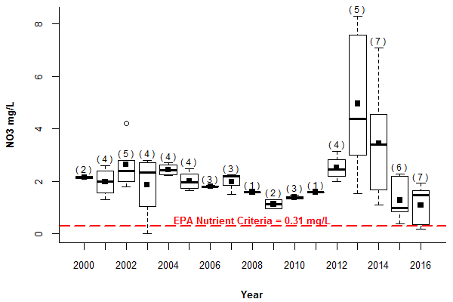

Figure : WA-17 Nitrate (NO3-) Concentrations (mg/L), 2000-2016.

**Numbers in parenthesis () indicate the total number of samples collected in the year.**

Fewer nutrient exceedances were observed for TP, with only the WA-17, Indust Brook, and Summer St medians exceeding the criteria (Table 44). However, all sites except for Lex Brook, Salt Depot, HB Below Dam, and SB @ Viles exceeded the TP nutrient criteria in at least one sample in 2016 (Table 44). WA-17 and Indust Brook had the highest median TP levels in the watershed at 0.032 mg/L (WA-17) and 0.030 mg/L (Indust Brook). Both sites were down stream of wetland systems which may export organic phosphorus. WA-17 is located downstream of a constructed stormwater wetland designed to treat highway runoff. The elevated TP levels, which begin after the pond went online in October of 2012, indicate that the pond is not performing as intended (Figure 16). CWD is working with USGS and MassDOT to study the constructed wetland’s inflow and outflow water quality and improve the system’s functionality with regard to TP.

In addition to exceeding the TP EPA nutrient criteria in 2016, Indust Brook and WA-17 also exceeded the nutrient criteria for turbidity (>1.68 NTU) (Table 45). Indust Brook had the highest median turbidity levels in the watershed (3.52 NTU) and all samples collected in 2016 exceeded the nutrient criteria (Table 45). WA-17 had a median turbidity level of 1.75 NTU and exceeded the turbidity standard in 5 of 7 samples. Although Summer St median TP exceeded the nutrient criteria, no samples exceeded the criteria for turbidity.

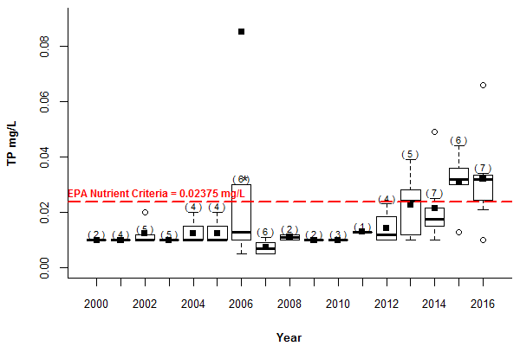Figure : WA-17 Total Phosphorus (TP) Concentrations (mg/L), 2000-2016.

**Numbers in parenthesis () indicate the total number of samples collected in the year.*Outlier of 0.44 mg/L not displayed, but is included in sample count.**

Table : Tributary NO3- Results (mg/L) and EPA Nutrient Criteria Exceedances (>0.31 mg/L), 2016.

**Values below the detection limit were set to the detection limit for the purposes of calculating means.** **Exceedances are bolded.**

|  |  |  |  |  |  |  |  |  |  |  |  |  |
| --- | --- | --- | --- | --- | --- | --- | --- | --- | --- | --- | --- | --- |
| **Site Name** | **HB Below Dam** | **HB @ Mill St** | **HB @ KG** | **Indust Brook** | **Lex Brook** | **MBS** | **RT 20** | **Salt Depot** | **SB @ Viles** | **Summer St** | **Tracer Ln** | **WA-17** |
| Median | 0.02 | 0.21 | 0.22 | **0.44** | **0.64** | **0.33** | **0.62** | 0.11 | **1.20** | **1.80** | 0.24 | **1.49** |
| Mean | 0.02 | 0.22 | **0.58** | **0.47** | **0.76** | **0.48** | **0.50** | 0.18 | **1.52** | **2.38** | **0.32** | **1.09** |
| Min | <0.01 | 0.12 | <0.05 | 0.15 | **0.50** | <0.01 | 0.11 | 0.08 | **0.69** | **1.34** | 0.01 | 0.17 |
| Max | 0.03 | 0.31 | **2.29** | **0.92** | **1.23** | **1.27** | **0.76** | **0.41** | **2.34** | **4.36** | **0.96** | **1.93** |
| Number of  Samples (n) | 5 | 5 | 6 | 6 | 5 | 6 | 5 | 4 | 7 | 5 | 6 | 7 |
| Number of  Exceedances | 0 | 0 | 3 | 3 | 5 | 3 | 4 | 1 | 7 | 5 | 2 | 5 |
| % Exceedance | 0% | 0% | 50% | 50% | 100% | 50% | 80% | 25% | 100% | 100% | 33% | 71% |

Table : Tributary TKN Results (mg/L) and EPA Nutrient Criteria Exceedances (>0.3 mg/L), 2016.

**Values below the detection limit were set to the detection limit for the purposes of calculating means. Exceedances are bolded.**

|  |  |  |  |  |  |  |  |  |  |  |  |  |
| --- | --- | --- | --- | --- | --- | --- | --- | --- | --- | --- | --- | --- |
| **Site Name** | **HB Below Dam** | **HB @ Mill St** | **HB @ KG** | **Indust Brook** | **Lex Brook** | **MBS** | **RT 20** | **Salt Depot** | **SB @ Viles** | **Summer St** | **Tracer Ln** | **WA-17** |
| Median | 0.22 | **0.57** | **0.33** | **0.67** | 0.24 | **0.60** | **0.37** | **0.40** | **0.43** | **0.48** | **0.36** | **0.38** |
| Mean | 0.21 | **0.50** | **0.32** | **0.66** | 0.25 | **0.57** | **0.33** | **0.39** | **0.39** | **0.50** | **0.40** | **0.42** |
| Min | 0.16 | **0.32** | 0.12 | **0.48** | 0.17 | **0.46** | 0.14 | **0.35** | <0.10 | <0.20 | 0.24 | <0.20 |
| Max | 0.28 | **0.60** | **0.47** | **0.92** | **0.42** | **0.62** | **0.40** | **0.41** | **0.66** | **0.83** | **0.80** | **0.68** |
| Number of  Samples (n) | 5 | 5 | 6 | 6 | 5 | 6 | 5 | 4 | 7 | 5 | 6 | 7 |
| Number of  Exceedances | 0 | 5 | 3 | 6 | 1 | 6 | 4 | 4 | 5 | 4 | 4 | 4 |
| % Exceedance | 0% | 100% | 50% | 100% | 20% | 100% | 80% | 100% | 71% | 80% | 67% | 57% |

Table : Tributary TP Results (mg/L) and EPA Nutrient Criteria Exceedances (>0.02375 mg/L), 2016.

**Values below the detection limit were set to the detection limit for the purposes of calculating means. Exceedances are bolded.**

|  |  |  |  |  |  |  |  |  |  |  |  |  |
| --- | --- | --- | --- | --- | --- | --- | --- | --- | --- | --- | --- | --- |
| **Site Name** | **HB Below Dam** | **HB @ Mill St** | **HB @ KG** | **Indust Brook** | **Lex Brook** | **MBS** | **RT 20** | **Salt Depot** | **SB @ Viles** | **Summer St** | **Tracer Ln** | **WA-17** |
| Median | <0.010 | 0.010 | 0.014 | **0.030** | 0.010 | 0.018 | 0.015 | <0.010 | <0.010 | **0.024** | <0.010 | **0.032** |
| Mean | 0.010 | 0.016 | 0.018 | **0.041** | 0.012 | 0.020 | 0.018 | 0.010 | 0.013 | **0.032** | 0.014 | **0.032** |
| Min | <0.010 | <0.010 | <0.010 | 0.017 | <0.010 | <0.010 | <0.010 | <0.010 | <0.010 | <0.010 | <0.010 | 0.010 |
| Max | <0.010 | **0.038** | **0.031** | **0.113** | 0.015 | **0.032** | **0.026** | <0.010 | 0.019 | **0.085** | **0.034** | **0.066** |
| Number of  Samples (n) | 5 | 5 | 6 | 6 | 5 | 6 | 5 | 4 | 7 | 5 | 6 | 7 |
| Number of  Exceedances | 0 | 1 | 2 | 5 | 0 | 2 | 2 | 0 | 0 | 3 | 1 | 5 |
| % Exceedance | 0% | 20% | 33% | 83% | 0% | 33% | 40% | 0% | 0% | 60% | 17% | 71% |

Table : Tributary Turbidity Results (NTU) and EPA Nutrient Criteria Exceedances (>1.68 NTU), 2016.

**Exceedances are bolded.**

|  |  |  |  |  |  |  |  |  |  |  |  |  |
| --- | --- | --- | --- | --- | --- | --- | --- | --- | --- | --- | --- | --- |
| **Site Name** | **HB Below Dam** | **HB @ Mill St** | **HB @ KG** | **Indust Brook** | **Lex Brook** | **MBS** | **RT 20** | **Salt Depot** | **SB @ Viles** | **Summer St** | **Tracer Ln** | **WA-17** |
| Median | 0.78 | 1.10 | 1.67 | **3.52** | 1.20 | 1.41 | 1.31 | 0.72 | 0.67 | 0.75 | 1.38 | **1.75** |
| Mean | 0.76 | **2.11** | 1.94 | **3.67** | 1.14 | **1.93** | 1.35 | 0.76 | 0.80 | 0.83 | **2.26** | **1.84** |
| Min | 0.58 | 0.74 | 0.66 | **2.44** | 0.66 | 0.88 | 0.78 | 0.47 | 0.53 | 0.47 | 0.78 | 0.68 |
| Max | 0.94 | **6.26** | **4.21** | **5.50** | **1.74** | **3.57** | **2.07** | 1.14 | 1.52 | 1.24 | **4.56** | **3.80** |
| Number of  Samples (n) | 5 | 5 | 6 | 6 | 5 | 6 | 5 | 4 | 7 | 5 | 6 | 7 |
| Number of  Exceedances | 0 | 1 | 3 | 6 | 1 | 2 | 2 | 0 | 0 | 0 | 2 | 4 |
| % Exceedance | 0% | 20% | 50% | 100% | 20% | 33% | 40% | 0% | 0% | 0% | 33% | 57% |

# Tributary Wet Weather Monitoring

Stormwater runoff disproportionally impairs water bodies in developed watersheds. Impervious surfaces such as parking lots and roadways store metals, oils, and sediments. These pollutants come from cars, aerial deposition, and other sources, which, during storms, can be rapidly shunted to streams via piped drainage networks at erosive velocities. In undeveloped watersheds, trees, uncompacted soils, and vegetation capture and recharge most of the stormwater runoff. The small amount of water that flows to streams as runoff does not exacerbate erosion and is generally of good quality.

The Cambridge watershed is relatively developed and increases in pollutant concentrations such as TP are observed in stream flows dominated by stormwater. However, contaminants present in high levels in groundwater, such as sodium and chloride, can become diluted during heavy rain events. Four USGS continuous monitoring stations in the Cambridge watershed collected flow-weighted stormwater samples in 2016. The stormwater sampling data are available [online](http://nwis.waterdata.usgs.gov/ma/nwis/qwdata) by station ID number.[11] Between January and December 2016, the USGS sampled between four and six storm events at each of the following sties: Lex Brook, Tracer Ln, WA-17, and Summer St. USGS also collected four to five water quality grab samples during base-flow conditions at each site. The USGS stormwater chloride, calcium, sodium, and TP concentrations in 2016 are compared to USGS and CWD base-flow samples in Figures 17 through 20.

Median sodium, calcium, and chloride concentrations in watershed catchments with high percentages of roadway areas (Lex Brook, Tracer Ln, WA-17) decreased during storm events due to dilution from runoff (Appendix C, Figures 17 through 19). However, there was considerable overlap in the spread of base-flow and stormwater samples at Tracer Ln. This suggests that storm events were not as effective in diluting road salt impacts from Interstate 95 compared to the Lex Brook and WA-17 catchments. Variation in sodium, chloride, and calcium concentrations between dry and wet sampling efforts were minimal in the less developed Summer St catchment, which does not receive highway runoff

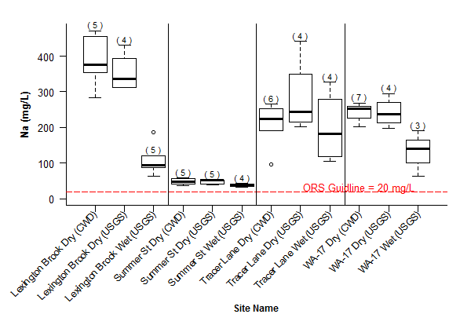

Figure : Comparison of Sodium Concentrations in CWD Base-flow and Preliminary USGS Base-flow and Stormflow Data, 2016

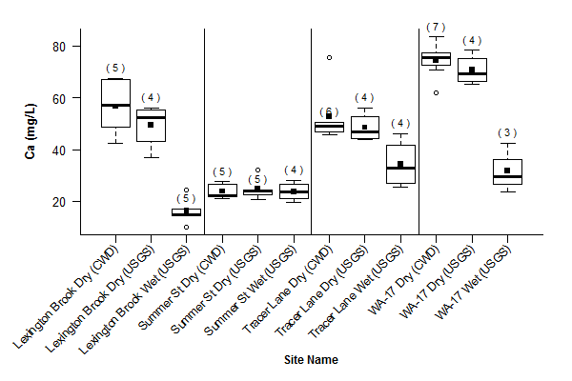

Figure : Comparison of Calcium Concentrations in CWD Base-flow and Preliminary USGS Base-flow and Stormflow Data, 2016

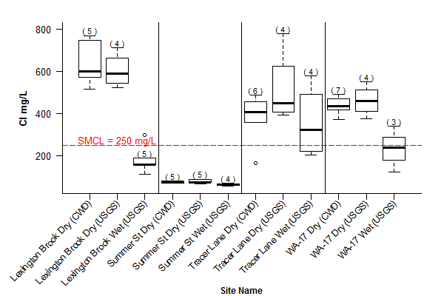

Figure : Comparison of Chloride Concentrations in CWD Base-flow and Preliminary USGS Base-flow and Stormflow Data, 2016

Phosphorus tends to stay in the particulate phase, and is thus introduced to the water supply most commonly in runoff (Smith, 2013). Sources of TP in the watershed include fertilizers, the natural weathering of rocks and soils, septic tank leaks and failures, and occasional sewer overflows during heavy rains. Sediment from vehicle tracking and erosion from construction or development activities are also potential sources of phosphorus. As of June 05, 2016, new regulations from the Massachusetts Department of Agricultural Resources prohibit the application of phosphorus containing fertilizers on lawns and turf fields unless soil tests indicate a phosphorus deficiency. These regulations have not yet had a noticeable impact on TP levels in the watershed.

Total phosphorus concentrations were higher in stormflow samples than in base-flow at every monitoring location sampled in 2016 (Figure 20). This difference was most pronounced at Lex Brook, which receives stormwater discharge from multiple outfalls along Interstate 95. Tracer Ln and WA-17 also receive stormwater discharges from the highway, although median TP concentrations during stormflows were lower than at Lex Brook. This suggests a need for increased maintenance activities or additional stormwater treatment devises in the Lex Brook catchment.

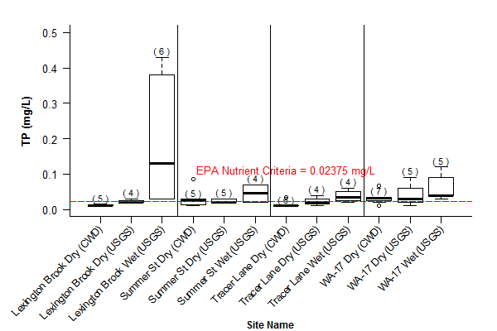

Figure : Comparison of Total Phosphorus (TP) Concentrations in CWD Base-flow and Preliminary USGS Base-flow and Stormflow Data, 2016.

**Samples below the detection limit were set to the detection limit for the purposes of this analysis.**

# Load and Yields

Loads and yields of sodium, chloride, nitrate, and TP were calculated for all tributaries entering the Hobbs and Stony Brook Reservoirs. Understanding the contribution of each tributary to reservoir pollutant loads can help prioritize and target management activities within the watershed.

In 2016, the Stony Brook Reservoir received annual tributary pollutant loads of sodium, chloride, nitrate, and TP that were four to fourteen times higher than the Hobbs Brook Reservoir. This is due to the fact that the Stony Brook Reservoir has a larger drainage area (17 mi2, 24 mi2 including the Hobbs drainage area) than the Hobbs Brook Reservoir (7 mi2) and receives a greater volume of water as a result. Just over 30 percent of tributary water entering the Stony Brook Reservoir was attributable to releases from the Hobbs Brook Dam in 2016. [12] As such, the quality of water leaving the Hobbs Brook Reservoir has implications on water quality in the Stony Brook Reservoir.

Although efforts to reduce pollutant loads typically focus on stormwater management, the majority of sodium, chloride, nitrate, and TP entering the reservoirs via tributaries did so through base-flow (Figure 21). The one exception is TP at the Hobbs Brook Reservoir where, in 2016, stormflow accounted for 75 percent of the TP load (Figure 21). Lexington Brook had the highest TP yields within the Hobbs Brook Reservoir watershed, with stormflows accounting for 95% of the TP load at the site (Figures 22 and 23). However, HB @ Mill St had the highest overall load of the Hobbs Brook Reservoir tributaries (Figure 22). Given that three-quarters of the total TP loads were attributable to stormflow in 2016, stormwater management remains an important watershed protection strategy (Figure 21).

RT 20 had the highest sodium, chloride, nitrate, and TP due to its large drainage area, which encompasses the Hobbs Brook Reservoir (Figure 22; Appendix C). However, on a per area basis, Lex Brook, Tracer Ln, and Salt Depot were the largest contributors of sodium and chloride (Figure 23). WA-17, which contributes to RT 20 loads and yields, had the highest base-flow sodium yield when analyzed separately from RT 20. Summer St had the highest yield for nitrate, likely attributable to fertilizer use at a golf course and at residences and septic leachate within the catchment area. WA-17 had the second highest nitrate yield when analyzed separately from RT 20.

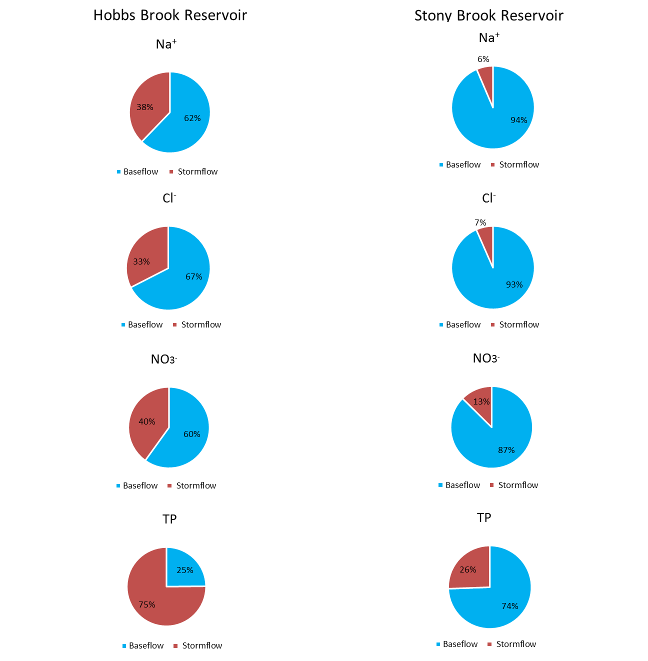

Figure . Base-flow and Stormflow Na+, Cl-, NO3- and TP Load Comparison at Hobbs and Stony Brook Reservoirs, 2016

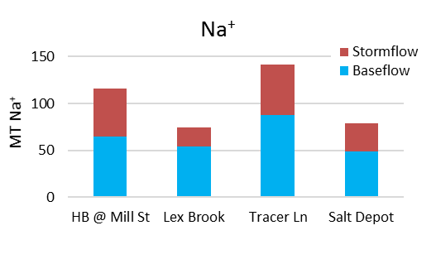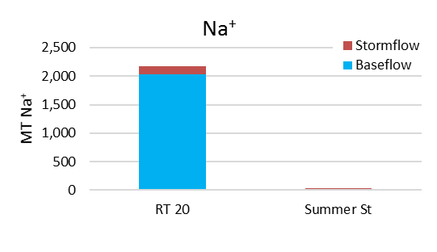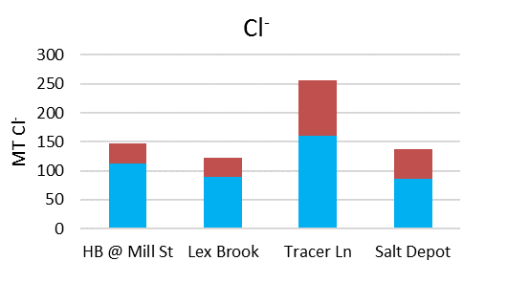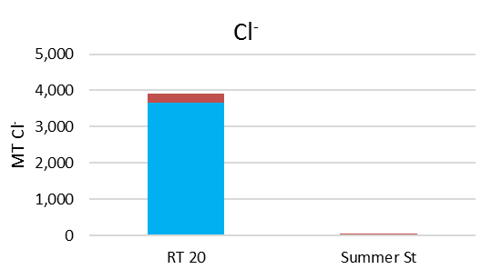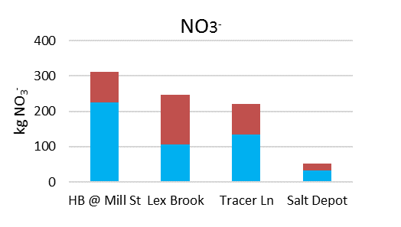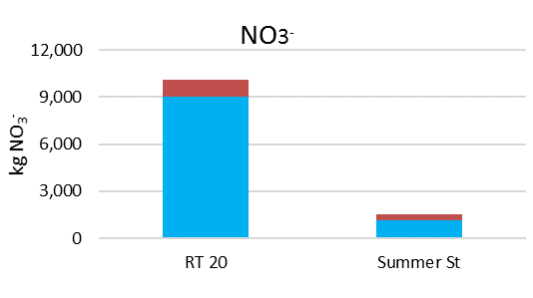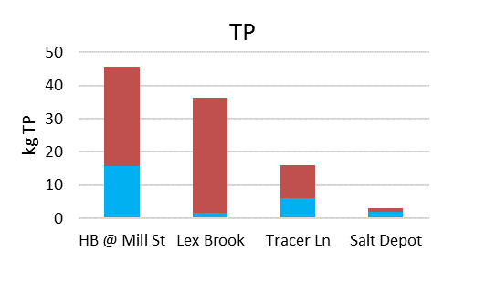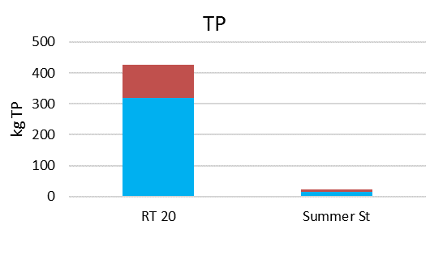

**Stony Brook Reservoir**

**Hobbs Brook Reservoir**

Figure . Comparison of Stormflow and Base-flow Na+, Cl-, NO3-, and TP Loads in Gauged Hobbs and Stony Brook Reservoir Tributaries, 2016

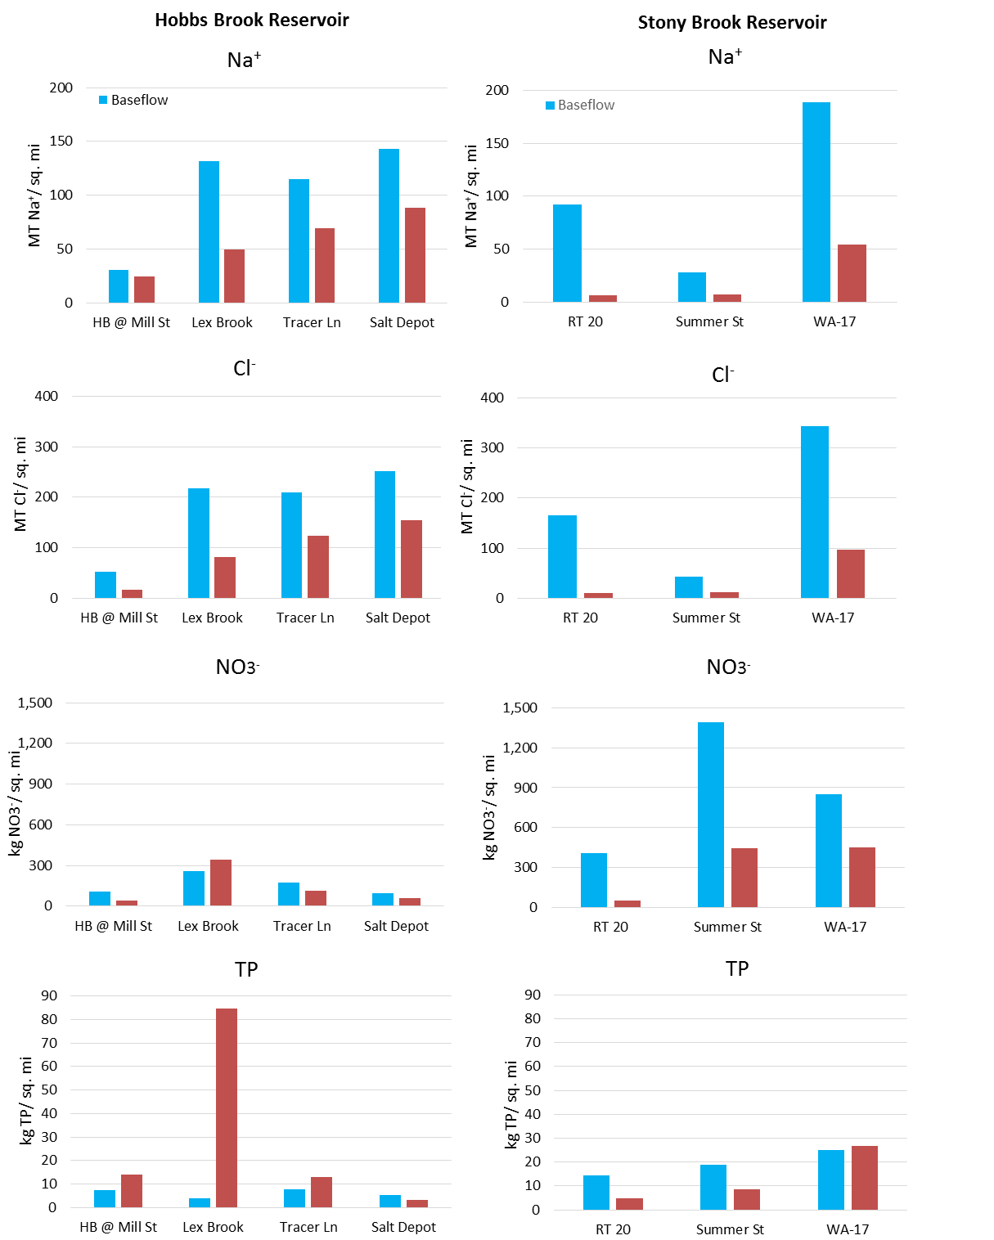

Figure . Comparison of Base-flow and Stormflow Na+, Cl-, NO3-, and TP Yields in Gauged Hobbs and Stony Brook Reservoir Tributaries, 2016

# 

# Reservoir Retention Time

## Retention Time Overview

Reservoir retention time is the amount of time necessary for a reservoir to refill if it were completely empty, or the amount of time that it would take to drain if inputs ceased. The retention time is also defined as the average amount of time a water molecule remains in a waterbody, or the flushing rate. Reservoir retention time assumes equal inflows and outflows to the reservoir and is calculated by dividing the total storage capacity by the total inflows to, or outflows from, the waterbody. Reservoirs with longer retention times (low flushing rate) may respond slower to degradation or improvement of inflow water quality; water in a reservoir with a shorter retention time (high flushing rate) will turn over more quickly. Therefore, changes in source water quality are likely to impact reservoir water quality faster when the retention time is shorter.

The retention times of the Hobbs Brook, Stony Brook, and Fresh Pond Reservoirs were calculated using outflow data from USGS gaging stations from Hobbs Brook and Stony Brook Reservoirs. CWD raw water intake data from Fresh Pond to the Walter J. Sullivan Treatment Plant was used to quantify outflows from Fresh Pond. Cambridge reservoirs are managed water bodies, so variations in the timing of water releases can result in an imbalance between reservoir inflows and outflows within a year. Despite annual variation in reservoir storage, the Cambridge reservoirs are believed to be in long-term equilibrium.

## Reservoir Retention Times

The Hobbs Brook Reservoir had the longest retention time of the three reservoirs (Table 46). The hydraulic retention time in 2016 was 21 months and was 14 months for the nine-year average. The annual outflow estimated from the USGS monitoring station immediately downstream of Hobbs Brook in 2016 was 1.67 billion gallons (Table 46).

The retention time at the Hobbs Brook Reservoir was calculated using the total storage capacity of 2.5 billion gallons for 2010-2014 and 2.9 billion gallons for 2008-2009. The difference in storage capacity is due to the removal of spillway flash boards at the Hobbs Brook Dam in 2010. The flash boards were replaced in 2015[13] increasing the storage capacity back to 2.9 billion gallons.

|  |  |  |  |
| --- | --- | --- | --- |
| **Year** | **Hobbs Outflow (MG)** | **Storage Capacity (MG)** | **Estimated Retention Time (months)** |
| 2008 | 2,464 | 2,898 | 14 |
| 2009 | 3,613 | 2,898 | 10 |
| 2010 | 4,889 | 2,518 | 6 |
| 2011 | 2,653 | 2,518 | 11 |
| 2012 | 1,806 | 2,518 | 17 |
| 2013 | 1,431 | 2,518 | 21 |
| 2014 | 2,565 | 2,518 | 12 |
| 2015 | 2,858 | 2,898 | 12 |
| 2016* | 1,671 | 2,898 | 21 |
| *provisional USGS data, subject to revision | | |  |

Table . Hobbs Brook Reservoir Retention Time 2008-2016

Stony Brook Reservoir retention time was 26 days in 2016, the shortest retention time of all three reservoirs in the Cambridge water supply system (Table 47). Inputs to the Stony Brook Reservoir are contributed primarily by its watershed during winter and spring and from the Hobbs Brook Reservoir during the summer and fall. Outflow to the Charles River was estimated from the USGS gaging station located downstream of the Stony Brook gatehouse. Due to the continued drought conditions in 2016, the amount of flow diverted to Fresh Pond via a conduit was more than twice the flow released to the Charles River (Table 47). Data from the Cambridge Reservoir meteorological station (422518071162501) indicate that the Hobbs Brook and Stony Brook watersheds received an estimated 36.68 inches of rain in 2016 (Table 48). This is 9.03 inches less than the 45.71 inch National Oceanic and Atmospheric Administration (NOAA) 1981-2010 precipitation normal recorded at the Bedford Hanscom Field, MA weather station.[14]

|  |  |  |  |  |  |
| --- | --- | --- | --- | --- | --- |
| **Year** | **Stony to Charles (MG)** | **Stony to Fresh Pond (MG)** | **Total Output from Stony (MG)** | **Storage Capacity (MG)** | **Estimated Retention Time (days)** |
| 2010 | 10,514 | Data not available | Data not available | 418 | -- |
| 2011 | 7,663 | 4,899 | 12,562 | 418 | 11 |
| 2012 | 2,177 | 5,256 | 7,433 | 418 | 22 |
| 2013 | 4,220 | 4,098 | 8,318 | 418 | 18 |
| 2014 | 5,473 | 4,317 | 9,790 | 418 | 15 |
| 2015 | 2,375 | 5,691 | 8,066 | 418 | 18 |
| 2016* | 1,863 | 4,230 | 6,093 | 418 | 26 |
| *2016 Conduit flow data gaps 8/17, 8/23, 9/20-10/16 were estimated based on inflows, outflows, and changes in storage to the Stony Brook Reservoir monitored at USGS gaging stations. | | | | | |

Table . Stony Brook Reservoir Retention Time, 2011-2016

|  |  |  |  |  |  |  |  |  |  |
| --- | --- | --- | --- | --- | --- | --- | --- | --- | --- |
| **Year** | **2008** | **2009** | **2010** | **2011** | **2012** | **2013** | **2014** | **2015** | **2016\*** |
| Total Precipitation | 62.73 | 47.69 | 54.67 | 57.04 | 43.8 | 40.17 | 48.31 | 33.33 | 36.67 |

Table . Hobbs Brook Below Dam Precipitation Gage (01104430) Total Annual Precipitation (Inches)

*2016 provisional data from USGS meteorological station 422518071162501. Data from the precipitation gage at 01104430 station was missing from 2/18-3/3 in 2015 and 2/4-2/8, 2/10, 2/14-2/16, and 4/4-4/5 in 2016.

Total output from Fresh Pond to the treatment plant (estimated from the total water produced by the plant) was 3.9 billion gallons in 2016, with a retention time of 4.7 months (Table 49). The nine-year average retention time is approximately four months. Variations in outflows from Fresh Pond to the treatment plant (WTP) are accounted for by variation in water demand and supplemental purchases from MWRA. For example, from September 2013 through May 2014, MWRA purchases were used during construction and maintenance projects of Cambridge water infrastructure. In 2016, water main construction, along with a historic drought, resulted in the purchase of 848 MG of MWRA water to supplement the 3,855 MG supplied by Fresh Pond.

Table . Fresh Pond Reservoir Retention Time, 2008-2016

|  |  |  |  |
| --- | --- | --- | --- |
| **Year** | **Fresh Pond to WTP (MG)** | **Storage Capacity (MG)** | **Estimated Retention Time (months)** |
| 2008 | 4,878 | 1,507 | 3.7 |
| 2009 | 4,748 | 1,507 | 3.8 |
| 2010 | 4,850 | 1,507 | 3.7 |
| 2011 | 4,709 | 1,507 | 3.8 |
| 2012 | 4,749 | 1,507 | 3.8 |
| 2013 | 3,552 | 1,507 | 5.0 |
| 2014 | 3,764 | 1,507 | 4.8 |
| 2015 | 5,068 | 1,507 | 3.6 |
| 2016 | 3,855 | 1,507 | 4.7 |
|  | | | |

# References

Edwards, T.K., and Glysson, G.D., 1999, Field methods for measurement of fluvial sediment: U.S. Geological Survey Techniques of Water-Resources Investigations, chap. C2, book 3, 89 p.

Cambridge Water Department (CWD), 2014, City of Cambridge Water Department 2014 source water quality report, 90 p. <https://www.cambridgema.gov/Water/watershedmanagementdivision/sourcewaterprotectionprogram/sourcewaterqualitymonitoringprogram/datamanagement/reportsandresearch>

Carlson, R. E., 1977, A trophic state index for lakes: Limnology and Oceanography, v. 22, no. 2, p. 361-

369.

Geotechnical Engineers Inc, 1985, Hobbs Brook Reservoir sodium chloride study, 31 p.

Massachusetts Executive Office of Energy and Environmental Affairs, 2017, Recent Drought History,

accessed July 31, 2017, at <http://www.mass.gov/eea/docs/dcr/watersupply/rainfall/drought-status-history.pdf>.

North American Lake Management Society Secchi Dip-In Program, [n.d], Trophic State Equations,

accessed July 31, 2017, at <http://www.secchidipin.org/index.php/monitoring-methods/trophic-state-equations/>

Sloto, A.S., and Crouse, M.Y, 1999, HYSEP: A Computer Program for Streamflow Hydrograph Separation and Analysis: U.S. Geological Survey Water-Resources Investigations Report 96-4040, 46 p.

Smith, K.P., 2013, Water-quality conditions, and constituent loads and yields in the Cambridge drinking-water source area, Massachusetts, water years 2005–07: U.S. Geological Survey Scientific Investigations Report 2013-5039, 73 p., <http://pubs.usgs.gov/sir/2013/5039/>.

Waldron, C., Bent, G.C., 2001, Factors affecting reservoir and stream-water quality in the Cambridge,

Massachusetts, drinking-water source area and implications for source-water protection. U. S. Geological Survey Scientific Investigations Report 2000-4262, 89 p.

Wilde, F.D., Radtke, D.B., Gibs, Jacob, and Iwatsubo, R.T., 1999, Collection of water samples, National field manual for the collection of water-quality data: U.S. Geological Survey Techniques of Water-Resources Investigations, book 9, chap. A4, 103 p.

U.S. Environmental Protection Agency, 2000, Ambient water quality criteria recommendations, information supporting the development of state and tribal nutrient criteria, rivers and streams in nutrient ecoregion XIV: Washington, D.C., U/S. Environmental Protection Agency, Office of Water, December 2000, EPA 8822–B–00–022 [variously paginated].

U.S. Environmental Protection Agency, 2001, Ambient water quality criteria recommendations, information supporting the development of state and tribal nutrient criteria, lakes and reservoirs in nutrient ecoregion XIV: Washington, D.C., U/S. Environmental Protection Agency, Office of Water, December 2000, EPA 8822–B–01–011 [variously paginated].

# Glossary

**Algal bloom**— The rapid proliferation of passively floating, simple plant life in and on a body of water.

**Anoxic**— The absence of oxygen; anaerobic.

**Benthic sediments—** The surface layer and some sub-surface layers of sediment in contact with the bottom zone of a water body, such as a lake or ocean.

**Discharge (hydraulics)**— Rate of flow, especially fluid flow; a volume of liquid passing a point per unit of time, commonly expressed in cubic feet per second, million gallons per day, or liters per second.

**Dissolved oxygen (DO)** — Oxygen dissolved in water; one of the most important indicators of the condition of a water body. Dissolved oxygen is necessary for the life of fish and most other aquatic organisms.

**Drainage basin**— Land area drained by a river or stream; watershed.

**Epilimnion**— Warm, oxygen-rich, upper layer of water in a lake or other body of water, usually seasonal. *See also* Metalimnion, Hypolimnion

**Eutrophic**— Term applied to a body of water with a high degree of nutrient enrichment and high productivity.

**Eutrophication**— Process by which water becomes enriched with plant nutrients, most commonly phosphorus and nitrogen.

***Escherichia coli* (*E. coli*)bacteria**— Type of bacteria that is found in the human gastrointestinal tract. *E. coli* is commonly used as an indicator of fecal contamination in groundwater, as the result of an improper sewage connection or septic system failure.

**Groundwater**— In the broadest sense, all subsurface water, as distinct from surface water; as more commonly used, that part of the subsurface water in the saturated zone. *See also* Surface water.

**Hypolimnion**— Cold, oxygen-poor, deep layer of water in a lake or other water body. *See also* Epilimnion, Metalimnion.

**Hypoxic —** The deprivation of oxygen compared to how much is required by the system.

**Load**— Material that is moved or carried by streams, reported as the weight of the material transported during a specific time period, such as kilograms per day or tons per year.

**Maximum contaminant level (MCL)**— Maximum permissible level of a contaminant in water that is delivered to any user of a public water system, established by a regulatory agency such as the U.S. Environmental Protection Agency. *See also* Secondary maximum contaminant level.

**Mean**— The arithmetic average obtained by dividing the sum of a set of quantities by the number of quantities in the set.

**Median**— The middle or central value in a distribution of data ranked in order of magnitude. The median also is known as the 50th percentile.

**Mesotrophic**— Term applied to a body of water with intermediate nutrient content and intermediate productivity.

**Metalimnion**— Transition zone between the warm upper layer and the cold deep layer of a lake or other water body, characterized by rapidly decreasing temperature with increasing depth. *See also* Epilimnion, Hypolimnion.

**Minimum reporting limit (MRL) —** The lowest measured concentration of a constituent that can be reported reliably using a given analytical method.

**Monitoring station**— A site on a stream, canal, lake, or reservoir used to observe systematically the chemical quality and discharge or stage of water.

**Nutrient**— An element or compound essential for animal and plant growth. Common nutrients in fertilizer include nitrogen, phosphorus, and potassium.

**Oligotrophic**— Term applied to a body of water low in nutrients and in productivity.

**pH**— The logarithm of the reciprocal of the hydrogen ion concentration of a solution; a measure of the acidity (pH less than 7) or alkalinity (pH greater than 7) of a solution; a pH of 7 is neutral.

**Phytoplankton algae**— Free-floating, mostly microscopic aquatic plants.

**Phytoplankton chlorophyll-*a*** — Primary light-trapping pigment in most phytoplankton algae. Concentration can be used as an indirect indicator of the abundance of phytoplankton algae in a lake or other water body.

**Runoff**— The part of precipitation that appears in surface streams. It is equivalent to streamflow unaffected by artificial diversions, storage, or other human works in or on the stream channel.

**Secondary maximum contaminant level (SMCL)** — Maximum recommended level of a contaminant in water that is delivered to any user of a public water system. These contaminants affect the esthetic quality of the water such as odor or appearance; therefore, the levels are intended as guidelines. *See also* Maximum contaminant level.

**Specific conductance** — A measure of the ability of a sample of water to conduct electricity normalized to 25°C.

**Subbasin** — Drainage basin or watershed defined by a specific monitoring station and representing the land area that contributes water to that station.

**Surface water** — An open body of water, such as a stream or lake.

**Thermal stratification** — Seasonal division of a lake or other water body into a warm upper layer and a cold deep layer that is no longer in contact with the atmosphere. In some lakes, thermal stratification can result in a loss of oxygen in the deep layer and subsequent chemical stratification.

**Trihalomethane formation potential (THMFP)** — Tendency of naturally occurring organic compounds in a water supply to form toxic trihalomethanes during water treatment.

**Trophic state** — The extent to which a body of water is enriched with plant nutrients. *See also* Eutrophic, Mesotrophic, Oligotrophic.

**Trophic state index (TSI)** — A numerical index indicating the degree of nutrient enrichment of a body of water.

**Turbidity** — The opaqueness or reduced clarity of a fluid due to the presence of suspended matter.

**Water year** — The continuous 12-month period, October 1 through September 30, in U.S. Geological Survey reports dealing with the surface-water supply. The water year is designated by the calendar year in which it ends and which includes 9 of the 12 months. Thus, the year ending September 30, 1998, is referred to as the “1998” water year. This report, however, operates on a calendar year.

**Wetlands** — Lands that are inundated or saturated by surface or ground water at a frequency and duration sufficient to support, and that under normal circumstances do support, a prevalence of vegetation typically adapted for life in saturated soil conditions.

**Yield** — The weight of material transported during any given time divided by unit drainage area, such as kilograms per day per square kilometer or tons per year per square mile.

# Appendix A – Quality Control Measures

## USGS Side-by-Sides

CWD staff water quality grab samples alongside USGS staff three times in 2016. SB @ Viles was sampled on February 2, 2016 and August 15, 2016, and WA-17 was sampled on September 22, 2016. Comparing CWD and USGS results water quality results from the sample sampling event can provide a broad measure of the inherent and introduced variability in surface water samples. Variability may be introduced in results from the sample collection, processing, and analysis; from the differences in laboratory analysis techniques or handling; or from the natural variability of concentrations in surface waters.

Sample results were retrieved from the USGS website and compared to CWD results. The precision of the data was measured using the Relative Percent Difference (RPD) metric. RPD is calculated using the equation:

*x1 and x2 are the CWD measurement and corresponding USGS measurement*

Due to the nature of measurement error and environmental sampling constraints, differences within 20 percent are generally considered acceptable measurements. The RPD for each parameter is shown in Table 50.

Table 50. USGS Side-by-Side Sample Results and Percent Differences by Parameter, 2016.

**Values below the detection limit were set to the detection limit for the purposes of calculating RPD.**

|  |  |  |  |  |  |  |  |  |  |  |  |  |
| --- | --- | --- | --- | --- | --- | --- | --- | --- | --- | --- | --- | --- |
| **Site** | **Agency** | **Date (2016)** | **TP (mg/L)** | **SpC (µS/cm)** | **Ca2+ (mg/L)** | **Na+ (mg/L)** | **Cl- (mg/L)** | **Sulfate (mg/L)** | **Turbidity (NTU)** | **NH3 (mg/L)** | **NO3- (mg/L)** | **NO2+ (mg/L)** |
| **SB @ Viles** | CWD | 2/2 | <0.010 | 394 | 22.3 | 41.5 | 91.7 | 13.4 | 0.62 | ***--*** | ***--*** | ***--*** |
| USGS | 0.017 | 398 | 22.7 | 42.1 | 91.4 | 13.7 | 1.2 | ***--*** | ***--*** | ***--*** |
| ***RPD*** | | | ***52%*** | ***1%*** | ***2%*** | ***1%*** | ***0%*** | ***2%*** | ***64%*** | ***--*** | ***--*** | ***--*** |
| **SB @ Viles** | CWD | 8/15 | 0.017 | 565 | 30.8 | 76.5 | 132 | ***--*** | 1.52 | ***--*** | ***--*** | ***--*** |
| USGS | 0.026 | 565 | 28.9 | 69.2 | 135 | ***--*** | 2.1 | ***--*** | ***--*** | ***--*** |
| ***RPD*** | | | ***42%*** | ***0%*** | ***6%*** | ***10%*** | ***2%*** | ***--*** | ***32%*** | ***--*** | ***--*** | ***--*** |
| **WA-17** | CWD | 9/22 | 0.066 | 1624 | ***--*** | ***--*** | ***--*** | ***--*** | 0.68 | 0.12 | 0.19 | 0.011 |
| USGS | 0.091 | 1600 | ***--*** | ***--*** | ***--*** | ***--*** | 6.9 | 0.02 | 0.239 | 0.008 |
| ***RPD*** | | | ***32%*** | ***1%*** | ***--*** | ***--*** | ***--*** | ***--*** | ***164%*** | --- | --- | --- |

The RPD for SpC, calcium, sodium, and chloride were all below 20 percent. However, turbidity and TP had RPDs greater than 20 percent. The RPD between CWD and USGS turbidity grab samples ranged from with 32 percent to 164 percent. TP RPDs were less variable, ranging from 23 to 52 percent. The largest difference in turbidity samples (164 percent RPD) occurred on September 22nd when CWD measured a turbidity of 0.68 NTU and USGS recorded a value of 6.9 NTU. The turbidity level recorded at the USGS continuous monitoring station at WA-17 (station 01104455) from approximately the same time on September 22nd was 2.1 NTU which would result in a 68 percent RPD with the CWD sample.

Although field blanks were not collected during these sampling events, trip blank results from other events generally indicate that contamination from sample transport and handling was unlikely (Table 52). The discrepancy between the CWD and USGS turbidity and TP samples could indicate environmental variation in the water column or could contamination from suspension of bed sediments due to multiple people working in the stream. High turbidity may impact TP levels since sediment and organic matter are often sources of phosphorus in water. Because of this, extra care should be taken to cause minimal disturbance of the bed sediments in future sampling events.

USGS and the CWD contract laboratory use different tests to measure ammonia, nitrate, and nitrite. As such, the RPDs were not included, but measured values are included for reference in Table 50.

## Field Duplicates and Trip Blanks

Field duplicates and field blanks provide additional quality control checks for CWD data. Field duplicates, when a second or “duplicate” sample is collected during a sampling event, are a measure of sample precision and environmental variability. Field blanks ensure there is no cross-contamination of the samples during sample collection, transport, and processing.

Where field duplicate samples were collected, test results were reported as the mean of the two samples. If a sample was below the detection limit, the sample was set to the detection limit in order to average the two samples. Assigning a value of the detection limit errs on the side of overestimating rather than under estimating parameter concentrations.

The average RPD for duplicate samples analyzed by the CWD lab and Microbac Laboratories, Inc., the contract laboratory for CWD, was 17 percent and 12 percent, respectively (Table 51). While certain individual tests had an RPD above 20 percent, on average results had a 20 percent RPD or lower. Large variations between samples and duplicates could represent environmental variation, contamination of the sample, or an error in the laboratory analysis. RPDs for individual tests above 20 percent are bolded in Tables 52 and 53.

|  |  |  |  |  |  |  |
| --- | --- | --- | --- | --- | --- | --- |
| **RPD** | **Overall** | | **Tributaries** | | **Reservoirs** | |
| **Microbac** | **CWD** | **Microbac** | **CWD** | **Microbac** | **CWD** |
| Average | 12% | 17% | 19% | 20% | 5% | 13% |
| Min | 0% | 0% | 0% | 0% | 0% | 0% |
| Max | 84% | 190% | 84% | 130% | 20% | 190% |

Table : Average Relative Percent Differences, 2016

Table : Reservoir Relative Percent Differences (RPDs) by sample and parameter (mg/L unless otherwise specified), 2016.

**Values above or below the detection limit were set to the detection limit for the purposes of calculating RPD.**

|  |  |  |  |  |  |  |  |  |  |
| --- | --- | --- | --- | --- | --- | --- | --- | --- | --- |
| **Date** | **4/21/2016** | | | **07/20/2016** | | | **10/05/2016** | | |
| **Site** | **FP @ DH** | **Duplicate** | ***RPD*** | **HB @ Middle** | **Duplicate** | ***RPD*** | **FP @ DH Bottom (Chl-*a* only)** | **Duplicate** | ***RPD*** |
| **NH3** | 0.061 | <0.05 | 20% | 0.11 | 0.10 | 10% | *--* | *--* | *--* |
| **TKN** | 0.24 | 0.22 | 9% | 0.41 | 0.41 | 0% | *--* | *--* | *--* |
| **TP** | <0.01 | <0.01 | 0% | 0.029 | 0.03 | 3% | *--* | *--* | *--* |
| **Chl-*a* (mg/m3)** | 2.24 | 2.02 | 10% | 11.20 | 12.80 | 13% | <2 | <2 | 0% |
| **Ca2+** | 25.2 | 25.1 | 0% | 41 | 40.7 | 1% | *--* | *--* | *--* |
| **Cl-** | 182 | 182 | 0% | 356 | 358 | 1% | *--* | *--* | *--* |
| **Color (CU)** | 13 | 13 | 0% | 35 | 34 | 3% | *--* | *--* | *--* |
| **Lab Conductivity (umhos/cm)** | 638 | 658 | 3% | 1,210 | 1,250 | 3% | *--* | *--* | *--* |
| ***E. coli* (MPN/100 mL)** | *--* | *--* | *--* | 8 | 7 | 13% | *--* | *--* | *--* |
| **Mn** | 0.019 | 0.02 | 5% | 0.145 | 0.15 | 3% | -- | *--* | *--* |
| **NO3-** | 0.56 | 0.56 | 0% | 0.12 | <0.05 | **82%** | *--* | *--* | *--* |
| **NO2+** | 0.007 | 0.005 | **33%** | <0.01 | <0.01 | 0% | *--* | *--* | *--* |
| **Lab pH** | 7.58 | 7.56 | 0% | 8.25 | 8.22 | 0% | *--* | *--* | *--* |
| **Na+** | 95.1 | 96.1 | 1% | 220 | 219 | 0% | *--* | *--* | *--* |
| **TOC** | 2.8 | 2.8 | 0% | 3.8 | 3.9 | 3% | *--* | *--* | *--* |
| **Alkalinity (mg/L CaCO3)** | 28 | 28.5 | 2% | 31.1 | 40.2 | **26%** | *--* | *--* | *--* |
| **Al** | 0.02702 | 0.0278 | 3% | 0.0993 | 0.0936 | 6% | *--* | *--* | *--* |
| **Total Coliform (MPN/100 mL)** | *--* | *--* | *--* | >2419.6 | 65 | **190%** | *--* | *--* | *--* |
| **Fe** | 0.187 | 0.189 | 1% | 0.816 | 0.805 | 1% | *--* | *--* | *--* |
| **Turbidity (NTU)** | 0.68 | 0.54 | **23%** | 5.25 | 3.76 | **33%** | *--* | *--* | *--* |
| **UV254 (abs)** | 0.11 | 0.11 | 0% | 0.21 | 0.216 | 3% | *--* | *--* | *--* |

Table : Tributary Relative Percent Differences (RPDs) by sample and parameter (mg/L unless otherwise specified), 2016.

**Values above or below the detection limit were set to the detection limit for the purposes of calculating RPD. Values with * are flagged, anomalously high**

|  |  |  |  |  |  |  |  |  |  |  |  |  |
| --- | --- | --- | --- | --- | --- | --- | --- | --- | --- | --- | --- | --- |
| **Date** | **2/23/2016** | | | **06/02/2016** | | | **9/21/2016** | | | **12/15/2016** | | |
| **Test (mg/L)** | **HB @ KG** | **FDUP** | ***RPD*** | **WA-17** | **FDUP** | ***RPD*** | **Indust Brook** | **FDUP** | ***RPD*** | **HB @ KG** | **FDUP** | ***RPD*** |
| **NH3** | 0.21 | 0.210 | *0%* | 0.110 | 0.110 | *0%* | 0.40 | 0.32 | ***22%*** | 0.150 | 0.120 | ***22%*** |
| **TKN** | 0.42 | 0.39 | *7%* | 0.48 | 0.48 | *0%* | 0.88 | 0.55 | ***46%*** | 0.49 | 0.450 | *9%* |
| **TP** | 0.015 | 0.020 | ***24%*** | 0.020 | 0.022 | *10%* | 0.160 | 0.065 | ***84%*** | 0.03 | 0.032 | *6%* |
| **Ca2+** | 34.8 | 34.4 | *1%* | 82.3 | 84.9 | *3%* | 37.1 | 36.7 | *1%* | 45.1 | 43.6 | *3%* |
| **Cl-** | 291 | 642 | ***75%*** | 483 | 480 | *1%* | 249 | 248 | *0%* | 292 | 292 | *0%* |
| **Color (CU)** | 17 | 16 | *6%* | 16 | 14 | *13%* | 49 | 48 | *2%* | 25 | 25 | *0%* |
| **Lab Conductivity (umhos/cm)** | 962 | 962 | *0%* | 1760 | 1780 | *1%* | 924 | 909 | *2%* | 991 | 972 | *2%* |
| ***E. coli* (MPN/100 mL)** | 2 | 5 | ***86%*** | 83 | 64 | ***26%*** | 816 | 1,990 | ***84%*** | 51 | 50 | *2%* |
| **Mn** | 0.26 | 0.25 | *2%* | 0.226 | 0.221 | *2%* | 0.337 | 0.687 | ***68%*** | 0.774 | 0.660 | *17%* |
| **NO3-** | 1.07 | 3.5 | ***106%*** | 1.50 | 1.48 | *1%* | 0.138 | 0.16 | *15%* | 0.67 | 0.65 | *3%* |
| **NO2+** | 0.02 | 0.02 | *0%* | <0.005 | <0.005 | *0%* | 0.030 | 0.025 | *18%* | <0.005 | <0.005 | *0%* |
| **Lab pH** | 7.2 | 7.18 | *0%* | 7.09 | 7.06 | *0%* | 7.08 | 7.12 | *1%* | 7.32 | 7.12 | *3%* |
| **Na+** | 141 | 141 | *0%* | 262 | 276 | *5%* | 163 | 159 | *2%* | 163 | 156 | *4%* |
| **TOC** | ND | 1.7 | *--* | 1.6 | 1.6 | *0%* | 4.1 | 4.6 | *11%* | 2.3 | 2.4 | *4%* |
| **Alkalinity (mg/L CaCO3)** | 28.5 | 28 | *2%* | 59 | 26.5 | ***76%*** | 43 | 43.5 | *1%* | 32 | 27 | *17%* |
| **Al** | 0.01868 | 0.01 | ***36%*** | 0.0317 | 0.0653 | ***69%*** | 0.374 | 1.77* | ***130%*** | 0.21 | 0.13 | ***47%*** |
| **Total Coliform (MPN/100 mL)** | 345 | 105 | ***107%*** | >2419.6 | 2420 | *0%* | >2419.6 | >2419.6 | *0%* | 579 | 411 | ***34%*** |
| **Fe** | 0.411 | 0.400 | *4%* | 0.347 | 0.605 | ***54%*** | 2.28 | 6.37 | ***95%*** | 1.27 | 0.86 | ***38%*** |
| **Turbidity (NTU)** | 1.31 | 1.25 | *5%* | 1.72 | 1.78 | *3%* | 5.15 | 5.84 | *13%* | 2.56 | 2.24 | *13%* |
| **UV254 (abs)** | 0.081 | 0.080 | *1%* | 0.084 | 0.083 | *1%* | 0.277 | 0.281 | *1%* | 0.127 | 0.140 | *8%* |

|  |  |  |  |
| --- | --- | --- | --- |
| **Date** | **3/1/2016** | **7/6/2016** | **10/5/2016** |
| **NH3 (mg/L)** | <0.05 | <0.05 | <0.1 |
| NO3- **(mg/L)** | <0.005 | <0.005 | <0.05 |
| **NO2+ (mg/L)** | <0.005 | <0.005 | <0.01 |
| **TKN (mg/L)** | <0.1 | <0.1 | <0.1 |
| **TP (mg/L)** | <0.01 | <0.01 | <0.01 |
| **Chl-*a* (mg/m3)** | <2 | <2 | <2 |
| **Ca2+ (mg/L)** | 0.005 | 0.006 | NS |
| **Cl- (mg/L)** | 0.1 | 0 | NS |
| **Color (CU)** | 1 | 1 | NS |
| **Lab Conductivity (umhos/cm)** | 2 | 2.4 | NS |
| ***E. coli* (MPN)** | 1 | NS | NS |
| **Fe (mg/L)** | 0.05 | 0.05 | NS |
| **Mn (mg/L)** | <0.000 | <0.000 | NS |
| **Lab pH** | 5.88 | 6.15 | NS |
| **Na+ (mg/L)** | 0.05 | 0.05 | NS |
| **Alkalinity (mg/L CaCO3)** | 1 | 11.5 | NS |
| **Total Coliform (MPN)** | 1 | NS | NS |
| **TOC (mg/L)** | 0.3 | 0.3 | NS |
| **Lab Turbidity (ntu)** | 0.09 | 0.16 | NS |
| **UV254 (abs)** | 0.001 | 0.008 | NS |

Field blanks were included with tributary and reservoir samples on March 1, July 6, and October 5, 2016 (Table 54). Nearly all parameters were below the detection limit, and those parameters that were detected, such as 0.1 mg/L of chloride on 3/1/2016, were not present in quantities large enough to meaningfully affect sample results. Values for pH were within the expected ranges for de-ionized water exposed to the atmosphere. These results indicate that discrepancies between samples and field duplicates were unlikely due to contamination during sample transport or processing.

Table 54. Field Blank Results, 2016

NS=not sampled

# Appendix B – Base-flow and Stormflow Separation Method

Separation of base-flow from total discharge was performed according to the Fixed Interval Method, whereby the lowest recorded discharge value over a fixed time interval (3 to 11 days) is used to represent base-flow over the entire interval (Sloto and Crouse, 1996). The fixed time interval (2N*) is a function of the drainage area of a catchment, and is calculated by first estimating the recession period for surface runoff following a storm event:

N=A0.2

Where:

N=recession period, A=area of catchment (sq. mi)

2N* = the odd integer between 3 and 11 closest to twice the recession period (N*2)

In this study, all catchments had intervals of 3 days. Therefore, base-flow was calculated as the lowest discharge value in each three day period of 2016. For example, base-flow for each day between January 1 and January 3 was assigned based on the minimum value recorded during the interval. The same process was repeated for the next three days, January 4 – January 6. Stormflow was calculated as the difference between total discharge and base-flow.[15] A difference of zero between total discharge and base-flow represents dry conditions with no stormflow. Daily average discharge was used as proxy data during days where instantaneous data were missing from the record.

Annual total discharge, base-flow, and stormflow were calculated by integrating the discharge data for each category[16]:

Q annual = ((Q2+Q1)/2)*(t2-t1) + ((Q3+Q2)/2)*(t3-t2)…+ ((Qn+Qn-1)/2)*(tn-tn-1)

Where

Q annual = annual total discharge, base-flow, or stormflow in cubic feet per year

Qn = instantaneous total discharge, base-flow, or stormflow in cubic feet per second

tn = time and date of discharge measurement, in seconds elapsed since 1/1/1900[17]

Base-flow separation was performed for all sites where USGS instantaneous discharge data were available: Lex Brook, HB @ Mill St, Salt Depot, Tracer Ln, RT 20, WA-17, and Summer St. [18],

# Appendix C – Tributary Catchment Area and Land Cover

Table . USGS Stations and Corresponding CWD Site Names

|  |  |  |  |  |  |  |  |  |  |  |  |  |  |
| --- | --- | --- | --- | --- | --- | --- | --- | --- | --- | --- | --- | --- | --- |
|  | **HB @ MILL ST** | **SALT DEPOT** | **LEX BROOK** | **TRACER LN** | **HB BELOW DAM** | **INDUST BROOK\*** | **SB @ VILES** | **HB @ KG** | **MBS** | **WA-17** | **RT 20** | **SUMMER ST** | **STONY BROOK DAM** |
| **USGS Site ID** | 01104405 | 01104410 | 01104415 | 01104420 | 01104430 | 01104433 | 01104370 | 01104440 | 01104453 | 01104455 | 01104460 | 01104475 | 01104480 |
| **Drainage Area (mi2)** | 2.2 | 0.34 | 0.41 | 0.77 | 6.9 | 0.36, (0.33) | 10.2 | 8.5 | 2.2 | 0.48 | 22.0 | 0.85 | 23.7 |

*0.33 mi2 is the effective drainage area of the industrial brook catchment (Smith, 2013)

Table . 2005 MassGIS Land Use Classification, Percent by Area per USGS Subbasin

1. The Stony Brook tributary (SARIS ID 7239200) is categorized as a Cold Water Fishery by the Massachusetts Division of Fisheries and Wildlife (MassWildlife). Although the Stony Brook Reservoir is an impoundment with lentic attributes, the reservoir has an inlet and outlet and is classified as part of the Stony Brook tributary stream segment in the National Hydrography Dataset (NHD). MassWildlife recognizes that reservoirs may behave differently than a stream or river with respect to cold water fish habitat. Evaluations of habitat impacts in a reservoir would take into account these differences (Rebecca Quiñones and Jason Stolarski, MassWildlife, written and oral commun(s)., 2017).
2. It is assumed that the 25th percentile of median nutrient concentrations in lakes, reservoirs, and tributaries monitored by EPA in the relevant subregions of Ecoregion XIV represented reference conditions (U.S. Environmental Protection Agency 2000, 2001). The Cambridge watershed is located nutrient Ecoregion XIV and subregion 59. EPA encourages states to compare local conditions to the regional nutrient criteria and to develop nutrient criteria that are specific to conditions observed at the local level.
3. CWD switched its sampling protocol in October of 2016 to collect bottom samples from 1 meter, rather than 0.5 meters, above the reservoir bottoms. As a result, the bottom samples from October 5th at Fresh Pond and December 14th at Stony Brook Reservoir were collected from 1 meter above the reservoir bottoms.
4. USGS did not perform stormwater sampling at the Salt Depot site during 2016. The mean stormflow concentrations of sodium, chloride, and TP from 2005-2007 (Smith, 2013) were used instead.
5. USGS did not collect nitrate stormwater samples in 2016, so the CWD geometric mean nitrate concentration for base-flow was used as a proxy. According to Smith (2013), concentrations of total nitrogen are generally uncorrelated with streamflow. Although USGS did not evaluate the relationship between nitrate and streamflow, CWD used base-flow nitrateconcentrations as a proxy for the stormflow nitrate concentrations in 2016.
6. Water quality profiles were not collected at Hobbs Brook Reservoir September – December of 2016 due to low water levels. As such, the fall turnover event was not documented in 2016 in the Hobbs Reservoir.
7. See footnote 1, page 1.
8. Carlson’s TSI was calculated using chl-*a* (see section 5.2.4 Other Parameters)*.* The detection limit for chl-*a* was 2 mg/m3. To calculate TSI, it was assumed that all test results below the detection limit were equivalent to 2 mg/m3. This placed a floor on TSI of 37. As such, TSI statistics for sites with samples below the detection limit may be artificially high. In 2016, the following sites had at least one sample below the chl-*a* detection limit: HB @ Upper, HB @ DH surface, SB @ DH surface, and FP @ DH surface and bottom.
9. The detection limit for TP was 0.010 mg/L, which is above the EPA nutrient criteria of 0.008 mg/L. For the purposes of this analysis, it was assumed that sample results below the detection limit were below the EPA nutrient criteria.
10. Temperature data for 2016 included provisional data points subject to changes by USGS.
11. The USGS complied and analyzed stormwater samples from 2005-2007. Results are available as in an interpretive [report](http://pubs.usgs.gov/sir/2013/5039/), *Water-quality conditions, and constituent loads and yields in the Cambridge drinking-water source area, Massachusetts, water years 2005–07*.
12. Water released from the Hobbs Brook Reservoir dam was included as base-flow at RT 20 in this analysis. However, this discharge is actually the result of both stormflow and base-flow stored and mixed in the Hobbs Reservoir.
13. The flashboards were replaced between 2014 and 2015, although the exact timing of the replacement is unknown. These calculations assume the replacement did not occur until 2015.
14. Climate normal data were accessed from the NOAA National Centers for Environmental Information website at <https://www.ncdc.noaa.gov/cdo-web/datatools/normals>.
15. Discharge at Rt 20 is heavily influenced by upstream releases of water from the Hobbs Dam. Therefore, increases in discharge can be attributable to both storm events and to managed releases of water from dam. To avoid erroneously counting dam releases as stormflow, the daily average discharge measured from the HB Below Dam gage was subtracted from the daily average discharge at Rt 20; stormflow and base-flow calculations were performed using this difference. Discharge from the HB Below Dam gage was assumed to be base-flow at Rt 20 and was added to the annual base-flow total. This differed from 2014, which did not separate dam releases prior to calculating stormflow and base-flow (CWD, 2014).
16. Instantaneous data at WA-17 was unavailable from1/1/2016-10/17/2016. Therefore, daily average discharge data in cfs were used to calculate stormflow and base-flow for this time period. Rather than integrate the daily data, the average daily discharge was converted into total daily discharge by multiplying by 86,400 (the number of seconds in a day) and summed. The same process was used to calculate total annual stormflow and base-flow for RT 20.
17. Dates stored in Excel, when converted to numeric format, represent the number of days have elapsed since 1/1/1900. For example, 1/1/1900 at 00:00 = 0 days, 1/1/2014 at 12:00 = 41,640.5 days. This number can be converted into the number of seconds elapsed since 1/1/1900 by multiplying by 86,400, the number of seconds in a day. Having data in this format allowed for the calculation of the number of seconds elapsed between each discharge measurement (tn-tn-1).
18. Calculations for Lexington Brook, Tracer Lane, RT 20, Summer Street, and WA-17 were based on continuous discharge data from the USGS monitoring stations. As of October 2015, the HB @ Mill St and Salt Depot rating curves are no longer maintained by the USGS. However, USGS continues to collect real-time stage readings at both sites. Total discharge at Salt Depot was calculated using a USGS-supplied rating curve. However, at HB @ Mill St, the station control was removed so the rating curve developed by USGS was no longer valid. As such, total discharge in 2016 at HB @ Mill St was estimated based on the historical ratio of total average annual flow (calculated by summing the average daily flows in MGD for each calendar day over the station’s period of record) at HB @ Mill St to average annual flow at Lex Brook, Tracer Ln, and Salt Depot. This ratio (1.063) was multiplied by the total annual 2016 flow from Lex Brook, Tracer Ln, and Salt Depot to estimate total annual 2016 flow at HB @ Mill St. The percentages of total flow attributable to base-flow and stormflow varied by less than three percentage points between 2015 and 2016 at Lex Brook, and Salt Depot. Therefore, 2016 total flow at HB @ Mill St was divided into base-flow and stormflow using the same ratio as in 2015 (72 percent base-flow and 28 percent stormflow).