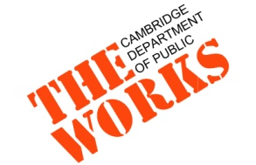

Community Meeting Notice
Cottage/Lopez Drainage Improvement Project
Central Square Library- Lewis Room
Tuesday, April 30th
6:00-7:30PM

Dear Neighbor,

The Cottage/Lopez Drainage Improvements Project includes new storm drain infrastructure to alleviate flooding in the Cambridgeport neighborhood as well as street and sidewalk surface repair.

On Tuesday, April 30th from 6:00-7:30 pm, the Department of Public Works will be hosting a construction open house at The Central Square Library- Lewis Room.
Engineering staff from the City and the contractor performing the work, P. Gioioso & Sons will unveil final design plans and explain the construction process. We encourage you to attend to learn about what you can expect as the construction progresses in your neighborhood over the next 18 months.
Over the next several weeks, you may start to see crews mobilizing in the area in advance of construction. They will be installing tree protection, marking out Dig Safe locations, conducting surveys and drilling into the street to determine subsurface conditions.
Additional information can be found on the project page at www.CambridgeMa.gov/TheWorks/CottageandLopez.

Information and Assistance
The City of Cambridge does not discriminate on the basis of disability. The City of Cambridge will provide auxiliary aids and services, written materials in alternative format, and reasonable modifications in policies upon request. For more information, please contact Jennifer Letourneau, Engineer, at jletourneau@cambridgema.gov / 617-349-4680. To receive future updates via email, please contact Kate Riley, Community Relations Manager kriley@cambridgema.gov / 617-349-4870

Sincerely,

Kate Riley
Community Relations Manager
Cambridge Department of Public Works

