 | City o | Appendix B:  Phase 1: Organics Assessment  Zero Waste Master Plan  Technical Memorandum #1 - FINAL  City of Cambridge, MA  January 25, 2019

Appendix B: Phase 1 Organics Assessment
Statement of Purpose
This Phase 1 Organics Assessment was originally issued to the City of Cambridge in March 2017 for review, and was finalized in May 2019. The first major component of the ZWMP identified at the beginning of the ZWMP process, was the expansion of the organics program, as this is one of the most significant program changes that would contribute to the City’s goals. The purpose of this document was to provide an Organics Program Assessment to the City and associated recommendations, to assist the City with implementing its organic program expansion.
The implementation of the organics program expansion to all buildings with 1 to 12 dwelling units in April 2018 is regarded as an early implementation activity, and is documented in the cover report for the Zero Waste Master Plan as appropriate. The subsequent expansion of organics collection to buildings with 13+ units with City trash collection forms part of the remaining Zero Waste Master Plan recommendations. Furthermore, expanding organics collection to buildings with City Recycling collection only (apprx 12,000 households) is an option for the City.
This document is a supporting background document for the ZWMP, documenting the outcome of one component of Phase 1 of the ZWMP process. No further amendments will be made to this document based on review of the ZWMP.

Contents
Executive Summary ES 1
Introduction ES 1
Why Consider an Expanded Organics Program? ES 1
Findings of the Organics Program Assessment ES 2
Organics Program Expansion Recommendations ES 2
1 Introduction 1
2 Where the City is Today with Organics Diversion 1
3 Why Consider Program Expansion? 2
4 Timing of Expansion 4
5 Organics in the Home 7
5.1 Kitchen Container Options 7
5.2 Liner Bags 10
5.3 Material Streams and Household Behavior 14
5.4 Recommended Approach for Management of Organics in the Home 16
6 Organics at the Curb 17
6.1 Curbside Containers 17
6.2 Recommended Approach 21
7 Curbside Collection 22
7.1 Current Collection System 22
7.2 Collection Considerations 23
7.3 Collection Options 25
7.4 Collection Modelling 26
7.5 Incentivizing Participation in the City’s Organics Program 30
7.5.1 Standard Trash Container Size 30
7.5.2 Bi-weekly (every other week) Trash Collection 31
7.5.3 Pay-As-You-Throw 31
7.5.4 Effective Promotion and Education 31
7.5.5 Regulatory Mechanisms 32
7.6 Recommended Approach 33
8 Organics Processing 33
8.1 Processing Technologies 34
8.1.1 Aerobic Composting 34
8.1.2 Anaerobic Digestion 36
8.2 Short Term Processing Options 38
8.3 Longer Term Processing Considerations 39
9 Summary of Recommendations 40
9.1 Material Streams and Household Behavior 40
9.2 Containers 40
9.3 Compostable Liner Bags 41
9.4 Collection Service Provision and Frequency 41
9.5 Short and Long Term Processing Capacity 42
9.6 Trash Limits and Disincentives 42
9.7 Potential Cost Implications 42
9.8 Potential Decrease in Trash Requiring Management 43
9.9 Potential Decrease in GHG Emissions 43
9.10 Timing 44
10 Public and Stakeholder Engagement 44
11 Next Steps 46

Tables
Table 2-1: Tons of City-managed Food Scraps and other Organic Material by Source (2012-2016) 2
Table 3-1: Estimated Annual Tons of City-Managed Waste (2016) 3
Table 7-1: Description of Collection Scenarios and Fleet Required 28
Table 7-2: Collection Scenario Comparisons 30
Table 10-1: Timing of Options based on Stakeholder Feedback 46

Figures
Figure 4-1: Timeline for Organics Expansion 6
Figure 5-1: Kitchen Containers used in Pilot Areas 7
Figure 5-2: Examples of Kitchen Containers 9
Figure 5-3: Examples of Compostable Liner Bags 13
Figure 6-1: Pilot Curbside Collection Containers 18
Figure 6-2: Examples of Curbside Containers 20
Figure 7-1: Curbside Setout 24
.

Executive Summary

Introduction
The City of Cambridge (the City) intends to develop a Zero Waste Master Plan (ZWMP) and strategy to assist with reaching its diversion and climate goals. The plan and strategy will examine the City’s current system and will consider options to enable the City to achieve its goals of reducing waste and greenhouse gas emissions. The first major component of the ZWMP is the expansion of the organics program, as this is one of the most significant program changes that would contribute to the City’s goals.

Why Consider an Expanded Organics Program?
- The City has ambitious targets set for reduction of waste and GHG emissions and diversion of organics is a critical path item for achieving those goals. Diversion of organics provides the greatest opportunity for the City to reach its waste reduction and climate change goals.
City Goals
By 2020
Reduce trash by 30% to 16 lbs/household/week

By 2050
Reduce trash by 80% to 4 lbs/household/week
Reduce GHG emissions by 80%.
- The expansion of the organics pilot to a full scale program is the most important component of the development of the City’s Zero Waste Master Plan as organics comprise the largest proportion of City-managed trash (apprx. 40%).
- Estimates of the organics that could be diverted from trash indicate that the City should realize their goal of reducing municipal waste to 16lbs/HH/wk by expanding the organics program to all 1-12 unit buildings in the City. Expansion of the program to all buildings including those with 13+ units, proactive measures to increase organics capture rates and/or expansion of the acceptable organics stream to some or all soiled paper, will achieve even better performance as indicated in the chart below which assumes a 40% capture rate of targeted organic materials.
Figure ES-1 Potential Waste Reduction Performance*
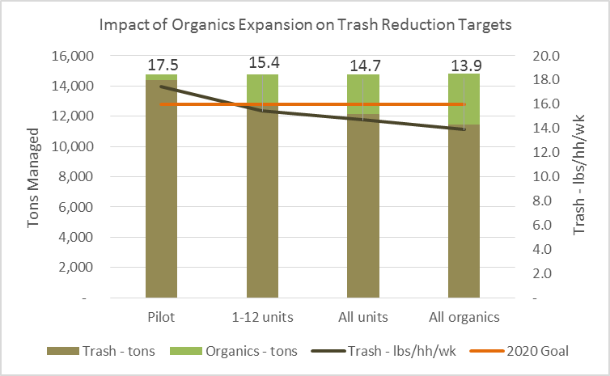
* Based on a 40% organics capture rate.
- There is potential for cost savings by diverting more organics from trash, as current and reasonably projected organics processing costs are lower than the cost of trash disposal, and as there are potential collection system savings associated with reducing the quantity of trash collected.

Findings of the Organics Program Assessment
- Continuing to collect the current organic stream, consisting primarily of food scraps and compostable paper fiber (soiled paper) is reasonable, and suits the current processing options available to the City.
- As part of the ZWMP, the City can consider implementation of other options to further encourage participation in the organics program such as trash limits, pay-as-you-throw and regulatory mechanisms or collection system changes such as every other week collection of trash.
- Initially the program expansion should focus on buildings of up to 12 households. Next, phase-in buildings of 13+ households with City trash. Lastly, phase-in 13+ unit buildings with City recycling service but not City trash. In regard to time of year, Fall is the optimum time for rolling out an organics program, as it allows residents to adjust behavior during cooler months. Early spring is the next best alternative.
- Allowing use of regular film plastic bags by residents for the organic materials may have a detrimental effect on residues and processing costs depending on the processing arrangements secured by the City. Once regular film plastic is allowed, residents tend to allow more plastic residue in with their organics. Continuing to allow residents to use compostable liner bags will encourage participation without affecting residues or processing costs.
- 12 and 35 gallon curbside containers (or containers within this range of sizes), compatible with semi-automated collection vehicles are most suitable for the City’s collection situation (e.g. on-street parking). Additional feedback from users of the curbside containers would be helpful in determining the specifications for the containers.
- There appears to be some operational cost savings associated with bringing organics collection in-house.
- Remaining with the status quo and continuing to contract out collection of curbside food scraps and recycling offers few efficiencies and less control over the City’s waste management system. Bringing collection of all organics in-house would provide some efficiencies by allowing for co-collection of organics and trash, rebalancing routes or changing collection frequencies; however, the City would have to secure sufficient staff and vehicles. This is something the City could consider in the future. NOTE: Co-collection refers to the collection of two types of material in the same truck but with two collection vessels.
- Collection scenarios that continue to utilize separate trucks for each waste stream will result in a minimal decrease in GHG emissions compared to the status quo. Greater reductions in GHG emissions would be realized through co-collection options where fewer truck passes are required.
- The City is currently paying a very reasonable tipping fee at processing facilities close to the City which minimizes haul costs. It is unlikely that the City will generate a sufficient volume of organics that would make construction of their own processing facility a feasible option (would lack economies of scale). The City should examine future processing opportunities as the organics program matures.
- Once the program is well-established, the addition of other organic material such as pet waste can be considered, depending on the acceptability of this material stream to the City’s processors. The potential expansion of the organics stream would also play into the City’s consideration of changes to trash collection.

Organics Program Expansion Recommendations
- Continue to collect food scraps and soiled/compostable paper for the initial program expansion. Expansion of the organic stream to include materials such as pet waste should be considered for the mid to long term.
- Commence roll-out of the program by early Spring 2018.
- Roll-out the organics program to all units in a phased manner, starting with buildings of up to 12 units in FY 18, and then 13+ units with City trash collection the following year, to allow the City to reach its waste reduction goals by 2020. Furthermore, expanding the program to buildings that have private trash collection, but City Recycling collection should be explored for implementation after a review of the curbside collection operations. This will likely take place in 2021-2022. After Phase 2, the City will explore organics collection at the 5000 households in Cambridge that don’t receive curbside collection services from the City.
- Provide a partially ventilated kitchen container which offers residents the most choice of whether or not to use compostable liner bags. The City should encourage the use of compostable liner bags to increase participation, bin cleanliness and ease of collection. Ongoing education for residents and retailers will be required. Contact compostable liner bag manufacturers for prices for supply of a certain quantity of liner bags and/or coupons for purchase of additional bags for the roll-out of the organics program across the City.
- Proceed to arrange for supply and delivery of 12 and 35 gallon curbside containers needed to support roll-out of the program across the City. The specifications should reflect feedback on curbside container performance currently being collected by the City.
- The City should provide organics collection using in-house (DPW) forces. Initially, the City should provide separate collection of organics and trash. Over time, as collection vehicles retire the City could consider replacing the fleet with split co-collection vehicles, or alternatively could look to downsize the fleet should the City decide on a transition to every other week trash collection in the longer term.
- Develop and deliver a promotion and education campaign in advance of the roll-out of the program. Ongoing promotion and education will be required to achieve organics capture rates greater than 40%. As part of the overall ZWMP the effect of trash disincentives such as standard trash containers and other measures will be assessed.
- Given that the current facility accepting the City’s organic stream (Waste Management CORe) is capable of managing both the quantity and quality of organics projected for the full expansion of the City’s program, that this facility is within reasonable haul times from the City and that the current processing cost for use of this facility is reasonable, it is recommended that the City consider negotiating directly with the current service provider for processing the expanded organic stream. The City should seek a longer term contract (e.g. 5-10 years) to provide certainty for program costs. Alternatively, the City could issue a Request for Proposals (RFP) for processing capacity to identify pricing for 5, 10 and 15 years within a reasonable hauling distance of the City.
The following table summarizes the potential performance of different organics collection system configurations, based on recommendations for the initial roll-out of the expanded program and with potential future changes (co-collection and/or moving to every other week trash collection).
Table ES-1 Potential Organics Collection System Performance
Potential Organics Collection System Configuration | Total Number of Collection Trucks Required (trash, organics and recycling) | Tons CO₂ Emitted (from collection) | Change in operational costs (for collection) from Status Quo | Tons of Curbside Organics Diverted
Initial Roll-Out: Separate weekly organics collection - to 1-12 unit buildings and adding 13+ unit buildings with City trash collection (40% capture of food scraps) | 13 | 1,059 | ($24,000) | 2,022 to 2,623
Future Scenario 1: Trash/organics co-collected weekly- all units (40% capture of food scraps) | 12 | 978 | ($147,000) | 2,623
Future Scenario 2: Separate weekly organics collection, Every other week trash collection - all units (increases capture of food scraps to 60%) | 11 | 896 | ($616,000) | 3,935
Future Scenario 3: Weekly organics co-collected with trash/recycling on alternate weeks - all units (increases capture of food scraps to 60%) | 5 | 407 | ($2,265,000) | 3,935

This page intentionally left blank.

Introduction
The City of Cambridge (the City) intends to develop a Zero Waste Master Plan (ZWMP) and strategy to assist with reaching its diversion and climate goals. The plan and strategy will examine the City’s current system and will consider options to enable the City to achieve its goals of reducing waste and greenhouse gas emissions.
The first phase in the development of the plan is to assess the potential to divert organics. This purpose of this report is to identify options for expansion of organics collection and diversion for the City’s consideration as part of the development of the ZWMP.

Where the City is Today with Organics Diversion
The City completed a feasibility study for a pilot curbside food scraps collection program for residents in 2012; and in 2015, completed the first year of a pilot collection program. Starting in 2014 with 554 households, the program expanded in the Fall of 2015 to include all eligible residences on the Monday collection routes in North Cambridge. The expanded program services approximately 5,200 households, serving residents in about 2,500 small (1-12 units) buildings with City trash/recycling pickup. As of November 2017, the City is considering whether to expand this program throughout the entire City in the near future to all buildings with 12 or fewer units, and potentially to buildings with 13+ units thereafter for which the City currently provides trash collection service. Future expansion to buildings with City recycling service, but not City trash service is being considered for 2021. Lastly, buildings without any City service will be considered separately as there are considerable hurdles for implementing service in new buildings.
For the existing pilot program the City provides a kitchen container to each household and a curbside green bin (12 or 35 gallon lockable container) to each collection location, and provides weekly collection of material at the curb. The City contracts with a private service provider (Save that Stuff) for collection, transfer and processing of food scraps. Up until February 2017, Save that Stuff also collected organic material (food scraps and compostable serving utensils and trays) from participating schools, drop-off centers (e.g. Community Centers), the Recycling Center, and participating non-profit organizations. These facilities are provided with a 65 or 68 gallon green bin by the City and collection of material on a weekly basis or on-call as needed. Some locations require twice weekly collection due to higher volumes collected.
Historically all food scraps were processed at an aerobic composting facility (Rocky Hill Farm) located in Saugus MA as part of the contract with Save that Stuff. As of February 2017, curbside collected residential food scraps will be processed at a processing facility owned by Waste Management Inc., situated at Save that Stuff’s facility located at 200 Terminal Street in Charlestown. At this facility, organics are processed into a slurry which is transferred to the Greater Lawrence Sanitary District wastewater treatment plant located at 240 Charles Street in North Andover, MA where it is anaerobically digested. The methane produced will be converted to electricity to be used for the plant’s power needs. The waste heat will be used to dry biosolids, heat buildings, and catalyze the digestion process. The facility aims to be Net Zero greenhouse gas emissions.
Table 2-1 presents the tons of City-managed food scraps and other organic material collected curbside from the pilot area, schools and other facilities and dropped-off at the Recycling Center and other locations. With the expansion of the pilot in Fall 2015, the quantities of food scraps collected have increased significantly.
Table 2-1: Tons of City-managed Food Scraps and other Organic Material by Source (2012-2016)
Source | 2012 | 2013 |  | 2014 | 2015 | 2016
Curbside
Pilot Area |  |  |  | 65 | 142 | 338
CRLS | 12 | 16 |  | 17 | 23 | 24
Schools & Senior Centers | 32 | 40 |  | 38 | 61 | 80
Drop-off
Recycling Center | 18 | 16 |  | 12 | 14 | 17
Other locations | 45 | 51 |  | 59 | 70 | 73
Total | 107 | 123 |  | 191 | 311 | 532
Source: City of Cambridge, Recycling Database
The City also collects yard waste seasonally from April to December. This service is performed by a private service provider. In 2016, approximately 2,000 tons of yard waste was collected. The City also collects approximately 45 tons of Christmas trees annually.

Why Consider Program Expansion?
The City of Cambridge has adopted a goal to reduce municipal waste by 30% by 2020 and by 80% by 2050 or before from 2008 base levels. The City has estimated achieving a goal of sixteen pounds of trash per household per week by 2020 and four pounds of trash per household per week by 2050. The City also has a goal of reducing greenhouse gas (GHG) emissions by 80% by 2050. The City’s goals of reducing waste and GHG emissions are aligned with those of the State of Massachusetts (the State).
The City has been diverting recyclables since the early 1990s as a result of the State’s waste disposal bans and volunteer efforts. The City also provides a number of other diversion programs for household hazardous waste, electronics, bulky waste, appliances and yard waste. The City needs other initiatives to reach its goals of reducing waste and GHG emissions. Other diversion programs will be considered in the Phase 2 of this study with the development of the Zero Waste Master Plan.
Diversion of organics provides the greatest opportunity for the City to reach its waste reduction and climate change goals as organics typically make up approximately one-third of trash and can be a significant source of GHG emissions through methane generated during decomposition when disposed in landfills. The expansion of the organics pilot to a full scale program is the most important component of the development of the City’s Zero Waste Master Plan as organics comprise the largest proportion of City-managed trash. Diversion of organics represents the last of the “low hanging fruit”; providing significant diversion opportunities for a reasonable cost, compared to other diversion initiatives which are often quite costly on a per ton basis for the tons of material diverted.
In regards to the City’s overall waste program costs, expansion of the organics program could result in minimal changes to operating costs depending on how the green bin materials are collected and processed. The results of the pilot program clearly indicate that residents are willing to participate in a green bin program and residents in other parts of the City have expressed interest in participating in an organics program. Residents are eager to do their part and are also interested in obtaining finished compost which is returned to the City and made available to residents.
Table 3-1 presents the estimated tons of waste requiring management for various expansion scenarios. Generation rates for trash, recycling and organics were calculated from 2016 tonnages and the number of households serviced annually. An initial 40% capture rate was assumed for the first few years of a city-wide organics program based on waste audits conducted by the City in 2016 for participating and non-participating households. Information from the waste audits was used to estimate generation rates for the expanded organics scenario (diapers and pet waste).
The expansion of the organics program could be expected to decrease the amount of trash requiring disposal by approximately 2 to 3 pounds per household per week with diversion of food scraps and compostable paper fiber (e.g. napkins) assuming a conservative 40% capture rate. Future inclusion of materials like pet waste and diapers could reduce trash by another 1 to 2 pounds per household per week as diapers and pet waste are quite dense. Should the capture rate increase beyond 40%, as is likely as the program becomes more established, the amount of trash requiring management would decrease accordingly.
Table 3-1: Estimated Annual Tons of City-Managed Waste (2016)
 | Organics | Trash | Recycling | Total | lbs trash/HH/wk
Status Quo | 338 | 14,419 | 9,204 | 23,961 | 17.5
Food Scrap Collection, Roll out to 1-12 units | 2,022 | 12,735 | 9,204 | 23,961 | 15.4
Food Scrap Collection, Roll out to 13+ units with City trash collection | 2,623 | 12,134 | 9,204 | 23,961 | 14.7
Organics Collection (all buildings, food scraps, pet waste, diapers) | 3,379 | 11,463 | 9,204 | 23,961 | 13.9
Note: Assumes a 40% capture rate for organics
For the most part, a conservative estimate of a 40% capture rate (which is reflective of the results of the City’s pilot) is also the typical capture rate observed in the first few years of an average organics program. As programs mature, organics diversion becomes a way of life, and as trash disincentives are introduced, capture rates should increase which will decrease the quantities of trash requiring management. As the ZWMP is developed the impact of other programs and disincentives such as standardized trash containers, trash limits, changes to collection frequency will be assessed on the City’s overall diversion rates.
There is strong rationale to expand the organics program now. The successful pilot program has clearly shown that residents can, and are eager to, divert more waste from disposal. The City has obtained good data from the pilot which can be used for the expansion. The City should capitalize on the buzz and excitement of the pilot and the desire of residents in other parts of the City to participate. Delaying the expansion of the program will cause the pilot to lose its novelty and appeal and could result in additional marketing costs required to promote the program expansion.
The City is also in a good position with respect to the potential to bring collection services in-house.
The City has the potential to provide a reasonable quantity of good, clean organic material for processing and should be able to secure a good long-term contract and cost for processing either through direct negotiations with the City’s existing service provider or through a competitive procurement process.

Timing of Expansion
Timing of the roll-out of an organics program needs to consider a number of factors that can contribute to the successful uptake of a program. These factors can include weather, resident turnover, and holidays/vacation which can impact delivery of containers, door-to-door promotion and education of residents and behavior change.
It is important that residents have adequate time to assimilate the program into their daily routine before being faced with the challenges associated with extreme hot or cold weather conditions. Otherwise, residents may choose not to participate in the program and it will be more difficult to get them involved later.
In general, the more temperate seasons of spring and fall are more conducive to delivering containers, reaching residents with door-to-door promotion and education, and allowing time for residents to incorporate the program into their daily routines. A roll-out during the summer months may not be as successful due to issues associated with hot weather such as odors, maggots, flies etc., which may discourage residents from participating in the program and/or residents may go on summer vacation and not be present for the roll-out. In the winter, inclement weather may affect delivery of containers which can throw the whole schedule off. Snow and/or freezing rain may also affect participation in the program as residents may be less inclined to bring material outside in bad weather and cart locking mechanisms may be affected.
Generally, fall implementation tends to be very successful due to the clemency of the weather and the longer period of time for the habit of organics diversion to become well ingrained prior to both poor winter weather and the summer heat. For a municipality like Cambridge, with more than 70% of lease start dates commencing September 1, the Fall seems to be the best time to integrate new habits. Early Spring 2018 would also be a reasonable time for implementation, prior to the summer heat and prior to the end of the academic year.
Early Spring 2018 is the most reasonable date for roll-out of the program within FY18.
The following Figure 4-1 presents a proposed timeline for the organics expansion commencing in the early Spring of 2018.
Figure 4-1: Timeline for Organics Expansion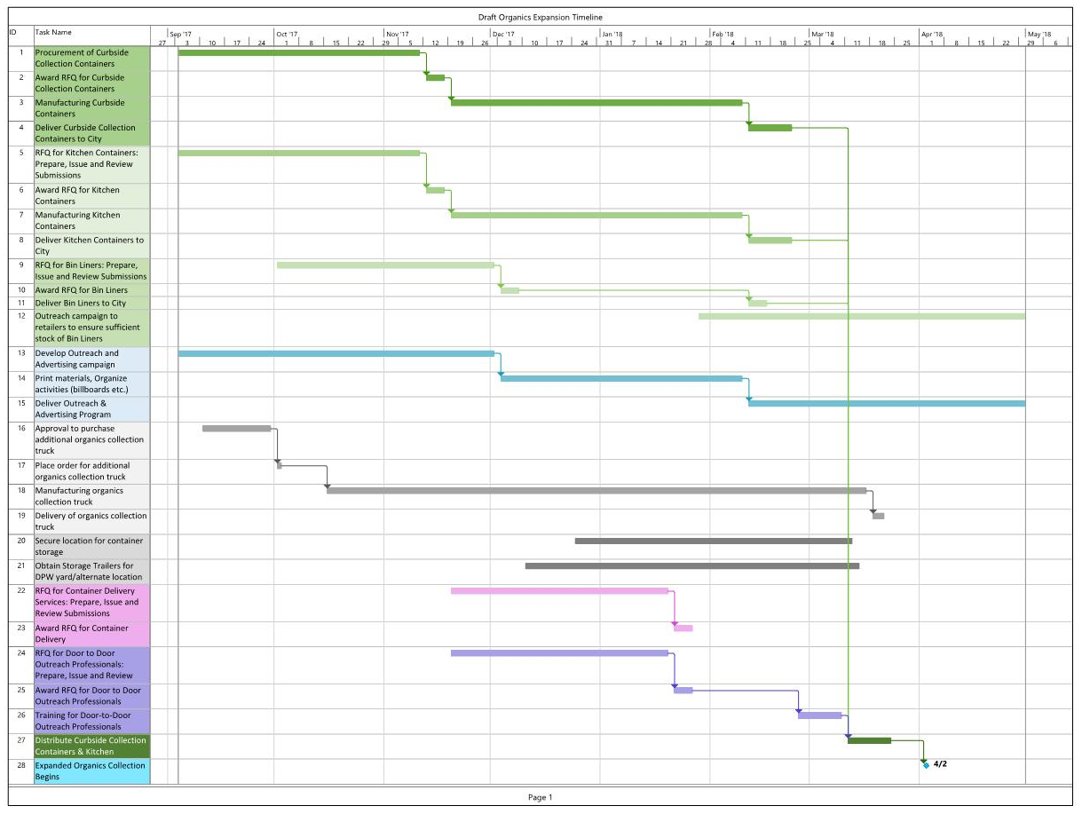

Organics in the Home
The following sections provide an overview of kitchen container options, liner bags, a discussion of material streams and household behavior and recommendations for managing organics in the home.

Kitchen Container Options
Kitchen containers are intended to manage food scraps generated in the kitchen and can be stored on or under the counter and emptied into larger curbside containers once full.
In general, kitchen containers are either fully ventilated (e.g. have perforations over the body of the container), partially ventilated (e.g. have perforations in the lid) or non-ventilated (solid body and lid). Recently, compostable kitchen containers have become available to the public. These are generally made from recycled corrugated cardboard and/or newsprint.
Fully ventilated kitchen containers require some sort of liner to contain the food scraps, whether paper or compostable plastic. Ventilation allows moisture from food scraps to evaporate and can reduce odors and anaerobic conditions.
Partially ventilated kitchen containers typically only have ventilation through the lid and solid walls which means the use of liner bags is optional. Partially ventilated containers are more capable of capturing any spills or organic residues within the container given the solid walls and bottom. These containers may also utilize charcoal filters.
The City has piloted different types of kitchen containers, including fully ventilated (Mattiussi Ecologia) and partially ventilated (Sure-Close) containers as presented in
Figure 5-1. One is a fully ventilated container, the other a semi-ventilated container. Note that the fully ventilated container must be used with a liner bag whereas use of a liner bag is optional with the semi-ventilated container. Nearly all current participants in the organics pilot are using the fully ventilated Mattiussi Ecologia kitchen container; the City provided only approximately 50 Sure-Close containers as part of the 2014 pilot.
Figure 5-1: Kitchen Containers used in Pilot Areas
Mattiussi Ecologia Kitchen Container | Sure-Close Kitchen Container
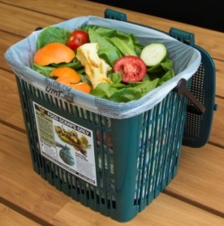  ventilation | 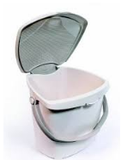

The City conducted focus groups with pilot participants to obtain feedback on the kitchen containers, among other matters related to organics collection and conducted a survey in February 2017, to which approximately 266 people responded. Approximately 76% of the pilot participants who responded to the survey are still using the City-provided kitchen container. Those who are using a different container cited reasons such as:
- Durability/sturdiness
- Already had a container
- Purchased a container with a carbon filter to reduce odors and fruit flies
- Purchased a container that looks nicer
- Bag breaks too easily in ventilated container
- Use bags only, freeze or refrigerate until disposing in curbside bin
- City-provided container broke
- Animals got into other container (mice, cats)
- City-provided container was too big
The following images represent a selection of kitchen containers available to municipalities and the general public. This is not meant to be an exhaustive list, nor is there any endorsement of any particular brand or manufacturer, it is merely to provide examples of choices available to residents. These examples of kitchen containers provide a variety of options for:
- Footprint/size;
- design/aesthetics;
- whether or not a bag is required;
- airflow (fully vs partially ventilated);
- ease of use (size of opening, handle for transport/emptying, ability to clean); and,
- disposability.
Many of these attributes are a matter of personal preference, but are important considerations in whether/how residents will use the containers and participate in the program.

Figure 5-2: Examples of Kitchen Containers
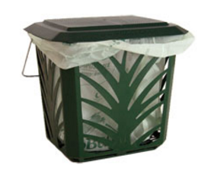  MaxAir/BioBag Kitchen Container | 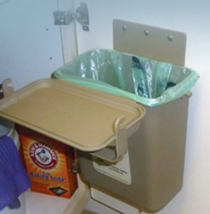  YukChuk Under-counter Kitchen Container | 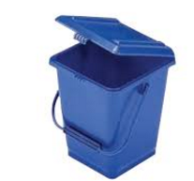  Rehrig Pacific
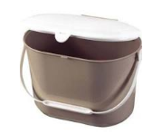  Earth Machine | 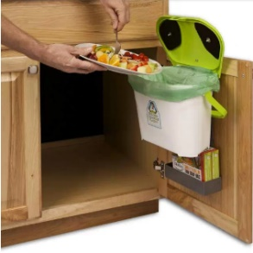  Kitchen Compost Caddy | 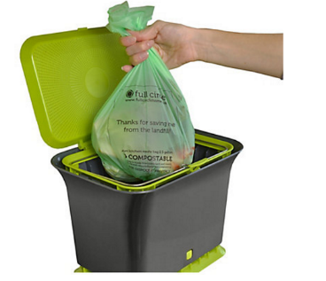  Full Circle Fresh Air Countertop Compost Collector
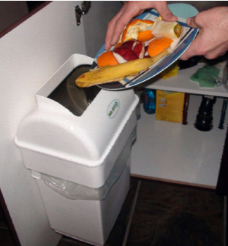  Mr. Eco Kitchen Compost Collector | 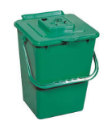  Busch Systems | 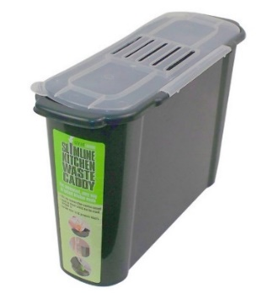  Bosmere Slim Kitchen Caddy
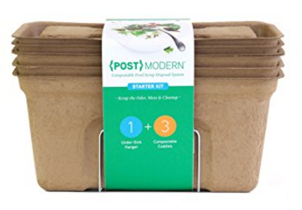  {Post}Modern | 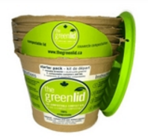  Green Lid | 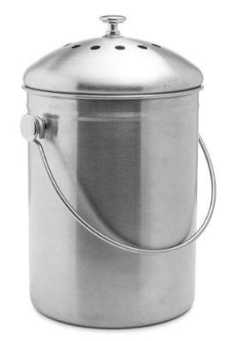  Epica

Considerations for choosing a kitchen container include:
- Durability
- Ventilation – allowing for release of some of the moisture contained in the food waste
- Footprint/size – when considering the space the container would take up on a counter or in a cupboard
- Capacity – typically 1.5 to 2.5 gallon
- Handle – a handle makes it easier to transport a full container for emptying
- Size of opening – the opening should be large enough to easily scrape leftovers without spilling
- Lid – some containers have lids that stand upright
- Ability to contain bags – some containers are designed so that liner bags are more easily held in place
- Ability to clean – containers should be dishwasher safe and easy to clean with a smooth interior and removable lid
Residents may also choose to purchase their own container to suit their own needs (e.g. larger or smaller) and aesthetics (e.g. stainless steel), regardless of what has been provided.

Liner Bags
Studies have shown that municipalities who allow for the collection of organic materials in compostable plastic bags demonstrate an increased capture rate of materials compared to municipal programs that ban compostable plastic bags (Municipal SSO Food Program Capture Rate Comparison, VisionQuest Environmental Strategies Corp. at US Composting Council AGM January 26th, 2011). Liner bags make collection of food scraps more convenient, and minimize work associated with cleaning the collection container. A certain number of liner bags are usually provided with the roll-out of a green bin program, after which residents can choose whether or not to continue purchasing bags. Some programs periodically provide additional liner bags as part of promotion efforts to encourage use of the program.
The type of liner bag has less impact on participation or capture rates compared to other factors such as frequency of garbage collection (i.e. collection of garbage less frequently than organics), lower bag/container limits for garbage or pay-as-you-throw (PAYT), size of green bin, inclusion of leaf and yard waste , maturity of curbside organics program; however, it can make a positive contribution to the success of the program.
In general, liner bags are either made of compostable plastic or paper lined with cellulose to give them more wet strength and are equally acceptable at organics processing facilities. Paper bags may break down more rapidly during composting with very little residue compared to compostable plastic bags which compost more slowly. On a per unit basis, paper bags tend to have a higher retail price point to consumers than the compostable plastic bags.
Recently, water-resistant, fully compostable containers made of recycled cardboard and/or newsprint have been introduced to the marketplace. These containers do not require any liner and can be disposed of in the curbside green bin which may appeal to people for its convenience and clean factor. However the unit costs of these compostable containers is comparatively high. These are shown above in Figure 5-2.
The U.S. Composting Council and the Biodegradable Products Institute (BPI) have developed standards for compostable plastics. BPI maintains a website listing all the certified compostable products, including certified compostable bags. All products that are certified have passed the ASTM D6400 Standard Specifications for Compostable Plastic and may use the following logo for easy identification of compliant products.
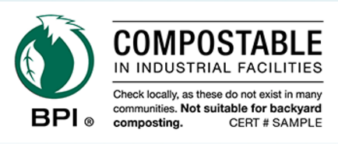
The City provided pilot participants with a 9 month supply of compostable liner bags (BioBags) and a coupon to purchase additional compostable liner bags, available at select retailers in the City. In the City’s recent survey for pilot participants, respondents were asked if the projected cost of purchasing additional bags would be a deterrent to continued participation in the program. Even at the City’s estimated projected cost of 10-20 cents per bag, 77% of respondents indicated they would be “very likely” to continue purchasing bags while only 4% were “not likely or somewhat unlikely” to continue purchasing bags (note that BioBags were specified in the question).
A brief internet scan of retailers of compostable liner bags for which online information was available, to illustrate the price range of compostable liner bags depending on brand, retailer and location. A variety of brands (15 brands), styles and sizes (2.5 to 3 gallon) were included.
Of the “bricks and mortar” stores (e.g. Walmart, Target, Lowes, Home Depot) prices ranged from 21 to 28 cents per bag with an average price of 25 cents per bag. Online retailers’ (e.g. Amazon.com) prices ranged from 18 to 45 cents per bag with an average price of 29 cents per bag. The average cost for all bag brands and types of retailers was 25 cents per bag.
Disposable compostable containers require the purchase of a starter kit which worked out to $1.25 per container, on average, with refills averaging 86 cents per container. The PostModern containers averaged $2.10 per container with the starter kit and $2.23 per container for refills (from Amazon.com).
Currently in Cambridge, residents are limited to purchasing select brands of compostable liner bags which are only available in a few stores unless they purchase them online or outside the City. It appears that despite this, Cambridge residents use compostable liner bags regularly, and are not overly deterred by cost, availability or durability of the bags.
Figure 5-3 below presents a selection of compostable liner bags for both kitchen containers and larger curbside collection containers. This is not meant to be an exhaustive list, nor is there any endorsement of any particular brand or manufacturer, it is merely to provide examples of choices available to residents.
The City should contact compostable liner bag manufacturers for prices for supply of a certain quantity of liner bags and/or coupons for purchase of additional bags for the roll-out of the organics program across the City. While the City provided a very generous quantity of compostable liner bags during the pilot (i.e. a 9 month supply plus coupons for additional rebates), most municipalities provide a more limited supply of compostable liner bags with the roll-out of a program (e.g. one or two months’ worth).
The City will need to work with retailers in and around the City to ensure sufficient stock of compostable liner bags, of various sizes, are available for the program roll-out and maintenance of adequate stock on an on-going basis. The City will also need to educate both retail staff and residents on the difference between compostable and non-compostable liner bags to ensure the proper types of bags are utilized. The City should maintain information on their website regarding acceptable manufacturers and bag brands including pictures and logo identification.
Once the program has been rolled out, it is recommended that the provision of liner bags would no longer be the responsibility of the City. Residents would be free to choose the brand and source of liner bags, and depending on the style of the kitchen container ultimately chosen by the participant, whether or not bags are even used. However, periodically over the first few years of the program, at community events and other forums where the organics program is promoted, additional bags and/or coupons could be provided as a tangible reminder to residents to participate in the program.

Figure 5-3: Examples of Compostable Liner Bags
Kitchen Container Liner Bags
Glad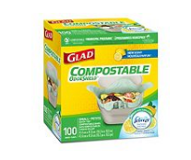 | Bag to Nature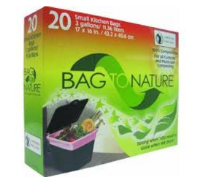 | Bag to Earth  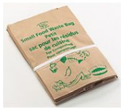
BioBag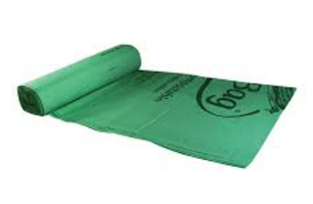 | 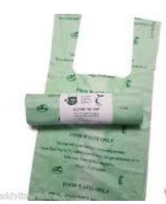 | Al-Pack  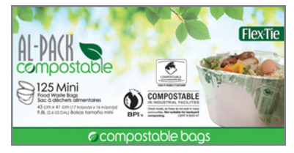
Curbside Collection Container Liner Bags
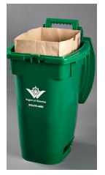 |  | 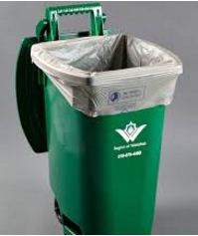
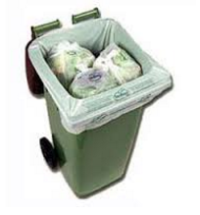 |  | 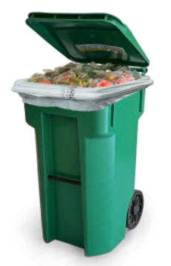

Material Streams and Household Behavior
Municipal curbside green bin programs range from only accepting only vegetative waste to accepting diapers and pet waste. Vegetative waste only curbside green bin programs are typically implemented by municipalities utilizing outdoor windrow composting only as this waste stream composts very quickly with a minimum of odors. This type of program often creates confusion for residents due to the uncertainty of what is accepted (e.g. why aren’t dairy or meat products acceptable?).
Most municipal curbside green bin programs accept all vegetative food waste as well as other proteinaceous food waste such as meat, dairy, fats and oils. Consumer acceptance of this type of program is very high as all food waste products are accepted, and the messaging is clear (e.g. “all food” is acceptable). Handling of these materials at processing facilities requires the ability to control odors, typically through a cover of some sort and aeration, or through anaerobic digestion.
Other materials such as plant trimmings, and soiled paper products (e.g. used paper napkins and towels, plates, coffee cups, paper take out containers) are also easily incorporated into a green bin program and provide further opportunities to divert additional materials.
The organic materials that remain in the curbside trash including diapers/incontinence products, pet waste, and sanitary products, are generally not accepted in most municipal curbside green bin programs; however, there are programs that accept some or all pet waste materials. Pet wastes like animal bedding is generally easily compostable. Dog waste generally must be bagged to minimize issues with collection, and can be included in programs that allow biodegradable bags. Cat litter also generally should be bagged, with the range of degradability varying depending on the type of litter used. Existing programs that accept pet wastes with food wastes in Canada, primarily use aerobic composting facilities to process the organic stream, although in some cases the organic stream is directed to anaerobic digestion (AD).
There are two municipalities in Ontario, Canada who accept diapers/incontinence products and sanitary products as well as pet waste, all of which can be placed in a regular plastic bag, in their green bin (City of Toronto and York Region). Most processing facilities do not accept this waste due to health and safety issues for workers potentially exposed to fecal matter and other human waste and the potential for plastic contamination in the finished compost. The shift in composition of disposal diapers and sanitary products away from paper fiber to gels has decreased the compostable content of these items, making them more difficult to integrate into aerobic composting systems. Generally this type of expanded organic stream is more suited to anaerobic digestion, with a front-end system for removal of inorganic residues like plastic.
Should the City decide in the future that pet waste could be included in the curbside green bin program, allowing the use of compostable liner bags is essential; residents are more likely to divert pet waste if it can be contained in a compostable bag within the curbside green bin. This is also critical for the collection staff emptying the green bins, as it limits unpleasant accidents. This could also lead to the collection of pet waste from parks through a dedicated collection stream program (with designated bins and supportive promotion and education). Currently, regulations prohibit the processing of pet or human waste without proper treatment. A future organics program to accept human and pet waste must first determine how to do so within the proper regulatory system.
It is likely that some residents who currently backyard compost may choose to place all of their food scraps in the curbside organics container upon expansion of the organics program instead of continuing backyard composting. Those residents who are avid gardeners may continue to backyard compost in order to have access to finished compost of a quality that they regulate. It is important to communicate to residents that there is no conflict between backyard composting and the curbside program, and that they can place many materials in their curbside bin (meat, cooked food, compostable paper) that they wouldn’t place in their home composter. Many municipalities give-away finished compost at events for residents as a way to incentivize participation in the program; which the City could continue to do.
Some residents may use in-sink disposal units for their organic materials. This is often regarded as a convenient method to dispose of many types of food scraps, however, with the age and types of housing in Cambridge and the existing sewer infrastructure, in-sink disposal presents problems and is not regarded as a viable alternative to replace expansion of the curbside collection program. The curbside program will also allow various materials (e.g. large bones, large vegetative items, compostable paper) that cannot be disposed by in-sink units.
The question has also risen as to whether the City should consider allowing use of non-biodegradable film plastic bags. Some jurisdictions have chosen to allow the use of regular plastic bags in their green bin programs, in order to allow residents the greatest choice in what type of liner bags to use and encourage participation in the program. This reduces confusion about what type of bag to use, allows residents to repurpose plastic bags (e.g. plastic shopping bags) and reduces the financial impact of purchasing compostable liner bags.
Use of non-biodegradable film plastic bags is not recommended for a number of reasons:
- Programs that allow use of film plastic bags, tend to experience much higher non-compostable residue rates. Residents often interpret that this means the program can manage plastic, and are less careful of ensuring that the food waste is clean (free of cling wrap, straws etc). Residue requires disposal and can result in lower grade finished compost due to the potential for plastic fragments
- This is contrary to the City’s intent to move away from single use film plastic bags made from fossil fuels.
- The majority of processing facilities that could accept the City’s organic streams in the short and long-term can accept and process material contained in biodegradable bags, but would have a more difficult time with the non-biodegradable film plastic and other residues.
- Although the Waste Management facility could theoretically manage organics contained in plastics, it is likely the only facility able to do so in the area and it is unknown if this facility would be selected to manage the City’s organics over the longer term.
- AD facilities are unwilling to process material with inert materials (e.g. fragments of plastic bags) should any remain in the slurry that would be directed to the digester. Contingency or alternative processing capacity may be very difficult to procure if the City was unable to send material to specific facilities due to a shut-down or change to a contract.
For the roll-out of the organics program across the City, it is recommended that the City continue to collect the current organic stream, consisting primarily of food scraps and allowing for inclusion of soiled paper materials. Once the program is well-established, the addition of other organic material such as pet waste can be considered, depending on the acceptability of this material stream to the City’s processors. The potential expansion of the organics stream would also play into the City’s consideration of changes to trash collection, discussed further in this report and in the Phase 2 report later in the ZWMP development.

Recommended Approach for Management of Organics in the Home
The City should consider the results of the focus groups and the surveys to identify those attributes identified by participants that would contribute to participation in the curbside organics program. Those characteristics should be included in the provision of kitchen containers to be issued by the City. In advance of receiving the results of the focus group and survey results, it is recommended that the City consider use of a container that allows for some ventilation (e.g. ventilated lid) as well as containment of food scraps and potential liquids released from the food scraps by having a solid bottom and sides. This type of container will allow for flexibility for those residents that do not choose to use liner bags.
It remains to be seen if the selection of a different container for the full roll-out would encourage higher participation rates in the program, as the current participation rates in the pilot area of approximately 45% are reasonably typical of the performance of an initial roll-out. It should be noted that in general, participants in the pilot area were self-selecting and would likely be committed to diverting organics regardless of the kitchen container provided. Additional community engagement planned by the City should be able to provide further input to the City on kitchen container choices, noting that many municipal programs have selected the Sure-close or similar containers for implementation of their residential green bin programs.
The City should also obtain quotes from manufacturers of compostable liner bags for provision of samples with the rollout of the program. Generally, roll-outs include the provision of free samples at the introduction of new organics programs, often coupons are provided to assist in the purchase of additional bags, and provision of an up-to-date list of acceptable manufacturers and bag brands including pictures and logo identification. As long as the liner bags meet the standards for compostability, there are no specific attributes of liner bags that would favor selection of one brand over another beyond price. Some brands may have differing abilities to wick moisture better suited to differing levels of ventilation. As the program expands, residents should have a greater selection of bag choices as retailers will have greater encouragement to carry stock, and can choose the brand that meets their needs and price point.
A robust promotion and education (P&E) campaign will be required to support the implementation and on-going use of these products to identify acceptable liners. Retailers in the City would need to be engaged, in order to ensure sufficient supply of reasonably priced liner bags, particularly at the start of the rollout of a program.
There is very little involvement for the City required as choice to use liner bags is up to the resident. The City may be required to provide ongoing P&E about which type of bags are acceptable for which some operating costs would be required. There would be no ongoing financial implications to City for provision of liner bags.

Organics at the Curb
The following sections provide a discussion of curbside containers and consideration of types of carts used for collection at the curb.

Curbside Containers
Curbside collection containers come in a variety of sizes intended for different collection methods (e.g. manual, semi-automated, fully automated), have wheels and a handle for easier maneuvering. These containers are being designed with locking features to discourage animals. Some containers also have venting systems intended to accelerate decomposition and/or bottom drainage. Container size is an important consideration in organics programs as organic waste is a very heavy, dense material; full containers can be very heavy making it difficult for residents to move containers to the curb, and for collection staff to maneuver bins into position and/or empty manually into collection vehicles, particularly in the winter.
Smaller containers, such as the 12 gallon green bins commonly found in municipal programs are meant to be emptied manually. These bins are compact with a smaller footprint and are intended primarily to collect food scraps. These bins are small, easily stored and maneuverable, but can be heavy for collection staff to empty and due to their smaller size, preclude collecting leaf and yard waste and food waste in the same container. Some bins come with lockable lids to keep animals out.
Larger 21 to 35 gallon green bins can be used for semi-automated or fully automated collection and many have lockable lids to discourage rodents/animals from getting into material. Some municipalities use these bins for collection from multi-family buildings or where more capacity is required for inclusion of other organic streams such as leaf and yard waste.
Green bins are also available in larger sizes (e.g. front-end load four wheeled cart) for larger quantities of organic waste (e.g. from commercial or multi-family buildings).
The size and design of the cart chosen is typically a function of the type of collection system utilized (manual, automated or semi-automated), whether food waste will be collected with yard waste and any animal resistant features are required. Generally experts base recommendations on whether food and yard waste should be combined, based on the performance of the existing diversion yard waste program, yard waste processing costs, the types of processing capacity available for the organic stream and potential effects on food waste capture rates.
Disadvantages of including this seasonal waste stream include;
- impacts on food waste capture rates, as programs that allow for the two streams to be combined usually demonstrate lower food capture rates;
- difficulty in adapting the system to address peak yard waste generation periods, in jurisdictions like Cambridge where there is a large seasonal fluctuation in yard waste;
- larger, more expensive bins are required;
- containers are more difficult to empty manually;
- more storage area is required for larger bins;
- limits processing technologies as leaf and yard waste is not suitable for AD;
City would be paying the same processing costs for leaf and yard waste as for food scraps when this material can be processed much cheaper on its own.
In general, organics containers are typically green in color to provide a visual cue to residents about the purpose of the container and materials to be diverted. Keep America Beautiful and the United States Composting Council recently announced a voluntary standard to designate green as the color to be used in organics collection containers across the nation.
The following images in Figure 6-1 present the two types of curbside collection containers used by the City in the pilot. Both containers have a locking mechanism and wheels. The 12 gallon containers are typically provided to residences with 1-2 units while the larger 21 gallon containers are provided to buildings with 3 or more units.
Figure 6-1: Pilot Curbside Collection Containers
12 Gallon Container (Orbis) | 21 Gallon Container (Orbis)
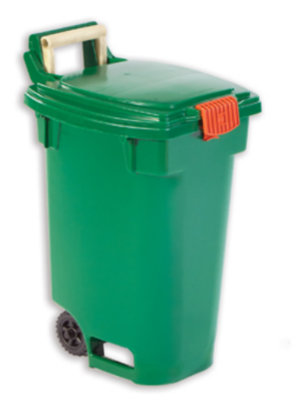 | 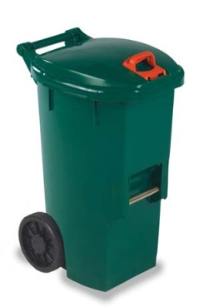

According to the City’s recent survey, when pilot participants were asked about any issues with the curbside bin, the majority (81%) of respondents to the survey have had no issues with the curbside bin. 18% indicated the latch was difficult to use and just 2 respondents (<1%) indicated the bin was not large enough.
When asked specifically about the locking mechanism, 55% of respondents indicated the locking mechanism was easy to use and that they lock the bin each time. 16% indicated the locking mechanism was easy to use but they do not lock the bin each time. 20% indicated the locking mechanism was not easy to use and that they lock the bin each time while 9% indicated the locking mechanism was not easy to use and that they do not lock the bin each time.
Although the majority of participants appear to be satisfied with the curbside container, the following types of comments were received about the containers;
- Lids broke or came off easily
- Latches broke
- Squirrels/other animals are chewing on or have chewed through the lid/latch/handle
- Handle on the 12 gallon is too short
- Latches sometimes freeze in the winter
- Bin is top-heavy and tippy
The following pages present images of collection containers from various manufacturers as available on the internet. This does not represent an endorsement of any particular manufacturer, nor does it represent all manufacturers. It is only intended to provide a brief overview of different designs and sizes of containers. It should be noted that all containers presented below are manufactured in a green color as well. Depending on the design, containers can be collected manually, semi-automated or fully automated. Some have lockable lids and all have wheels to facilitate movement. Some have ventilation and/or grates for drainage and airflow.
Figure 6-2: Examples of Curbside Containers

Manufacturer | Examples of Curbside Containers
Toter Inc. | Various Sizes  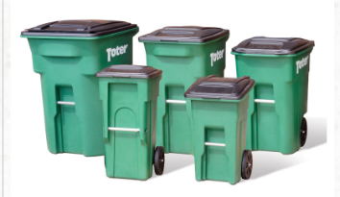
Rehrig Pacific Company | 10.5 gallon  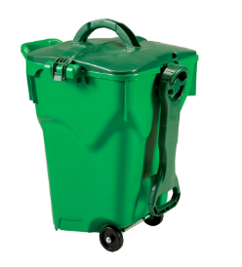 |  | 35 gallon  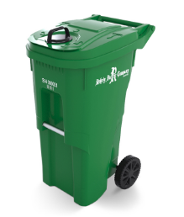
Busch Systems | 21 gallon  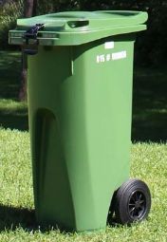
Orbis Corporation | 12 gallon  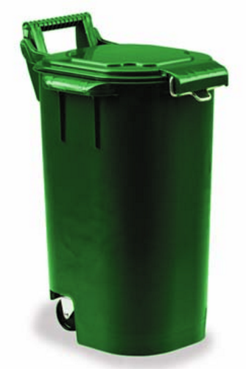 | 12 gallon  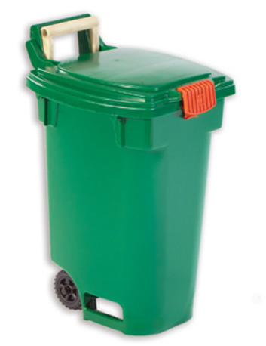 |  | 21 gallon  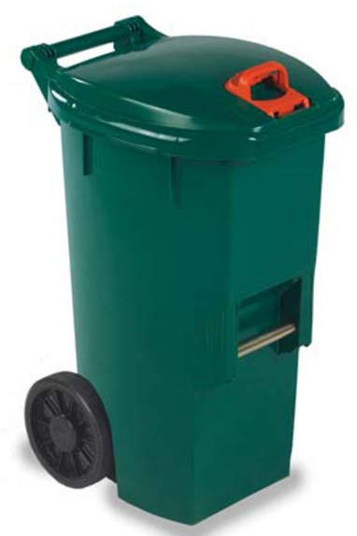
IPL Plastics | 21 gallon  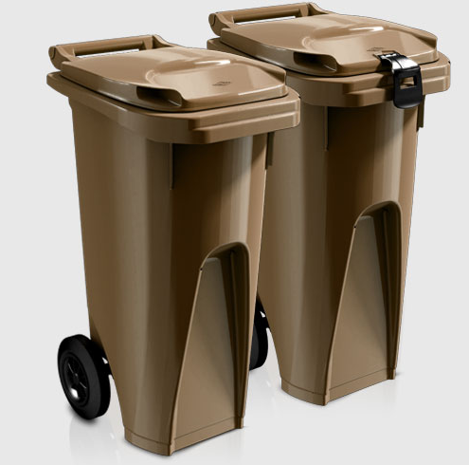 | 26 or 64 gallon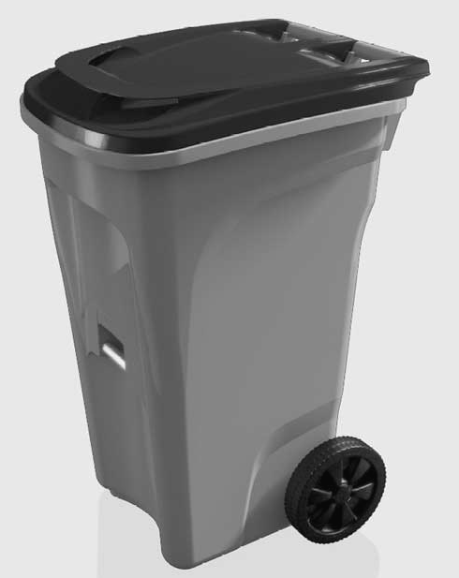 |  | 26 gallon  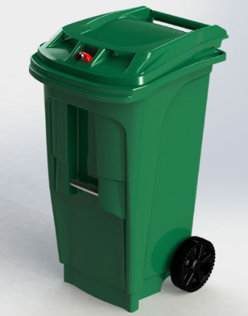 | 12 gallon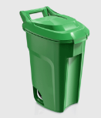

Consideration of cart choices for organics should include the following;
- Size – 12 and 21 gallon containers provide a good range of capacity for single and smaller multi-family buildings. Consideration could be given to larger carts for larger multi-family buildings where space is a concern. Smaller carts are easier to move, particularly when full, and store with a smaller footprint.
- Method of collection – Bins can be designed for collection by manual, semi-automated or fully automated collection.
- Wheel or axle design – Wheels can be made of rubber or plastic which can impact noise, maneuverability, strength and durability.
- Lid design – Should keep pests, rain and snow out of the bin. The grip should be deep enough for use with winter gloves. Any locking mechanism should be easy for residents to use and to facilitate semi or fully-automated collection should be a gravity type lock which can be opened upon emptying the cart.
- Service life and warranty – Specific terms and conditions related to the warranty should be considered, particularly for coverage for damage to handles, axles and wheels.
- Labels, logos and RFID tags – Logos and labels can be hot-stamped onto the bin to help with identification of bins and education of residents (e.g. which side of the bin should face the street). RFID tags can be used to track bins (set out and fullness).
- Material – Bins are usually constructed from polyethylene plastic; the grade of plastic is dependent on the manufacturing technique. The type of plastic is important to consider when bins are subjected to freezing winter temperatures and hot summer temperatures, as is experienced in Cambridge.
- Price – The City has estimated 12 gallon bin prices at $21.00 per unit and 21 gallon bins at $33.00 per unit. These are reasonable assumptions based on the costs incurred with the expansion of collection to the Monday zones, and based on current market prices. Competitive bidding may result in a lower unit cost, however, this remains to be seen.

Recommended Approach
The City should consider how collection of green bins will fit into their future collection system (i.e. semi-automated approaches are more suitable to the constraints on City streets) and future streams of organics that may be diverted using these bins. As this ZWMP report is finalized, the City will refine the estimates of weekly volumes of green bin organics that would be managed based on various capture rate and material stream scenarios (food, and food-soiled paper). Based on this analysis, the City should be able to determine whether the two current bin sizes on average suit resident’s current needs and have some additional space to accommodate higher organics capture rates and/or the future inclusion of materials such as pet waste in the bin. This can also be used to determine if the number of bins allocated to each building based on size is reasonable, or if an adjustment may be needed to the City’s assumptions on the number of bins that will have to be acquired for the roll-out to the 1-12 unit buildings and future roll-out to all 13+ buildings with City trash collection.
For the roll-out of the organics program across the City, it is recommended that the City continue to collect the current organic stream, consisting primarily of food scraps and allowing inclusion of soiled paper (paper napkins etc). Once the program is well-established, the addition of other organic material such as pet waste can be considered, depending on the acceptability of this material stream to the City’s processors. It is not recommended that the City include collection of yard waste in the curbside green bin containers.
The City should consider the size and type of bins that have been used in other jurisdictions with similar demographics and climate conditions to narrow down the choices. The City’s current bin types, are used by a number of programs and have been acceptable to the majority of the current participants in the program, however some issues particularly with the latching mechanism have been noted. The City should obtain quotes on provision of bins through the issuance of a tender or request for quotation for supply of collection containers meeting their requirements. The bin specifications for the locking mechanism included in the City’s tender or request for quotation should emphasize the requirement that it be easy for residents to use and, in order to facilitate semi-automated collection, it should be a gravity type lock which opens when the cart is tipped into the collection vehicle.

Curbside Collection
The following sections present an overview of the current collection system, collection considerations and a discussion of various collection options for the City’s consideration.

Current Collection System
The City provides weekly collection of trash to residential areas, public buildings, schools and non-profit organizations. The City provides weekly trash collection service with municipal crews (Department of Public Works) to approximately 68% of the households in the City; consisting of all single family homes and approximately two-thirds of all multi-family buildings, an estimated 32,000 households. The City also collects trash from all schools and City buildings, as well as from some Cambridge Housing Authority (CHA) buildings and the Cambridge Rindge and Latin School (CRLS). The Refuse and Litter Ordinance limits household trash to 150 pounds per week, 150 gallons per household in no more than three barrels, up to 50 gallons each, although this is seldom enforced. For example, a multi-family building with 6 units can have up to eighteen 50-gallon barrels and up to 900 pounds of trash per week set out for collection. The City does provide some collection of trash from dumpsters from select locations with regular collection vehicles.
The City manages a single stream residential recycling collection program that has been in effect for more than twenty years. Recycling is mandatory for all sectors in the City. Recycling is provided to approximately 95% of the households in the City or 44,000 households. The City provides most residences with 65 or 95 gallon recycling carts on wheels for weekly collection of single stream recycling. There are no limits on the amount of recycling placed out for collection. Recycling is collected by a private service provider, predominantly through automated collection of carts.
In the pilot areas, the City provides 12 or 21 gallon lockable curbside green bins for food scraps which are manually collected weekly by a private service provider. The City provides 65 or 68 gallon curbside green bins for organics collection at participating schools, drop-off centers (Community Centers), the Recycling Center, and participating non-profit organizations. Generally, collection is weekly or on-call as needed; however, some locations require twice weekly collection due to higher volumes collected. The City has taken over the provision of collection and transfer of compostable material (food scraps and compostable trays) from schools using City forces.

Collection Considerations
The City has a number of collection scenarios to consider as part of the future waste management system arising out of the ZWMP. The City can continue contracting out collection of certain waste streams by private service providers or can consider bringing collection of organics, and possibly collection of recycling, in house. Each of these scenarios has a number of pros and cons to consider. The City must also consider how waste will be collected (manual, semi or fully automated), the vehicles used to collect waste and what type of containers are best suited for various collection methods.
There are some unique collection challenges in the City associated with housing density and narrowness of many streets. As the housing in the City is quite dense with a mixture of single family and multi-family housing, currently collection typically involves a relatively small collection vehicle driving slowly down a street, or making short stops, with the collection crew (two throwers for trash collection, one for recycling and organics) working both sides of the street at the same time.
Due to on-street parking and configuration of City streets, there are limitations on the size and configuration of collection vehicles that are able to be used. In general, 20 to 25 cubic yard packer trucks are used for collection.
A variety of collection containers are currently utilized by residents including; 12 or 21 gallon curbside green bins, trash in barrels or plastic bags and recycling in 65 or 95 gallon carts, converted 32 gallon trash barrels, or blue bins.
The City has indicated that they will be examining the provision of a standard trash container to households, which could be a wheeled container suitable for semi or fully automated collection. These types of containers have proven to reduce injuries to the workforce and can also reduce litter and scavenging. This standard size container would also serve to reinforce trash limits. Further analysis of the move to standardized containers will be provided in the draft ZWMP report.
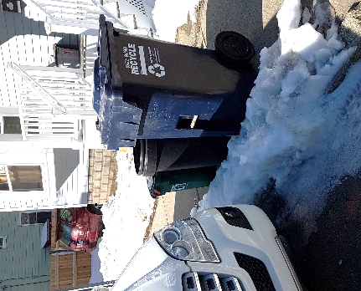
As part of the capital budget recently developed by the City, provisions for purchase of 12 and 21 gallon curbside green bins were included for the next fiscal year. 12 gallon green bins are typically emptied manually; 21 gallon curbside green bins can be emptied with semi-automated collection vehicles. Observations made during the pilot phase indicated that the 12 gallon manual curbside green bins were easy to miss during collection with on-street parking or if placed behind or between trash barrels or recycling bins (see Figure 7-1). The larger curbside green bins are easier to see and less likely to be missed. Given the City’s layout, demographics, and constraints such as on-street parking, consideration of 12 gallon curbside green bins is still a viable option for the City to consider even though it does require manual emptying and promotion and education will be needed to support proper placement of the bins at the curb.
Figure 7-1: Curbside Setout
Consideration of manual, semi-automated and fully automated collection needs to reflect the following;
- The City’s current system involves 3 staff collecting trash and generally one pass per street with both sides being collected at once.
- Semi-automated collection may be faster, may require fewer collection staff, and has the potential to reduce injuries to staff as they are not lifting heavy containers. Collection could continue to be a single pass down a street. Semi-automated collection would still rely on the collection crews to maneuver carts/bins into position for the lifting mechanism to empty the carts/bins into the truck but is a viable option for the City.
- Fully automated collection in other jurisdictions has been demonstrated to be faster, would require fewer collection staff, would reduce injuries and workers compensation claims, can collect more material as vehicles may be larger, and may reduce the number of vehicles required. However, collection can only be done on one side of the street and parked cars and improper setouts can hamper collection. Two passes down each street would likely be required for Cambridge and the time per stop would likely be increased which could have an impact on the number of trucks required. Other street constraints would also limit the ability to move to trucks with over 25 yard capacity, reducing the potential for greater fleet efficiency. Automated vehicles are reported to be more expensive and require more maintenance. A fully automated approach does not appear reasonable in the City.
Currently, collection of each waste stream is undertaken by a different service provider which makes making changes to the system more challenging. Options that have been proven to control or reduce collection system costs such as co-collection can only be considered if multiple material streams can be managed by a single service provider.

Collection Options
With the roll-out of the organics program to more households, the City has some options to consider for the configuration of the curbside collection system.
Options that were considered include;
- Separate weekly collection of trash, recycling and organics, essentially continuing the approach currently used in the Monday collection zone;
- Weekly co-collection of trash and organics in the same truck (separate compartments) and separate weekly collection of recycling;
- Weekly co-collection of recycling and organics in the same truck (separate compartments) and separate weekly collection of trash;
Separate weekly collection of trash, recycling and organics has an advantage over the other options, as only a few additional dedicated organics collection trucks (in the order of 2 trucks) would need to be purchased, while co-collection options would require replacement of more of the fleet.
Once the organics program is established across the City, the City may wish to consider collection scenarios which would promote participation in the organics program through reduced frequency of collection of trash. These could include;
- Separate weekly collection of organics and recycling and every other week collection of trash; and,
- Weekly collection of organics and alternating weekly collection of recycling and trash in a separate compartment on the same truck (i.e. organics and recycling collected in week 1, organics and trash collected in week 2).
These scenarios can be considered once the City has had a chance to assess the effect of standardized curbside trash bins and cart fullness for recycling. It is likely that the rollout of the organics program will cause an increase in participation in the recycling program with the associated promotion and education for the organics program. The effects of increased recycling and the capacity within the residential recycling carts needs to be assessed to determine the implications associated with the concept of alternating weekly collection as described above. The City should also see a decrease in the tons of trash managed with increased diversion of food scraps and recycling.
For any co-collection option, collection would need to be provided by one service provider, whether that is the City or a private service provider. The City should consider whether it will bring collection of green bin organics in-house, or alternatively, if it will contract out collection of organics City-wide to a private service provider. As discussed in the next section related to collection modelling, in the order of two collection trucks would be required each collection day for organics collection City-wide based on a 5 hour operating day. Based on current contract costs, green bin organics collection by City forces could save more than $200,000 per year compared to contracting out this collection service.
Once the expanded organics program has been rolled out to the entire City, it will be easier to implement trash limits, trash disincentives with less frequent collection or mandatory participation in diversion programs. With greater participation in the green bin program, residents should experience a significant reduction in the amount of trash requiring disposal and may be more accepting of a change to the level of service for trash. Setting limits on trash and/or a standardized container also helps to improve collection efficiencies. However, with less frequent collection of trash there is the potential for odors from diapers that have been sitting in a trash container for two weeks.
Families or home daycares that generate greater quantities of diapers or households where a member has a specific medical condition and generates more waste may be eligible for a special considerations policy. Some municipalities that have moved to every other week trash pick-up have addressed this issue by providing residents with options to apply for additional collection services if they meet certain criteria (e.g. home daycare operation, homes with residents with special medical conditions).

Collection Modelling
A variety of collection scenarios were modelled to identify the impacts of expanding to all units, different collection frequencies and co-collection. In order to conduct the modelling, it was necessary to make a number of assumptions;
- Set out rates were set at 90% for Trash and Recycling and at 45% for Organics for systems with weekly collection of trash. With reduced frequency of trash collection, set out rates were changed to 95% for Trash, 90% for Recycling and 60% for Organics.
- All packers for trash collection and/or organics co-collection were assumed to have 20 cubic yd capacity, all packers for recycling collection and/or organics co-collection were assumed to have 25 cubic yd capacity. All packers for separate organics collection would be 20 cubic yd. Trash packers would be manned by 3 staff (1 driver, 2 throwers), organics packers by 2 staff (1 driver, 1 thrower).
- Trash, recycling and organics were assumed to be collected 52 weeks per year. The number of trash collections was halved for every other week collection scenarios.
- The number of operating hours per day was assumed to be 5 hours per day. This considers off-route time associated with driving to the transfer station, MRF or organics processing facility (assumed to be the Waste Management facility) and dumping times for each waste stream. It does not include time at the start and end of the day to inspect vehicles, for maintenance or breaks or lunches.
- On and off-route speeds to the various transfer and processing facilities were considered as well as distances from the centroid of each collection zone to each transfer and processing facility.
- Estimates for contracted costs for organics and recycling collection were based on current contract costs.
- Organics collection service would only be provided to those buildings with City trash service.
- For co-collection scenarios, the truck split was assumed to be 70:30 with the larger portion assigned to either trash or recycling and the smaller portion for organics.
Table 7-1 presents the collection scenarios that were modelled and the estimated fleet required. The existing fleet used by the City (as of 2017) includes 7 trash collection trucks, 5 recycling collection trucks and 2 trucks used for the organics collection program in the Monday zones. The impact of increasing the number of operating hours from an average of 5 hours a day (current approach) to 6 hours a day is also presented in this table. Running the collection model assuming a 6 hour collection day, determined the effect that increasing productivity of the collection system (whether collection is undertaken by City forces or under contract) could have on the system. Overall, increased productivity through lengthening the active collection period has the potential to reduce fleet requirements for all collection streams under all scenarios, potentially providing additional savings to the City and further offsetting the cost of adding green bin organics collection to the City’s programs.
Table 7-1: Description of Collection Scenarios and Fleet Required
System | Total Fleet Required (5 hour collection day) | Total Fleet Required (6 hour collection day)
Weekly Separate Collection
Status Quo – collection of food scraps from pilot area only | 14 | 10
Expansion of program to collect food scraps from all buildings with 1-12 units | 13 | 10
Expansion of program to collect food scraps from all buildings with 1-12 units and 13+ units with City trash collection | 13 | 10
Weekly Co-collection
Collect food scraps from all units – recycling and organics co-collected | 12 | 10
Collect food scraps from all units – trash and organics co-collected | 12 | 10
Every Other Week Separate Collection
Collect food scraps from all units with weekly collection of recycling and organics and trash collected every other week | 11 | 9
Alternating Weeks, Co-collection
Collect food scraps from all units with organics collected every week, and alternating weeks for recycling and trash | 5 | 5
Collection Model Findings
- The additional cost to collect the green bin organic material ($430,000 annually for City collection, $650,000 annually for contracted collection) should be partially offset by potential reductions in trash collection costs with the reduction in number of trash collection vehicles.
- Bringing organics collection in-house could potentially result in savings of around $200,000 annually.
- No additional organics fleet requirements should be needed to include the 13+ unit buildings with City trash in the program. Buildings with City recycling service, but not City trash service are estimated to be approximately 12,000 households in 250 buildings. With an average of 48 units per building, this subset of the Cambridge community will likely need to be studied more closely to determine if the City could accommodate organics collection without an additional collection truck.
- Switching to every other week (EOW) collection of trash could realize operational savings of around $600,000 or more annually through reduction of the trash collection fleet requirements.
- In-house collection of organics co-collected with trash could result in savings of approximately $350,000 annually, compared with separate contracted organics collection.
- The greatest potential for savings is with in-house co-collection of organics with trash and recycling on alternating weeks. This system is the most efficient, with only one pass of a collection vehicle per street on each collection day and results in the greatest savings due to the reduction in capital and operating costs. It is estimated that this system could save approximately $2 million in annual operating costs compared to the other systems.
- Co-collection scenarios have the potential to result in annual savings in collection system costs through fleet reductions, while scenarios with every other week trash collection could further reduce collection costs compared to the status quo.
Changes in fleet requirements, will also affect the greenhouse gas emissions from fleet operations. GHG emissions estimates were developed based on a conventional diesel fleet, based on the assumed operating hours and number of vehicles operating each collection day. All collection scenarios have the potential to reduce GHG emissions compared to the status quo, given that all scenarios have potentially smaller fleets.
The following Table 7-2 provides a summary of the modelled collection system costs, indicating the order of magnitude differences in costs between the various scenarios. Further details on the outcome of collection modeling will be provided in the Phase 2 report documenting the overall ZWMP recommendations.

Table 7-2: Collection Scenario Comparisons
 | # Collection Trucks Required | Annual Tons CO₂ Emitted (from collection) | Annual Change in operational costs (for collection) from Status Quo | Annual Tons of Organics Diverted
Contracted Organics Collection
Status Quo | 14 | 1,141 | - | 338
Rollout to 1-12, 13+ buildings with City trash collection (40% capture of food scraps) | 13 | 1,059 | $180,000 to $200,000 | 2,022 to 2,623
EOW Trash Collection - all units (60% capture of food scraps) | 11 | 896 | ($384,000) | 3,935
In-house Organics Collection
Separate Collection - to 1-12 unit or including 13+ unit buildings with City trash collection (40% capture of food scraps) | 13 | 1,059 | ($24,000) | 2,022 to 2,623
Trash/Organics Co-collected - All units (40% capture of food scraps) | 12 | 978 | ($147,000) | 2,623
EOW Trash Collection - all units (60% capture of food scraps) | 11 | 896 | ($616,000) | 3,935
Weekly organics co-collected with trash/recycling on alternate weeks - all units (60% capture of food scraps) | 5 | 407 | ($2,265,000) | 3,935

Incentivizing Participation in the City’s Organics Program
There are a number of options available to the City to encourage and incentivize participation in the new organics program, and in the existing recycling program.

Standard Trash Container Size
The City has a limit on the size and weight of trash containers and is considering the provision of a standard trash container size to remove the variability in the trash set-outs. The key to the success of this option is communication of the container limit to the public and enforcement of the limit and use of a standard trash container. This is a relatively easy option for the City to implement, requiring a change to the ordinance and a period of enforcement as residents adjust to the change. As trash collection is conducted by City forces, enforcement of the standard trash container can be done by collection staff by not collecting the container and leaving an “oops” sticker on the non-compliant container.

Bi-weekly (every other week) Trash Collection
Bi-weekly (i.e. every other week) collection of trash has been implemented in many municipalities to encourage participation in diversion programs. If residents are participating in the green bin program to the fullest extent, there should be very little odorous material remaining to be placed in the trash, with the exception of diapers, pet waste and the like. Food scraps, placed in the curbside green bin, will be collected more frequently than trash thus encouraging participation in the organics program rather than placing food waste in trash containers where it will sit for two weeks. As discussed in Section 7.3, a special considerations policy can be implemented for households with young families or medical conditions where households can experience issues with large quantities of materials like diapers in the trash. This could be an option for the City to consider with the expansion of the organics program, or as method to bump-up performance of the program in the future.

Pay-As-You-Throw
Pay-as-you-throw (PAYT), also known as Save-as-you-throw, programs charge households for collection of solid waste based on the volume of waste generated. In general, there are three common pricing structures;
- Set price per bag or unit of trash;
- Variable rate based on volume of waste; and,
- Combination of set and variable pricing with a flat fee plus additional charges based on volume of waste.
Many municipalities utilize partial or full PAYT programs which can generate revenue to partially or fully recover the cost of managing trash. One drawback of this program is that with waste reduction and diversion measures, fewer funds are generated through trash fees which are often used to fund other programs.
This option may be more difficult to implement in the City due to the proliferation of multi-unit buildings where would be challenging to enforce the use of bag tags and/or charges for variable sized collection containers on specific residents, compared to single family residences.

Effective Promotion and Education
A community-based social marketing approach can be used to develop an effective communications plan for promotion and education of waste reduction and reuse initiatives. Behavior change tools that can be employed include those that appeal to norms, prompts, and commitments.
There are two types of norms; descriptive and injunctive. Descriptive norms provide examples of what is commonly done and reinforce that waste diversion through recycling and organics is normal. Injunctive norms focus on what should, or should not be done and does not target specific behaviors. As an example, injunctive messages would focus on the benefits of using the green bin and environmental awareness.
Prompts remind residents to recycle and place food waste in the green bin and can consist of magnets, stickers or even the collection containers themselves.
Commitments include pledges that residents can take to agree to take action towards waste diversion and reduction. People are more likely to follow through with their commitments when making a public statement about their commitments.
It is crucial to maintain the change in behavior through feedback and reporting on how behaviors have changed and the impact on the system. Media events, information on the City’s website, newsletters, and social media are all useful ways to provide feedback. The City has employed similar mechanisms for the current Monday pilot. Adopting a broad-based social marketing campaign for the full roll-out across the City would be a continuation/expansion of this approach.

Regulatory Mechanisms
Regulatory instruments may be considered to force people to utilize the diversion programs, particularly the green bin program provided by the City. A mandatory diversion by-law for organics could incent the greatest diversion.
In the absence of implementing other measures to encourage diversion (biweekly garbage collection, full PAYT), a mandatory organics diversion by-law could be considered. Most methods of enforcing mandatory diversion are relatively clumsy. Enforcement of a mandatory diversion by-law by looking for presence of organics in the garbage bag itself is very difficult to implement, as it cannot be quickly or easily applied by the collection contractor at a glance, it requires more time to observe the set-out including potentially opening the garbage bag. One approach to consider would be only collecting trash from those locations where a green bin is also set out. Enforcement of a mandatory by-law that requires set-out of organics in order for trash to be collected would provide for more straightforward enforcement requiring less time and energy reducing potential effects on collection costs. It is simple for residents to understand. In cases of non-compliance collection staff would take a picture of the set-out or otherwise document why material was not collected and sticker the garbage bag/container with an explanation to the resident. However, it would be difficult to enforce mandatory diversion in this fashion in Cambridge where a large proportion of locations share the green bins, and not all residents in the same building may participate.
This type of approach would also require a review of the buildings from which the City collects as currently the City does not provide trash collection to all buildings which receive recycling and organics collection.
There are very few jurisdictions with a mandatory diversion by-law for organic materials. Some municipalities require certain streams to be separated (e.g. organics) or target certain sectors (e.g. multi-residential and IC&I sectors). Some examples of regulatory initiatives include;
- The City of San Francisco California has enacted a Mandatory Recycling and Composting Ordinance which requires everyone to separate their recyclables, compostables and trash. Fines for non-compliance range between $80.00 and $500.00 dollars.
- A mandatory commercial organics Statute (Statute AB 1826) was signed in October 2014 for the state of California that will require businesses and multi-family units (5 or more units) to implement an organics recycling program as of April 1, 2016.
It is not clear to what extent these types of mandatory policies are actually enforced in other jurisdictions and whether garbage is still collected if other bins are not placed out as well. Additional research would be required to investigate successes and challenges experienced by other municipalities with similar by-laws.

Recommended Approach
Decisions regarding how collection of the green bin organics will be incorporated into the City’s collection system (collection via contract or City forces) will little direct impact on residents, but can affect the overall costs of the program. Similarly, how material is collected (separate vs co-collection) has little impact on residents as long as the collection frequency is the same.
It is recommended that the City proceed with in-house collection of organics with the expansion of the organics program to serve all 1-12 unit buildings. The increased labor requirements and operational cost for organics collection, should be partially offset by reducing the fleet required and operational cost for trash collection on the majority of collection days. This would also facilitate consideration of co-collection of trash and organics, which would be best implemented through a transition over time to replace trash collection trucks with split vehicles. Alternatively, this would facilitate consideration of changing the collection frequency of trash. In the longer term, the City could consider bringing recycling collection in-house and transitioning to the collection scenario where organics are collected weekly and trash and recycling are co-collected on alternating weeks which could offer substantial collection savings.
Once the organics program is established, the City can consider implementation of other options to further encourage participation in the organics program.

Organics Processing
With the landfill ban on organics from commercial generators, a number of jurisdictions in Massachusetts have been considering developing processing capacity, both aerobic and anaerobic. It is estimated that the state of Massachusetts requires approximately 250,000 to 300,000 tons of processing capacity annually to meet their organics diversion goals for 2020. The State has introduced several programs to further the development of organics processing facilities and has funded feasibility studies for public entities to develop AD facilities or use existing wastewater treatment facility digesters to accept food waste. Several grants have been awarded to projects, including the Greater Lawrence Sanitary District which is accepting food waste from the City that has been initially pre-processed by the Waste Management CORe facility. The State has made provisions for grants, loans and other programs from government agencies and other quasi-public organizations for site assessment, feasibility studies, construction financing assistance, production-based incentives and project review. As well, funding is available to qualifying cities and towns for projects that increase waste diversion, through the Sustainable Materials Recovery Program. Lastly, the Massachusetts Clean Energy Center provides funding for Organics to Energy projects.
Based on information that is currently publicly available, it does not appear that there are any proposed new aerobic or AD facilities under construction at the moment, or under consideration by jurisdictions within a reasonable haul distance of the City that could currently be considered as long-term processing options for the City. It is likely that the marketplace is as robust as it is going to get in the near term during the roll-out of the City’s expanded organics program.
The following sections provide an overview of aerobic and anaerobic processing technologies, and short and long-term processing considerations.

Processing Technologies
The following sections provide an overview of aerobic composting and anaerobic digestion processing technologies.

Aerobic Composting
Aerobic composting is a biological process conducted in the presence of oxygen; naturally occurring microorganisms (e.g. microbes, insects, invertebrates etc.) convert organic materials into carbon dioxide, water and a stabilized material known as compost. Aerobic composting is suitable for a range of organic feedstock, including LYW, vegetative and expanded food organic materials, pet waste and paper fibers. There are a number of aerobic composting technologies in use around the world, ranging from simple open windrows to more complex systems involving tunnels, aeration and agitation. The following sections provide a description of the two aerobic composting systems most likely to be utilized by the City to accomplish the composting process in a cost-effective manner.

Windrow Composting
Aerobic windrow composting is the most conventional non-enclosed composting approach. The materials (generally green material) are placed in elongated piles called windrows that are aerated by mechanically turning the piles with a machine. It is important to maintain optimal moisture levels and to redistribute cooler and hotter portions of the piles through turning. In turned windrows, temperature control and oxygen levels are managed via mechanical agitation. Pile temperature and oxygen levels need to be taken by a site operator with hand-held monitoring tools. Pile turning introduces oxygen, accelerates physical degradation of feedstock and provides an opportunity to adjust the moisture content to the optimum level. Many windrow turners have a watering attachment, which enables moisture to be added to the pile while turning. Generally speaking, the total composting time can be managed by the aggressiveness of the turning regime. More frequent turning breaks particles down more quickly, and provides an opportunity to optimize composting conditions, thus accelerating the composting process. This enables a windrow composting facility to increase its annual throughput capacity. The average time required for active composting is 8 to 12 weeks. Storm water contact water needs to be managed appropriately and run-on restricted through engineered controls. Make-up water is typically required to maintain optimum moisture content depending on the mixture of materials in the compost, the evaporation rate, and the porosity of the material.

Forced Aerated Composting
In forced aerated compost technologies, fresh air is introduced through air management systems to ensure that the system remains aerobic and to control odors. This method is suited to managing large volumes of organic material. Process control parameters include carbon to nitrogen ratio, pile size, temperature, moisture content and porosity. This technology can be particularly odorous if food waste is included in the feedstock and if the composting is allowed to have pockets of anaerobic activity. When conducted in an enclosure, a robust air management system is necessary to maintain the aerobic process.
The aerated composting process refers to any of a number of systems used to biodegrade organic material without frequent physical manipulation during primary composting (which is critical in aerobic windrows). The blended mixture is usually placed on perforated piping, providing air circulation for controlled aeration. It may be in windrows or piles, that are open or covered, or in closed containers (in-vessel). Common facility types ranging from the least complex to most complex include: aerated static piles (covered or uncovered), modular tunnels/biocells, horizontal bioreactors and in-vessel bays with mechanical agitation.
The forced aerated compost process utilizes a series of perforated pipes, in ground manifold or similar device that draws air down through the windrows to an air collection manifold that runs under the windrows. The compost-air can be drawn through the compost using a blower system which then pushes the air through a biofilter and/or other alternative technologies (e.g. scrubber) for emission and odor control. Alternatively, air can be injected into the windows; however, this results in dispersing the potentially odorous air and therefore is not common. Fresh air is drawn through the compost piles and forces the off-gases through the biofilter/odor control system. Biofilters filter/cleanse air as it is passed through organic medium consisting of various types of chipped wood and finished compost.
Generally with this composting technology, frequent turning is not required to replenish the oxygen. Periodic turning/movement is needed (movement every 2 or more weeks) in order to ensure that porosity in the composting mass is kept at optimal levels. The aeration rates can be set very low to conserve moisture and fan power without releasing odors. The ability to retain moisture is a benefit for an enclosed composting operation. Some facilities feature more active turning movements that can further reduce the length of time for the primary composting period.
Forced aerated composting, whether completed under a canopy roof, with covers or in and enclosure to control odorous emissions, can significantly reduce the active (primary) composting period from a standard windrow operation, potentially by half depending on the system, reducing the area required to process the same amount of materials.

Anaerobic Digestion
Anaerobic digestion (AD) is a biological process that treats organic residuals in the absence of oxygen. Microorganisms that thrive in an anaerobic environment degrade the waste materials and produce methane as a by-product. The methane can be captured and converted into energy. The solids from the digestion process need further treatment to be considered a finished product and this is usually accomplished through a final stage of aerobic composting.
The following sections provide an overview of the two main types of anaerobic digestion; wet and dry anaerobic digestion.

Wet Anaerobic Digestion
Wet anaerobic in-vessel digestion (Wet AD) can occur using a variety of methods. Typical waste water treatment plant (WWTP) technology employs a single phase, low solids method of digestion. Technologies developed to treat high strength industrial wastes such as food process wastes or agricultural manure wastes typically use a higher solids dual or single phase digestion technology. In-vessel digestion retains more nitrogen and organic matter. Wet AD is generally more suited to food residuals and some paper fiber materials, as is not as suited for yard waste material which tends to include more woody materials and solids like grit/dirt. Generally wet AD facilities that manage food waste, operate in the range of 5% solids content in the digester, with some reaching up to 15% solids content depending on the manufacturer.
The anaerobic decomposition process produces a biogas consisting mostly of methane and carbon dioxide. The biogas can be collected, conditioned and used as a fuel for energy or used to generate electricity. Generally some form of green energy premium for the sale of the biogas as a fuel or the electricity generated from biogas is needed for financial viability of anaerobic digestion. Wet anaerobic digestion tends to generate higher rates of biogas per ton of input organic material compared to dry anaerobic digestion as noted below.
Temperature, pH, and volatile acids composition are closely controlled and must be maintained under uniform conditions to maintain optimal conditions for the anaerobic microorganisms. Organic decomposition happens very rapidly in these contained quarters under properly controlled conditions, taking in the order of 14 to 20 days. Following digestion, the resulting digestate is usually separated into solid and liquid fractions. The resulting solid fraction must then be aerobically composted for several weeks or months before being sold as a finished product. The liquid fraction of the digestate may be marketed as a liquid fertilizer, but more commonly is sent for wastewater treatment.
The wet anaerobic digestion process generally occurs within a reaction vessel/tank(s) and is often modular in nature so additional vessels must be added when volumes increase. In-vessel digestion requires more expensive capital investment.
Since anaerobic digestion (AD) deals with the highly biodegradable portion of the waste stream, odors from an AD plant can be a concern. Although public perception of AD is generally positive, odor episodes from a working AD plant can turn local public opinion against the plant. A plant that is designed and operated to minimize odor releases should not have major odor problems, but it is an issue that must be considered in the planning and siting of a plant.

Dry Anaerobic Processing
Dry AD is another form of AD technology. Like in-vessel digestion, dry AD is a biochemical process in which organic material is broken down by microorganisms in an environment lacking oxygen. Biogas, composed primarily of methane and carbon dioxide, is released as a by-product. The methane content of biogas can be utilized to generate electric and thermal power. AD systems can be utilized to take in organic wastes materials and process them to generate energy. Once gas generation peaks and declines, the partially stabilized organic matter can be aerobically processed and used as compost. Dry anaerobic digesters treating solid waste streams are becoming relatively common throughout Europe, but are an emerging treatment technology in the US. Dry AD facilities tend to operate in the range of 20 to 50% solids content, and can manage a broader range of organic material input including food waste, paper fiber and LYW material. Two key technology types in the Dry AD category include vertical digesters similar in appearance to Wet AD but functioning at total solids content of 20 to 35% and that use concrete type pumps to recirculate the materials during the process. Another approach is dry fermentation which uses more of a horizontal configuration and stacked material which is not physically moved until the digestion process is complete.
Dry fermentation anaerobic digestion systems are being considered in the US as a method to efficiently utilize and manage non-liquid organic wastes. Dry systems can use input organic material that has much higher total solids content of up to 50% (i.e., if the material is stackable). Dry fermentation plants are designed around the principle that microorganisms are more easily moved than a large amount of material. To facilitate digestion, a solution containing the necessary microorganisms is percolated through the mass of waste by the forces of gravity. This allows the organic input to remain stationary for the digestion retention time while the needed biochemical interactions still occur. Because the mass stays stationary, the overall structure of a dry fermentation plant is very different than a wet plant. There are no moving parts inside the fermentation chamber. Solution is sprayed over the organic material and collected as it seeps through to be recycled within the system. After digestion, the remaining material is removed from the fermentation chamber and can potentially be used as-is for a soil amendment (depending on the feedstock used in the process) or further aerobically composted.
Because there are no moving parts inside the fermentation chamber of a dry system, non-organic pollutants, like plastic bags, do not pose a hazard. However, a plastic bag in a wet fermentation system can catch on the agitation mechanism and cause failure. The absence of mechanical parts in the fermentation chamber, and fewer mechanical parts in the dry system overall, reduces overall maintenance time and costs. These characteristics also lead to lower parasitic energy values of the system when compared to wet fermentation plants. A dry system also requires less processing of the digestate after digestion, generating an output than can directly be taken to a composting operation. All of these aspects present great savings of energy, resources and money and create an optimal situation for processing the organic fraction of municipal solid waste.
When considering the use of an AD system for the processing of the organic feedstock, selection of the appropriate type is a major concern. Using a dry AD system minimizes processing costs, both prior to and after digestion, and the use of water and other resources within the system itself. This allows for the most efficient and productive recovery of resources within the organic material.

Short Term Processing Options
There are 223 municipal, private, commercial, state, federal and agricultural active compost sites in Massachusetts. MassDEP maintains a list of active composting sites located in the state of Massachusetts. There are approximately 40 sites that accept diverted food material in Massachusetts with additional facilities located in neighboring states of New Hampshire, Rhode Island and Connecticut which may be able to manage the City’s organic material.
The City anticipates collecting 7 tons per day before expanding to 13+ unit buildings. Short term processing options for food scraps include the following facilities:
- Rocky Hill Farms, Saugus, MA www.rockyhillfarm.net. This facility, located approximately 14 miles from Cambridge, utilizes an in-vessel digester for vegetative food waste mixed with grass clippings and leaves followed by open windrow composting. Material collected from the pilot areas and schools was hauled to this facility for processing before February 2017. This facility is permitted to accept about 5 tons of food waste per day.
- Waste Management Inc., CORe Facility, Charlestown, Boston, MA. Waste Management has developed a processing facility at the Save That Stuff location on Terminal Street in Charlestown. Food scraps are processed into a slurry which is hauled to the Greater Lawrence Sanitary District wastewater treatment plant located in North Andover, MA where it is anaerobically digested. The methane produced will be converted to electricity to be used for the plant’s combined heat and power needs. Food scraps are currently processed at this location. The CORe facility is permitted to accept 250 tons of food waste per day.
The tipping fees at these two facilities are quite reasonable based on the current volume of organics currently being processed. As of May 2017, the City paid $60/ton to Rocky Hill Farms for composting the non-curbside organics, and $60/ton to Save that Stuff for processing curbside collected food scraps at the Waste Management facility on Terminal Street. For comparison’s sake, the current fees paid by the City are 30 to 50% lower than the processing costs experienced in other jurisdictions with full residential food scrap diversion programs.
The majority of composting facilities in Massachusetts are farm-based, small scale facilities. Larger facilities located within a 50 mile radius of Cambridge which may be suitable alternative processing locations include:
- Brick Ends Farm, Hamilton MA www.brickendsfarm.com. This facility accepts food scraps which are then mixed with leaf and yard waste and manure and composted in an outdoor windrow.
- WeCare Environmental LLC, Marlborough, MA www.wecareorganics.com. This facility co-composts solid waste and residuals from waste water treatment using the Bedminster composting process and aerated windrows. The facility can process 54,000 tons per year of mixed solid waste and biosolids. The town of Marlborough uses approximately half the capacity with the remaining capacity utilized by other entities. It is unclear whether this facility is operational at this time as it appeared to be shut-down for a period of time due to operational issues.
As mentioned above, there are other facilities located beyond the 50 mile radius which may be capable of managing the City’s organics. The City must consult with MassDEP to determine which facilities are permitted to accept quantities up to 15 tons/day. Most traditional compost sites are unlikely to be permitted to accept more than 15 tons of food scraps per day.

Longer Term Processing Considerations
In general, based on the anticipated quantities of organic waste requiring management, it does not appear to be feasible for the City to consider development of their own processing facility. At a 40% capture rate, it is anticipated that the City would only be managing in the order of 2,000 tons annually of food scraps. At higher capture rates, an additional 1,000 to 2,000 tons could be diverted for processing. These quantities are far less then what would be considered reasonable for economies of scale in development of a new processing facility.
What the City does have the potential to provide, is a relatively clean stream of largely food based organic materials, which could make up 10 to 20% of a larger facilities’ feedstock requirements.
Given the number of processing facilities within a reasonable hauling distance of the City, and the anticipated difficulties associated with siting a facility, it makes more sense to procure merchant processing capacity. It is likely that the Waste Management processing facility would be able to accommodate the City’s organics in the near term, and potentially in the longer term.
The tipping fees that the City is currently paying may change (generally one would expect to be reduced) with a longer contract term or a larger volume of material. There is also movement in the State in the development of additional organics processing capacity, that could increase competition and thus may control processing costs. The City should seek long term processing capacity to support the organics program. There may be facilities looking to secure sufficient high-quality compostable material required for an expansion, either within or outside of the state of Massachusetts. The City could ask for prices for a 5, 10 or 15 year term in order to understand the marketplace and the different fees associated with the stability of longer term contracts. The City should also request pricing to reflect the potential expansion of the acceptable organics stream in the future to include soiled paper and possibly other materials (e.g. pet wastes) to determine the potential costs associated with expanding the organics stream. Processing solutions that are located further from the City of Cambridge would result in increased costs associated with transportation of the material. If the receiving location was located more than 45 minutes away, this could result in longer off-route haul times for the organics which would then result in the need for a larger organics collection fleet.
In the long term, the City will need to consider the quality and composition of material coming from residential sector and from schools/senior centers and whether or not to continue providing collection service to these locations. Already, it is apparent that some processors are only able or willing to manage organics with low levels of contamination and very little compostable tableware. These products take longer to break down, even in an aerobic processing facility and can require additional screening and processing times. Facilities such as the one operated by Waste Management are less willing to accept material with PLA based compostable tableware/serving trays as this can contribute to processing residues. Additionally, provision of a separate collection route and haulage to a different processing facility located at some distance from the City is very cost-prohibitive when there are alternatives available.
With the ban on single-use, disposable, polystyrene containers for prepared take-out food or beverages, more compostable serving containers and utensils are being used in restaurants and institutions. Should it become more difficult to find processors who will accept organics with higher amounts of compostable trays and utensils, schools and other institutions may be required to switch to reusable trays, utensils and serving dishes in order to receive organics collection service from the City.

Summary of Recommendations
The following is a summary of the recommendations for the preceding sections.

Material Streams and Household Behavior
It is recommended that the City continue to collect the current organic stream, consisting primarily of food scraps and compostable paper fiber (soiled paper). Once the program is well-established, the addition of other organic material such as pet waste can be considered, depending on the acceptability of this material stream to the City’s processors and based on the ability to process this material under State regulations.

Containers
It is recommended that the City provide residents with a kitchen container that allows for some ventilation (e.g. ventilated lid) as well as containment of food scraps and potential liquids released from the food scraps by having a solid bottom and sides. This type of container allows for flexibility for those residents that do not choose to use liner bags.
The City should review the feedback provided by pilot participants on the kitchen curbside containers and consult with their collection service provider regarding the curbside collection container to get feedback on the performance of the current containers.
The City should then develop a list of specifications for the kitchen and curbside collection containers based on feedback from users and then develop and work with vendors and the State to obtain pricing for supply and delivery of the containers needed to support roll-out of the program across the City. The curbside containers should include locking mechanisms and be suitable for semi-automated collection.

Compostable Liner Bags
Allowance for the use of compostable liner bags is critical to the success of an organics program. The City should prohibit the use of regular film plastic bags (i.e. shopping bags) and should only permit the use of compostable liner bags, as the use of compostable liner bags is more compatible with the types of merchant processing capacity that is currently available to the City.
The City should contact compostable liner bag manufacturers for prices for supply of a limited quantity of liner bags for the roll-out of the organics program and/or coupons for purchase of additional bags to encourage residents to try using a compostable liner bag.
The City will need to work with retailers in and around the City to ensure sufficient stock of compostable liner bags, of various sizes, is available for the program roll-out and maintenance of adequate stock on an on-going basis. The City will also need to educate both retail staff and residents on the difference between compostable and non-compostable liner bags to ensure the proper types of bags are utilized. The City should maintain information on their website regarding acceptable manufacturers and bag brands including pictures and logo identification.

Collection Service Provision and Frequency
The City currently collects trash on a weekly basis using City forces. The City contracts with separate private service providers for weekly collection of organics for the pilot in the Monday collection zones and recycling city-wide. It is recommended that organics be collected on a weekly basis with the full roll-out across the City. It is recommended that the City undertake collection of organics in-house which should provide some operational savings over contracting the service and would allow the City more control and flexibility over program changes. The estimated savings are based on a comparison with current contract collection cost for the pilot program. Initially, separate collection of trash and organics would be the most reasonable approach, with the City acquiring two new organics collection trucks.
In the longer term, the City could replace the existing fleet with split trucks to co-collect trash and organics, or the City could reduce the trash collection fleet by shifting to every other week trash collection. If the City were to bring recycling collection in-house sometime in the future, the City could consider moving to every other week collection of trash, and potentially recycling. The City has indicated biweekly collection of recycling would be problematic given the volume of recycling currently collected weekly. A move to every other week trash collection has the potential for collection system savings as well as increased capture and diversion of organics. However, it would be a substantive change to the City’s programs which requires further review and discussion during the completion of the ZWMP.

Short and Long Term Processing Capacity
It is recommended that the City negotiate directly with their current service provider (Waste Management) for a longer term contract (e.g. 10 years) for organics processing. The Waste Management CORe Facility can process the proposed organic material streams, offers shorter haul distances and reasonable pricing, allowing the City to reduce GHG emissions and costs associated with haul of curbside organics to facilities farther from the City.
Should the City be unable to negotiate a reasonable contract in the near-term and certainly for long-term processing capacity, it could issue a Request for Proposals for organics processing capacity to identify pricing for 5, 10 and 15 years within a reasonable hauling distance of the City (i.e. less than one hour). Either option would be reasonable to secure a longer-term processing rate based on the current market, which would be in the City’s best interest.
The City should also request pricing to reflect the potential expansion of the acceptable organics stream in the future to include soiled paper and/or pet waste to determine the potential costs associated with expanding the organics stream.

Trash Limits and Disincentives
The City is considering provision of a standard size trash container which, if the use of that container is properly enforced, will encourage waste diversion and organics capture. The City will need to amend its trash ordinance and develop a contract for provision of a standard trash container and/or distribution of containers. The City is in a position to enforce the use of the standard container through regular collection staff and may not require additional enforcement staff. This is addressed in more detail in the ZWMP recommendations.

Potential Cost Implications
Based on preliminary estimates, there appears to be some operational cost savings associated with bringing organics collection in-house. Initially, the organics collection would be provided largely with a separate new fleet (that could be single compartment or split trucks, just with both sides holding organics) given that the City’s current trash fleet cannot accommodate co-collection and as the City has a gradual vehicle replacement approach. This is a more fiscally responsible approach compared to retire the current fleet.

Potential Decrease in Trash Requiring Management
As presented in Table 3-1, the City’s households are currently generating approximately 17.5 pounds of trash per week. Rolling the organics program out to buildings with 12 or less units would reduce this to about 15 pounds of trash per week. Adding in all buildings with 13 or more units (which receive City trash collection) would drop this rate even more to about 14.5 pounds per week. These estimates are based on a conservative capture rate of 40% for the food waste stream. As the organics program matures, capture rates would be expected to increase.
The implementation of other options such as every other week trash collection, a standard trash container or other regulatory initiatives would also be expected to increase the organics capture rate and thus, reduce the amount of trash requiring management.

Potential Decrease in GHG Emissions
Collection scenarios that continue to utilize separate trucks for each waste stream will result in a minimal decrease in GHG emissions compared to the status quo, given overall fleet requirements, the number of collection vehicles required each collection day and that three ‘passes’ (trash, organics, recycling) are required based each collection location. Greater reductions in GHG emissions would be realized through co-collection options where fewer truck passes are required. These reductions may be partially offset by an increased number of trips that may be required to unload materials due to smaller compartment sizes with co-collection.
Diversion of organic material can result in a significant decrease in GHG emissions through the avoidance of methane generation with the decomposition of organic material in a landfill. While most landfills have landfill gas capture systems, there will still be some fugitive emissions.
Aerobic composting facilities have fewer GHG offsets compared to anaerobic digestion facilities, particularly with the capture and use of biogas. Overall, considering GHG offsets, anaerobic digestion results in lower GHG emissions. The actual GHG emission reduction associated with increased organics diversion, will depend on the processing facility selected by the City to support the full roll-out of the program. Use of the Waste Management CORe facility to pre-process the organics stream, followed by anaerobic digestion of this material by the Greater Lawrence Sanitary District wastewater treatment facility would have lower GHG emissions. As part of Phase 2 of the ZWMP, detailed GHG emission calculations will be undertaken to reflect the recommended waste management system including expansion of the organics diversion program.

Timing
It is important that residents have adequate time to assimilate the program into their daily routine before being faced with the challenges associated with extreme hot or cold weather conditions. Otherwise, residents may choose not to participate in the program and it will be more difficult to get them involved later on.
In general, the more temperate seasons of spring and fall are more conducive to delivering containers, reaching residents with door-to-door promotion and education, and allowing time for residents to incorporate the program into their daily routines.

Public and Stakeholder Engagement
Public engagement was undertaken throughout March and April 2017 through surveys and focus groups for pilot area participants conducted by the City. Feedback from the public will be considered as part of the procurement process for kitchen and curbside containers as well as for the overall implementation of the organics program.
Stakeholder engagement took place on March 21 and 22, 2017. A visioning workshop was held on March 21st with various City representatives including Land Use, Economic Development, Public Works, Community Development, and Inspectional Services. Twenty people were in attendance including two contracting staff. A presentation was given by the contractor with discussion points as required during the presentation. Discussions with this group included;
- Provision of recycling collection services to the small commercial sector;
- Impact of expanded services on resources (i.e. staff, office space, equipment);
- Franchising;
- Constraints on participating in various diversion programs due to limitations on storage space in multi-family buildings;
- The City’s role in Extended Producer Responsibility (EPR);
- Metrics for monitoring performance of diversion programs for residential and non-residential waste;
- Performance of internal City operations;
- Challenges associated with high proportion of renters and multi-family buildings;
- Rodent control;
- Trash limits and disincentives; and,
- Diverting additional materials.
A meeting with the Recycling Advisory Committee (RAC) was held on March 22nd 2017. Nineteen people were in attendance, including 3 City staff members and 2 consultants. A presentation was given by the consultants with discussion points as required during the presentation. Discussions with this group included;
- State regulations mandating frequency of collection of compostable material;
- Inclusion of other/soiled paper in organics program;
- Impact of organics program on backyard composting;
- Rodent control;
- Trash disincentives and impact on recycling;
- Difficulty of finding cities with similar demographics and characteristics (e.g. climate) to compare programs/systems;
- Container sizes;
- Collaboration with other municipalities and institutions; and,
- Use of in-sink food waste grinder/disposers (i.e. garburator, InSinkErator).
Goals and objectives were discussed with each group. The following table provides an overview of the feedback received from each group regarding timing of options discussed during the presentations.
Table 10-1: Timing of Options based on Stakeholder Feedback
Planning Period | Visioning Workshop (City) | RAC Meeting
Short-term (1-3 years) | - Organics expansion  - Standard trash container  - Outreach with small businesses to understand how often collection is needed and constraints  - Commercial recycling collection pilot  - Internal City waste audits | - Organics expansion  - Trash disincentives  - More resources for Promotion & Education  - Active re-use programs
Short-medium term (3-5 years) | - Development approval process (e.g. Design guidelines)  - Monitor opportunities to include design guidelines into new developments (e.g. Alewife)  - Consider City role in EPR  - Develop Internal Goals & Metrics  - Develop performance metrics  - Consider if/how to continue or start to charge for collecting additional divertible materials  - Roll out organics program to 13+ units | - Mattress recycling  - Policies  - Regulatory instruments
Medium term (6-10 years) | - Franchising  - Procurement goals  - Consider moving to EOW trash collection  - Consider adding other materials to organics program | - EPR

PLA or BPI certified plastic resin food packaging, plates, cups, cutlery
Capture rates refer to the quantities of material placed in a green bin or recycling bin and not in the trash.
Report on Impacts of Kraft Paper, Certified Compostable Plastic Bags, Biodegradable Plastic Bags and Plastic Bags on green bin Program Performance, Kelleher Environmental, 2012
Product Catalog of BPI Approved Compostable Bags
Some retailers are exclusively on-line retailers and prices do not include shipping (e.g. Amazon).
Green is for Organics
Random field observations by the Project Team in March 2017 indicated the majority of bins were unlocked at the curb.
RFID – Radio Frequency Identification
In a random field visit in March 2017 by the Project Team, most curbside organic bins observed were only one-third to one-half full indicating there would be sufficient room for additional organics with increased participation.
2015 Cambridge Curbside Organics Phase 2 Report
A separate model was developed using 20 cubic yard organics packer trucks. The fleet size remained unchanged
http://www.mass.gov/eea/docs/dep/recycle/priorities/mprtc13.pdf
http://www.mass.gov/eea/agencies/massdep/climate-energy/energy/anaerobic-digestion/anaerobic-digestion-financing-and-technical.html
http://www.mass.gov/eea/agencies/massdep/recycle/grants/smrp-grants.html
http://www.masscec.com/programs/commonwealth-organics-energy
List of Active Composting Sites in Massachusetts, 2017, MassDEP
Map and List of Site accepting Diverted Food Material, MassDEP, 2016

